|  |  |
| --- | --- |
| **Touch Less Elevator Panel for Prevention of Coronavirus** | |
|  | |
| **Aditiya Ranganath Rao** | |
| *Masters Student* | |
| *Department of Embedded Systems and Electronics* | |
| *ISEP Paris, France* | |
|  | |
| **Joseph Nirmalraj Jeyanathan** | **Dr. Xun Zhang** |
| *Masters Student* | *Professor* |
| *Department of Embedded Systems and Electronics* | *Department of Embedded Systems and Electronics* |
| *ISEP Paris, France* | *ISEP Paris, France* |
|  |  |
| **Abstract** | |

This paper proposes an embedded based project to develop a touch less panel for elevator operations. The panel interface uses IR sensor to identify the obstacles, and provides an input signal to the controller through which an algorithm is designed for achieving the elevator operation. Touch less technology helps in current pandemic situation to prevent spreading contagious diseases from spreading from place to place as it is contactless technology. When we start adhering to this system for commercial or common use, human safety will be given a high priority. Touch less technology applications have numerous application such as contact less checks-in, automated entrance QR code, elevator panel, door handles and more.

**Keywords- Microcontroller, Infrared Sensor, SD Card Module, Audio Amplifier, Embedded Systems, Hardware, Software, Open Source Platform**

# Project summary

## Introduction

This report provides details of the development and implementation of touch less elevator system and mentions the project management. It is specially designed for fighting in pandemic situation to prevent the virus spreading over elevator buttons due to contact. As per Research, there are 3500 bacteria’s per square inch on Lift Button. It has 17 times greater bacteria than the toilet seat. In current Scenario of COVID-19, there is a high possibility that someone could get infected contact based elevator buttons (retouching the same buttons by many people). This interface would give less chances of getting infected. It has been designed to operate when it senses an object or presence in a presence of person choosing the appropriate floor at a distance of 1-10cm. Consequently, this report provides details of the development of the touch less panel design, administrative report, software and hardware integration, testing and mentions the project management activities. The tasks accomplishments can be roughly broken down into four main components: Identification of floor level, output of audio for corresponding floor level, memory location of audio files and utilization of aurdino controller. The sub tasks includes procurement of sensor, controller kit, extensive thought in approaching with outputs, power calculation, sensor specification fitness, identifying memory space for an audio storage and outputs.

## Project Goals and Objectives

The main objective of this project is to implement touch less elevator panel for upcoming installation lifts for commercial and the goal is to prevent touching the lift buttons which will reduce the spreading of the viruses.

* Contact less action
* Ease of use
* GUI design
* Safety environment options

## Project Scope

The project will introduce touch less elevator panel including the following features,

* Outfit Panel with active state LED identification
* Audio output
* Alarm state identification
* Software reset option

Acknowledgement

During this project period we encountered several ideas that were discussed and implemented among ourselves. Firstly we would like to thank Dr Xun Zhang (Isep) for providing this idea to us to do this project and for continuous support throughout the project.

Responsibilities and Resources

|  |  |  |  |
| --- | --- | --- | --- |
| *Slno* | *Tasks* | *Aditiya* | *Joseph* |
| *1* | *Project Plan* | *√* | *√* |
| *2* | *Risk and Mitigate actions* | *√* | *√* |
| *3* | *Identification of components* | *√* | *√* |
| *4* | *Procurement* | *√* |  |
| *5* | *Components testing* | *√* | *√* |
| *6* | *Audio file conversion* | *√* |  |
| *7* | *3D model design* |  | *√* |
| *8* | *Hardware integration* | *√* | *√* |
| *9* | *Firmware development* | *√* | *√* |
| *10* | *Application development* | *√* | *√* |
| *11* | *Software and Hardware integration* | *√* | *√* |
| *12* | *Testing & Deliverables* | *√* | *√* |

Abbreviations and Acronyms

|  |  |  |
| --- | --- | --- |
| *Slno* | *Shortcuts* | *Abbreviations and Acronyms* |
| *1* | *IR* | *Infrared Sensors* |
| *2* | *OP amplifier* | *Operational amplifier* |
| *3* | *IDE* | *Integrated development environment* |
| *4* | *PWM* | *Pulse width modulation* |
| *5* | *I/O* | *Inputs outputs* |
| *6* | *EEPROM* | *Electrically Erasable Programmable read-only memory* |
| *7* | *RAM* | *Random access memory* |
| *8* | *SPI* | *Serial Peripheral Interface* |
| *9* | *WAV* | *Waveform Audio File format* |
| *10* | *VCC* | *Voltage Common collector* |
| *11* | *GND* | *Ground terminal* |
| *12* | *MISO* | *Master In Slave Out* |
| *13* | *MOSI* | *Master Out Slave In* |
| *14* | *Clck* | *Clock signal* |
| *15* | *CS* | *Chip Select* |
| *16* | *GUI* | *Graphical User Interface* |

Identification of Components

Below are the components are used for project purpose,

1. Infrared sensors
2. Speaker module
3. Power amplifier module
4. Aurdino board
5. SD card module

# Hardware Architecture and Technical Components

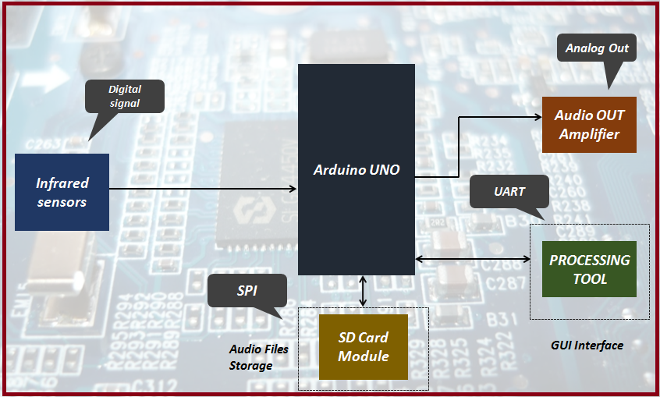

*Figure 1Hardware architecture of this project*

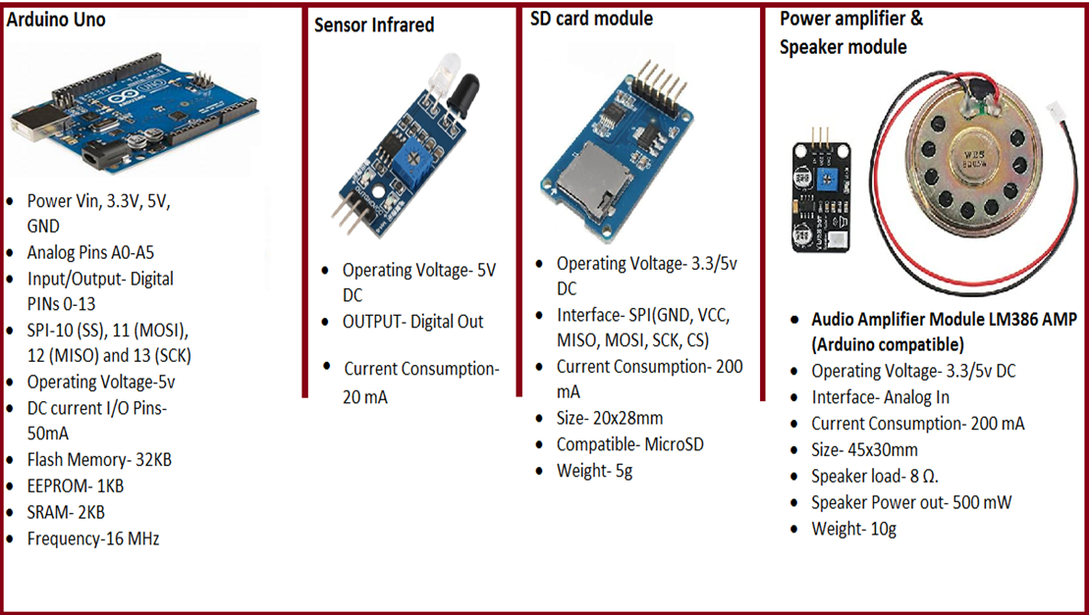

*Figure 2 Technical components which we have used in this project*

# Firmware and software design

## Function Case and Block Diagram Firmware

The program is designed for to provide functionalities for accessing to the hardware board with the integration of Sensors, Speaker, SD card with SPI communication and power amplifier. The figure below provides the design flow for this implementation using case diagram.

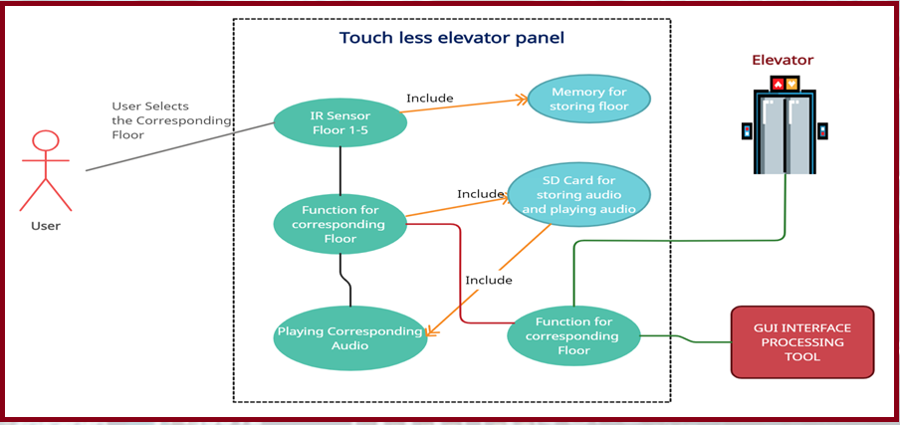

*Figure 3 Functional case diagram of the firmware design*

Figure

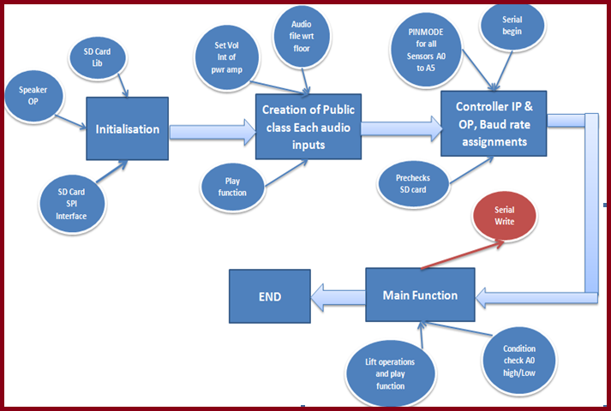

*Figure 5 Functional block diagram of the firmware design*

## Function block diagram software application

The graphical user interface designed for displaying and monitoring the floor operation. Monitoring the power up condition, level of sensor states active or inactive, emergency alarm and a moving GUI objects that provides simulation and view of elevator movement.

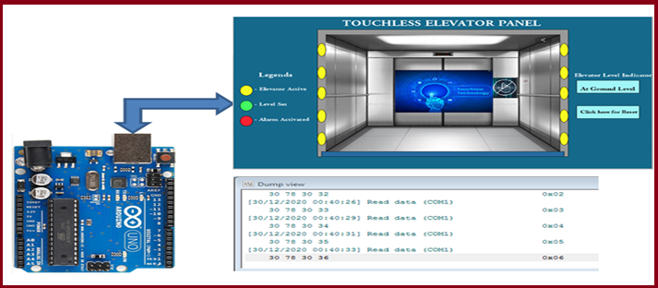

*Figure 6 Reference of Graphical User Interface*

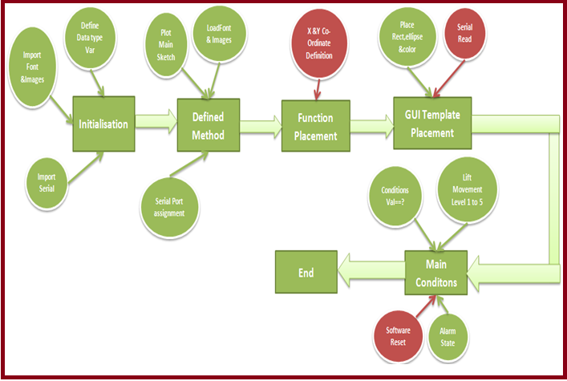

*Figure 7 Functional block diagram of the software (GUI) design*

# Process management

## Risk and Mitigate Actions

* Risk mitigation is prior planning of the process for designing solutions to problems and reducing threats to project objectives.
* Risk mitigation implementation is the process of executing risk mitigation actions.
* Risk mitigation progress monitoring includes tracking identified risks, identifying new risks, and evaluating risk process effectiveness throughout the project.

|  |  |  |  |
| --- | --- | --- | --- |
| *S.no* | *Identified Risks* | *Risk Level* | *Mitigate Advice* |
| *1* | *Collision between two or more sensors when detects the obstacles* | *High* | *Install the IR sensor with No conflict. Installation should be perfect* |
| *2* | *Audio storage memory storage insufficiency for storing audio files* | *Low* | *Utilize inbuilt SD card function of Aurdino UNO or Use external SD card and store the files* |
| *3* | *Storing the floor level data in EEPROM and set active and inactive state* | *Low* | *Check EEPROM memory of Aurdino UNO to enhance this requirement, and consider the time of the project for deployment* |
| *4* | *Binary inputs passing by serial communication and GUI must understand the value* | *Medium* | *Use serial port monitor tools to identify the format of serial read and implement the values into the GUI conditions* |

# Project result

## Project Hardware and Software integration diagram

The complete project had been designed incorporated as per the objectives, Sensor inputs are red via serial communication and controller decides the operation based on this and provides functions to the GUI for visualization.

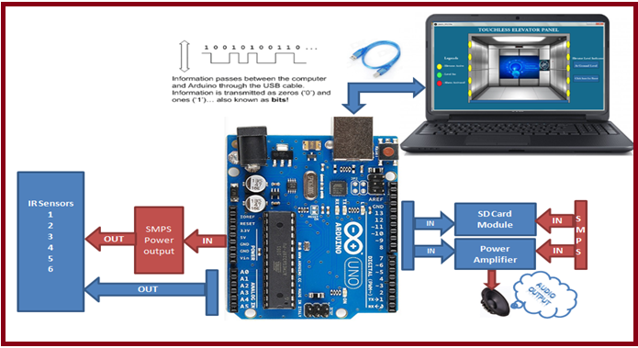

*Figure 8 Reference of hardware and software Integration diagram*

## Serial Port Monitor output

A tool used for acquiring and reading the serial data from the USB port.

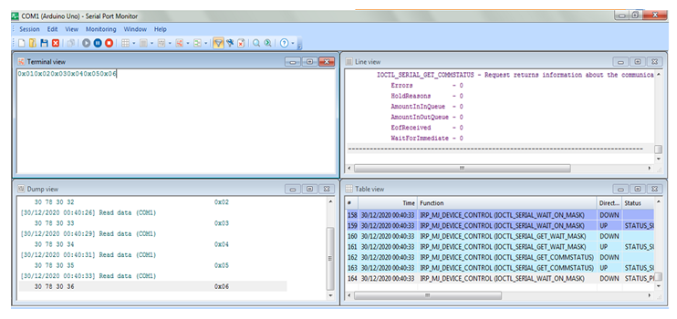

*Figure 9 SPM output from the Hardware signal to GUI*

GUI References for the Hardware output

Level 1 have reached, Sensor 1 is active with indication of Green color and moveable object reaches to level 1 to ensure the lift movement and pending all sensors status are signal off which is indicated by color yellow.

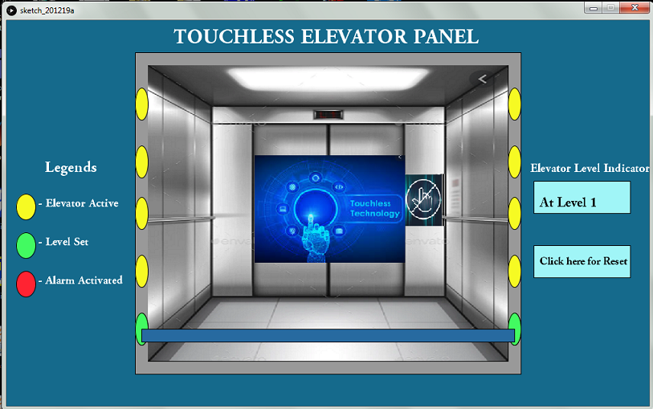

*Figure 10 Indication of first floor with Green color*

Level 4 have reached, Sensor 4 is active with indication of Green color and moveable object reaches to level 4 to ensure the lift movement and pending all sensors status are signal off which is indicated by color yellow.

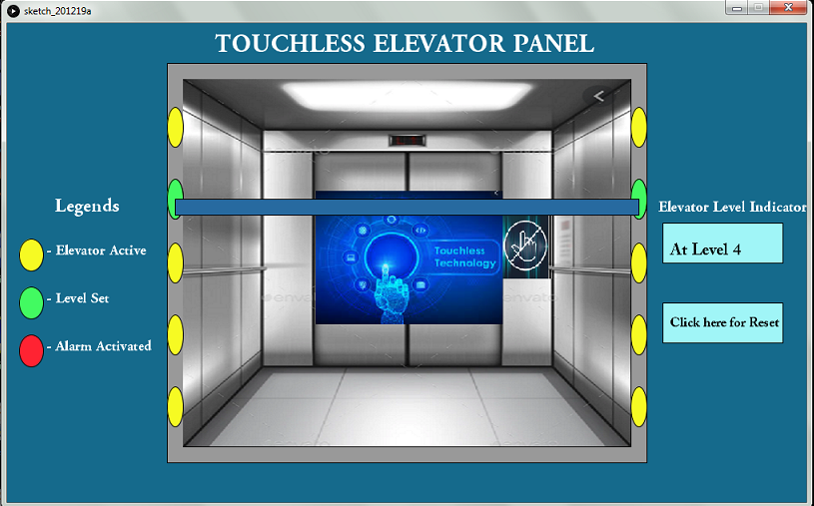

*Figure 11 Indication of fourth floor with Green color*

Alarm state active indication all sensor turns Red and moveable object stands or hold at the level where it was.

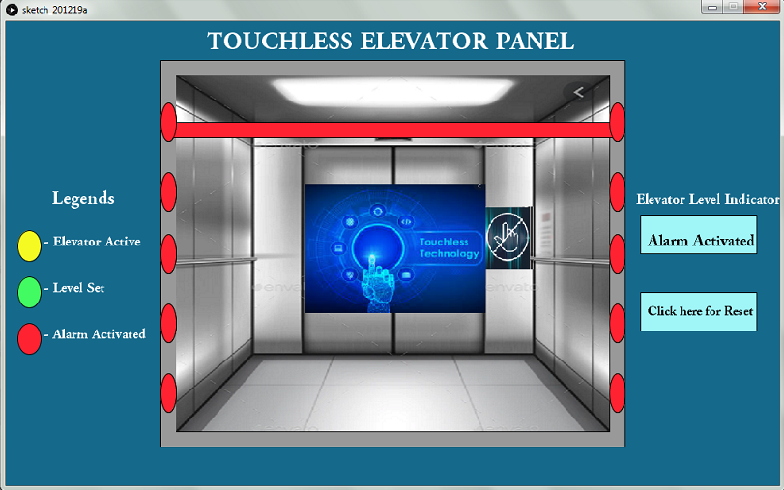

*Figure 12 Alarm set active and indication of emergency in Red*

Note: Software reset (manual) shall make status normal or again activate any of the floor sensors for the normal initial state.

Milestones (latency, power consumption, Problem statement & resolved state)

Latency - “Time delay between input event being applied to a system and the associated output action from the system”

For real-time embedded systems that process and respond to sensor data, a key measure of network performance is how long it takes data to get from one device to another – in other words, latency.

Example: An application such as email can take several seconds to deliver a message, with delays introduced by servers, switches and routers, before it lands in the recipient’s inbox.

For our specific application, latency is typically measured by sending traffic between two endpoints that are

IR sensor and information signal reaches to controller and 8 bit data send to application over serial communication.

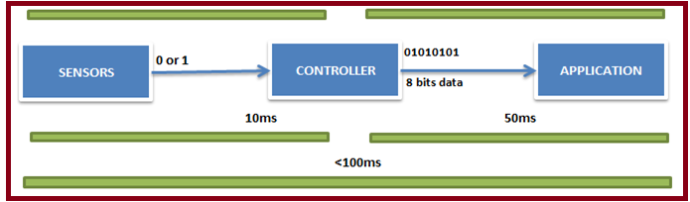

*Figure 13 Time delay between sensor signals to the software application*

Power consumption

* Arduino UNO- 250mW
* IR Sensor-74mW, for 5 sensors-370mW
* SD card module-100mW
* Audio speaker module with amplifier- 24mW
* Total Power consumption of module-744mW

# Problem statement & solution

Project is designed and implemented, as per the problem statement which are, Implementation of audio output, due to the lack of memory in controller (only 32KB of Flash memory), so it is not possible to store audio files in the main program memory of the controller.

Solution proposed:

We tried to compress audio files to load into our controller, but we have had no successes with this, So we decided to use the SD card module and integrate with controller which uses SPI communication. We were able to achieve the goal generating and storing the audio files for announcing the current elevator floor level.

References

Prof. Omkar M. Shete, Divyani V. Shete, Surabhi G. Pise. "A Survey Paper on Design & Control of an Elevator for Smart City Application." International Journal of Advanced Research in Electrical, Electronics and Instrumentation Engineering 6.4 (2017): 3021 – 3027.

Mohd Mustafa, Siti Nurul Ainun & Asmone, Ashan & Chew, Michael. (2018). An assessment of maintainability of elevator system to improve facilities management knowledge-base. IOP Conference Series: Earth and Environmental Science. 117. 012025. 10.1088/1755-1315/117/1/012025.

Rózanowski, K. & Murawski, Krzysztof. (2012). An Infrared Sensor for Eye Tracking in a Harsh Car Environment. Acta Physica Polonica A. 122. 874-879. 10.12693/APhysPolA.122.874.

Ms. Sneha Nahatkar, Prof. Avinash Gaur, Prof. Tareek M. Pattewar. “Design of a Home Embedded Surveillance System with Pyroelectric Infrared Sensor & Ultra-Low Alert Power” International Journal of Advanced Research in Electronics and Communication Engineering (IJARECE) 1.3 (2012): 86 – 90.

Benet Gilabert, Ginés & Blanes, Francisco & Simo, Jose & Perez, Pepita. (2002). Using Infrared sensors for distance measurement in mobile robots. Robotics and Autonomous Systems. 40. 255-266. 10.1016/S0921-8890(02)00271-3.

Amir Karim and Jan Y Andersson 2013 IOP Conf. Ser.: Mater. Sci. Eng. 51 012001

SitiAsmah Daud, NasrulHumaimi Mahmood, Pei Ling Leow, FauzanKhairiChe Harun. “Infrared Sensor Rig in Detecting Various Object Shapes.” International Journal of Advanced Research in Electrical, Electronics and Instrumentation Engineering 2.10 (2013): 4726 – 4732.

Pavithra B. G, Siva Subba Rao Patange, Sharmila A, Raja S, Sushma S J. “Characteristics of different sensors used for Distance Measurement.” International Research Journal of Engineering and Technology (IRJET) 4.12 (2017): 698 – 702.

Veeramanikandasamy, Dr T. (2016). Microcontroller and SD Card Based Standalone Data Logging System using SPI and I2C Protocols for Industrial Application. 5. 2208-2214. 10.5281/zenodo.3543657.

Vinodkumar P. More, Vikas V. Kulkarni. “Design and Implementation of Microcontroller Based Automatic Solar Radiation Tracker.” International Journal of Current Engineering and Technology Special Issue-3 (2014): 230 – 234.

Aishverya Kumar Sharma, Kushagra Kumar Choubey, Mousam Sharma. “INDUSTRIAL AUTOMATION USING 8051 MICROCONTROLLER.” International Journal of Advanced Engineering Research and Studies [BITCON-2015], BIT, Durg, CG, India, (Jan-March 2015): pp. 361 – 364.

Louis, Leo. (2018). Working Principle of Arduino and Using it as a Tool for Study and Research. International Journal of Control, Automation, Communication and Systems. 1. 10.5121/ijcacs.2016.1203.

Kuldeep Singh Kaswan, Santar Pal Singh, Shrddha Sagar. “Role of Arduino in Real World Applications.” International Journal of Scientific & Technology Research 9.1 (2020): 1113 – 1116.