# **Question 7**

1. **1NF Dependency Diagram**
   1. 1NF (**MEMBER_NUM**, **INVITE_NUM**, MEMBER_NAME, MEMBER_ADDRESS, MEMBER_CITY, MEMBER_ZIPCODE, INVITE_DATE, ACCEPT_DATE, DINNER_DATE, DINNER_ATTENDANCE, DINNER_CODE, DINNER_DESCRIPTION, ENTRÉE_CODE, ENTRÉE_DESCRIPTION, DESSERT_CODE, DESERT_DESCRIPTION)

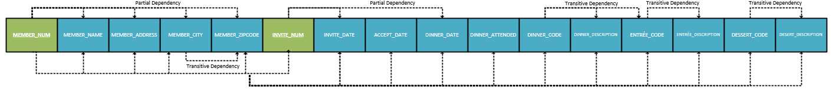

1. **3NF Dependency Diagrams**
   1. MEMBER (**MEMBER_NUM**, MEMBER_LNAME, MEMBER_FNAME, MEMBER_ADDRESS)
   2. ADDRESS (**MEMBER_ADDRESS**, **MEMBER_CITY**, MEMBER_ZIPCODE)
   3. INVITE (**INVITE_NUM**, INVITE_DATE, DINNER_DATE)
   4. MEMBERSHIP_DINNER (**MEMBER_NUM**, **INVITE_NUM**, ACCEPT_DATE, DINNER_ATTENED, DINNER_CODE, DESSERT_CODE)
   5. DINNER (**DINNER_CODE**, DINNER_DESCRIPTION, ENTRÉE_CODE)
   6. ENTRÉE (**ENTRÉE_CODE**, ENTRÉE_DESCRIPTION)
   7. DESSERT (**DESSERT_CODE**, DESSERT_DESCRIPTION)

1. **Crow’s Foot Notation**

# **Question 8**

1. **2NF and 3NF Dependency Diagram**
   1. 3NF (**A**, B)

* 1. 2NF (**A**, **B**, C, E, F, G)

1. **3NF Dependency Diagram**
   1. 3NF (**A**, B)

* 1. 3NF (**A**, **B**, C, E, F)

* 1. 3NF (**E**, G)

1. 3NF and 3NF with BCNF Dependency Diagrams
   1. 3NF (**A**, D)

* 1. 3NF with BCNF (**A**, **C**, E, F)

* 1. 3NF with BCNF (**C**, B)

* 1. 3NF (**E**, G)

