**This lab is worth 15% of your final AI4G grade.**

**Due Fri Nov 10th 5pm**

**Lab 6**

You are to implement the Goal-based Vector Field pathfinding algorithm (also known as the Flow Field pathfinding algorithm).

To demonstrate your algorithm, you should create a 50 X 50 tile-based world. Each tile can either be traversable or not traversable therefore allowing you to set some obstacles in the world. The user should then be allowed to pick the Goal and Start tiles e.g. via left and right mouse clicks. Your program should then display the path it would take to get from Start to Goal while avoiding the obstacles by following the flow field.

It would be advantageous for the cost field to be displayed on each tile and also the vector field. Ideally these could be toggled on and off. If you are feeling fancy, then the cost value of each tile could be used to set the intensity of the colour of the tile thus implementing a heatmap.

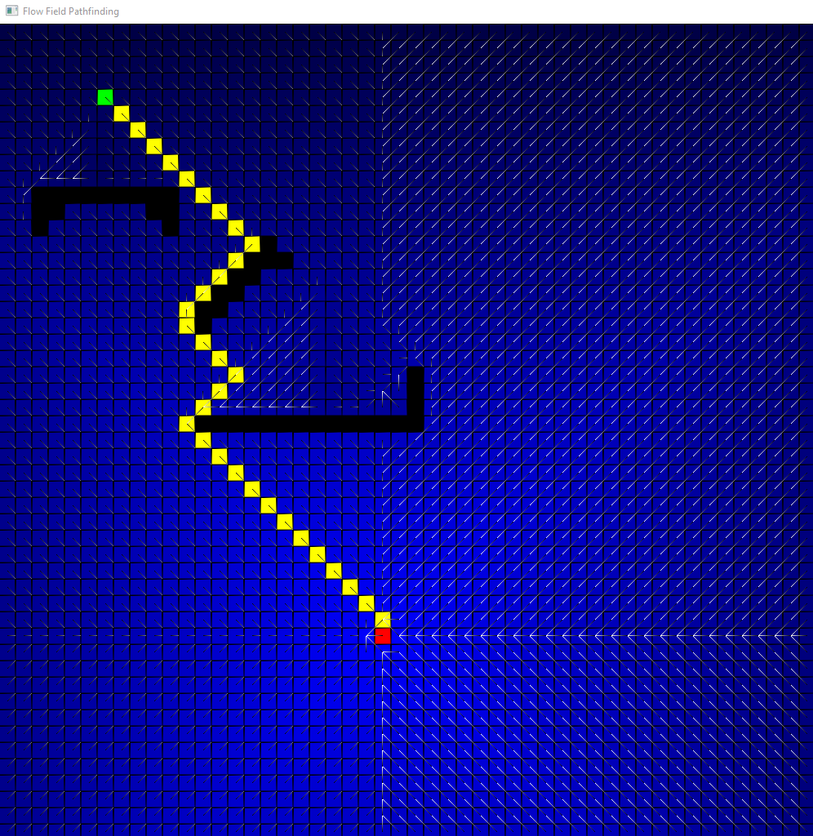

**Marking Scheme:**



If you do not implement the flowfield algorithm as described in the notes you will loose marks.

The extra 10 going for specific attention to efficiency, and/or visualisation. For example, you might have NPCs travelling from Start node to Goal node. You can include a Readme.txt to explain the Extra you have done.

**Submission**:

I will put up a link on Blackboard where you should upload the VS project. This should be a slimmed down version so we are not swamping the system with huge VS projects.