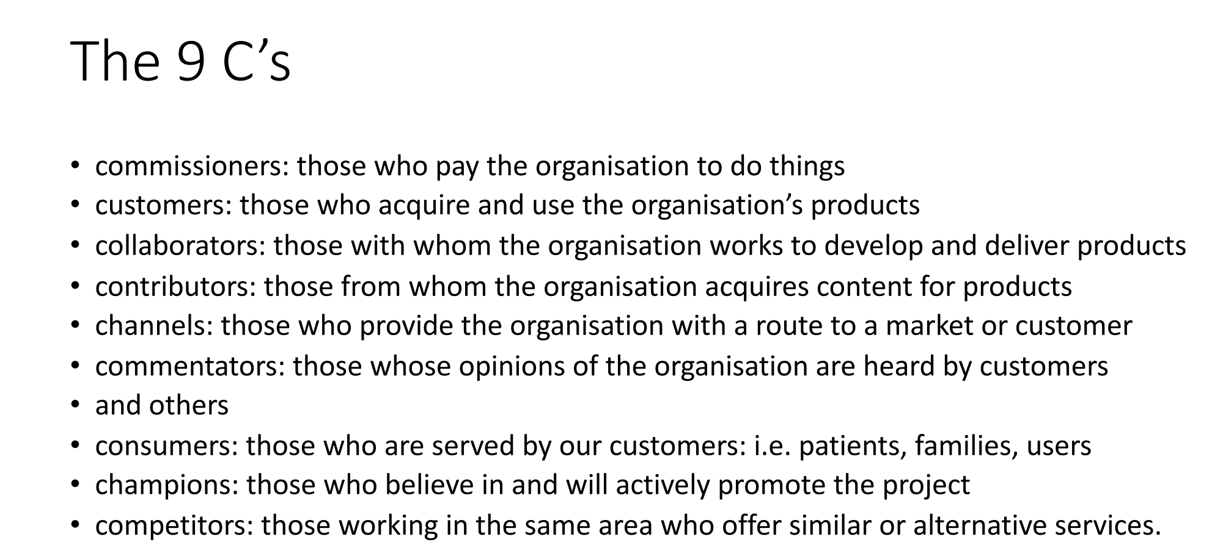

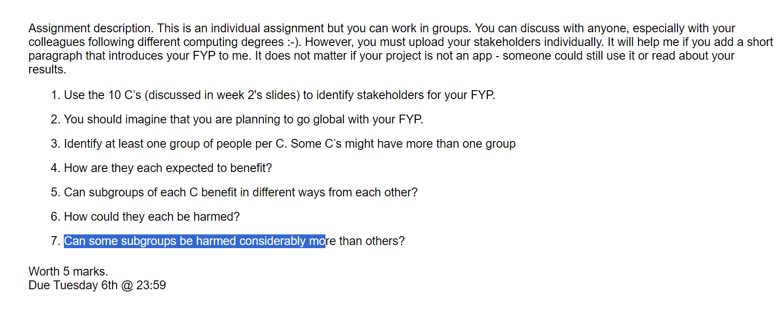

**Shareholder Analysis – FYP**

My FYP is a Real Time Strategy Game, where you have to build your base to unlock new things, train units so you can fight the enemies on the map. You can also create your own levels with the level editor. You can group units together and attack as a formation

**Customers**

**Groups of people**

Gamers

**How they benefit**

These customers would benefit by being able to play my game and have fun.

**Subgroups**

Married people, working people, children, other people (in general)

**How can they be harmed?**

Married people could be harmed if my game was too distracting and they prioritised it over more important things in life, this could lead to problems around the house and could destroy the relationship.

Working people could be harmed because they might stay up too late playing my game and then they could end up being late to work or not going at all.

Children could be harmed by playing my game too much and this would distract them from doing school work

General people could be harmed if I decide to monitise my game. They could spend money on my game while they have much more important things to be do with their money

**Can some subgroups be harmed more than others?**

Yes, certainly some subgroups could be harmed more than others. Some people could lose their job or partners due to this.

**Collaborators**

**Groups of people**

Lecturers, game developers, artists

**How they benefit**

Lecturers can benefit from having the satisfaction and pride in knowing that one of their students made a successful game.

Game developers and artists who work on the game with me would get paid and they’ll be happy with how successful the game is

**Subgroups**

**How can they be harmed?**

If the game ends up not making much money then the artists and game developers might lose their jobs and they will be very disappointed and let down that all their time and effort didn’t pay off

**Can some subgroups be harmed more than others?**

I can’t really think of any subgroups for this but game developers and artists would definitely be harmed more than my lecturers

**Contributors**

**Groups of people**

Microsoft, artists, other game developers

**How they benefit**

If I use products from Microsoft to make my game, this might get other people to use Microsoft products

**Subgroups**

Visual studio

**How can they be harmed?**

I don’t think they can be harmed really, even if my game was very bad

**Can some subgroups be harmed more than others?**

**Channels**

**Groups of people**

Social Media platforms, social media influencers, online streaming websites

**How they benefit**

If my game is very popular and a social media influencer promotes or starts uploading videos of my game this would lead to them also gaining more popularity and money. This would also earn the social media platforms more money

**Subgroups**

TikTok, Instagram, YouTube, Twitch, X

**How can they be harmed?**

If the game isn’t good and they promote it then they might lose followers and supporters and this could lead to them losing money

**Can some subgroups be harmed more than others?**

Yes, I think the influencers would be much more hurt than the platforms, as in severe cases the game might be so dodgy or bad they could lose all their respect and followers

**Commentators**

**Groups of people**

Game reviewers, social media influencers, game developers

**How they benefit**

These would benefit because they would get feedback or opinions from the public and would then share all the feedback with people

**Subgroups**

?

**How can they be harmed?**

Maybe because these are the people who listen to the people and review the game, they might get a lot of hate directed towards them and if their opinions are different than others people might start arguments with them

**Can some subgroups be harmed more than others?**

Yes, if the reviewers have a good reputation and then if everyone disagrees with their opinion in my game it might make them lose their credibility

**Competitors**

**Groups of people**

Other game developers, other games, other forms of entertainment

**How they benefit**

Competition is always good as it makes people step up their game and try make a better product. It might increase the development standards of other games in a similar genre, also making the developers themselves better at programming and making games. It might also change other forms of entertainment to change how they do things and copy some features from my game and this would make their product better.

**Subgroups**

Employees (game developers)

**How can they be harmed?**

Other games could be harmed because my game could be better than theirs and it might take away all their player base. This would cost them big time and they would lose money.

Also, it could lose game companies their jobs because they wont be making enough money as their game isn’t as popular anymore

**Can some subgroups be harmed more than others?**

Yes, I think individual developers would be harmed because if the game they worked on wasn’t doing as good as it used to, their positions might be in danger and they might be let go

