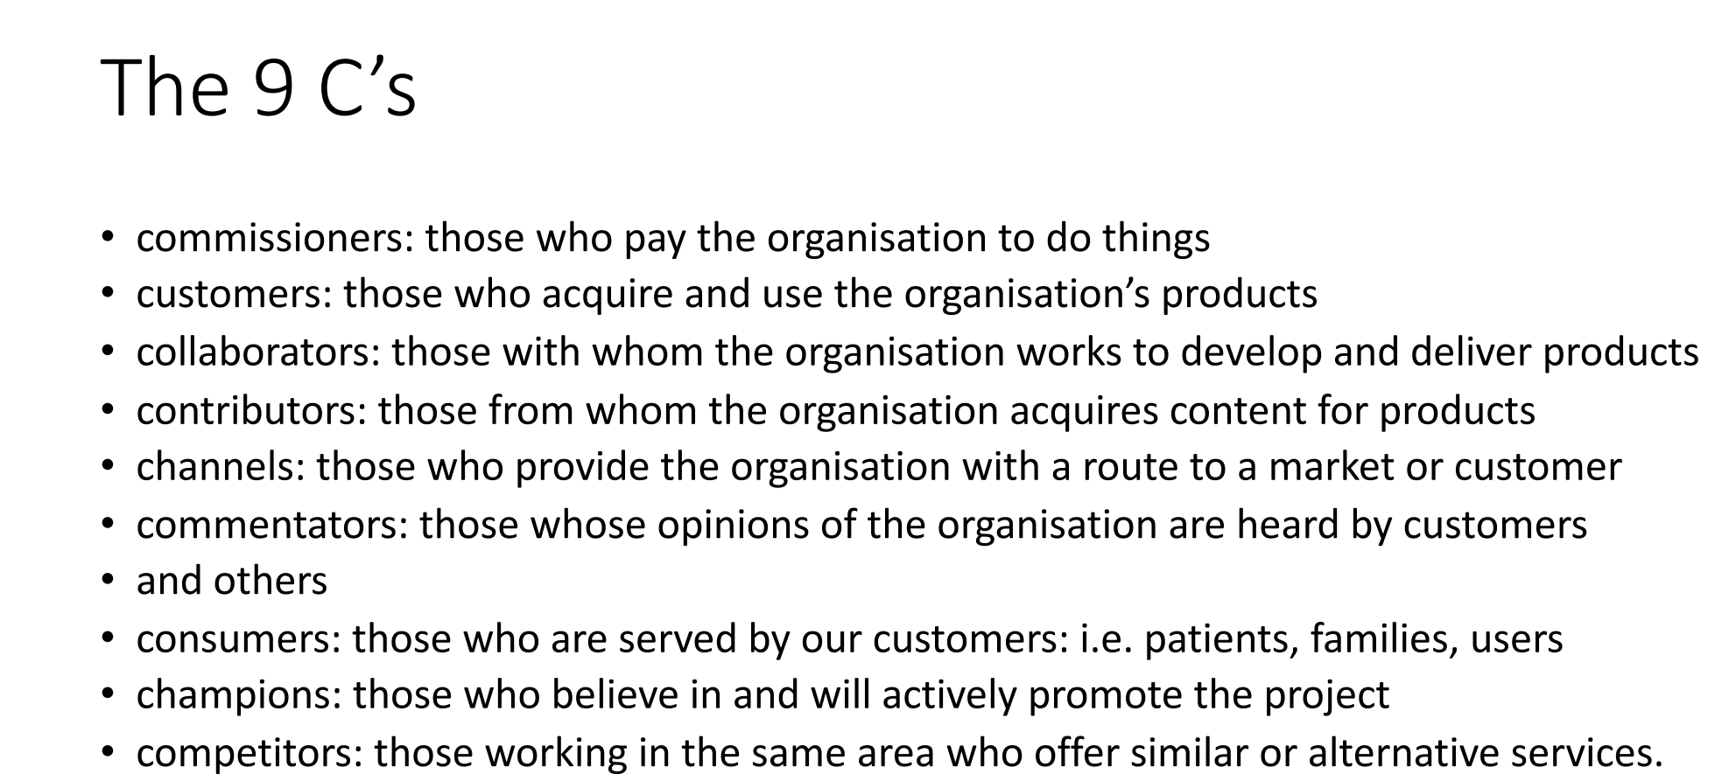

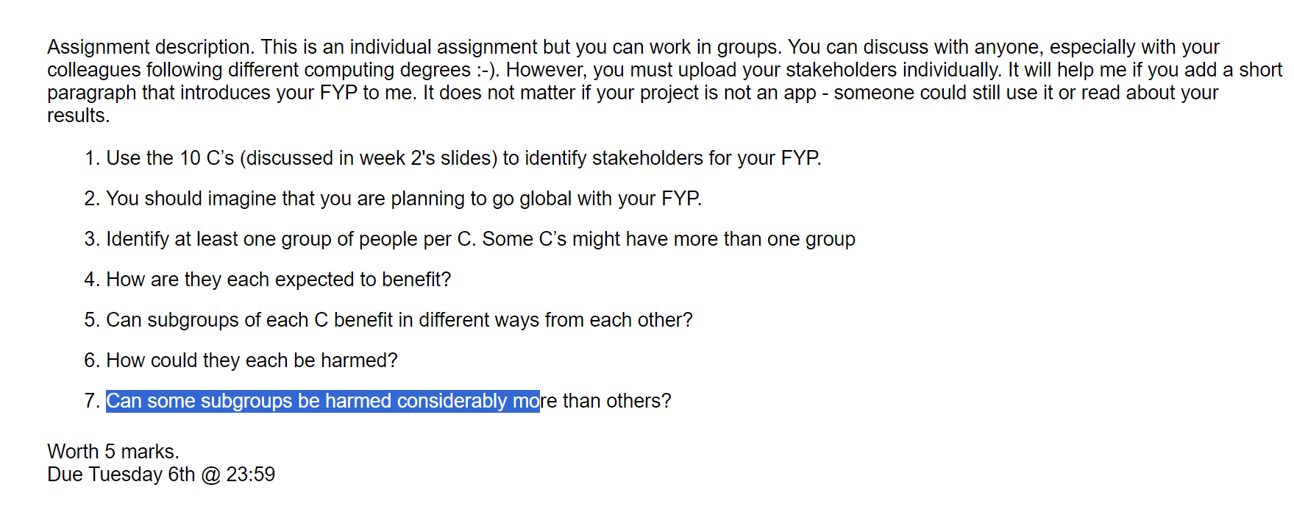

**Stakeholder Analysis – FYP**

My FYP is a Real Time Strategy Game, where you have to build your base to unlock new things, train units so you can fight the enemies on the map. You can also create your own levels with the level editor. You can group units together and attack as a formation

**1 - Commissioners**

**Groups of people**

* Investors
* Sponsors

**How they benefit**

Investors can benefit from making a big return on their investment if the game does successful

Sponsors would gain brand exposure from this and if the game is popular they would get recognised more often which would make their brand grow

**Subgroups**

Investors

* Venture capitalists
* Angel investors
* Bigger game companies

Sponsors

* Corporate sponsors
* Local businesses

**How can they be harmed?**

Investors – They would lose money if the game isn’t successful

Sponsors – If the game isn’t liked, then it would harm the brand that sponsored them and if the game has different values to the sponsor it would lead to a them earning a bad reputation

**Can some subgroups be harmed more than others?**

Investors - I think angel investors might be the most effected because they are individual people risking their own money compared to big companies and businesses but then again, they are risking lots of peoples money, not just one person in particular

Sponsors – I think local businesses would get impacted very badly because these are usually small business and if they get a bad reputation it could ruin them

**2 - Customers**

**Groups of people**

Gamers

**How they benefit**

These customers would benefit by being able to play my game and have fun.

**Subgroups**

* Married people
* Working people
* Children
* Other people (in general)

**How can they be harmed?**

Married people - Could be harmed if my game was too distracting and they prioritised it over more important things in life, this could lead to problems around the house and could destroy the relationship.

Working people - Could be harmed because they might stay up too late playing my game and then they could end up being late to work or not going at all.

Children - Could be harmed by playing my game too much and this would distract them from doing school work

General people - Could be harmed if I decide to monitise my game. They could spend money on my game while they have much more important things to be do with their money

**Can some subgroups be harmed more than others?**

Married people - I think this would harm people who are married the most because it could end a marriage and tear families apart in serious cases.

Working people – These could be damaged by this in a major way because all their life they spent getting an education and earning this job all for it to be taken away because they got addicted to playing my game

**3 - Collaborators**

**Groups of people**

* Lecturers
* Game developers
* Artists

**How they benefit**

Lecturers - Can benefit from having the satisfaction and pride in knowing that one of their students made a successful game.

Game developers and artists - These people work on the game with me would get paid and they’ll be happy with how successful the game is

**Subgroups**

* Lead Developers
* Lead Artists
* Developers
* Artists

**How can they be harmed?**

Game developers and artists - If the game ends up not making much money then the artists and game developers might lose their jobs and they will be very disappointed and let down that all their time and effort didn’t pay off

**Can some subgroups be harmed more than others?**

Lead developers and artists – They might lose their roll as ‘lead’ if the game goes bad and they would have worked a long time to get to that position so I think these would be harmed the most

**4 - Contributors**

**Groups of people**

* Microsoft
* SFML
* Artists
* Game Developers

**How they benefit**

Microsoft and SFML– If people knew what my game was created with, it might cause others to use it

**Subgroups**

* Visual studio

**How can they be harmed?**

Microsoft - I don’t think they can be harmed really, even if my game was very bad. The company is much bigger than any game that fails

Artists and Game developers – If I use any of their free licensed art or if I get code from people, they would feel disappointed as I used their work but got all the money from it and didn’t give them credit

**Can some subgroups be harmed more than others?**

Artists and game developers – I think these would be harmed much more than Microsoft and the bigger companies that contributed

**5 - Channels**

**Groups of people**

* Social Media platforms
* Social media influencers
* Online streaming websites

**How they benefit**

Social Media platforms – My game being popular would get people to share clips and talk about my game on their platform. Increased engagement would increase their ad revenue as well

Social Media influencers - If my game is very popular and a social media influencer promotes or starts uploading videos of my game this would lead to them also gaining more popularity and money.

Online streaming websites – Increased viewer ship on their website which would lead to an increase of subscriptions

**Subgroups**

* TikTok
* Instagram
* YouTube
* Twitch
* X

**How can they be harmed?**

Social media platforms – If the game is bad or controversial then this might lead to advertisers being unhappy and pulling away from the platform

Social Media influencers – They might lose some of their followers if the game isn’t received well

Online streaming websites – Once the games popularity starts to die down then the sites wont get as much viewership as it used to

**Can some subgroups be harmed more than others?**

Influencers – I think they would be much more hurt than the platforms themselves. This is because if the game is bad it could cause them to lose some of their followers, but that doesn’t mean that the people will stop using the platform

**6 - Commentators**

**Groups of people**

* Game reviewers
* Social media influencers
* Game developers

**How they benefit**

Game reviewers – By offering good, informational opinions, this can enhance their credibility. They can also gain their audiences trust within the gaming community

Social media influencers – They might get more followers

Game developers – As they are in the business, they might be able to share their opinions on my game and then it might bring a new audience to their games

**Subgroups**

* Professional reviewers
* Independent reviewers

**How can they be harmed?**

Game reviewers and Social media influencers - Maybe because the public who play the game listen to the influencers and reviewers, so if the public don’t like their opinions it might cause them to lose fans and lose their credibility

**Can some subgroups be harmed more than others?**

Game reviewers - If the reviewers have a good reputation and then if everyone disagrees with their opinion in my game it might make them lose their credibility

**7 – Consumers**

**Groups of people**

* Casual gamers
* Gaming enthusiasts

**How they benefit**

Entertainment, Enjoyment, and relaxation through playing games.

Accessible Gameplay, Games designed for casual enjoyment without complex mechanics.

**Subgroups**

* Mobile gamers
* Console gamers
* PC gamers

**How can they be harmed?**

All of these can be harmed by spending too much money on in game purchases. They can also be very let down if the game isn’t fun and enjoyable to play

**Can some subgroups be harmed more than others?**

Mobile Gamers – May be harmed if you have an older device and the game takes up too much storage or ram, it could also make your mobile data run out very fast compared to other apps

Console Gamers - May be less affected by technical issues but still impacted by unmet expectations.

PC Gamers - More impacted by technical issues due to the complexity of PCs and how easily they can crash or get corrupt

**8 – Champions**

**Groups of people**

* Gaming Community Leaders
* Brand ambassadors

**How they benefit**

Gaming Community Leaders – They have good influence on other people and have the ability to shape opinions and promote positive aspects of a game. They can also bring together who share a passion for the game

Brand ambassadors - Opportunities to promote the game through various channels and are recognised as an official representative of the game

**Subgroups**

* Forum moderators
* Content creators
* Influencers
* Cosplayers

**How can they be harmed?**

All of these can lose their credibility by promoting a game that is poorly received

Forum moderators and content creators - Negative reactions to a game may lead to the community getting annoyed and frustrated

Ambassadors - If the game is poorly received, it may negatively impact the brand ambassador's personal brand and reputation, also, due to the decline in the game's popularity, this may reduce opportunities for promotion in the future by other games

**Can some subgroups be harmed more than others?**

Forum Moderators - May experience direct consequences due to community dissatisfaction.

Content Creators - Loss of credibility can impact their influence and audience trust.

Influencers - May experience a more direct impact due to the strong association with their personal brand.

Cosplayers - Impact may vary based on the level of reliance on the game for opportunities

**9 - Competitors**

**Groups of people**

* Game developers
* Different games
* Different forms of entertainment

**How they benefit**

Game developers – After seeing my game they might want to decide to apply for a job with better pay and it would make developers strive to make better games and have better coding quality

Different games – It would make good competition in the game space, so the other game companies would need to step up and make better games

Different forms of entertainment – Movies and shows could be made based off my game, opening up lots of doors and getting the players to experience my game in different forms of entertainment

**Subgroups**

* Individual developers
* Development teams
* Gaming companies
* Entertainment companies

**How can they be harmed?**

Individual developers and development teams – Job security, if the game wasn’t successful then they might lose their job

Development teams – If a game was unsuccessful then a few teams might be shut down

Entertainment companies – Would lose business as people might stop watching shows and just focus on playing my game

**Can some subgroups be harmed more than others?**

Individual developers - I think would be harmed the most because if the game they worked on wasn’t doing as good as it used to, their positions might be in danger and they might be let go

