**SERVER PROPOSITION**

This proposition will go over a server facility for use with the local hospital.

At an overall flooring area of 20,000 sq ft, this gives us a room of 113.14 ft x 176.77 ft

**SERVER HARDWARE REQUIREMENTS**

**Server Racks -**

The primary housing of our servers and all other hardware modules. To a standard preferred scale of 7 ft height, 4-foot front clearance, and 3-foot rear clearance.

**Main Distribution Frame -**

* The Main Distribution Frame (MDF) is the main source of connectivity and communication within a computer network. This is the device which will allow the main hospital building from 200 miles away to gain access into the server network and all of its data and assets.

**Server Modules -**

* In order to serve 350 definitive workstations and up to a total of 500 potential workstations, with a total of 800 users overall, a data center would only require around 3-5 servers.

**Storage -**

* The server's storage is run off a Storage Area Network (SAN), connected to the main servers via Fabric Switch devices. These allow for fast connection to the server's storage, important in a medical environment.

**Redundancy -**

* Redundancy ensures that a server runs as seamlessly as possible; multiples of everything in your server room - storage devices, servers, power supply, etc. That way if one piece of equipment happens to fail, it has a backup in place.

**Security Hardware -**

* Access to the server's many components and data can be reliably secured with firmware and firewalls, As well as monitoring access to the server (who, when, and/or why a user has accessed the server)

**Backup -**

* Thanks to the use of virtualization, which generally uses snapshots, backing up a failed system is much simpler. Automatic scheduled backups can be of great help to a server, along with Network Attached storage. Regular documentation of said backups should be implemented.

**Virtualization -**

* It is most optimal that the server relies mainly on the Citrix XenDesktop Virtual Machine, as virtualization allows for much flexibility, and simpler isolation, and is more effective in backup and disaster recovery.

**HVAC -**

* **Heat -**
  + Heat detectors placed throughout the data center can ensure that the room remains at a consistent temperature. The room should remain fairly cool, between 18-27 degrees Celcius (32.39 BTUs). Should not change more than 5 degrees Celsius within an hour.
* **Air conditioning -** 
  + The air conditioning units within the Data center are intended to blow between the hot aisles of the data center, in order to send the warm air through the ventilation ducts in the ceiling.
* **Ventilation -** 
  + In tandem with the air conditioning units, Ventilation ducts placed on the ceiling are to circulate the warm air from the server racks out of the building.

**Humidity -**

* A server room's humidity should be no less than 40% to prevent static shock, but no more than 60% to prevent excessive moisture.

**Power requirements / UPS -**

* To ensure that a server is constantly up and running, an uninterrupted power supply (UPS) is in place. Taking into account redundancy, Multiple UPS devices shall be added. Alternatively, certain UPS devices include multiple batteries within, accounting for built-in redundancy. The idea behind multiple batteries being in use is once one battery is low, it will immediately switch over to using the other battery, and recharge the other battery using a generator.

**Power distribution -**

* Power Distribution Modules (PDM) are responsible for efficiently distributing electricity to all the components contained on the server racks. This is to make sure that there is no short-circuiting or overloading of any modules.

**Physical security**

* Since this facility is intended to house all of the hospital's data and information, well-implemented security must be in place.
* Physical security for the building includes video surveillance monitoring, as well as doorway ID entry.

**Printing -**

* Printing services are to be provided for both the main hospital building, as well as the Data center building. Given the redundancy of rack servers, printer usage can be managed on these server modules.

**Disaster Recovery -**

* All former precautions listed in this document aid in the server disaster recovery strategy -
  + Redundancy of network devices lessens the likelihood of total device failure
  + Both physical and digital security protect the organization's valuable resources
  + Backups of files and VMWare snapshots ensure that the total loss of a company's data is not entirely lost.
  + Documentation and monitoring of server usage can be helpful in recovering from a disaster.

**Fire detection/suppression/prevention**

* If a fire occurs, powder-based fire extinguishers are to be employed on the premises. In this context, portable fire extinguishers will most likely not be employed, instead replaced by an automatically triggered extinguishing system.
* Smoke alarms within the building will trigger the system to activate, followed by the extinguishing powder being released.

**BUILDING LAYOUT**

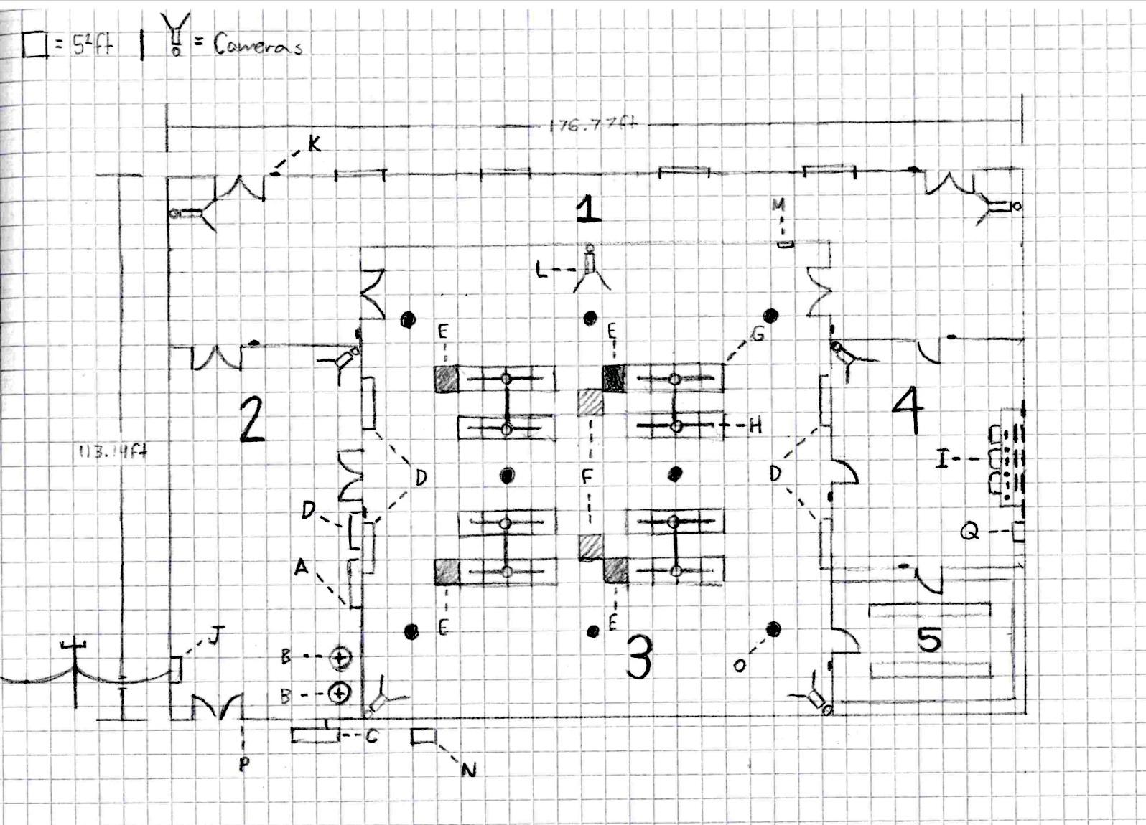

Image layout of hospital server building proposal

**Rooms -**

* 1 - Main Entrance
* 2 - Electricity/Power Room
* 3 - Data Center
* 4 - Security Monitoring/Net Operations Room
* 5 - Equipment Storage Room

**Equipment -**

* A - Main Distribution Frame
* B - Uninterruptable Power Supply
* C - Generator
* D - Air Conditioning Units
* E - Power Distribution Modules
* F - Ventilation Ducts (Fixed to ceiling)
* G - Server Racks
* H - Fire Extinguishing Systems (activated by smoke detectors, Powder-based)
* I - Monitoring/Net Operations Station
* J - Entrance Facility
* K - Key Fob Entry Security
* L - Surveillance Cameras
* M - Digital Thermometer
* N - Environmental Control Unit
* O - Heat Sensors
* P - Emergency Exit
* Q - Printer