Matthew Murnin’s Logs
Table of Contents

10/3/25 2
10/13/25 6
10/17/25 6
10/18/25 7
10/20/25 7
11/3/2025 8

9/16/2025
Held Team meeting with sponsor.
## Questions
1. Why is solving this problem important to your organization/cause?
2. What has been done to solve this problem? Has anything worked?
3. What would success look like?
4. Of all the things you would like to see, which are necessary, and which are stretch goals?
5. What constraints should we be aware of?
6. Describe in detail what the end user would look like.
7. How aware is the end user of this problem? How familiar is the end user with technology?
8. How will this project be evaluated on your end?
9. How often would you like updates or check-ins?
10. How can we access the data necessary to complete this project?
11. What does a use case look like?
12. What are the customer inputs to this application?
- Use this answer to create UX mocks.
13. What data is sensitive?
- Stored locally? Encrypted?
14. Is Microsoft Azure required, or must it be in the cloud?
15. Are there requirements for languages, libraries, or IDEs?

9/22/25
- Held Team meeting.
Agenda:
### Welcome (1 min)
- Purpose and goals of meeting.

### Refine Model and Equation Understanding (15-20 min)
- Define predictive model inputs/outputs.
- Discuss static equations for biochar application.
- Frame ROI expectations:
- Costs, benefits, time horizon, possible outputs.
- Discuss whether previous biochar applications should be an input.

### Wrap-Up (2 min)
- Summary discussion if necessary.
- Confirm action items.

---

## Action Items

- UX Mockups.
- Sequence Diagrams.
- Use Case Diagrams.
- Data Flow Diagrams.

9/29/25
- Held team meeting
## Agenda

### Welcome (1 min)
- Purpose and goals of meeting.

### Refine Model and Equation Understanding (15-20 min)
- Define predictive model inputs/outputs.
- Discuss static equations for biochar application.
- Frame ROI expectations:
- Costs, benefits, time horizon, possible outputs.
- Discuss whether previous biochar applications should be an input.

### Wrap-Up (2 min)
- Summary discussion if necessary.
- Confirm action items.

---

## Action Items

- UX Mockups.
- Sequence Diagrams.
- Use Case Diagrams.
- Data Flow Diagrams.

10/3/25
- Created a mockup of the budget plan.
- Converted it to a `.md` file.
Budget Plan:
# Capstone Project Budget

## Cloud Hosting
*(Azure account already exists, so payment may be deferred)*

- **Azure Web App (Basic B1 Plan, ~1 vCPU, 1.75GB RAM):** $55/month
- **Azure Storage** (for heightmaps, yield data, backups): $10/month
- **Azure SQL Database** (Basic tier for farmer data): $5/month
- **Bandwidth & Scaling Allowance:** $15/month

## APIs & Tools
- **Domain Registration** (e.g., .org or .com): $15/year
- **SSL Certificate** (Let’s Encrypt free option available, otherwise ~$50/year)

---

### **Total Monthly Cloud Costs:** ~$150
### **Estimated Annual Cost (12 months):** $1,800

10/13/25
- Team meeting on plans for Project Portfolio Assignment & Snapshot Day #1.

10/17/25
- Created a sequence diagram for the website's backend. (More visible in backend folder)
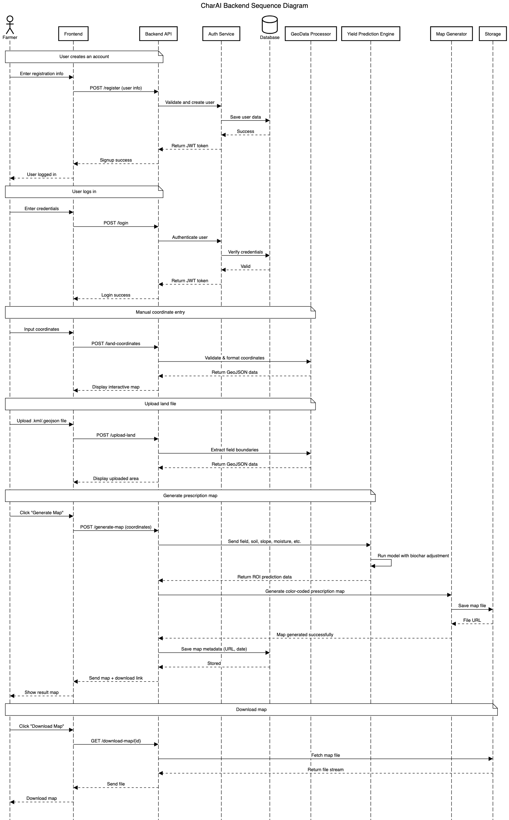

10/18/25
- Documented relevant APIs for the backend (found in backend folder)

10/20/25
- Changed backend documents to `.uml`

11/3/2025
- Held team meeting to begin coding the web app

11/11/2025
- Held team meeting on Concept Design Review
- My job: Budget, Risks, and Mitigation
Risks:
- Farmer PII / Farm Data
- Session Hijacking. Make sure we log out
Mitigations:
- Login info: SQLite, Django auto salts & hashes them
- Farm Data: Encrypted Json File (just coords & yield for farm)
- Session hijacking: stored in cookies

11/17/2025
- Held 1-on-1 meeting with Terry Soule.
- Discussed next steps to create a way to input location/parse data from it.

11/25/2025
- Complete test for GeoTiff Generation in generator.py
- Implemented a way to convert coordinates into a TIF file (contains coords and elevation)
- Held a meeting discussing backend + combining this with the TIF parser Bradyn created.

