Joseph Baruch

CS 212

Assignment 4

October 23, 2023

Airline Baggage Satisfaction 2004-2010

Assignment Description

Assignment 4 aims at becoming a better python programmer and understanding matplotlib and Pandas to a higher degree. This assignment has us import and read a CSV file into a Pandas Data Frame which airline baggage data. We then calculate the average baggage complaint per person who boarded the plane for every year and every airline. This data is then represented in a matplotlib diagram with the calculated standard deviation for each airline.

Program Description

Outside of the commands provided in the program, here is a brief description of my program that helped analyze the Airline Baggage Data:

Setting up the program starts by first including all necessary libraries and reads the required csv file into a panda’s data frame. The program then calculates the ratio of the Baggage column over the Enplaned column and places this into a new column in the data frame titled B/E.

The main body of the program calculates the average B/E and standard deviation for all three unique airlines for every year. This is done using data frame manipulation techniques, programming logic and looping. These values are added into sub data frames for every airline.

Next a new data frame is created using the pd.concat() method that combines the sub data frames of the previous paragraph into one cumulative data frame.

Lastly, using matplotlib the data is presented using the ax.errorbar() plot type in matplotlib.

Pandas Data Frame Containing Plotted Data

Baggage Complaint Per Person Per Year

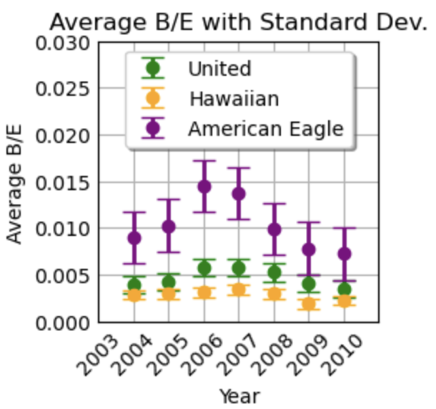

Conclusion

Based on the information gathered and represented in the above diagram, American Eagle shows to the produce the most baggage complaints followed by United then Hawaiian. Among these trends, American Eagle is the outlier whereas Hawaiian and United were comparable.

Another trend found with the data shows an increase in baggage complaints for the years 2006 and 2007 for all airlines. Interestingly, American Eagle Airlines responded the worst to these trends which contributed to the largest standard deviation out of the three airlines present in this data set.