Joseph Baruch

CS 212

Project 1 Checkpoint

11/1/2023

Checkpoint

This is a checkpoint of the objectives that I set before starting this program.

Objectives Completed

1. API Handling

* I was able to complete all API handling and retrieved that data. I only have data for IBM but could use other stocks if I wish.
* I was able to return these values as json.

1. Pandas Data Frame:

* Converting to pandas’ data frame was completed.
* There wasn’t really any data cleaning that needed to be done but I needed to do some reformatting. For instance, I needed to convert everything into floats from strings are reverse the order of the data.

1. Plotting

* I converted everything into numpy arrays (data values) for easier plotting.
* I was able to plot everything but couldn’t fix the axes labels. They are very dense with values.

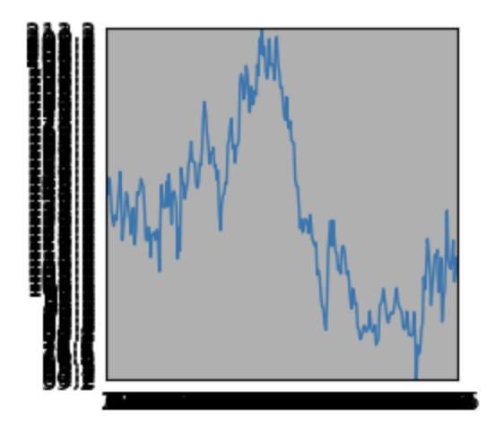

Future Objectives

1. MatPlotLib

* Clean axes labels and make data more presentable.

1. Data Learning

* Start experimenting with machine learning to predict what future values might be.

1. Comparing Data

* Finding trends where the values of are high or low and relay them on real world events to show meaning (this will be the final report).