Stock Market vs Bitcoin Price Comparison

Joseph Pauly and Braden Molvig

2022-12-10

## Motivation

   We want to try to find a relationship between the stock market sectors and the top cryptocurrency to find money making opportunities.

This project is aimed at answering the question: Are trends in the crypto market influenced by trends in different sectors of the stock market?

   The stock closing price data are from Yahoo finance. Bitcoin price data is from Nasdaq. All stock datasets contain daily prices such as open, close, high, low, and adjusted close. Cryptocurrency dataset include daily prices, open, high, and close. All four datasets span over the past three years. We will be analyzing different S&P 500 sector ETF’s as indicators for different sectors of the market. The 11 sectors are information technology, health care, financials, consumer discretionary, communication services, industrials, consumer staples, energy, utilities, real estate, and materials.

## Methods

   The sector etf stock data was gathered from yahoo finance for each sector and merged into a dataset using the date variable. Because all these data observations were from the same website, we did not need to do much cleaning. The Bitcoin data was found using a CSV file found from NASDAQ. We chose to do the past three years because we thought that would be enough data to realize a trend, but recent enough data to help it still be applicable to the present. We decided to use sectors of the market instead of the overall stock market to try to remove bias from marco economic trends that would effect all parts of the financial markets. We chose to use Bitcoin as our preferred cryptocurrency because it is the most recognizable and was the greatest market share of all the cryptocurrencies. An issue we ran into was that the Bitcoin data was every day while the stock data was only on the weekdays. This was dealt with by merging the data by the date so it threw out the Bitcoin weekend prices. Once all the data was merged into a dataset, we tried to figure out the best way to compare the trends between each stock to the trends seen in the Bitcoin market.

   The best way we figured was to look at the closing price change in closing price from day to day for each stock and Bitcoin. This helped take out the problem we had of looking at how trends in the market dominated every sector and they all moved together. The daily price shifts helped us look at how each changed specifically. We used closing price as our variable of interest because it was the easiest to understand and use as each dataset had it. After the day-to-day price changes were found, we began our analysis.

   Our data had to be transformed in order to find the day to day change. This was done by adding a first difference column for each stock and Bitcoin closing price. We then first differenced the data to get it stationary and to help look at the trends from one day to the next. This was done using a simple function in R. This was done for each stock and Bitcoin and the results were stored in a new column of the data frame. After merging the Bitcoin and stock data together, there were a few NA values for day to day price changes. To address this problem, we replaced the NA values with zeros assuming that there was no day to day change.

## Results

## Warning: Removed 22 rows containing missing values (`geom_line()`).

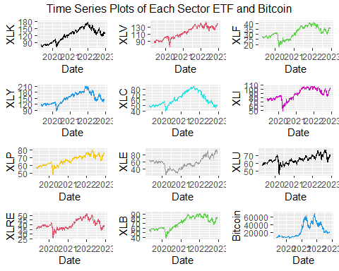 | The first graph we created was just graphing each ETF and Bitcoin as a time series to see if we could see a trend from just looking at the series. Our first takeaway was there was not much overlap between any of the ETFs and Bitcoin. It was also really easy to notice how much bigger the scale of Bitcoin was compared to the ETFs. Bitcoin has much more variation in movements than the ETFs do as well. Another thing we noticed was the dip in covid and how it impacted all ETFs, but Bitcoin didn’t really have a dip. Each stock also seemed to have been increasing after the dip from covid while Bitcoin has beeen in free fall since before the start of 2022. We originally had graphed all the time series plots on one graph, but decided that graph was too hard to interpret. Another issue with that graph was the scale of Bitcoin as that made it impossible to see the trends of the other graphs because they just looked straight.

## `geom_smooth()` using formula = 'y ~ x'  
## `geom_smooth()` using formula = 'y ~ x'  
## `geom_smooth()` using formula = 'y ~ x'  
## `geom_smooth()` using formula = 'y ~ x'  
## `geom_smooth()` using formula = 'y ~ x'  
## `geom_smooth()` using formula = 'y ~ x'  
## `geom_smooth()` using formula = 'y ~ x'  
## `geom_smooth()` using formula = 'y ~ x'  
## `geom_smooth()` using formula = 'y ~ x'  
## `geom_smooth()` using formula = 'y ~ x'  
## `geom_smooth()` using formula = 'y ~ x'

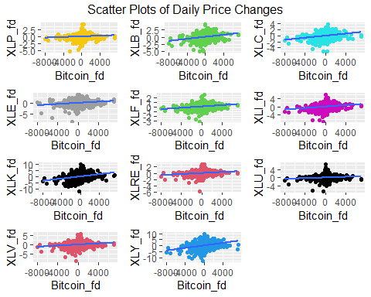 | Our next visualization that was used to analyze the relationship between the ETFs and Bitcoin was a scatter plot of daily price changes. These graphs show the daily changes of the ETFs on the y axis with the daily changes of Bitcoin on the x axis. As you can see most of the relationships are a very close slope to 0 showing that there is almost no positive trend with any of the ETFs. The biggest slope came from the XLY ETF which is the consumer discretionary ETF. This makes sense becuase when people spend money, they also spend money on Bitcoin. 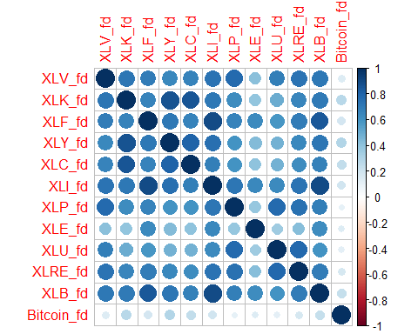

## XLV_fd XLK_fd XLF_fd XLY_fd XLC_fd XLI_fd  
## XLV_fd 1.0000000 0.7254167 0.6931098 0.6454621 0.6682403 0.7312731  
## XLK_fd 0.7254167 1.0000000 0.6665854 0.8671402 0.8517416 0.7147986  
## XLF_fd 0.6931098 0.6665854 1.0000000 0.7107477 0.6634781 0.8968424  
## XLY_fd 0.6454621 0.8671402 0.7107477 1.0000000 0.8063613 0.7558113  
## XLC_fd 0.6682403 0.8517416 0.6634781 0.8063613 1.0000000 0.6854072  
## XLI_fd 0.7312731 0.7147986 0.8968424 0.7558113 0.6854072 1.0000000  
## XLP_fd 0.7738475 0.6236078 0.6682017 0.5920779 0.5950040 0.7200391  
## XLE_fd 0.4160965 0.3973308 0.6364156 0.4301996 0.4034104 0.6410325  
## XLU_fd 0.6895484 0.4927354 0.5844648 0.4781360 0.4780431 0.6377740  
## XLRE_fd 0.7376546 0.6579289 0.6948950 0.6485090 0.6207778 0.7373110  
## XLB_fd 0.7104226 0.7022613 0.8467194 0.7272227 0.6714917 0.8948257  
## Bitcoin_fd 0.1497759 0.2757449 0.1866812 0.2907583 0.2474100 0.1943252  
## XLP_fd XLE_fd XLU_fd XLRE_fd XLB_fd Bitcoin_fd  
## XLV_fd 0.7738475 0.4160965 0.6895484 0.7376546 0.7104226 0.1497759  
## XLK_fd 0.6236078 0.3973308 0.4927354 0.6579289 0.7022613 0.2757449  
## XLF_fd 0.6682017 0.6364156 0.5844648 0.6948950 0.8467194 0.1866812  
## XLY_fd 0.5920779 0.4301996 0.4781360 0.6485090 0.7272227 0.2907583  
## XLC_fd 0.5950040 0.4034104 0.4780431 0.6207778 0.6714917 0.2474100  
## XLI_fd 0.7200391 0.6410325 0.6377740 0.7373110 0.8948257 0.1943252  
## XLP_fd 1.0000000 0.3896857 0.7784791 0.7438312 0.6822058 0.1087265  
## XLE_fd 0.3896857 1.0000000 0.3567367 0.4261813 0.6262729 0.1435843  
## XLU_fd 0.7784791 0.3567367 1.0000000 0.7875643 0.5965239 0.1150020  
## XLRE_fd 0.7438312 0.4261813 0.7875643 1.0000000 0.6947323 0.1727491  
## XLB_fd 0.6822058 0.6262729 0.5965239 0.6947323 1.0000000 0.2333377  
## Bitcoin_fd 0.1087265 0.1435843 0.1150020 0.1727491 0.2333377 1.0000000

  Our third visualization shows a heat map of the correlations of daily price changes. From the heat map, you can see that the ETF’s are fairly correlated with one another, but there is low correlation between the ETF’s and Bitcoin. The consumer discretionary sector has the highest correlation to Bitcoin at 0.29. This is likely due to the assumption that the more money people have to spend on things, the more money the are willing to gamble with by buying Bitcoin as a speculative investment.

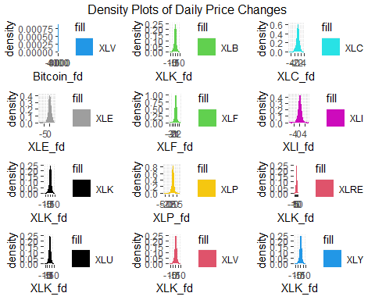 | The final graph shows the density of daily price changes. As expected, the ETF’s follow a log-normal distribution centered around zero with the tails accounting for periods of high volatility in the market. The distribution of Bitcoin’s daily price changes is also centered at zero, but has more activity in the tails. Bitcoin’s price can rise and fall by more than $4,000 in a given day supporting the claim that cryptocurrency is a very volatile investment.

## Conclusion

  In conclusion, Bitcoin was mostly not correlated with any of the ETFs. The most correlated ETF to Bitcoin was the consumer discretion index and even that only had a correlation of about 0.30. Bitcoin has much more variance than any of the ETFs which is expected because the scale of Bitcoin is so much bigger than that of the ETFs. The final and biggest takeaway is Bitcoin is very volatile and a very risky investment that has giant price changes that are not indicated by anything in any market sector.