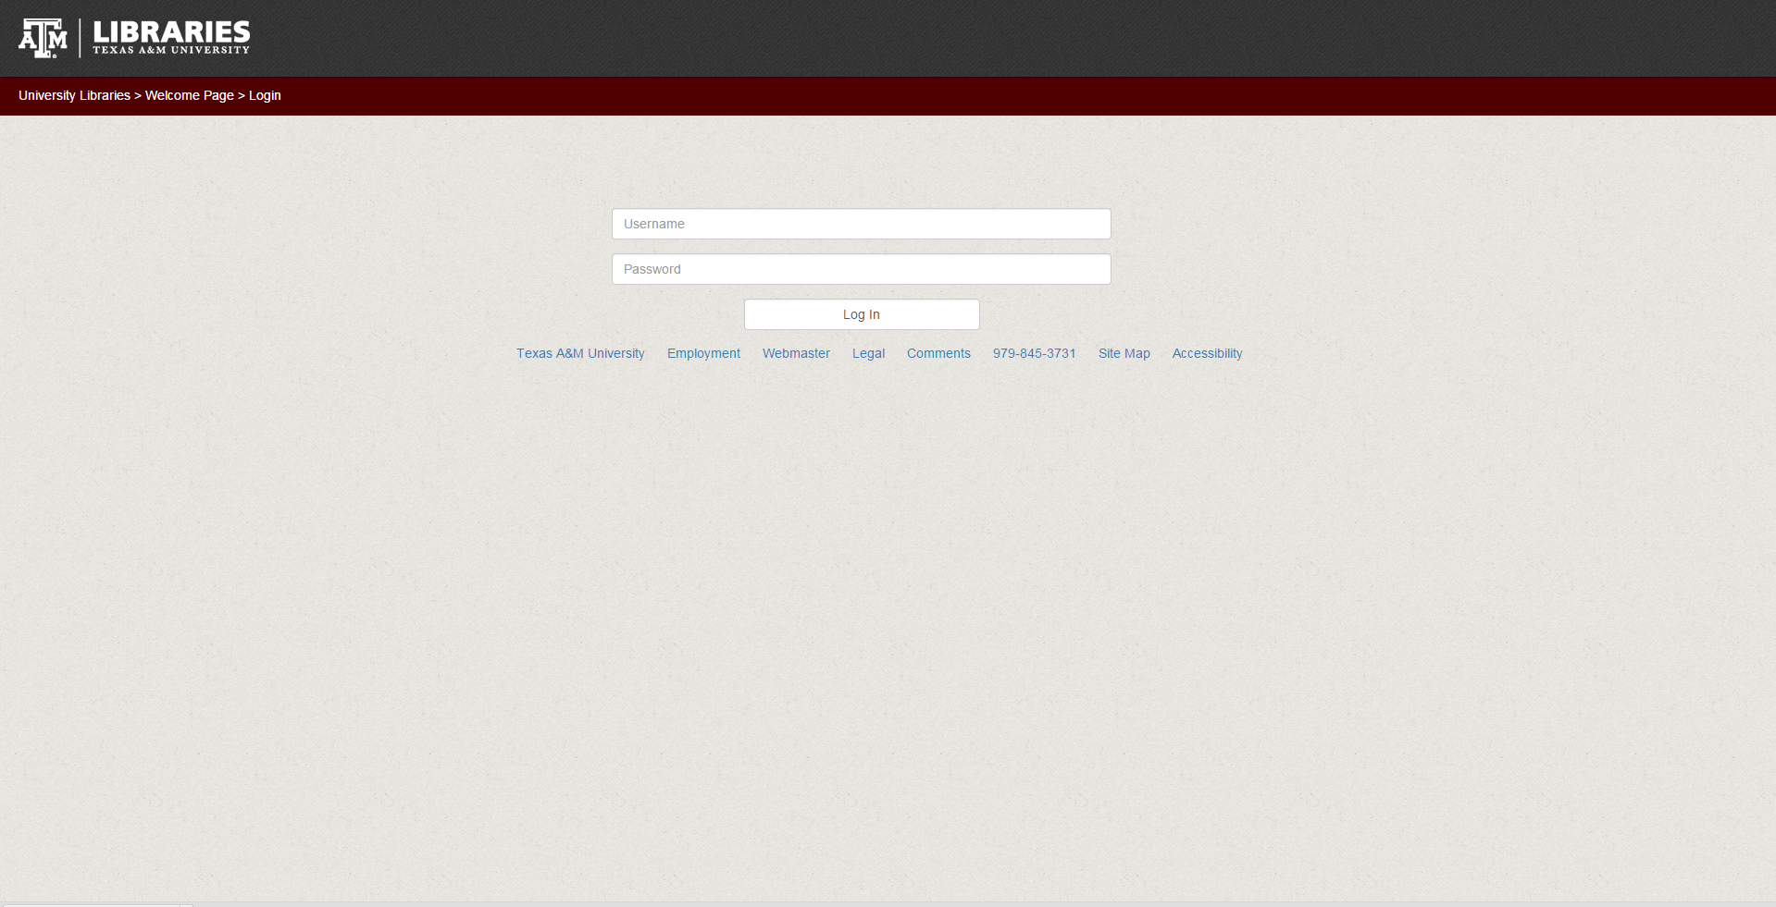

From Here you log in with your username and password.

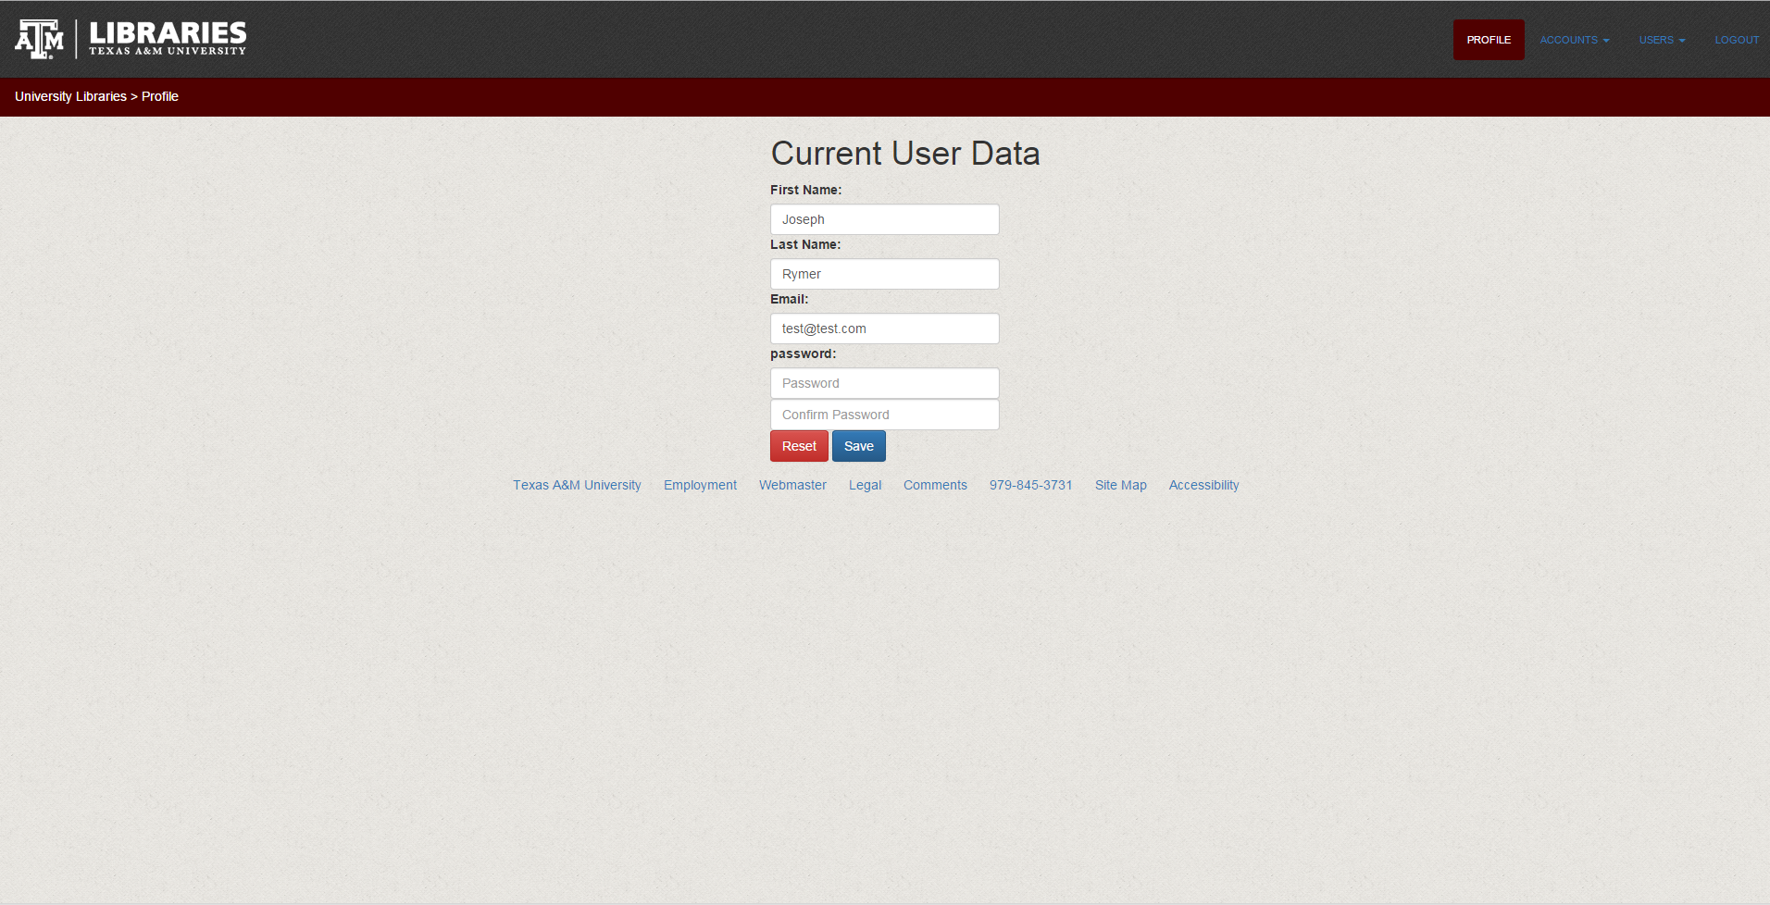

You can see your profile data and access the following pages for users on the tab menu at the top right.

Accounts

Create Account

Logout(Please note this will log you out of the application and is not another page)

If you are and admin you can access any of the pages under the users tab.

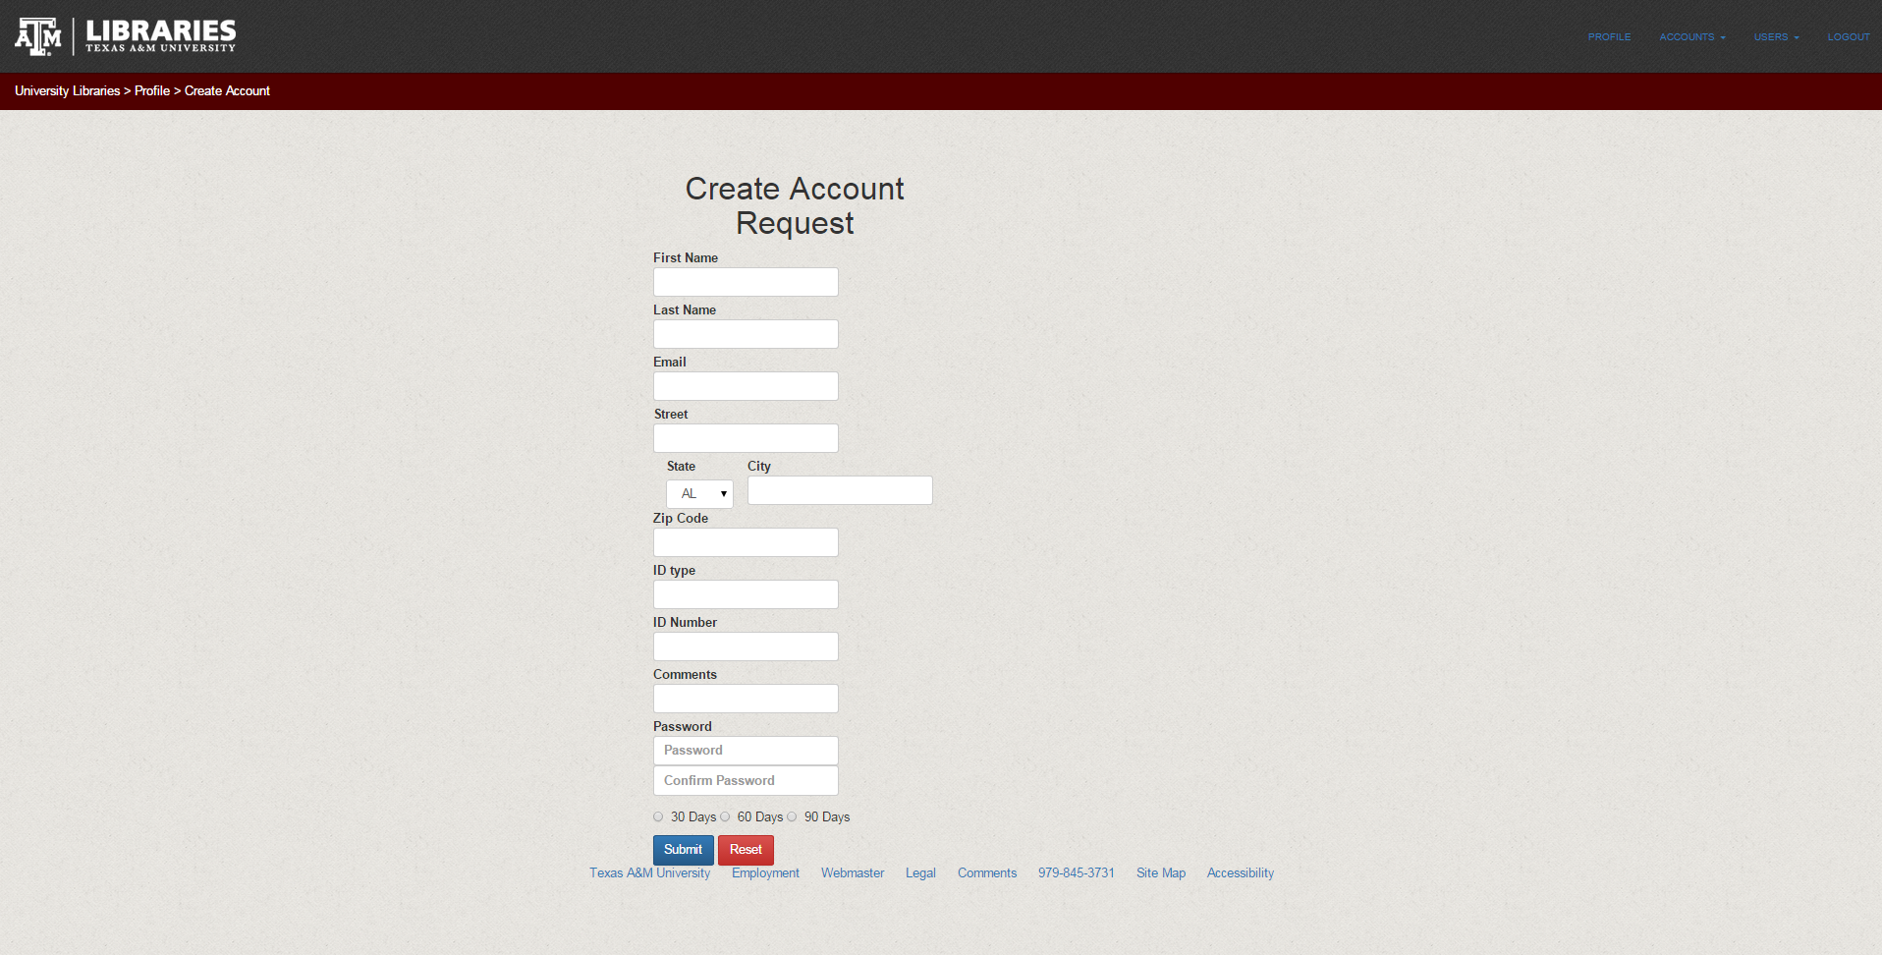

From here you can create a new account request.

Please note that if not expiration date is chosen then it will expire in 30 days

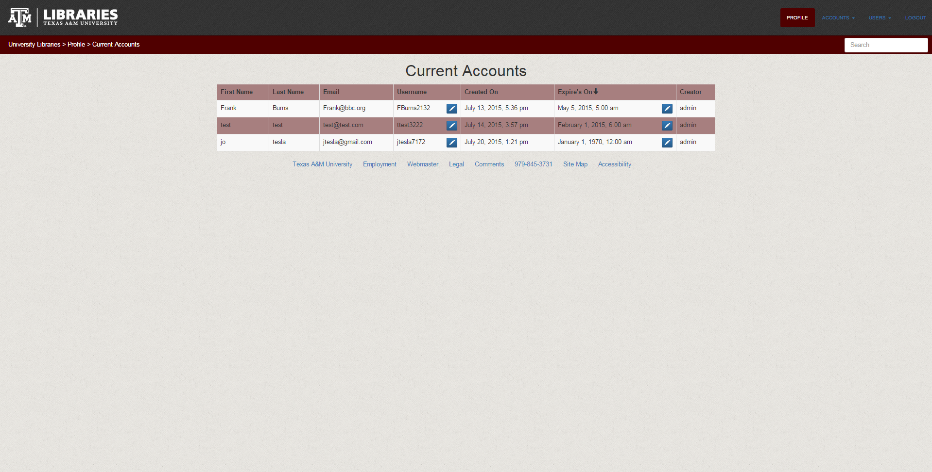

From here you can edit account requests like yours by clicking on the pencils the first pencil will let you edit the username for your account request and the other it for editing the expiration date for your account request

Please note the rest of the tutorial is for ADMINS of this application

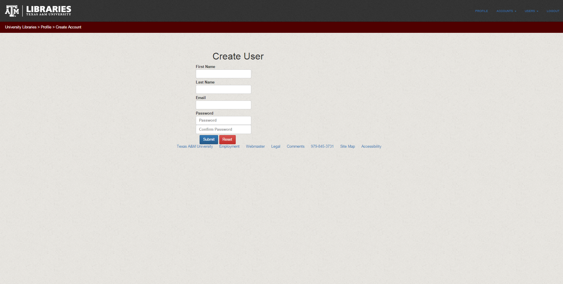

Here as and admin you can create a user for this application that can log in and make new account requests. Please not that all users are automatically by default not admins.

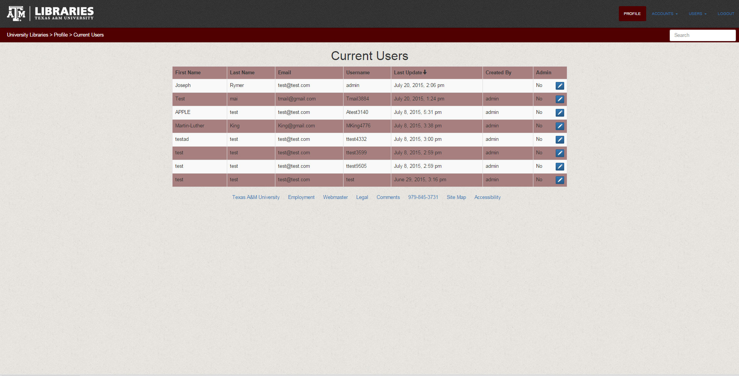

From here you can see the list of all users of this application and click on the pencil to edit each of the users please note that you will gave to check of you want them to be and admin.