Sprint Backlog
INB201
Tasks list
Associate with
Name
State
Remaining time
Responsible
Description
Notes
Creator
ID
Urgent task
Documentation
Done
0.0
Joseph Salmond
outline of documentation

Joseph Salmond
4
Urgent task
User Interface Draft - Member1
Done
0.0
Syed Ali

Joseph Salmond
3
Urgent task
DataBase Schema Tables
Done
0.0
Kaan Osmanagaoglu

Joseph Salmond
1
Urgent task
User Interface Draft - Member 2
Done
0.0
Saud Al jehani

Syed Ali
5
Urgent task
DataBase RelationShips
Done
0.0
Abdullah Alghunaim

Joseph Salmond
2
Scrum report generated with iceScrum
Page 1 /
4
Thursday 27 March 2014
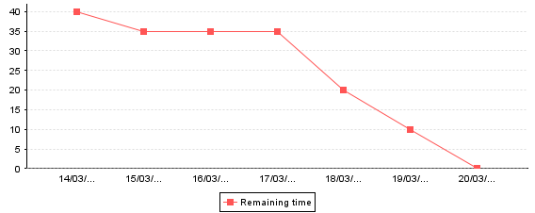
INB201
Sprint burndown chart
Remaining time
Days
Scrum report generated with iceScrum
Page 2 /
4
Thursday 27 March 2014
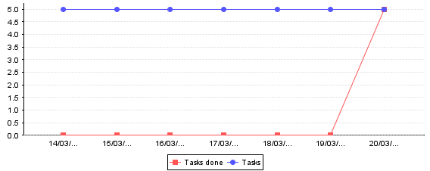
INB201
Sprint burnup chart (tasks)
Tasks
Days
Scrum report generated with iceScrum
Page 3 /
4
Thursday 27 March 2014
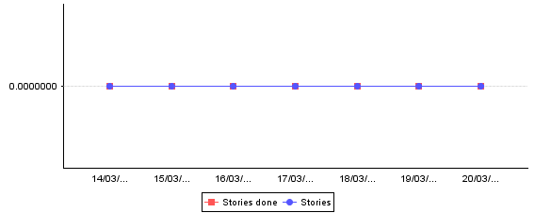
INB201
Sprint burnup chart (stories)
Stories
Days
Scrum report generated with iceScrum
Page 4 /
4
Thursday 27 March 2014

