Joe Standerfer, Spriha Gupta, Jasmine Kaur, Daniel Lesser

Marketing Analytics 95-832

Assignment 1: Ford Ka

3/24/2019

In the mid-1990s, Europe accounted for 26% of Ford’s sales, with France as a key market for the company. The European market was dominated by smaller cars, with the Ford Fiesta competing against the Renault Clio and Peugeot 106 for market share. In 1992, the Renault Twingo was launched, catching Ford off-guard. The surprising success of the model threw into question the traditional customer segmentation and marketing strategies for Ford. As the company prepared to launch its competing Ford Ka, it needed to rethink the target customer and its go-to-market strategy. Based on our findings, we suggest Ford implement a psychographic clustering approach. Two segments of customers stood out as opportunities: fashion-focused customers and those interested in performance and comfort.

The case study begins in 1995 in France. Up until this point, Ford and other car manufacturers had historically segmented the car market according to vehicle size. Within each of these segments there were entrenched assumptions regarding which demographic each vehicle type appealed to. For instance, small cars, which could be manufactured cheaply and with few frills, were primarily marketed to “younger, lower income buyers”. Large vehicles were typically marketed to older, wealthier buyers.

Although this approach had remained effective for several decades, there were several societal changes in the 1980’s and 1990’s that rendered this strategy obsolete. Rising road congestion led to reduced parking availability. New environmental regulations and taxes had increased gas prices. The average household size had fallen below three. Women were more likely to participate in the workforce. All these factors led to a sharp rise in the popularity of small vehicles in France. However, the needs of the consumer were also evolving, leading to an “increasingly fragmented small car market” that reflected “an increase in the variety of consumer needs”. Personal income was no longer the determining factor in small car purchases and “the traditional categories no longer [meant] anything.” Ford needed to rethink its segmentation of the market in order to compete with the domestic manufacturers who were already responding to the new small car landscape.

To better understand the market, Ford commissioned a study on a new panel of customers. Based on their rankings of the new Ford Ka versus its competitors, Ford assigned the customers to a preference group: choosers (1), non-choosers (2) and neutrals (3). One of the first questions Ford wanted to ask next was whether these customers desired a trendy car on a scale of 1-7. The crosstabulation of preference group versus style (figure 1) shows that those who prefer the Ford Ka generally prefer more stylish cars. Group 2 was more neutral in their preference to style, while Group 3 was more inclined to like a stylish vehicle. In order to convince Group 2 to purchase a Ka, Ford may need to focus on features aside from just style, such as technical capabilities. For Group 3 and Group 1, the focus should remain on the stylistic aspects of the vehicle.

Surprisingly, these findings are not reinforced by the market research agency’s results in Exhibit 10 of the reading (Figure 2). Non-choosers associated the Ford Ka with words such as “flimsy” and “ugly,” implying that this group cares about the looks of the car.

Our group has applied a k-means clustering approach to attempt to segment the customer base in France. First, we used the psychographic responses to the panel study to segment the market. We tried clustering with various levels of k, settling on k=4 as the best result (Figure 3). A greater number of clusters appeared to split the data into too many overlapping groups without enough distinction from each other. A smaller number of clusters (Figure 4) resulted in too much variance within clusters and was unlikely to capture the complexity of the market described in the supplementary readings.

We used the questions with the highest variance between clusters as identifying factors for the cluster labels. Based on this (Figure 5), we can say that Cluster 2 respondents prefer small, fashionable cars that can serve as a fashion statement. Cluster 1 is almost the exact opposite, with little focus on fashion and a bigger focus on performance and comfort. Cluster 4 is similar to Cluster 1, though they are willing to compromise on comfort. Cluster 3 is practical and cares about comfort more than fashion.

In Figure 6, Cluster 1 is most likely to choose the Ka. However, this cluster is relatively small and may not be an ideal place to focus all of Ford’s marketing initiatives. Although Cluster 2 is fundamentally different from Cluster 2, nearly half of the segment rates the Ka well and a significant portion of the remaining panel would consider the car. As such, it may make sense to target this segment to convince the middle-ground consumers. This aligns with the previous analysis that fashion-centric customers are the appropriate market segment to target.

Rather than clustering on psychographic features, one could also try clustering on demographic features. Unfortunately, regardless of what size k was chosen, demographic clustering did not return satisfactory results. As can be seen in Figure 7, there is one distinct cluster in the lower left-hand corner, with the remaining three clusters heavily overlapping each other. We chose to look at Age and First Time Purchase because these were statistically significant differentiators in the prior research.

Overall, the psychographic clustering returned more distinct results than the demographic clustering. As such, we would recommend Ford use this approach. Cluster 1 is the natural buyer for the Ford Ka, but given the relatively small size of the cluster (12.8%), Ford will need to reach beyond this segment to gain back market share from the Twingo. We suggest Ford focus on Cluster 2, which accounts for 31.2% of the market. Ford could take a page out of Renault’s book as the Twingo had targeted consumers who were both fashionable and desired a comfortable, practical car.

**Appendix**

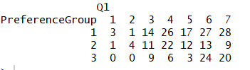

Figure 1

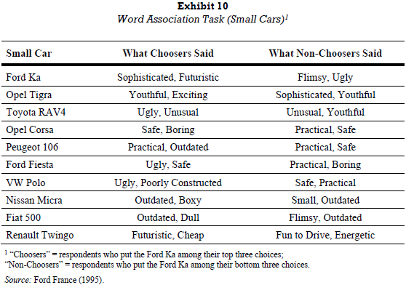

Figure 2

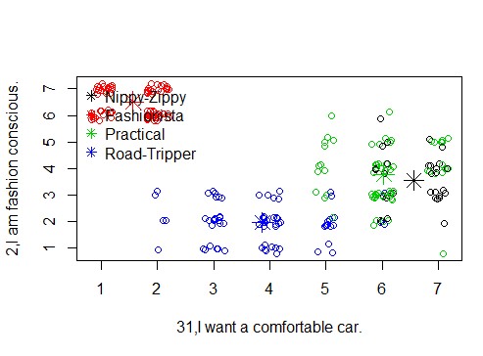

Figure 3

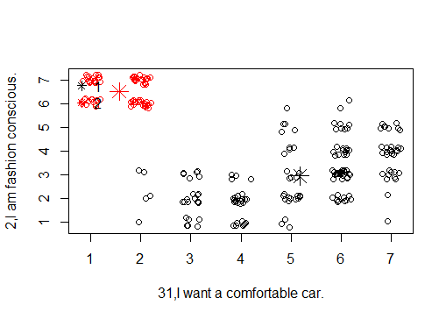

Figure 4

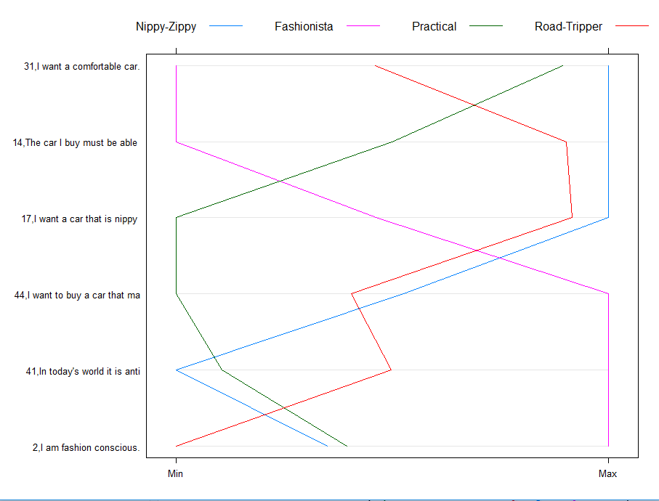

Figure 5

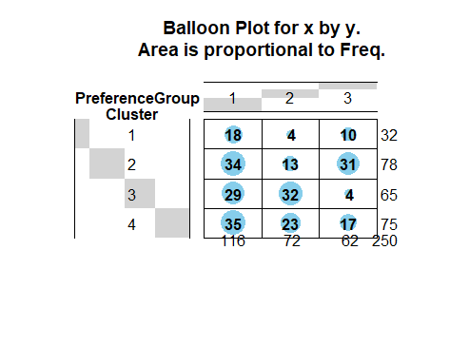

Figure 6

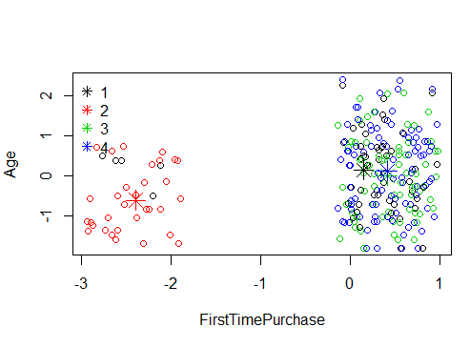

Figure 7