**Marketing Analytics: Homework 4**

**Group Members:** Spriha Gupta; Jasmine Kaur; Daniel Lesser; Joseph Standerfer

To: Lisa Peschke

From: Group 2

**Subject: Recommendations for Freemium user conversion**

Converting free users to premium users is one of the most certain ways to improve profitability and longevity for the High Note platform.  Low conversion rates are typical of freemium models, with even the biggest players like LinkedIn, Pandora and Dropbox having subscriber rates in the low single digits.  High Note has a 6.7% adoption rate based on the most recent data, which appears to be above the industry average. This may make it challenging to raise the adoption rate further.  Regardless, the remainder of this memo outlines what types of users are more likely to be subscribers, how we might convert those users, and how we might attract premium users to the platform.

The first step to better understand the user base of High Note is to review some basic descriptive statistics about users who take advantage of the free platform vs. those who subscribe.  Based on figures 1 and 2, we can see that subscribers are typically slightly older than free users and more likely to be male. These users use the platform more to get value out of their subscription. From a music perspective, they listen and favorite more songs on average.  From a social media perspective, they have more friends on the platform and have five times more posts and shouts. One similarity of note is the tenure on the platform: both free and premium users have similar account ages. Thus, we should not count on length of time of the platform as being a natural driver towards subscription.

Just based on these descriptive statistics, there are multiple potential opportunities for us to focus on.  Since we know that males in their late 20s tend to be adopters, we may want to first focus on converting males in their early 20’s to premium users before branching out to other groups. We also know that subscribers have are greater users of the social media functionality of the platform. This aligns with our suggestion of targeting young males as they are more likely to be influenced by their peers at this age. While it is not yet clear if this is a causal relationship, if we incentivize these users to post, shout, and connect over the app, this may drive deeper user engagement with the platform and lead to an increase in subscriptions.

One way to promote social engagement on the platform could be providing a free one-month premium subscription to users. The additional features (enhanced interface and recommended playlists) and the absence of advertisements would likely prompt users to spend more time on the site during their trial period. We suspect that these higher usage rates would in turn drive more social interaction, which has historically been the case with premium subscribers. Ideally, at the end of the subscription period, users will now find more value in the site because of the social networks that they’ve developed. That, along their experience of using the premium site features ad free, may just tip these users from “free to fee”.

The primary risk we see in this proposal would be a temporary loss of ad revenue from those who take advantage of the promotion. This should not be a major concern as ads account for a small portion of the company’s revenue. We used a logistic regression model to provide a good starting point for identifying the users who should be targeted by this marketing program.

Several forward stepwise regressions models with varying features and interaction terms were tested out in this study. When determining a measure of fit, we focused on the concept that likely adopters have a high chance of converting regardless of promotions and thus we would like to target the non-adopters who contribute to 90% of the user base. We therefore chose the model that returned a low False Positive Rate. This is because we do not want to miss out on advertising to non-adopters that may have been incorrectly classified as adopters. Accuracy should not be used in this study due to the imbalance between classes in the data.

The model indicates that males have an odds ratio of 1.5 to 1, implying that they are more likely to take a premium subscription anyway. So, our focus would be on females in their early 20s. Also, we should target people from the U.S., U.K. and Germany who have an odds ratio of 0.74 to 1, as people from the rest of the countries have higher rates of adoption.

Other than the ‘one-month free trial’ strategy proposed above; we can also offer reduced annual subscriptions if users opt to try the premium version within a defined time-frame soon. Such techniques have been shown to work in increasing paid subscribers. Additionally, we can use second degree price discrimination and offer discounted group or family plans to attract them. This would leverage the peer network effect as well.

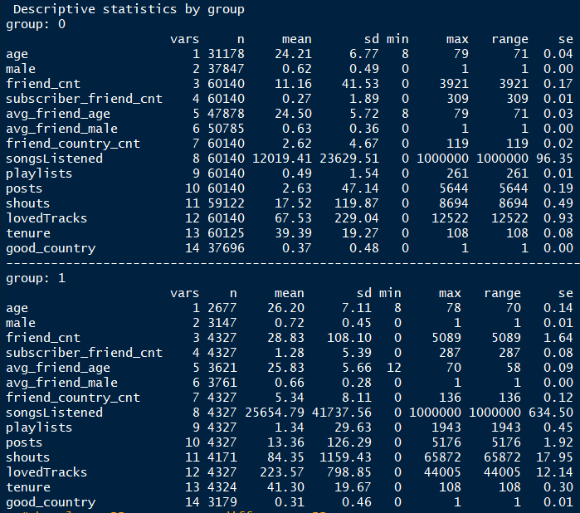

Figure 1: Free users vs. Subscribers, raw non-imputed data

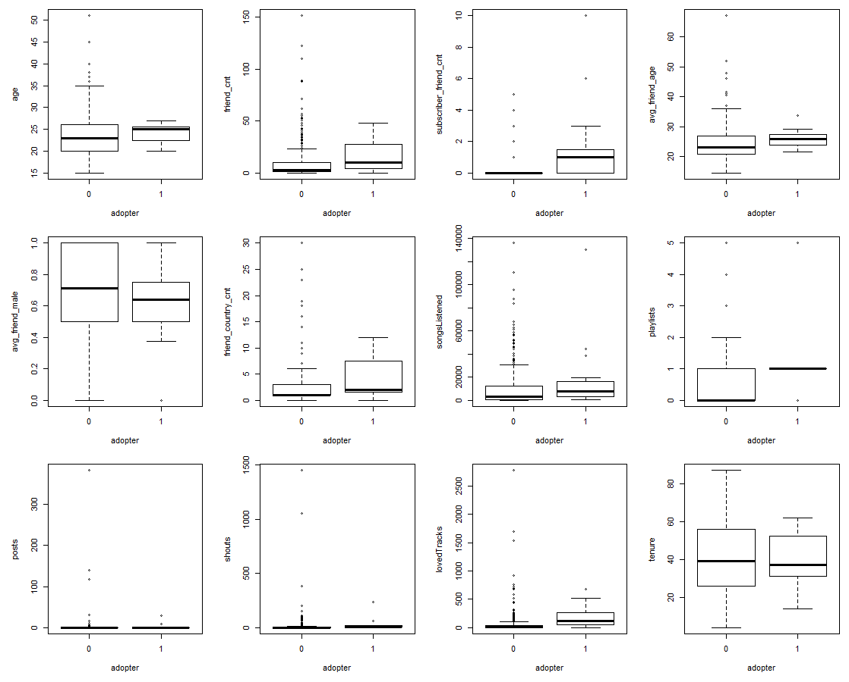

Figure 2: Boxplot of free users vs. premium users

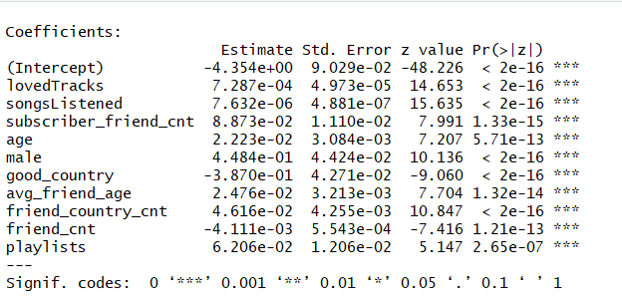

Figure 3: Logistic Regression model with 10 steps

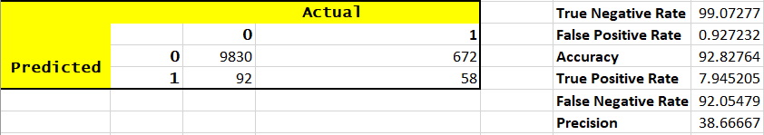

Figure 4: Evaluation metrics