**Marketing Analytics: Homework 5**

**Group Members:** Daniel Lesser, Joseph Standerfer, Jasmine Kaur, Spriha Gupta,

To: Lisa Peschke

From: Group 2

**Subject: Recommendations for Freemium user conversion follow-up**

At your request, our team has completed the alternative study to assess the possibility of using Decision Trees instead of Logistic Regression to segment free users and subscribers.  The goal of this model was consistent with that of the Logistic Regression one: to identify approaches that may help convert more free users to paid premium subscribers. Through our analysis, we have found that the Decision Tree approach yielded better results and was more interpretable than the Logistic Regression model.  Our findings are detailed in the memo below.

    While exploring the implementation of a Decision Tree solution, multiple iterations were attempted to ensure the highest performance measurement as well as the best interpretability.  Our best suggested model can be seen in Figure 1. Specifically, there were four factors that went into deciding the best model:

* Maximize the true positive rate.  This means that our model accurately identified the most subscribers as possible.
* Minimize the false positive rate.  This means that our model reduced the number of individuals that appeared to be potential premium users who were in fact not.
* Maximize the lift.  This means that our model tried to maximize the number of incremental subscribers that would not have subscribed otherwise.
* Have interpretability.  We wanted to ensure the results were coherent and easily presentable to the management and investors.

    The model we chose was the best performer on true positive rate, lift, and interpretability, though it did lag slightly on the false positive rate.  This means we might provide a promotion to a few more users than necessary.

    Based on the model chosen, we have identified that the ideal users to target are those who “love” a lot of tracks (>50) and have multiple friends who are subscribers (>2).  For those who have fewer subscriber friends, we can still target those who have listened to a lot of songs (>2713), particularly those who have a lot of friends (>22).

    Per your suggestion, we attempted to use the period data in our model to track the change in songs favorited, tracks listened, and number of friends.  These features are in fact more deterministic than the static versions. However, the model was less able to sustain a high true positive rate, meaning we may have lost out on some potential users.  In addition, interpretability was a bit less clear, though the overarching takeaway remained the same: favorited tracks and subscriber friend counts are the most important indicators of subscription.

Next, we looked at the costs associated with implementing the proposed program. Questions regarding lost ad revenue and opportunity costs are certainly valid concerns. However, all costs included, we predict that using our model to inform promotional offers will lead to a profit of $52,700 when applied to current users and a 7% profit increase for the average new user on the platform. These results are based on the assumption that 30% of users who receive the promotion will convert. While this figure may appear optimistic at first, we feel it’s appropriate when considering that the offer will be made only to our most promising users who already have a relatively high likelihood to subscribe. Should the program be expanded to less probable subscribers, the conversion rate would be lower.

Specifically, the $52,700 would come from offering promotional offers to the 5,950 false positive users in the model. These are persons that show all the attributes of a subscriber (high usage rates, several subscriber friends, dozens of “loved” tracks) but have yet to make the leap. We would only be making offers to the false positives in this circumstance because true positive customers are those who are already subscribed. By offering these users the promotion, we imagine their extended exposure to an ad free, premium feature HighNote will entice a significant proportion to make the switch. A 30% conversion would lead to an additional $64,200 yearly subscription income. This will be offset by $2,200 in lost ad revenue as well as $9,300 in opportunity cost, if these users would have subscribed anyways without the promotion. The 7% ($0.20) profit increase for each new user on average, mentioned earlier, was calculated using the same methodology. However, in this case, we felt it was more appropriate to state the increase on a per user basis to accommodate for any variability in the platform’s growth.

Overall, the decision tree approach provided a more interpretable and accurate representation of HighNote’s user base.  Based on our findings, we suggest offering the promotion to users who are most like our subscribers, but have yet to sign up to the premium platform.  This will lift yearly revenue by $52,700.

**Appendix**

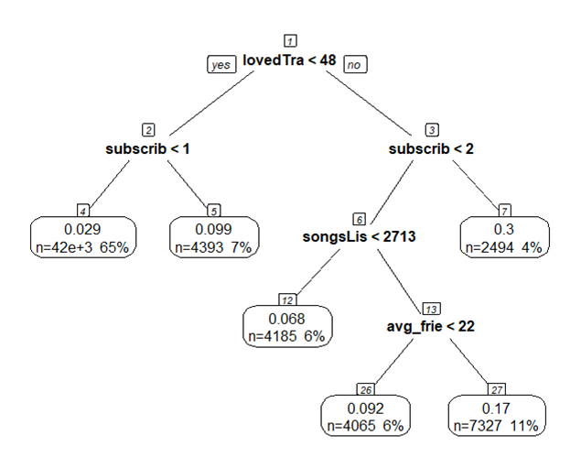

Figure 1