When joint 3 rotational freedom is 360 degrees

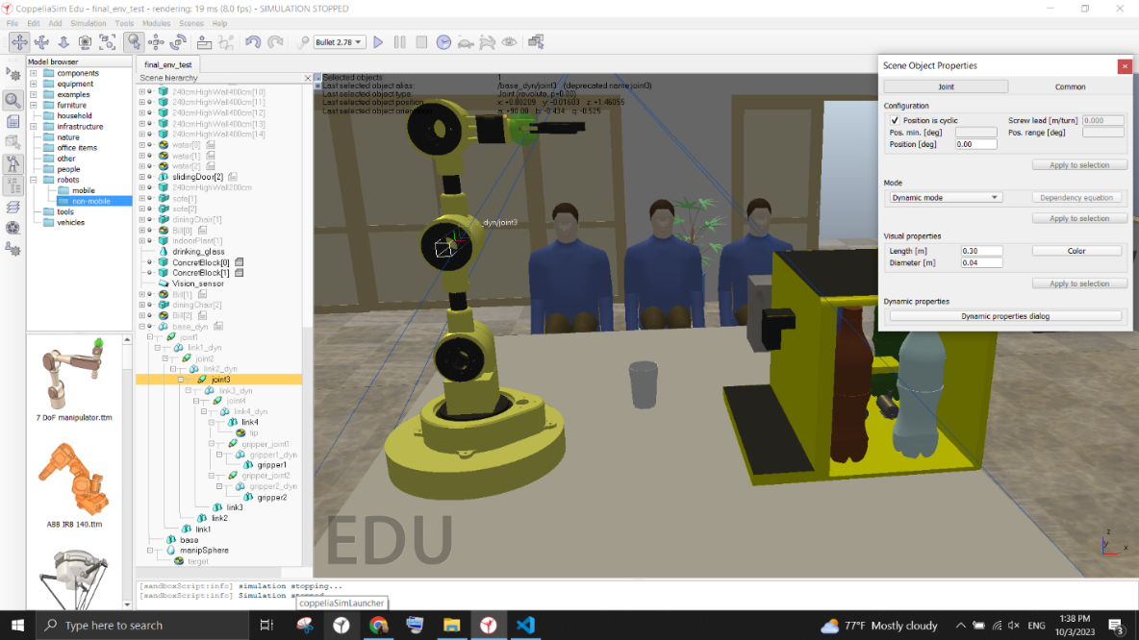

Fig joint 3 cyclic mode cyclic mode

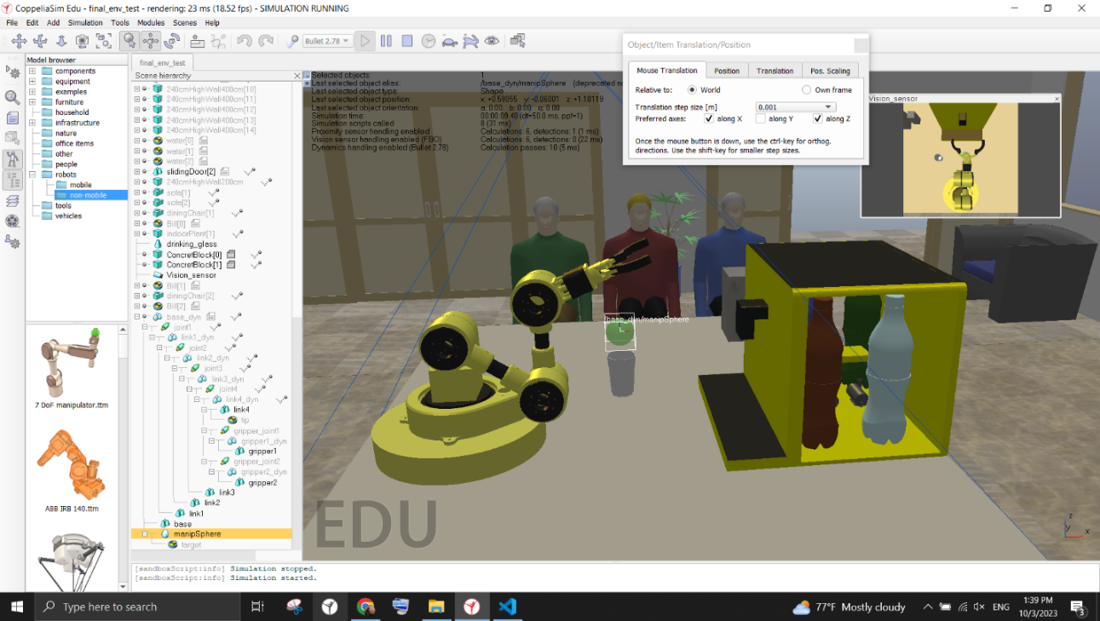 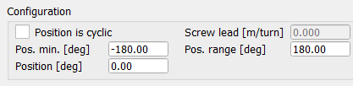

Fig joint 3 full range cyclic mode effect

When the joint 3 angle is restrited to 180 degrees the joint will bent upward which is the desired output. It causes the joint 3 to rotate downwards and it will hinder the end effector’s ability to sweep along the z axis.

When joint 3 rotational freedom is 180 degree

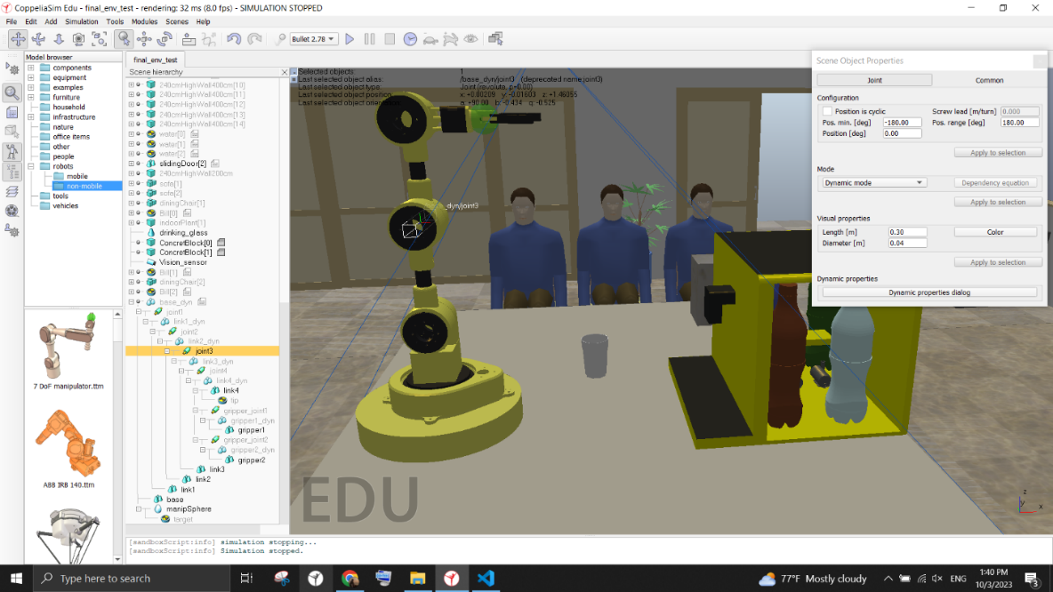

Fig joint 3 limited range of motion

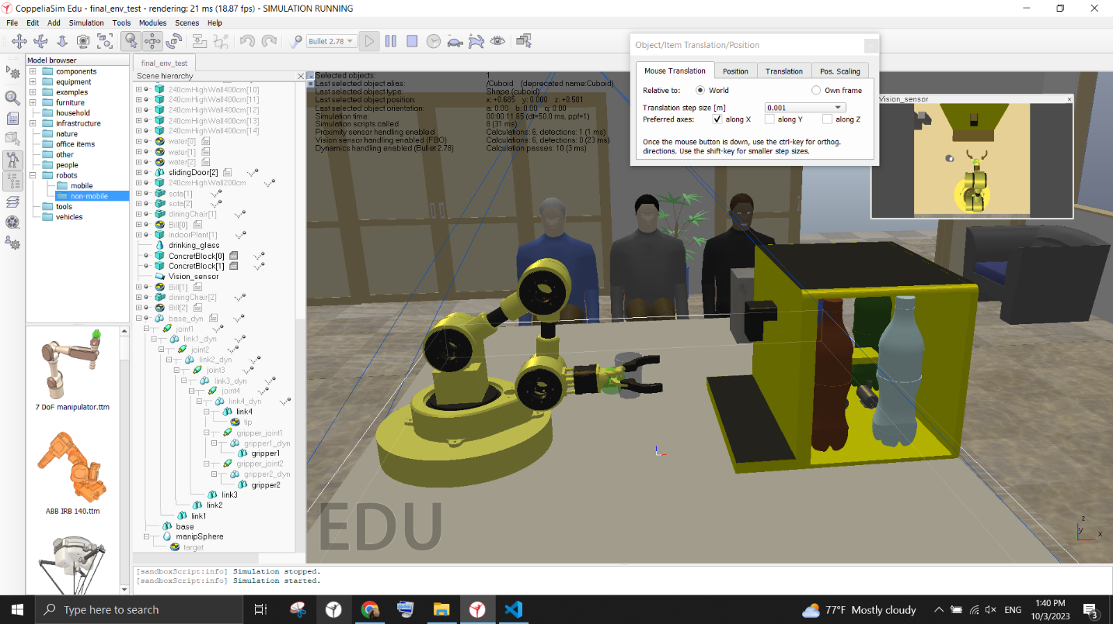

Fig 3 desired posture