# Materials Required

|  |  |  |  |  |
| --- | --- | --- | --- | --- |
| S.N. | Materials | Quantity | Price per piece | Total |
| 1 | ESP32 | 1 | 900 | 900 |
| 2 | DS18B20 | 1 | 300 | 300 |
| 3 | Relay Module | 1 | 120 | 120 |
| 4 | ZMPT101B | 3 | 450 | 1350 |
|  |  |  | Grand Total | **2670** |

1. ESP 32

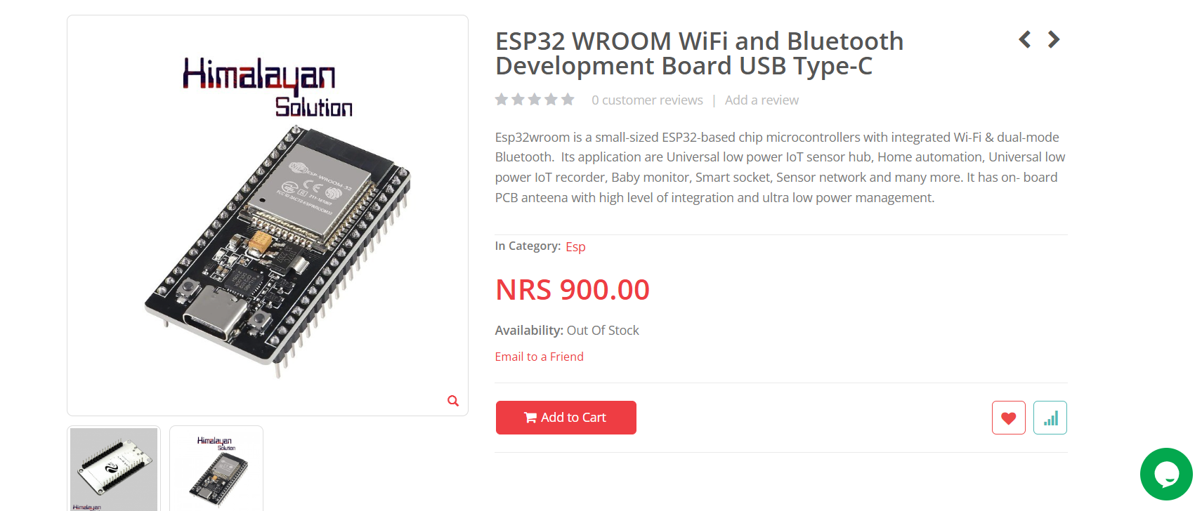

1. DS18B20

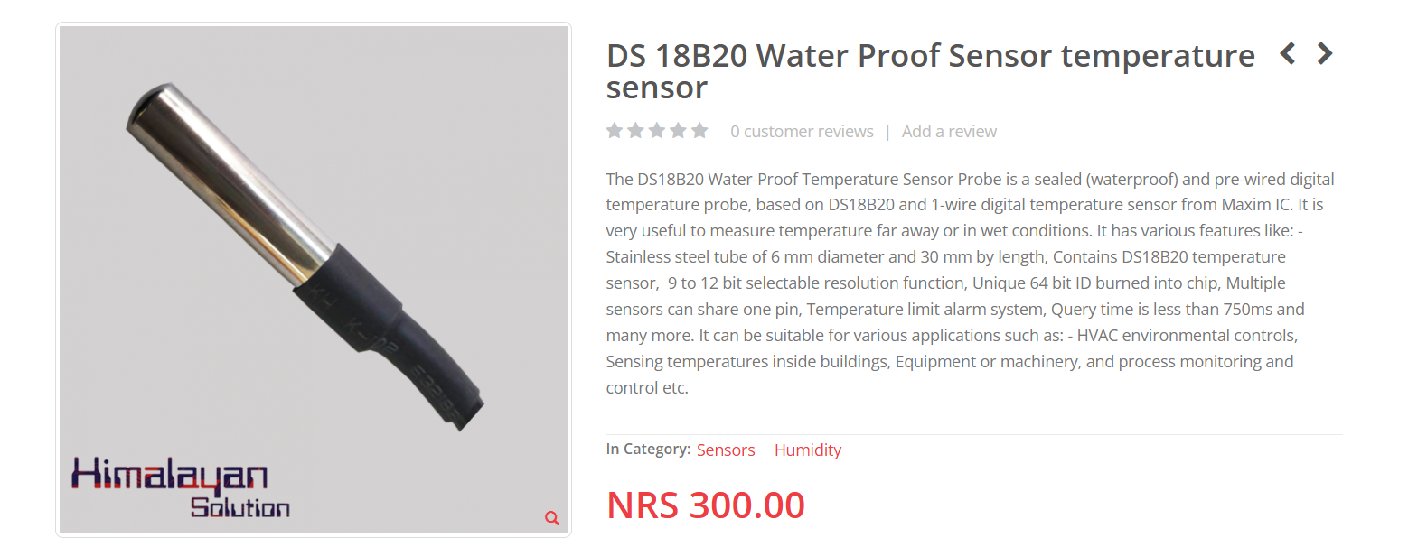

1. Relay Module

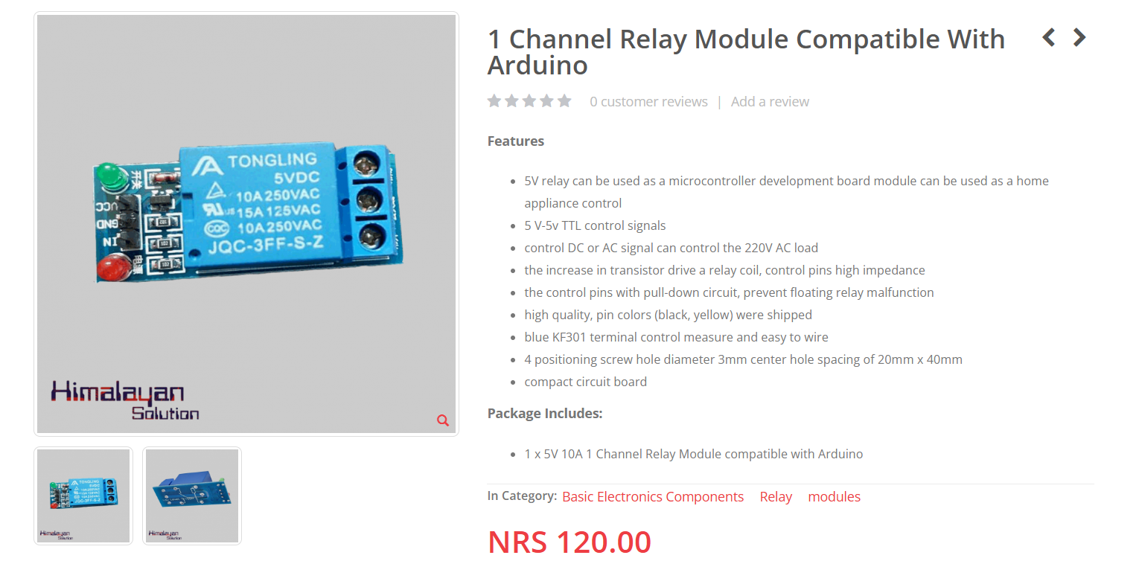

1. AC Voltage sensor

