Materials Required

S.N. | Materials | Quantity | Price per piece | Total
1 | ESP32 | 1 | 900 | 900
2 | DS18B20 | 1 | 300 | 300
3 | Relay Module | 1 | 120 | 120
4 | ZMPT101B | 3 | 450 | 1350
 |  |  | Grand Total | 2670

- ESP 32
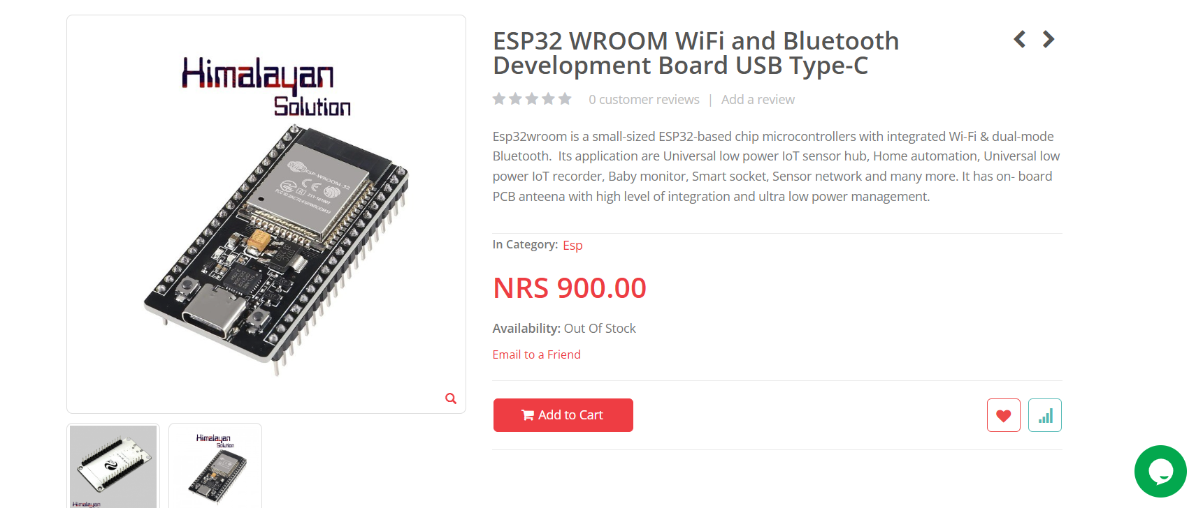

- DS18B20
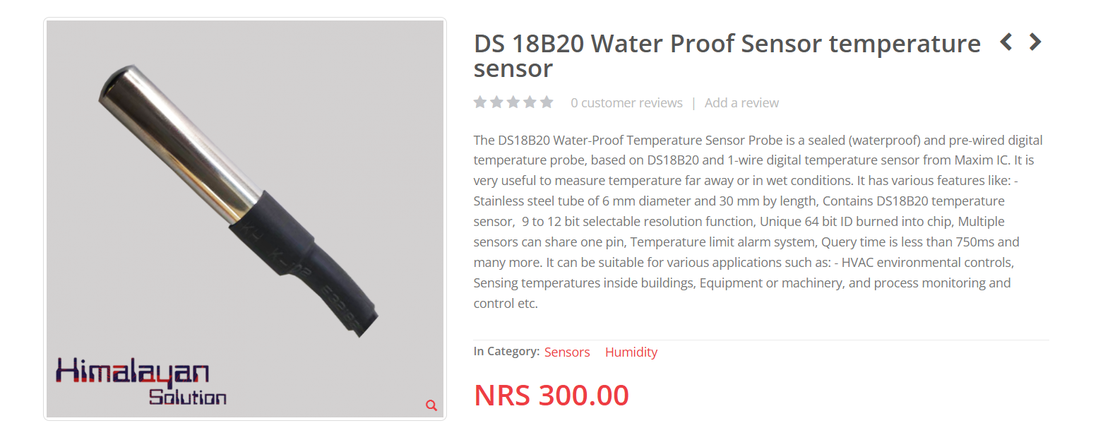

- Relay Module
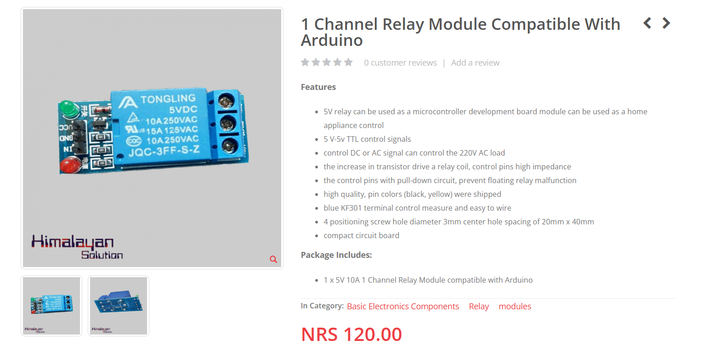

- AC Voltage sensor
