**Connect 4 Project Plan**

Joseph Thomas, Vishwa Kode, Anshuman Dikhit

Submitted to: George Peck

Project Manager: Joseph Thomas

Date: May 2, 2014

Project Overview: The purpose of this project is to create a piece of software such as a game or productivity program and to sell this program to the teacher. Our game we chose is Connect 4.

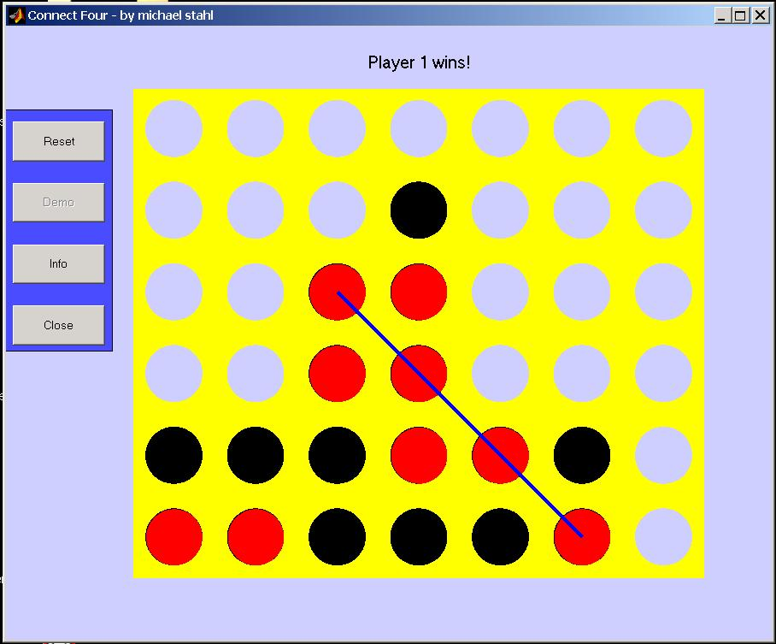

This game involves dropping pieces into a 6 by 7 board, and the first person to get 4 of these pieces in a row wins.

We will be using gridworld for the base of our GUI. We will also attempt networking so that people on different computers can play against each other. There will also be a computer AI with different difficulty levels so that the game can be single player. We will also be creating JUTests for all of our project to make sure everything works properly, and we don’t get any unintended “features” in our project.

We may also create different game modes that deviate from the normal Connect 4 rules, such as powerups in certain sections of the board.

If we have enough time we will create a GUI without the use of Gridworld to make it look better, but this would require a lot of rewriting if we do not start with it.

Project Team:

Vishwa Kode: GridWorld + GUI and networking.

Joseph Thomas: AI for computer.

Anshuman: Mechanics.

Challenges: One of the problems may be the AI, because I do not really know how to approach a problem like that. Also, at our current rate of getting work done, we may not be able to finish in time.

Major Tasks and Schedule

|  |  |  |
| --- | --- | --- |
| Task | When | Responsible |
| Work on GUI | 5/5/14 – 5/9/14 | Vishwa |
| AI | 5/5/14 – 5/16/14 | Joseph |
| Mechanics | 5/5/14 – 5/10/14 | Anshuman |
| Networking | 5/10/14-5/16/14 | Vishwa |
| Testing | 5/19/14-5/23/14 | Vishwa and Joseph |
| PowerPoint Presentation | 5/19/14 – 5/27/14 | Anshuman |