./

Report – ELECTRONIC VOTING MACHINE PROTOTYPE

Course Code: <CODE>



Submitted By: Sushma SM

Candidate ID: 104348

Version Number:

Team Members :

Team No:

Module: Model Based System Engineering

|  |  |  |  |  |  |
| --- | --- | --- | --- | --- | --- |
| **Ver. Rel. No.** | **Release Date** | **Prepared. By** | **Reviewed By** | **Approved By** | **Remarks/Revision Details** |
| 1.0 | 21/09/2020 | Sushma SM |  |  |  |
| 1.1 | 23/09/2020 | Sushma SM |  |  |  |
| 1.2 | 25/09/2020 | Sushma SM |  |  |  |
|  |  |  |  |  |  |
|  |  |  |  |  |  |

**Document History**

**TABLE OF CONTENTS**

1. **Problem Statement 4**
2. **Introduction 4**
3. **Research 4**
4. **Project Description 4**
5. **Requirements 5**
6. **Software Requirements 5**
7. **Functional Requirements 5**
8. **Non-functional Requirements 5**
9. **Design 6**
10. **High Level Design 6**
11. **Low Level Design 6**
12. **UML Diagram 7**
13. **Test Plan 7**
14. **Test Cases 8**
15. **Results and Conclusion 9**

**1. Problem Statement**

Manual process of voting is more time consuming and requires more manual power in order to reduce it, we are designing electronic voting machine using C programming.

**2. Introduction**

Electronic Voting Machine (EVM) has become an effective tool for voting during elections. Electronic voting (e-voting) is voting which uses electronic means for casting and counting votes. EVM is simple to use and construct, flexible and cost-effective. Voters have to press the button reflecting to either party name or the member of party of their choice and the votes will be automatically registered in the machine. Later, the user can find the number votes of each candidate or the party and finally the user declares the leading party.

EVM provides faster results, cost-effective, accurate, portable, reduces the role of people and saves a lot of paper. EVM also ensures that one person can vote only once. It ensures people about their vote being secured. It avoids any malpractices and invalid votes. Here voters can save time. EVM has no more ballot papers, ballot boxes, stamping, etc.

In the paper ballot system, voters mark their choice on the ballot papers and drop the voted ballot paper in the ballot box. After casting votes, ballot papers are counted while counting many votes become invalid for giving the seal in an unexpected region and the number of votes will be declared along with the leading party. The process of counting votes consumes more time and also leads to errors. There is a wastage of papers, needs a lot of people to control the people and for counting votes, leads to booth capture by influencing power and leads to vote manipulation in ballot papers.

**3.Research**

In 2012[1], “Electronic Voting Machine-A Review” has been proposed by D. Ashok Kumar et al. This article discusses complete review about voting devices, issues and comparison among the voting methods and biometric EVM.

In 2017[2], “Arduino Based Smart Electronic Voting Machine” has been proposed by V. Kiruthika Priya et al. The basic idea of this project is to create an electronic voting machine that will help to eradicate defrauding of the manual voting system and prior versions of electronic voting.

**4.Project Description**

In this project we are designing EVM using C program. The first step is to login. There are 3 options such as admin login, voter login and exit. If we are user then login to admin account or else login to voter account or exit from the system.

In user login, we have to enter the password to access it further, the system will display the number of votes of each party and display the result of the election.

In voter login, voter have to enter the unique voter Id number, voter can choose the party to whom he/she is willing to vote and vote accordingly. User can vote only once.

**5. Requirements**

1. **Software Requirements:**

Code Blocks IDE is used in order to write and execute the C program.

GNU GCC compiler is used in order to compile the C program.

1. **Functional Requirements**

* The main menu will display 3 options i.e.

1. Voter login and

2. Admin login

3. Exit

* Each voter has to enter his/her unique voter Id to cast his/her vote. Voter can cast his/her vote only once. If the voter Id is repeated, then it will display “Already voted”.
* Voter can opt for which party he/she is willing to vote and vote accordingly.
* Admin has to enter his/her unique password which set by them to access the details or else it will display access denied.
* The system will display the votes of each party and also the winning party when admin has logged in.
* If there any tie between the parties then the system should display there is between the parties.

1. **Non-functional Requirements**

* It consumes less time when compared to ballot voting system.
* The result can be announced in very short period of time.
* It reduces the cost of the system such as in ballot voting system we require more manual power, paper usage and etc.

**6. Design**

1. **High Level Design**

* Main menu will display the 3 options

1. Voter login: Here, the voter can cast his/her vote.
2. Admin login: Here, the admin can check the votes of each party and leading party.
3. Exit: It exits from the code.

* If user as chosen other 1, 2 or 3, then system will display “Invalid option”
* If user has opted option 1, then he/she has to enter the voter Id. If the voter Id entered by, he/she is not unique, then system will display “You already voted”.
* If the voter Id entered by, he/she is unique, then the system will display the voter Id and displays “Which party do you want to vote for”. He/she should enter the option in between 1 to 5, else the system will display the “Invalid option”. Here,

1. BJP
2. Congress
3. JDS
4. Other
5. NOTA

* Finally, after casting the vote, the system will display the “Thank you for voting”. Then, the system will display “To return to login access enter 1 else 0 to continue.
* If user as opted option 2, the system will display “Enter the password”.
* Admin has to enter the password which has been set by him/her. If admin enters wrong password, the system will display “Sorry, access denied. Only admin can access”.
* If admin enters the correct password, the system will display the votes of each party and also the winning party.
* If user as opted option 3, the system will exit from the compilation.

1. **Low Level Design**

Functions defined in the program are

1. void display (): This function calls either voter () function, admin () function or it will exit from compilation.
2. void voter (): This function helps to cast the vote of voter and also checks whether the voter is casting his/her vote for 1st time or not. If he/she is casting vote for 1st time, then it asks for which party the voter is willing to vote else it displays you already voted. When voter is casted his/her vote, then the vote of particular party will get updated.
3. void admin (): This function can be only accessed by administrator. Admin will have to enter the password to access further. If admin enters the wrong password then system will display access denied. If admin enters the correct password then system will display the votes of each party and also the winning party.
4. bool validate_voterId (char *id): This function is used to check whether the voter is casting his/her vote for 1st time or not.
5. void largestVotes (int bjp, int congress, int jds, int other): This function is used to find the winning party.

**7. UML Diagram**

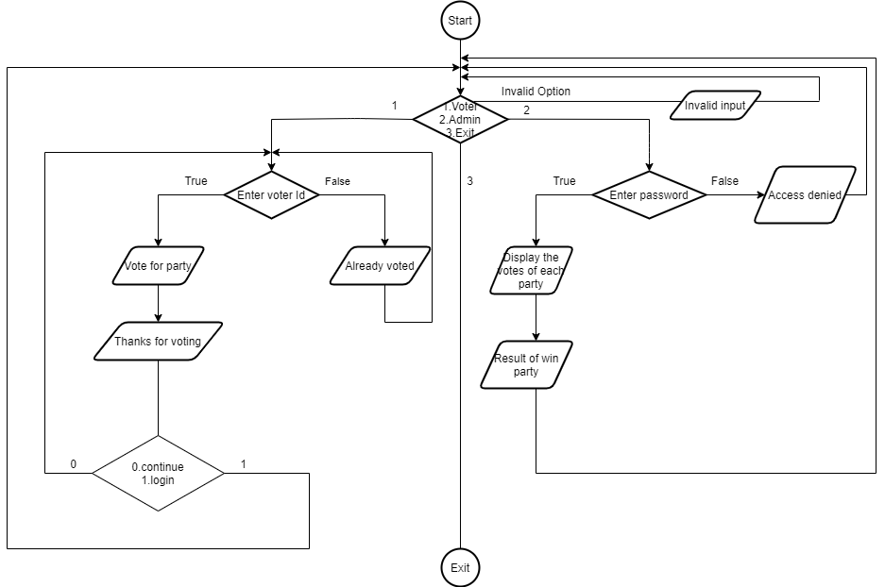

**8. Test Plan**

* To check whether the system distinguishes between the admin login, voter login and exit.
* To check whether the voter is entering the unique Id or not.
* To check whether the admin is entering the correct password or not.
* To check whether the voter can vote only once.
* To check whether the system distinguishes between the parties
* To check whether the voter can vote for the party has he/she is willing to vote.
* To check whether list of votes each party is displayed or not.
* To check whether the result or winning party is displayed or not.
* To check whether the system exits or not.

**9. Test Cases**

|  |  |  |  |  |  |
| --- | --- | --- | --- | --- | --- |
| Test Case ID | Test Scenario | Test Data | Expected  Result | Actual Result | Pass/Fail |
| 1 | Enter the option for voter login | Enter the option 1 | The system asks for voter Id | As expected | Pass |
| 2 | Enter the option for admin login | Enter the option 2 | The system asks for admin password | As expected | Pass |
| 3 | Enter invalid option i.e. except 1 and 2(single digit number) | Enter 5 | Displays invalid option | As expected | Pass |
| 4 | Enter unique voter Id | Enter ELECT123 | Displays the voter Id | As expected | Pass |
| 5 | Enter same Id used before | Enter ELECT123 | Displays you are voted | As expected | Pass |
| 6 | Enter option between 1 to 5 to vote for party | Enter option 1 | Displays thank you for voting | As expected | Pass |
| 7 | Enter invalid option i.e. other than from 1 to 5(single digit number) | Enter option 6 | Displays Invalid option | As expected | Pass |
|  |  |  |  |  |  |
|  |  |  |  |  |  |
| 8 | Enter valid admin password | Enter admin123 | Displays the list of votes of each party and winning party | As expected | Pass |
| 9 | Enter invalid admin password | Enter Sushma | Displays the sorry access denied, only admin can access | As expected | Pass |

**10.Result and Conclusion**

In this project, EVM is designed using C programming, in order to reduce the manual process. Here, voter has to enter his unique voter Id, so that multiple votes of same voter can be reduced. By choosing the party, voter can easily vote. Finally, the election result will be displayed.

It is user-friendly, flexible, reliable, less time consuming and cost effective. By this we can avoid political problems, cheating and election process will go smoothly without any problems.

# 