My name is Rishi Mishra, and I’m a Sophomore at Providence Day School. If you’ve ever been to Providence Day Fall Fest, Camp Spirit, or any of the athletic events you may have seen me behind a colorful snow cone stand called Frostbite’s Frozen Ice. What started in sixth grade as a simple idea on a hot summer tennis day has grown into something I’d never imagined - the lending arm for a global financial inclusion movement, “PD Microfinance”.
Every dollar I’ve earned from Frostbite’s Frozen Ice, from summers at Camp Spirit, and from odd jobs has gone into running PD Microfinance, a Kiva high school chapter and making microloans on Kiva (a crowdfunding organization that brings borrowers & lenders together from across the globe). The club is built on a simple belief: that access to opportunity should not depend on where you were born. We raise money here in Charlotte and channel it through Kiva to entrepreneurs from unbanked and underserved communities around the world. In just 1 year, we have lent over $4000 to farmers, artisans, shopkeepers, and women running family businesses, across 22 countries and 6 continents.
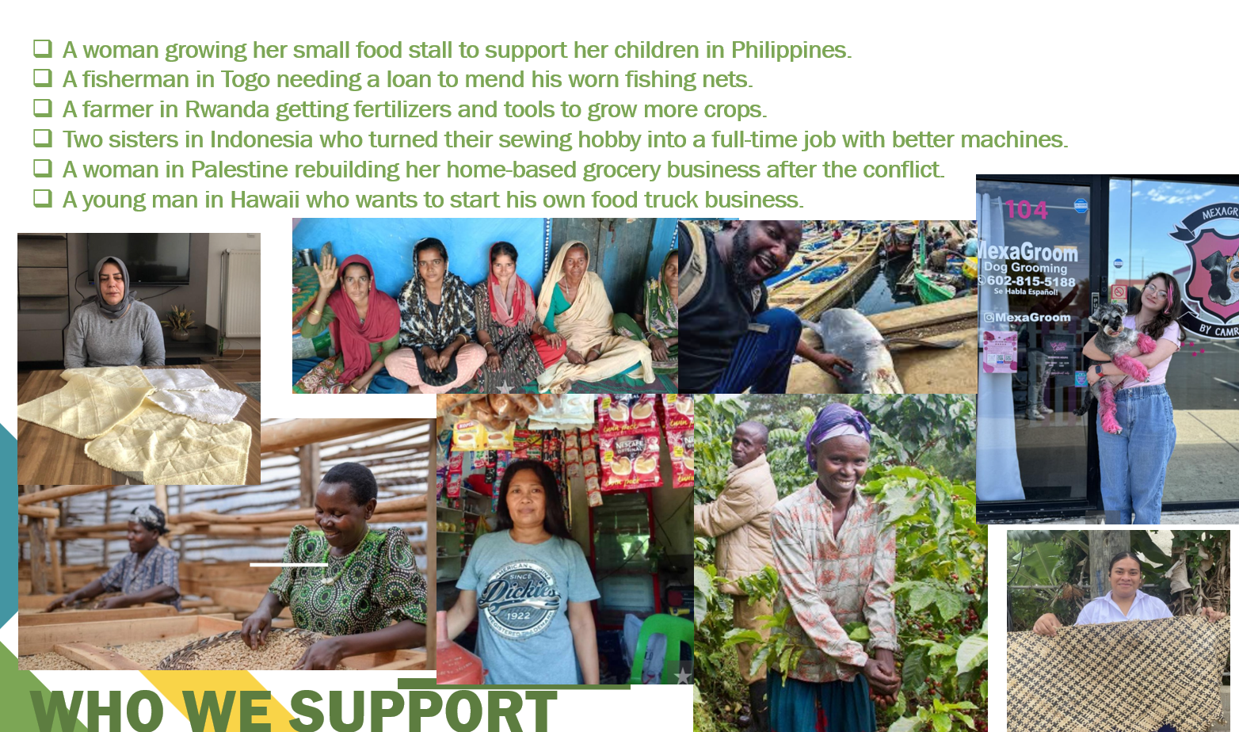

The idea came to me during a summer trip to Tanzania in 2024. At Kambarage Primary School, I met students who studied in crowded classrooms, some wearing torn uniforms and others playing soccer with bricks for goalposts. Our safari driver told me he wanted to start his own company but was held back by high interest rates and the dominance of foreign operators. That trip was a revelation that poverty is not just about lacking food or resources, it is also about lacking access to opportunity.
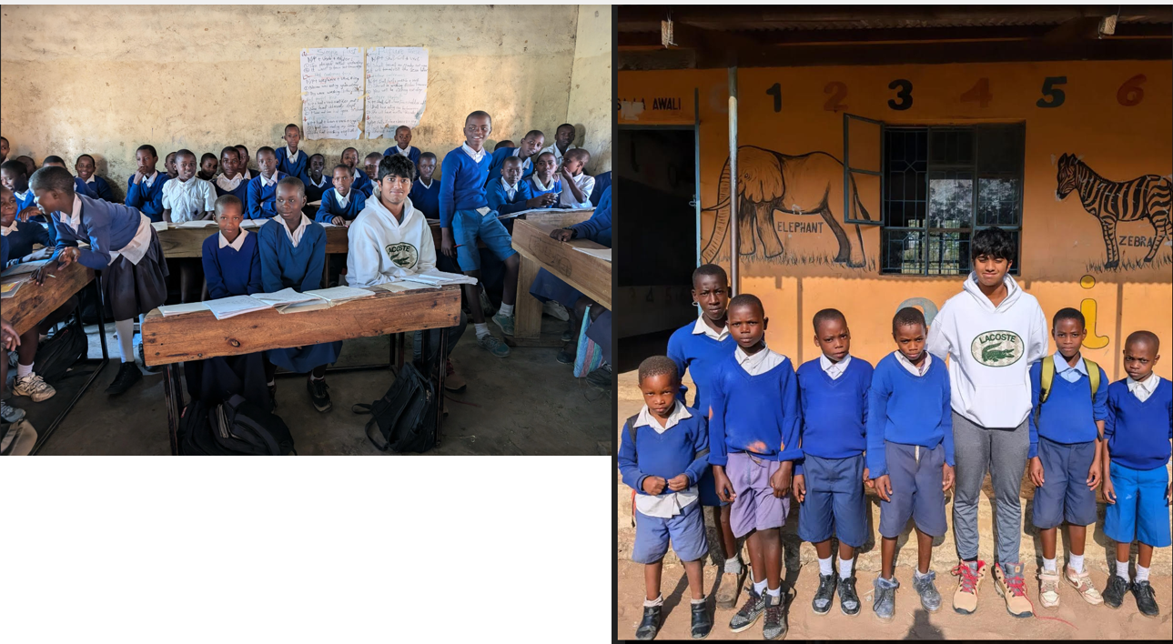
My experience in Serengeti led me to explore microfinance and the story of Muhammad Yunus, who created a way for unbanked communities to access small loans for improving their standard of living. I wanted to join the global financial inclusion movement and launched ‘PD Microfinance Club’ at my school which is also a Kiva chapter. Kiva is a $34.7 million nonprofit company which has facilitated over $2B in loans since it was founded in 2005. It provides a crowdfunding platform to connect lenders and borrowers around the world.
Running the club has been an adventure. We’ve grown to 40 members, won first place in a national Kiva pitch competition, and even received a note of appreciation from Kiva’s CEO. But the part I’m proudest of is watching high school students become strong advocates of financial inclusion through impact investing. They research borrowers, track repayment cycles, and learn how a revolving fund can amplify the effect of a $25 and help more than one person achieve their goals.
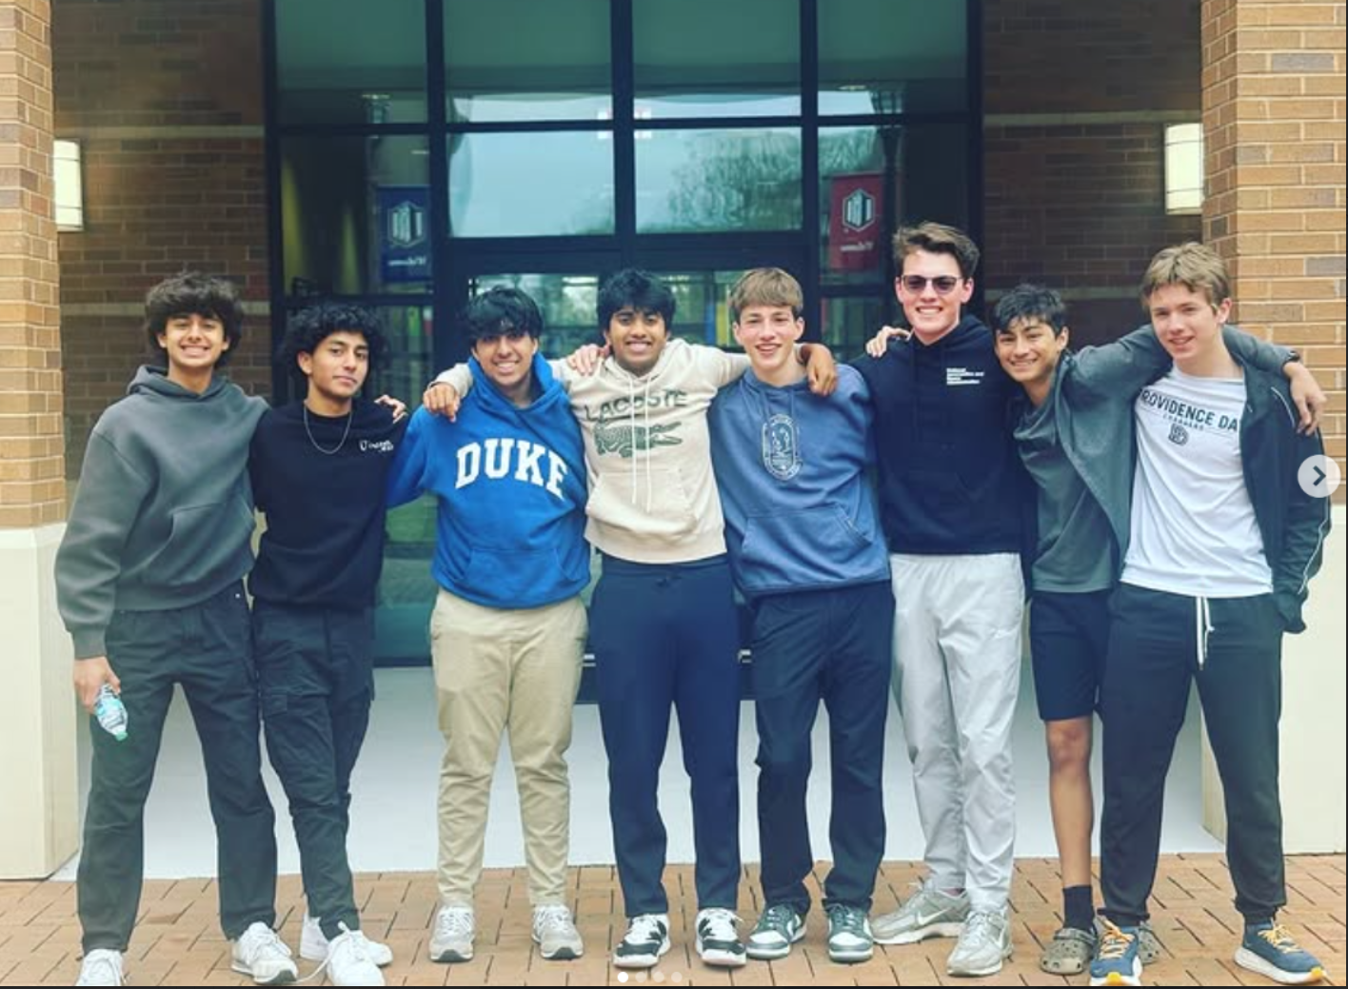

Currently, I serve as the National Co-President (High School Div) on the Kiva Students Board and help students like me launch or run their own Kiva chapters. I also wrote a research paper on microfinance as a tool for long-term poverty alleviation, which I presented at both the JSHS and eCYBERMISSION competitions. My goal was to network with other students and raise awareness around financial inclusion. I was honored to place second at the state level in eCYBERMISSION and paper and poster finalist at JSHS. I pledged my award money to support future microloans through my club.
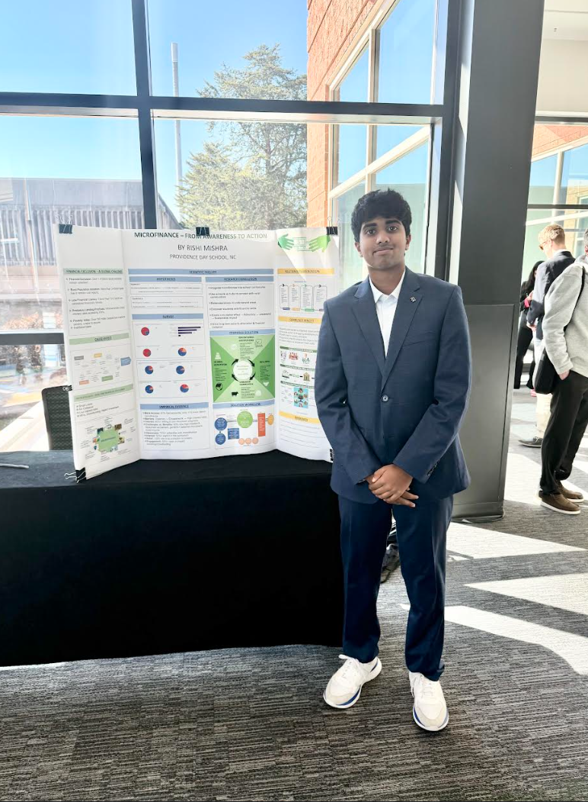
My snow cone stand has become the “lending arm” of our club, and every shaved ice I sell helps someone on the other side of the world start or grow a business. From Tonga to Rwanda to India, we’ve supported families and farmers who remind us that the desire to build a better future is universal.
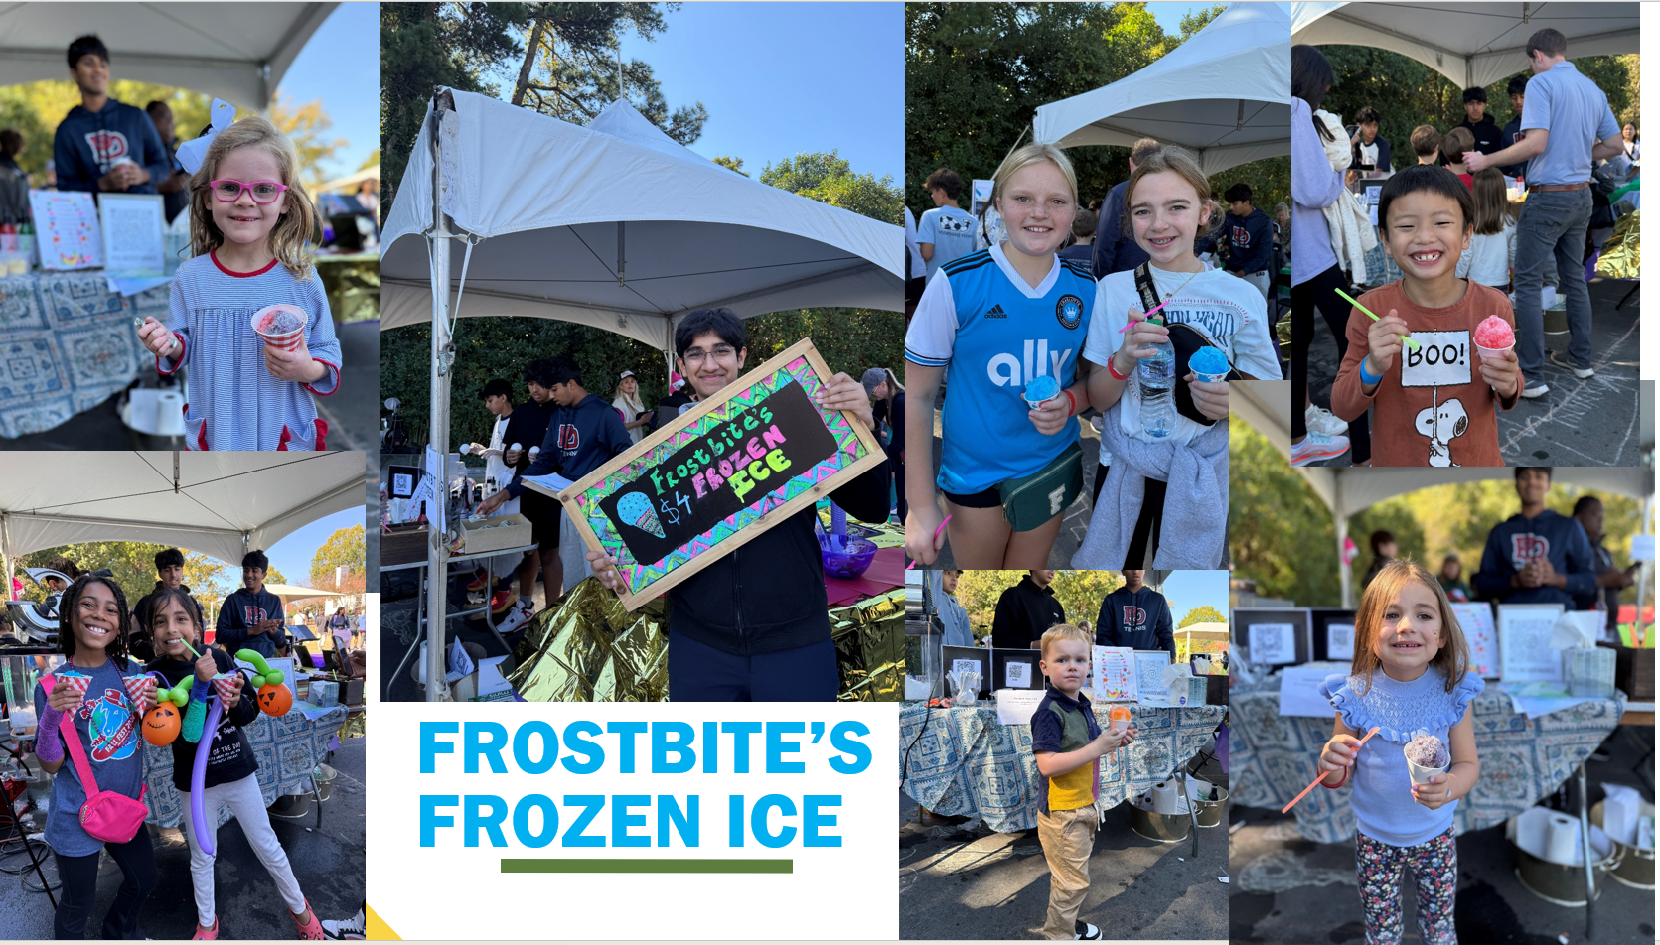
I never expected Frostbite’s Frozen Ice to turn into something so impactful, so much more than just a summer hustle. But now, every cup of flavored ice is part of a bigger story: students at Providence Day working together to make the world a little fairer and more equitable- one microloan at a time.

More about the PD Microfinance
Kiva lending team: https://www.kiva.org/invitedto/pd_microfinance/by/rishi6608
Instagram: https://www.instagram.com/pdmicrofinance/
Linkedin: https://www.linkedin.com/feed/
Blog: https://r4u2010.blogspot.com/

