CAPSTONE PROJECT REPORT
Data-Efficient Wildlife Detection from Ugandan Field Footage
Label recovery, class imbalance and small-data training strategies
Joseph Walusimbi
B.Eng. Electronics and Computer Engineering, 3rd Year
Course unit: Machine Learning — Capstone Project
October 2026
Dataset: NESTLER Wild Animal Recognition Video Dataset, Zenodo, doi:10.5281/zenodo.17036940 (CC BY 4.0).
Model: YOLOv8-nano (Ultralytics). Code, model, results notebook and figures accompany this report.

Contents
Summary 2
1. Introduction and objectives 2
2. The dataset 3
3. Methods 4
3.1 Splitting the data 4
3.2 Model and training 4
3.3 The ablation ladder 4
3.4 How results were judged 5
3.5 Differences from the proposal 5
4. Results 6
4.1 Fixing the split rescued the chimpanzee class 6
4.2 Standard augmentation helped most; the other techniques did not clearly add to it 7
4.3 Test-set results 9
4.4 New recording sessions: detection collapses 9
4.5 New videos: species recognition is unreliable 10
4.6 Export and speed 10
4.7 Precision, recall, F1 and what the errors look like (test set) 11
5. Discussion and limitations 13
6. Conclusions and future work 15
Appendix: reproducibility, files and references 15

Summary
A small YOLOv8-nano detector trained on 1,220 annotated Ugandan field frames finds seven animal classes with a test mAP50 of 0.71, but it fails on recording sessions it has never seen. The main results, all measured with three random seeds per setting:
- A flawed data split hid the chimpanzee class. Cutting each video in time left only distant, padded portrait footage in the chimpanzee validation set. Under identical training settings, fixing the split raised chimpanzee mAP50 from 0.14 to 0.67 (Section 4.1).
- Standard augmentation is the one technique that clearly helped. It raised overall test mAP50 from 0.61 to 0.71, mostly for antelope (0.14 to 0.49), hippo and elephant (Section 4.2 and 4.3).
- The other data-efficiency techniques gave no clear net gain. Built-in copy-paste cannot run on box-only labels. Copy-paste with SAM masks raised bird recall on validation from 5% to 29%, but not on test. Class-balanced sampling, class-weighted loss and pseudo-labelling were within noise of standard augmentation (Sections 4.2 and 4.3).
- Generalisation to new sessions is poor. Holding out whole recording sessions dropped gorilla test mAP50 from 0.77 to 0.15 and hippo from 0.97 to 0.06. On four new videos the models picked the right species in 0 to 82% of frames (Sections 4.4 and 4.5).
- Bird is not solved. Test mAP50 is about 0.03 for every setting.
- The model is small and fast. The ONNX export is 12 MB, matches the PyTorch model within 0.003 mAP50, and runs at about 13 ms per image on a desktop CPU (Section 4.6).

1. Introduction and objectives
This project asks which cheap data techniques actually help a wildlife detector trained on very little data, and how honest a normal test score is. Camera-trap monitoring in Uganda's protected areas is slow when people review footage by hand, and detection models trained at one site often degrade at another because of changes in vegetation, light and camera angle.
Three problems make a small field dataset hard. Frames from one video are nearly identical, so the number of distinct scenes is far smaller than the frame count. Some species have few examples (elephant has 131 boxes against 1,219 for hippo). And the source annotations call both gorillas and chimpanzees "monkey", which has to be repaired before training.
The objectives, taken from the project proposal, were to:
- Recover separate gorilla and chimpanzee labels from the session each frame came from.
- Fine-tune a pretrained YOLOv8-nano detector on the corrected seven-class data.
- Design a split by recording session and time that avoids leakage between training and test.
- Measure how well hippo and gorilla detection carries over to a recording session never seen in training.
- Test a ladder of data-efficiency techniques, one added at a time: standard augmentation, copy-paste, class-imbalance handling and pseudo-labelling.
- Report per-class precision, recall and mAP, with attention to the smallest class.
- Export the final model to ONNX and measure its speed.

2. The dataset
The data are 1,220 video frames with 3,909 hand-drawn boxes, from nine recording sessions in Uganda (January to June 2025). They come from the NESTLER Wild Animal Recognition Video Dataset on Zenodo (doi.org/10.5281/zenodo.17036940, licence CC BY 4.0). The Zenodo description states 1,173 frames; the nine session folders contain 1,220 image files, and all of them were used.
Table 1. The nine recording sessions.
Session | Frames | Boxes | Main content
antelope | 142 | 347 | Uganda kob (visually confirmed)
chimpanzees | 374 | 1,173 | chimpanzee; some hippo
elephant | 43 | 86 | elephant
gorillas | 44 | 88 | gorilla; some elephant
gorillas2 | 61 | 122 | gorilla
gorillas3 | 48 | 83 | gorilla
hippo | 100 | 211 | hippo; some elephant
hippo2 | 267 | 1,390 | hippo, bird, hog
hog | 141 | 409 | warthog; some bird

Box totals after repairing the labels are hippo 1,219, chimpanzee 1,163, hog 421, bird 379, antelope 347, gorilla 249 and elephant 131. Hippo and chimpanzee together are 61% of all boxes, and the imbalance between the largest and smallest class is about 9 to 1.
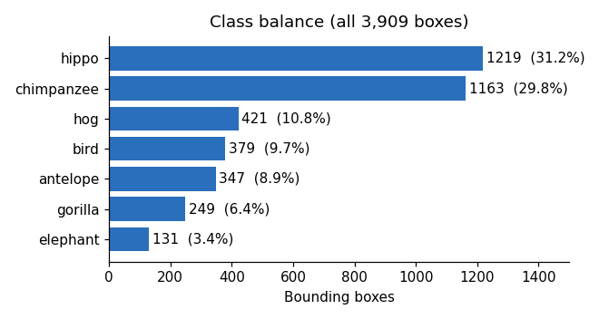
Figure 1. Number of boxes per class (3,909 in total).
Label repair. The raw annotations give gorillas and chimpanzees the same "monkey" category. Each session shows only one of the two species, so every "monkey" box was relabelled from its session folder. This produced the seven classes antelope, bird, chimpanzee, elephant, gorilla, hippo and hog, in that fixed order. Bird has no session of its own; birds are annotated inside hippo2 and hog frames, usually small and in scenes dominated by other animals.
What the data cannot tell us. The archive has no park or camera-location field, so generalisation across parks cannot be tested. Frames within a session are near-duplicates, so the number of truly different scenes is small.

3. Methods

3.1 Splitting the data
Each session was cut in time order, 70% train, 15% validation, 15% test, so nearby frames never sit on both sides of a boundary. A first exploratory run showed this was not enough. The chimpanzee video starts as normal widescreen footage (112 frames) and then switches to portrait phone footage padded with blurred side bars (262 frames). A single time cut put only the padded, distant footage in validation and test.
The fix detects padded frames by comparing the sharpness of the side strips with the centre (padded frames scored 0.25 or lower; every normal frame in all nine sessions scored 0.62 or higher), crops the bars off (the picture occupies x = 656 to 1264 of 1920 pixels, checked on all 262 frames), and splits the two formats separately. Every class appears in all three splits and no frame is in two. The result is 849 training, 180 validation and 191 test images. The original split was kept as evidence.

3.2 Model and training
All runs fine-tune the COCO-pretrained YOLOv8-nano (Ultralytics 8.4) at 640 pixels, batch size 16, up to 100 epochs, stopping when validation mAP does not improve for 20 epochs. Training ran on one NVIDIA RTX 5070 Ti with a nightly PyTorch build (CUDA 12.8). Every setting was run with seeds 0, 1 and 2.

3.3 The ablation ladder
Each step changes one thing relative to the one before, and every other training setting is held fixed.
Table 2. The ablation ladder.
Step | What changes | Notes
S0 | No augmentation | All Ultralytics augmentation explicitly set to zero
S1 | Standard augmentation | Mosaic, colour jitter, shift, scale 0.5, flip, mixup 0.1
S2 | Copy-paste | Built-in version is a no-op on box-only labels; replaced by 400 synthetic training images with SAM-masked elephants, birds and antelope pasted in
S3 | Class imbalance | Two variants: repeat-factor sampling, or class-weighted loss
S4 | Pseudo-labelling | 38 frames from four new videos, labelled by the S2 model at confidence 0.6 or higher

All steps S2 to S4 are applied on top of S1, separately rather than stacked, so each effect can be read on its own. The synthetic and pseudo-labelled images were added to the training split only; validation and test files are hard links to the same originals in every variant.

3.4 How results were judged
I report precision, recall, mAP at 0.5 overlap (mAP50) and averaged over 0.5 to 0.95 overlap (mAP50-95), overall and per class. Choices were made on the validation set, and the test set was scored once at the end. Differences are given as the mean over three seeds with the standard deviation. A difference is flagged "beyond noise" when a Welch t-statistic over the three seeds exceeds 2.8 in size. This is a rough screen, not a formal test, and with many comparisons a few flagged cells will be chance.
Two further checks go beyond the standard split. Experiment A trains on gorillas, gorillas2 and hippo2 only and tests on the unseen sessions gorillas3 and hippo. The external check runs the models on four new videos that each show one known species, after confirming by image fingerprint that none of their frames appears in the annotated data.

3.5 Differences from the proposal
The proposal remains an accurate record of the plan, but the finished work differs from it in the places below. Anything not listed was done as proposed (three seeds per setting, precision, recall and mAP, ONNX export, leave-session-out test for hippo and gorilla).
Table 3. Differences between the proposal and the finished work.
Topic | Proposal | What was done
Frame count | 1,173 frames | 1,220 image files in the nine folders, all used; the 3,909 boxes match
Main split | Hold out whole sessions for validation and test | Time-ordered 70/15/15 cut within every session; chimpanzee video split by format. Whole-session holdout only in Experiment A
Model | YOLOv8 or YOLO11, nano and small | YOLOv8-nano only
Fine-tuning | Lower learning rate, cosine schedule, freezing comparison | Early stopping and default optimiser settings only
Baseline (S0) | Minimal augmentation | No augmentation at all
Ladder | Cumulative, each step on the last | S2, S3 and S4 each added to S1 separately, not stacked
S2 copy-paste | SAM masks | Done offline for elephant, bird and antelope; the built-in version was shown to be a no-op
S3 imbalance | Sampling, class weights or focal loss | Repeat-factor sampling and class weights; focal loss not tried
S4 pseudo-labelling | Gorilla, Elephant, Hippopotamus, Warthog videos | Four new videos; the Gorilla files and one hippo clip duplicated annotated data and were excluded; 38 frames labelled
S5 synthetic images | Optional | Not done
Local-language table | Stretch feature | Not built; planned (see Section 6)
Added work | Not in proposal | Chimpanzee padding fix with a matched check, antelope time-shift analysis, external check on new videos, 1280-pixel test, a prediction script (predict.py)

4. Results

4.1 Fixing the split rescued the chimpanzee class
The first exploratory run scored 0.09 mAP50 on chimpanzees while most other classes scored 0.55 to 0.99 (bird was also weak, at 0.40). It was not a labelling problem: the confusion matrix showed one chimpanzee/gorilla swap in each direction. On the original split, the median chimpanzee box was 2.0% of the image in training but 0.3 to 0.4% in validation and test, because the late, padded footage went only to evaluation.
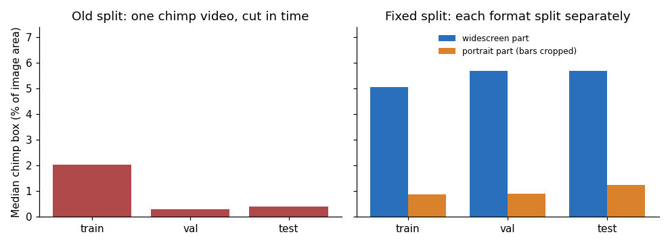
Figure 2. Median chimpanzee box size by split, before and after the fix.
To check that the split, and not a change in training settings, was responsible, I trained three seeds on the original split using exactly the no-augmentation recipe (S0). The old and new datasets differ in both what the model trains on and what it is scored on, so the table separates the two.
Table 4. Chimpanzee mAP50 under matched training settings (mean ± standard deviation, three seeds).
Trained on | Scored on | Chimpanzee mAP50
Original split | Original validation | 0.143 ± 0.048
Original split | Fixed validation | 0.481 ± 0.016
Fixed split | Fixed validation | 0.670 ± 0.014
Original split | Fixed test | 0.680 ± 0.031
Fixed split | Fixed test | 0.750 ± 0.026

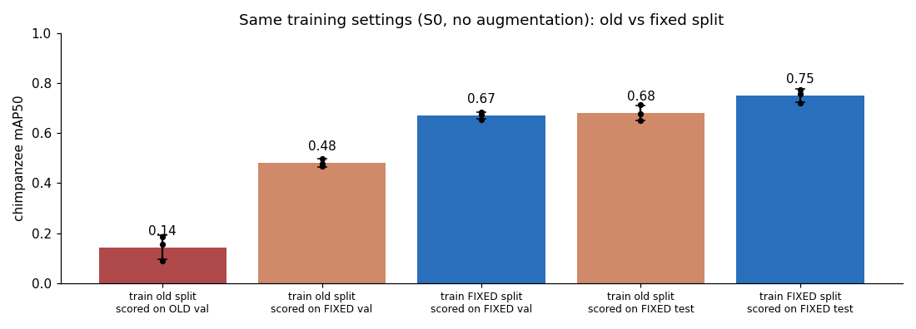
Figure 3. Chimpanzee mAP50 under matched training settings.
The jump from 0.14 to 0.67 holds with identical training settings, so it is not caused by augmentation or stopping. About two-thirds of the gain appears already when the old models are scored on the fixed evaluation set (0.14 to 0.48), so the composition of the original validation set was a large part of the problem; the rest (0.48 to 0.67) comes from training on the fixed split. Scores on two differently built evaluation sets are not strictly comparable. I also expect that cropping the padded frames helps by itself, because chimpanzees appear about 1.8 times larger after shrinking to 640 pixels; that was not tested separately.
Antelope has a similar, subtler shift. It is one video cut in time. Early frames show one animal close up; later frames show a distant herd.
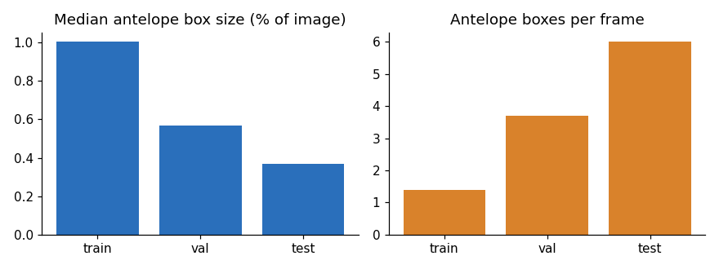
Figure 4. Antelope box size and count per frame across splits.
Median antelope box size falls from 1.00% of the image in training to 0.57% in validation and 0.37% in test, while boxes per frame rise from 1.4 to 3.7 to 6.0. No cropping fixes this, so I kept the split as it is and treated it as a measured limitation. Antelope scores should be read as "early footage to late footage".

4.2 Standard augmentation helped most; the other techniques did not clearly add to it
Overall validation scores, mean ± standard deviation over three seeds:
Table 5. Overall validation scores for every setting.
Setting | mAP50 | mAP50-95
S0 No augmentation | 0.691 ± 0.018 | 0.440 ± 0.007
S1 Standard augmentation | 0.767 ± 0.020 | 0.458 ± 0.004
S2 Copy-paste with SAM masks | 0.746 ± 0.039 | 0.467 ± 0.006
S3 Repeat-factor sampling | 0.730 ± 0.026 | 0.457 ± 0.003
S3 Class-weighted loss | 0.733 ± 0.017 | 0.458 ± 0.010
S4 Pseudo-labelling | 0.751 ± 0.017 | 0.454 ± 0.005

Table 6. Per-class validation mAP50 for every setting.
Class | S0 | S1 | S2 SAM | S3 sampling | S3 weights | S4
antelope | 0.433 | 0.565 | 0.472 | 0.548 | 0.538 | 0.553
bird | 0.175 | 0.242 | 0.335 | 0.141 | 0.204 | 0.215
chimpanzee | 0.670 | 0.723 | 0.712 | 0.723 | 0.701 | 0.716
elephant | 0.788 | 0.974 | 0.859 | 0.892 | 0.828 | 0.958
gorilla | 0.973 | 0.978 | 0.988 | 0.963 | 0.978 | 0.956
hippo | 0.822 | 0.907 | 0.866 | 0.857 | 0.898 | 0.881
hog | 0.978 | 0.977 | 0.989 | 0.988 | 0.985 | 0.980

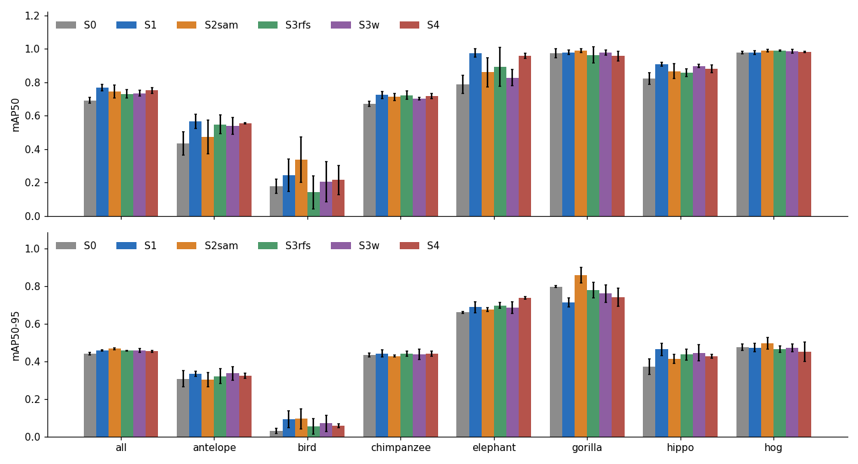
Figure 5. Per-class validation mAP50 and mAP50-95 for every setting, with seed spread.
- S1 is a real gain. Overall mAP50 rises by 0.075, about four times the seed spread, and the gains are largest for the classes that were thin or shifted: elephant (+0.19, but scored on only 18 validation boxes), antelope (+0.13) and hippo (+0.09). One cost: gorilla box tightness (mAP50-95) fell from 0.80 to 0.71.
- The built-in copy-paste did nothing. Ultralytics skips it when labels have no outlines, and this dataset has only boxes, so those runs reproduced S1 exactly. I therefore built the proposal's version: SAM outlines were cut from training boxes only, and 400 synthetic training images were made by pasting elephants, birds and antelope onto other training frames (777 pasted animals). Gorilla and chimpanzee outlines were too fragmented to use. This raised bird recall on validation from 5% to 29%, and nothing else clearly.
- Class-balancing and pseudo-labelling gave no clear gain. The S3 and S4 differences from S1 are inside seed noise. Pseudo-labelling had little to work with: the model was confident enough to label only 38 of 305 frames from the four new videos, and its boxes were incomplete (a herd of seven elephants had three boxed).

4.3 Test-set results
The test set was scored once, after S1 had been chosen on validation. Mean mAP50 over three seeds:
Table 7. Test-set mAP50 for every setting (mean of three seeds).
Class | S0 | S1 | S2 SAM | S3 sampling | S3 weights | S4
all | 0.612 | 0.713 | 0.658 | 0.687 | 0.693 | 0.690
antelope | 0.136 | 0.492 | 0.402 | 0.431 | 0.362 | 0.418
bird | 0.039 | 0.041 | 0.032 | 0.033 | 0.010 | 0.026
chimpanzee | 0.750 | 0.781 | 0.797 | 0.790 | 0.767 | 0.772
elephant | 0.826 | 0.973 | 0.900 | 0.939 | 0.946 | 0.995
gorilla | 0.793 | 0.768 | 0.664 | 0.733 | 0.827 | 0.728
hippo | 0.805 | 0.970 | 0.827 | 0.908 | 0.951 | 0.915
hog | 0.935 | 0.962 | 0.986 | 0.977 | 0.986 | 0.975

Overall test mAP50-95 is 0.337 for S0 and 0.370 for S1.
- S1 confirms its lead. The gain over no augmentation is +0.10 overall on test, larger than on validation. Antelope, the class with the strongest time shift, goes from 0.14 to 0.49.
- Chimpanzee holds up on test (0.75 to 0.80), so the split fix is not a validation-only effect.
- Bird is essentially undetected by every setting (0.01 to 0.04), including the copy-paste model that raised bird recall on validation.
- No variant clearly beats S1. The lower overall scores of S2 to S4 (0.01 to 0.06 below S1) were not tested for seed noise on the test set, so I do not claim they are worse.

4.4 New recording sessions: detection collapses
Experiment A trained on three sessions only (gorillas, gorillas2, hippo2; 314 training images) and tested on two sessions never seen (gorillas3 and hippo). With the same S1 settings, test mAP50 fell from 0.77 to 0.15 for gorilla and from 0.97 to 0.06 for hippo, and mAP50-95 fell from 0.46 to 0.04 and from 0.32 to 0.01.
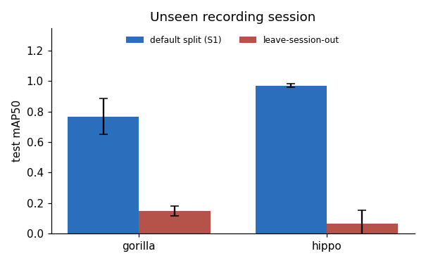
Figure 6. Test mAP50 for gorilla and hippo, standard split versus unseen sessions.
This is the gap a standard split hides. It is a rough measure, not a precise size, for four reasons. The two columns use different test images. The held-out models had far less training data (about 88 gorilla frames). The held-out hippo session shows mostly tiny, distant hippos, so scale is a second cause beside "new session". And the hippo result has a spread as large as its mean (0.064 ± 0.087).

4.5 New videos: species recognition is unreliable
Four further videos from the same Zenodo record (two of elephants, one of hippos, one of warthogs) were checked against all 1,220 annotated frames with an image fingerprint. Five other videos in the record turned out to be the same footage as annotated sessions (all four Gorilla files and the 1080p hippo clip), so they were excluded; using them would have leaked validation and test frames into any pseudo-labelling.
For each model I took the highest-confidence detection in about 305 frames and asked whether it was the video's species. Models were right in 0% to 82% of frames, depending on the video and model.
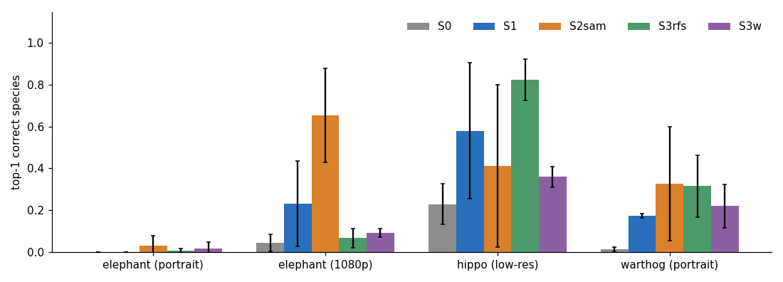
Figure 7. Share of frames with the correct top species on four new videos.
The portrait phone clips were hardest (elephant: 0 to 3% for every model; warthog: 1 to 33%). S1 beat S0 on three of the four videos and tied at 0% on the portrait elephant clip. The copy-paste model did best on the 1080p elephant clip (65% against 23% for S1), but with a seed spread of ±22 points. A reasonable guess is that pasting the same few elephants onto many backgrounds made the model less tied to the one elephant scene; I did not test that. This check gives species recognition only, not box accuracy; each video is one correlated clip, so the effective sample is four videos.

4.6 Export and speed
The S1 model (seed 0) was exported to ONNX and checked on the validation set: mAP50 0.7783 with PyTorch and 0.7757 with ONNX, a loss of 0.003. The PyTorch checkpoint is 6.2 MB and the ONNX file 12.3 MB.
Table 8. Inference time per image (640 × 640, batch 1, model only).
Setup | Median (ms) | 95th percentile (ms)
PyTorch, RTX 5070 Ti, fp32 | 3.3 | 3.8
PyTorch, RTX 5070 Ti, fp16 | 5.9 | 6.2
PyTorch, CPU | 17.8 | 20.4
ONNX Runtime, CPU | 13.3 | 14.5

The ONNX model runs at about 75 images per second on this PC's CPU. Image loading and non-maximum suppression add about 1 ms. These numbers come from one desktop machine and say nothing about a low-power field device.

4.7 Precision, recall, F1 and what the errors look like (test set)
Precision is the share of boxes the model draws that are right; recall is the share of real animals it finds; F1 combines the two. Values below are the Ultralytics precision and recall at the confidence level that maximises F1, averaged over three seeds.
Table 9. Precision, recall and F1 on the test set for S0 and S1.
Class | S0 prec. | S0 recall | S0 F1 | S1 prec. | S1 recall | S1 F1
all | 0.73 | 0.57 | 0.64 | 0.79 | 0.68 | 0.73
antelope | 0.28 | 0.11 | 0.16 | 0.64 | 0.40 | 0.49
bird | 0.75 | 0.01 | 0.03 | 0.69 | 0.00 | 0.00
chimpanzee | 0.88 | 0.67 | 0.76 | 0.80 | 0.73 | 0.76
elephant | 0.80 | 0.81 | 0.80 | 0.86 | 0.98 | 0.92
gorilla | 0.73 | 0.74 | 0.74 | 0.73 | 0.71 | 0.72
hippo | 0.73 | 0.72 | 0.72 | 0.95 | 0.94 | 0.95
hog | 0.94 | 0.92 | 0.93 | 0.87 | 0.96 | 0.91

Bird shows the pattern most clearly: when the model does draw a bird box it is usually right (precision 0.69), but it almost never draws one (recall 0.00), so F1 is zero. Standard augmentation mainly raised recall (0.57 to 0.68), especially for antelope.
Error counts at a fixed operating point. To see which kind of mistake dominates, I matched the S1 (seed 0) boxes to the 662 test animals at confidence 0.25 and overlap 0.5:
Table 10. Error counts for S1 (seed 0) on the test set at confidence 0.25.
Class | Real animals | Found, right class | Found, wrong class | Missed | False-alarm boxes
antelope | 132 | 60 | 0 | 72 | 48
bird | 67 | 0 | 0 | 67 | 0
chimpanzee | 138 | 98 | 0 | 40 | 59
elephant | 22 | 22 | 0 | 0 | 11
gorilla | 44 | 32 | 0 | 12 | 15
hippo | 186 | 181 | 0 | 5 | 41
hog | 73 | 67 | 0 | 6 | 12

The errors are overwhelmingly misses and false alarms, not mix-ups between species. Most of the 202 misses are in antelope (72), bird (67) and chimpanzee (40); the examples I inspected were small animals inside a herd, birds, and chimpanzees half-hidden in foliage, though I did not measure the size of every miss. Lowering the threshold finds more animals but adds mistakes: of the 662 animals, 552 are found correctly at confidence 0.001, 461 at 0.25 and 387 at 0.5, and wrong-species matches appear only at the lowest thresholds (23 at 0.001, 5 at 0.05, none from 0.25 up).
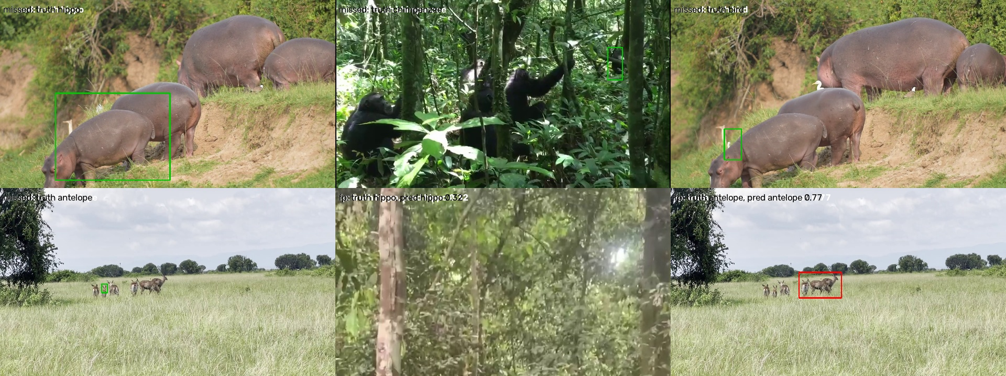
Figure 8. Example errors on the test set: missed hippo, chimpanzee, bird and antelope, and false alarms. Green box = real animal, red box = the model's box. In the false-alarm tiles the word "truth" in the image caption means the predicted class.
The examples show the typical causes: a hippo hidden behind others in a herd (missed), a small chimpanzee at the edge of dense foliage (missed), a white egret standing beside a hippo (missed), one small antelope inside a herd (missed), a low-confidence hippo box in empty forest (false alarm), and one large antelope box drawn over several animals at once (a false alarm by the matching rule, since it does not overlap any single animal enough).
Confusion matrix. The matrix below is the Ultralytics confusion matrix for S1 (seed 0) on the test set at the same 0.25 confidence threshold, with boxes matched at overlap 0.45. Rows are what the model predicted and columns are the real class; the last row counts missed animals and the last column counts false alarms.
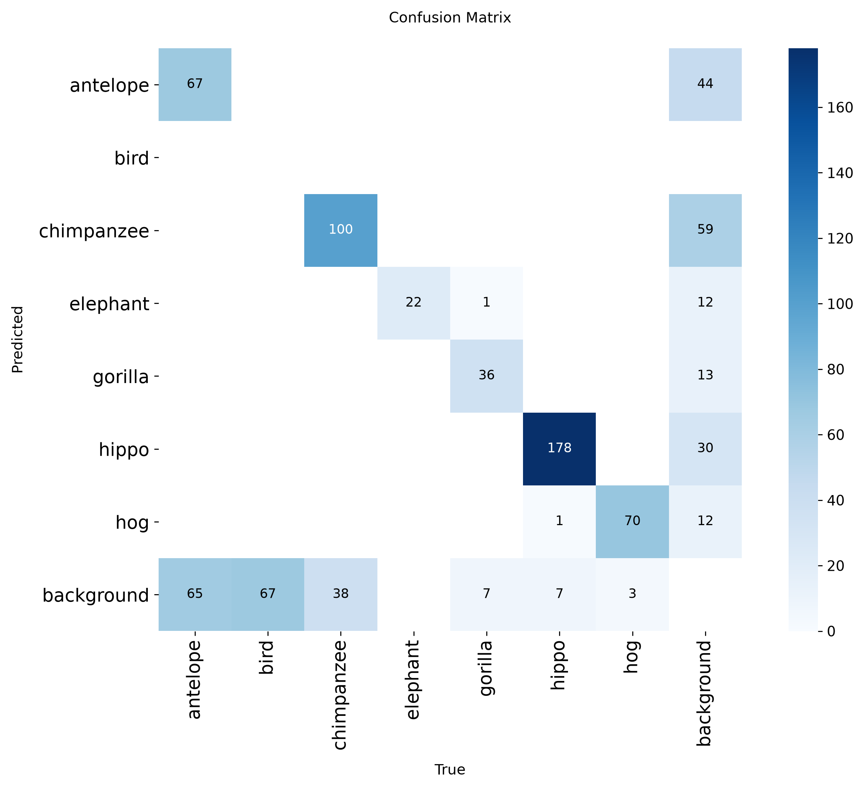
Figure 9. Test-set confusion matrix for S1, seed 0, at confidence 0.25 (counts). Rows: predicted class; columns: real class.
It agrees with the count table: 473 of 662 animals found with the right species, only 2 given the wrong species (one gorilla called elephant, one hippo called hog), 187 missed and 170 false alarms. The small differences from the table (460 found, 202 missed, 186 false alarms) come from the matching overlap, 0.45 here against 0.5 in the table.
One trap is worth recording. Ultralytics draws its confusion matrix at the confidence threshold used for validation, which defaults to 0.001 so that mAP can be computed over all thresholds. At 0.001 the same model shows 229 apparent species mix-ups and 17,426 false alarms, because thousands of near-zero-confidence boxes are counted. Those matrices (also saved during training) describe no realistic setting, and reading them at face value suggests large confusions, such as gorillas taken for hippos, that do not happen at a working threshold. All matrices in this report are therefore drawn at 0.25.

5. Discussion and limitations
The central lesson is that a normal split, even a careful time-ordered one, measures "the next few seconds of a scene already seen". For classes recorded in a single session, the validation and test scores (0.7 to 0.97) say little about how the detector will behave on a new animal in a new place. The two checks that leave the training sessions behind, Experiment A and the new-video check, both show a large drop. The most valuable improvement is therefore more varied footage, not another training trick.
Within what the data can support, standard augmentation is the technique to keep. It is cheap, it helped on validation and test, and it helped most where footage differed in scale between early and late frames. The other techniques are best described as "tried, no clear gain here". I can offer reasons, but none was tested:
- Class balancing: the imbalance is only about 9 to 1, mosaic and scale augmentation already show rare classes in many contexts, and the hardest classes (bird, antelope) are hard because of size and distance, which re-weighting cannot change.
- Pseudo-labelling: the footage most unlike the training data is exactly where the model is least confident, so it yields no labels, and the footage that does pass is the footage the model already handles.
- Copy-paste: the library of cutouts was small (36 elephants from one video, pasted 296 times) and the pasted scenes are often unrealistic. It did lift bird recall on validation, which is the case it suits best.
- An unexplained result: copy-paste also raised gorilla box tightness (mAP50-95 from 0.71 to 0.86) although no gorillas were pasted. I do not know why and would not rely on it.

Was a cheap fix possible for the weak classes? The obvious one for small animals is a larger input image, so I retrained S1 at 1280 pixels instead of 640 (three seeds, otherwise identical). It did not help. Overall test mAP50 was 0.69 against 0.71, bird stayed near zero (0.02), antelope recall rose from 0.40 to 0.55 but antelope mAP50 did not change (0.49), and elephant fell from 0.97 to 0.86. The weak classes are therefore not just a resolution problem: birds in particular need many more labelled examples. These weaknesses are recorded as limitations, with this experiment as evidence that the simplest remedy was tried.
Limitations to state in any use of these numbers:
- Three seeds per setting and a 180-image validation set; elephant is scored on only 18 validation boxes. About 120 comparisons were made, so a few cells flagged "beyond noise" are expected to be chance.
- S3 strengths and the S4 confidence threshold were chosen once and not tuned, so the negative results apply to those settings only.
- Experiment A compares different test images and very different training sizes, so it shows a large gap, not its exact size.
- The new-video check uses one species label per clip, correlated frames and no box accuracy.
- No park or camera-location data exists, so generalisation across parks was not measured.
- All timings are from one desktop PC. Nothing was measured on a field device.
- Bird remains unsolved; the model almost never finds it.

6. Conclusions and future work
A YOLOv8-nano detector fine-tuned on 849 training frames reaches 0.71 test mAP50 on seven Ugandan wildlife classes and exports to a 12 MB ONNX model that runs at about 75 images per second on a CPU. Three conclusions follow from the experiments:
- Check how the data were split. A time cut left only distant, padded footage in chimpanzee validation and test; repairing it raised chimpanzee mAP50 from 0.14 to 0.67 under identical training.
- Standard augmentation is worth using; the further techniques tried were not. It added 0.10 test mAP50 overall. Copy-paste with SAM masks, class balancing and pseudo-labelling gave no clear net gain.
- Test scores overstate real-world performance. On unseen sessions gorilla and hippo detection fell to 0.15 and 0.06, and on new videos the right species was found in as few as 0% of frames.

Planned next step, not yet done: the local-language species-name table (a stretch feature in the proposal). It maps each of the seven class names to its name in Luganda and four western Ugandan languages (Runyankole, Rukiga, Rutooro, Runyoro) using the Sunbird AI translation service, checks each term by translating it back to English, and marks every term as unverified until a native or fluent speaker confirms it. It is a lookup table, so no translation is needed when the detector runs. It is blocked only on a Sunbird AI API key and on speakers to check the terms; the full plan is in the file NEXT_STEPS.md in the supporting materials folder.
Next steps, in order of expected value:
- Collect footage of the same species from more places and cameras, and add held-out sessions to every evaluation.
- Improve bird detection with higher input resolution or tiled inference and with more bird examples.
- Test whether cropping alone (without the format-aware split) explains part of the chimpanzee gain.
- Compare an interleaved antelope split with the time-ordered one, to separate "hard late footage" from "unseen footage".
- Tune the S3 and S4 settings and rerun with more seeds before ruling those techniques out.
- Measure speed on the intended field hardware.

Appendix: reproducibility, files and references
Software. Ultralytics 8.4.171 (YOLOv8-nano, COCO-pretrained), PyTorch nightly with CUDA 12.8, Python 3.12, ONNX 1.23 and ONNX Runtime 1.30, SAM ViT-B (sam_b.pt) through Ultralytics. Training used one NVIDIA RTX 5070 Ti. Exact package versions are in requirements_exact.txt.
What is in the submission folder. The folder is organised in numbered parts: this report (01), the trained model with a prediction script and instructions (02), the results notebook with all figures and tables (03), the code used to build the data, train and evaluate (04), and supporting material including the proposal, a list of differences from it, and a dated project log (05). The raw training outputs, extracted images and the 4.3 GB source data are kept in a separate working archive.
Data variants (validation and test are identical files in all of them): wildlife-yolo (fixed split), wildlife-yolo-naive (original split, kept as evidence), wildlife-yolo-cp (+400 copy-paste images), wildlife-yolo-rfs (repeat-factor list), wildlife-yolo-ps2 (+38 pseudo-labelled frames) and wildlife-yolo-lso2 (Experiment A). The label files for each are in the supporting materials.
A note on the original data.yaml. After the old dataset folder was renamed, its config still pointed at the new data. The matched run used a corrected config so it trained on the old split.
References
- Wildlife Detection Dataset, Kibale, Queen Elizabeth and Bwindi Impenetrable National Parks, Uganda (Feb to Jun 2025). Zenodo. doi.org/10.5281/zenodo.17036940. CC BY 4.0.
- Jocher, G., Chaurasia, A. and Qiu, J. (2023). Ultralytics YOLOv8. github.com/ultralytics/ultralytics.
- Kirillov, A. et al. (2023). Segment Anything. IEEE/CVF International Conference on Computer Vision.
- Ghiasi, G. et al. (2021). Simple Copy-Paste is a Strong Data Augmentation Method for Instance Segmentation. IEEE/CVF Conference on Computer Vision and Pattern Recognition.
- Gupta, A., Dollar, P. and Girshick, R. (2019). LVIS: A Dataset for Large Vocabulary Instance Segmentation. IEEE/CVF Conference on Computer Vision and Pattern Recognition (source of repeat-factor sampling).

