The Original Reference Design
Multi-Input Piezoelectric Harvester with MPPT Charging and USB Output
Technical Explainer -- Full-Complexity Version
This document explains the full-complexity piezoelectric energy harvester design that the companion 5-component capstone board (see “Simplified Piezoelectric Energy Harvester”) was derived from by simplification. Where the capstone version demonstrates the core energy-harvesting principles with parts a student can reason about individually, this is the design intended for real deployment: it combines three piezoelectric transducers, extracts power from each near its maximum power point, manages a storage element through a dedicated energy-harvesting IC with multiple protection thresholds, and regulates its output to a clean, phone-charger-compatible 5 V over USB.

1. Purpose and Scope
A single small piezoelectric element produces only microwatts of power, and that power is not delivered as a steady voltage -- it arrives as irregular bursts tied to mechanical events (footsteps, vibration, ambient sound pressure), at a source impedance and open-circuit voltage that both vary with how hard and how fast the element is driven. Getting useful, regulated power out of that source, and doing it from three transducers at once, is a harder problem than the capstone's passive 5-part circuit is built to solve. This design takes it on with two purpose-built power-management ICs.

2. System Architecture
At the block level, three independent piezo/rectifier front ends feed a combined DC bus into a dedicated energy-harvesting charger IC, which manages a storage element (supercapacitor or battery); a second IC then boosts that stored energy to a regulated 5 V USB output.
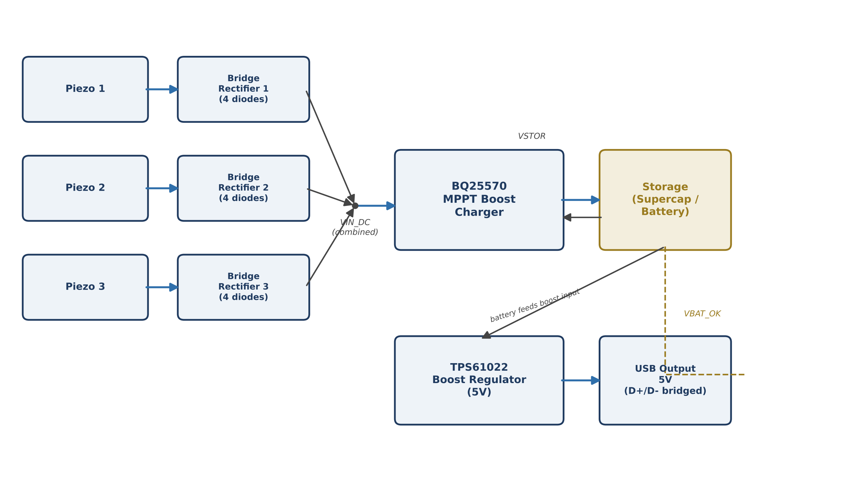
Figure 1 -- Full system block diagram: three harvesting front ends, a BQ25570 MPPT charger managing storage, and a TPS61022 boost stage driving the USB output.

3. How It Works -- Stage by Stage

3.1 Three Independent Piezo Inputs and Rectifier Bridges
Each of the three piezoelectric elements has its own full-wave bridge rectifier, built from four small-signal SMD Schottky diodes (twelve diodes total across the three bridges), rather than sharing one rectifier. Keeping the bridges independent matters because each piezo element has its own source impedance and is driven by an independent, uncorrelated mechanical input -- wiring them into separate bridges before combining the rectified outputs avoids one element's instantaneous voltage loading down or back-driving another's through a shared rectifier. The three rectified outputs are then combined onto a single DC bus (VIN_DC) that feeds the charger IC.

3.2 BQ25570: Maximum Power Point Tracking Energy Harvester
The combined DC bus feeds a Texas Instruments BQ25570, a nanopower boost charger purpose-built for harvesting from high-impedance sources like piezo elements and small solar cells. It does four distinct jobs, each set up by its own resistor divider network -- seven precision resistors in total across the functions below.
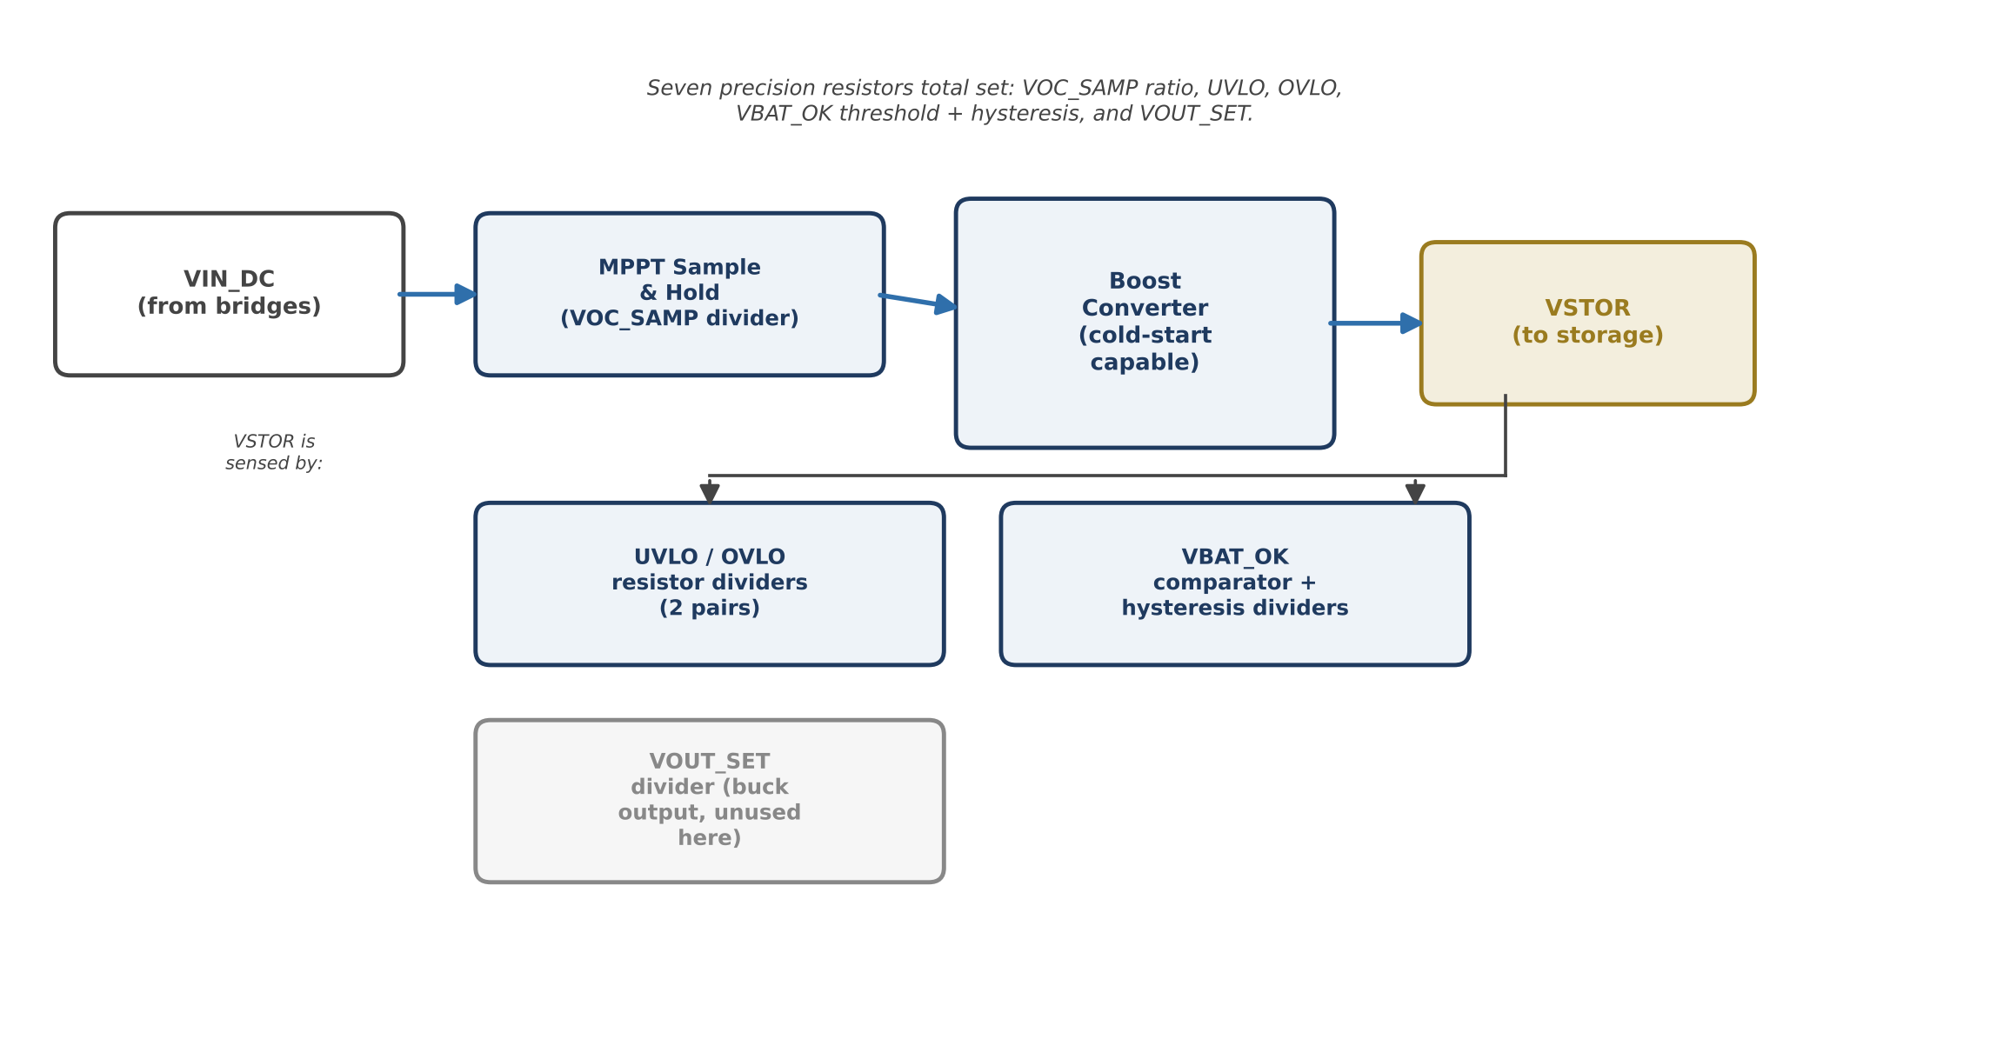
Figure 2 -- Functional blocks inside the BQ25570 harvester/charger, and the resistor-programmed thresholds that configure each one.
- Maximum power point tracking (MPPT): rather than just rectifying and dumping current into storage, the chip periodically disconnects from the input and samples its open-circuit voltage through a resistor divider (VOC_SAMP), then regulates its boost converter to hold the input near a fixed fraction (typically ~80%) of that open-circuit voltage -- the point at which a high-impedance source delivers the most power -- instead of letting the input sag toward zero under load.
- Cold start: with the storage element fully depleted, the chip's main control logic has no power to start from. A dedicated cold-start circuit bootstraps the chip from a very low input voltage (on the order of 100 mV) just far enough to begin operating its own boost converter and start charging storage from nothing.
- Undervoltage / overvoltage lockout (UVLO / OVLO): two further resistor dividers monitor the storage voltage (VSTOR) and shut the charger down if it falls too low (protecting a battery from deep discharge) or rises too high (protecting a supercapacitor or battery from overcharge).
- VBAT_OK comparator with hysteresis: a final pair of resistors sets a threshold (with a deliberate on/off gap, i.e. hysteresis, so the output doesn't chatter near the threshold) above which the chip asserts a VBAT_OK status signal -- used elsewhere in the system to enable the output boost stage only once enough energy has actually accumulated.

3.3 Energy Storage Element
A supercapacitor or small rechargeable cell sits on VSTOR, charged by the BQ25570's boost converter and bounded by its UVLO/OVLO protection. This is the same energy-accumulation role C1 plays in the simplified design, scaled up: because three transducers and an MPPT charger can deliver meaningfully more average power than one passive bridge, the storage element here is sized to buffer enough energy to actually run the USB output stage for a useful burst, not just to smooth ripple.

3.4 TPS61022: USB Boost Output Stage
VSTOR is not a clean, fixed voltage -- it rises and falls across the whole UVLO-to-OVLO range as the storage element charges and discharges. A phone or USB device expects a steady 5 V. The TPS61022, a second, separate boost converter, takes VSTOR as its input and regulates it up to a fixed 5 V output, with its own feedback resistor divider setting the exact output voltage, independent of the BQ25570's internal buck output (VOUT_SET), which this design leaves unused in favour of driving the USB port directly from this stage.
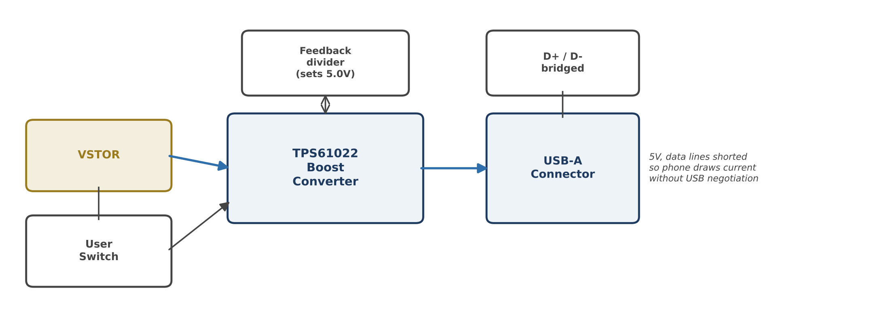
Figure 3 -- Output boost stage: VSTOR is gated by a user switch and boosted to a regulated 5 V, with the USB data lines bridged to request charging current.
Two further details complete the output stage. First, a physical user switch sits between VSTOR and the TPS61022's enable input, so the board does not continuously drain the storage element trying to drive a USB load that may not be connected -- the user turns the output on only when they want to draw power (the BQ25570's VBAT_OK signal can additionally gate this, so the output cannot be enabled before enough energy has accumulated). Second, the USB connector's D+ and D- data lines are deliberately bridged together (a common “dedicated charging port” signature) so that a connected phone recognises the port as a charger and draws current immediately, instead of waiting on a USB data-negotiation handshake this board has no controller to perform.

4. Construction: Why This Board Needs SMD and Vias
Unlike the capstone board, this design cannot be built from through-hole parts on a simple hand-routed two-layer board. The BQ25570 and TPS61022 are both fine-pitch QFN/SON packages with no through-hole equivalent; the twelve rectifier diodes and fourteen-plus programming resistors are only practically available at this scale in small SMD packages (their through-hole equivalents would make the board enormous and add parasitic inductance the boost converters are sensitive to); and a board this dense, with two switching converters running at megahertz-range frequencies, needs a solid, well-stitched ground plane -- hence the roughly 100 ground-stitching vias connecting top and bottom copper -- to keep switching noise from corrupting the chips' own sensitive feedback and MPPT-sampling nodes. None of this can be routed by hand in a reasonable amount of time, which is precisely why the capstone version exists as a separate, deliberately simplified design.

5. Component Summary
Function Block | Component(s) | Role
3x Piezo input + bridge | 3 piezo elements, 12 SMD Schottky diodes (4 per bridge) | Independent AC→DC conversion per transducer, combined onto one DC bus
Energy harvesting charger | Texas Instruments BQ25570 (QFN/DSBGA) | MPPT boost charging, cold start, UVLO/OVLO protection, VBAT_OK status
Threshold-setting resistors | 7 precision SMD resistors (2 dividers + VOC_SAMP + VBAT_OK pair) | Program VOC_SAMP ratio, UVLO, OVLO, and VBAT_OK threshold/hysteresis
Energy storage | Supercapacitor or small rechargeable cell | Buffers harvested energy between charging and output bursts
USB boost output | Texas Instruments TPS61022 (QFN/SON) + feedback divider | Regulates VSTOR up to a fixed 5 V USB rail
Output control | User switch, USB D+/D- bridge | Gates output draw; signals “dedicated charging port” to the connected device
Board construction | ~100 ground-stitching vias, 2+ copper layers, SMD/QFN footprints | Low-noise ground reference for two switching converters at high component density

6. Relationship to the Simplified Capstone Design
The capstone board keeps the same five-stage concept -- input, rectify, store, protect, output -- but collapses each stage to its simplest passive implementation:
Stage | This (Original) Design | Capstone (Simplified) Design
Input | 3 piezo elements, 3 bridges (12 diodes) | 1 piezo element, 1 bridge (packaged IC or 4 diodes)
Storage / regulation | BQ25570 MPPT charger, cold start, 7-resistor protection | Passive smoothing capacitor only
Overvoltage protection | Resistor-programmed OVLO inside the BQ25570 | Single 5.1 V Zener diode
Output | TPS61022 boost to regulated 5 V USB, with switch and D+/D- bridging | Bare 2-pin screw terminal, unregulated
Construction | SMD/QFN, ~100 vias, multilayer | Through-hole, hand-routed 2-layer board
In short: this design optimises for how much usable, regulated power reaches a real USB load from three transducers under varying conditions. The capstone design optimises for how clearly a single student can explain, by pointing at five parts, exactly what happens to the energy between the piezo element and the output terminal.

7. Conclusion
This reference design shows what a production-oriented piezoelectric energy harvester actually requires once the goal shifts from demonstrating a principle to delivering usable, regulated power from a genuinely weak and variable source: parallel harvesting front ends, a dedicated maximum-power-point-tracking charger with multiple resistor-programmed safety thresholds, a managed storage element, and a second regulation stage to present a clean, device-compatible output. Understanding why each of these pieces exists here -- and seeing exactly which capability is lost when it is removed -- is what makes the simplified capstone version meaningful rather than merely smaller.

