Simplified Piezoelectric Energy Harvester
A 5-Component Passive Design for Vibration Energy Harvesting
Capstone Project Report
This report documents a simplified piezoelectric energy harvesting circuit: a self-contained module that converts the small alternating voltage produced by a piezoelectric element under mechanical vibration or sound pressure into a stable, clamped DC output suitable for charging a supercapacitor, a small rechargeable battery, or powering a low-current indicator. The design reduces a far more complex reference design (around 40 components, including a dedicated maximum-power-point-tracking charger IC and a USB boost converter) down to five through-hole parts arranged in a single, hand-routable signal path, trading peak efficiency for simplicity, buildability, and ease of understanding -- making it well suited to a capstone-level demonstration of energy harvesting principles.

1. Project Goal and Design Philosophy
The purpose of this project is to demonstrate the core principles of piezoelectric energy harvesting -- generation, rectification, storage, and protection -- in a circuit that can be fully understood, hand-built, and hand-routed on a simple two-layer PCB, without surface-mount soldering or microcontroller firmware. The original reference design this project simplifies used three piezoelectric inputs, twelve SMD Schottky diodes forming three separate rectifier bridges, a Texas Instruments BQ25570 maximum-power-point-tracking (MPPT) energy harvester IC with seven precision resistor dividers and a cold-start inductor, and a TPS61022 boost converter stepping the stored voltage up to a regulated 5 V USB output.
That design is appropriate for a real deployable product, where extracting the maximum possible power from a scarce and variable input matters. For a capstone project, however, the priority is different: every design decision below favours a part count and a circuit topology a student can derive, simulate, and explain line by line.
Original Design Element | Simplified Replacement | What Is Traded Away
3 piezo inputs, 3 independent rectifier bridges (12 SMD diodes) | 1 piezo input, 1 bridge rectifier (packaged IC or 4 THT diodes) | Total harvested power -- one transducer instead of three
BQ25570 MPPT charger: cold-start inductor, 7 precision resistor dividers | Smoothing capacitor (C1) + Zener clamp (D1), fully passive | Maximum-power-point tracking -- energy is not extracted optimally as source impedance varies
TPS61022 boost converter, feedback network, switch, USB data lines | Bare 2-pin screw terminal output (J2) | Regulated 5 V USB rail -- output voltage follows the clamp, not a fixed regulated level
SMD / QFN packages, ~100 ground-stitching vias, autorouted | Through-hole (THT) components, hand-routed 2-layer board | Board density -- the simplified board is physically larger per function
The result drops the component count from roughly 40 to 5, and the entire schematic fits on a single sheet.

2. System Overview
At the block level, the circuit is a single, linear signal path: mechanical energy goes in on the left, usable DC power comes out on the right.
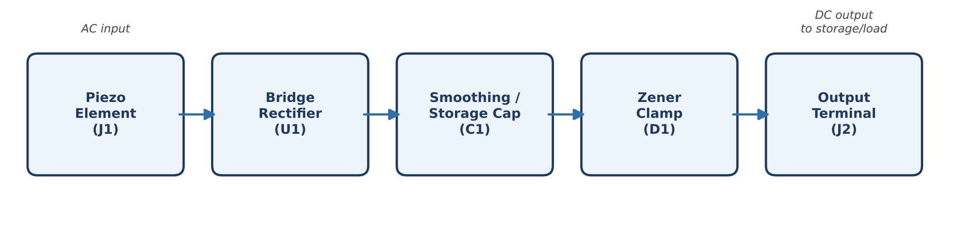
Figure 1 -- Signal flow through the five functional stages.
Each block is implemented by exactly one reference in the bill of materials (Section 6), so there is a direct, one-to-one mapping between “what the circuit does” and “what you can point to on the board.”

3. How It Works -- Stage by Stage

3.1 Piezoelectric Input (J1)
A piezoelectric material (commonly a PZT -- lead zirconate titanate -- disc or a piezo buzzer element repurposed as a sensor) generates an electric charge across its faces when it is mechanically deformed: flexed, struck, or driven by sound pressure. As the element vibrates back and forth, it generates a correspondingly alternating voltage (AC) -- its two leads swap which one is momentarily positive several times per second, following the mechanical vibration. This output has a high source impedance and can reach tens of volts under a sharp mechanical shock, but can only supply a very small current (microamps to low milliamps), which is why the rest of the circuit is built around accumulating energy over many cycles rather than delivering continuous power. J1 is a simple 2-pin screw terminal that brings these two AC leads onto the board as nets PIEZO_A and PIEZO_B, with no other circuitry -- it exists purely to make a mechanical connection that can be wired, unwired, and re-terminated without soldering.

3.2 Full-Wave Bridge Rectification (U1)
Because the piezo output is AC, it is not yet usable by anything that expects a one-directional (DC) supply -- a capacitor or a battery cannot be charged by a voltage that reverses polarity every cycle. U1 solves this with a full-wave bridge rectifier: four diodes arranged so that regardless of which of PIEZO_A or PIEZO_B happens to be momentarily positive, current is always steered the same way into the output rail (VOUT_PLUS) and returns the same way through GND.
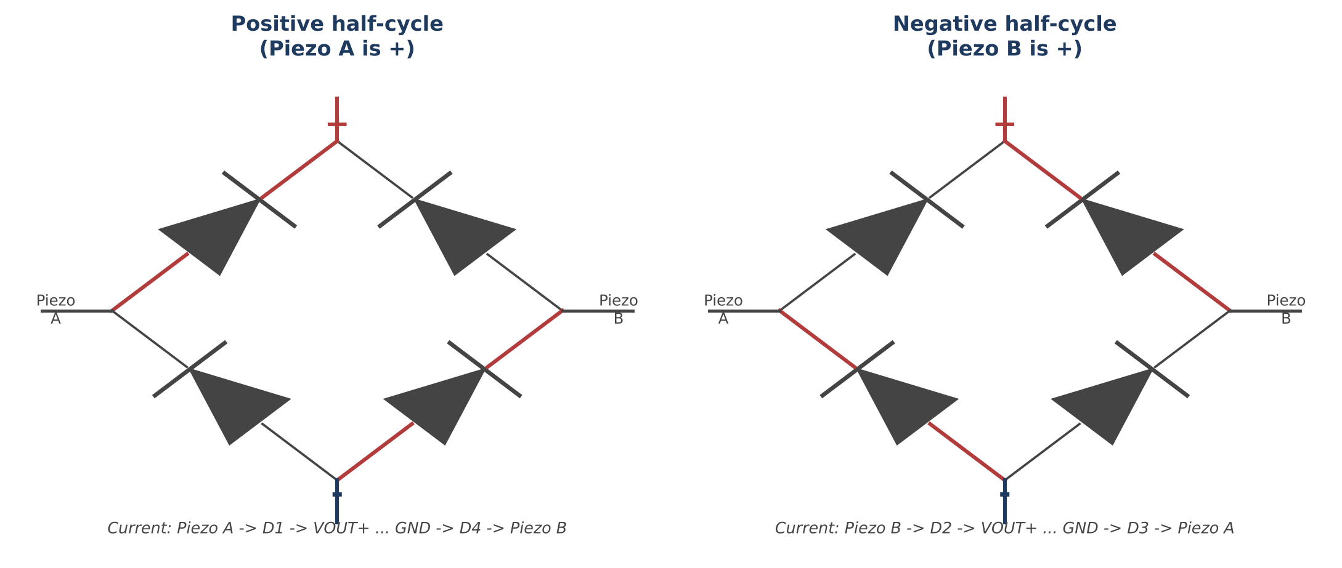
Figure 2 -- The bridge rectifier's internal diode pairs conduct in alternating pairs, so both AC half-cycles contribute current in the same direction at the output.
On the half-cycle where PIEZO_A is positive, current flows out of PIEZO_A, through one diode to VOUT_PLUS, through whatever load/capacitor is attached, back in on GND, and through a second diode back to PIEZO_B. On the opposite half-cycle, the roles reverse and a different diode pair conducts -- but the output polarity at VOUT_PLUS/GND never flips. The practical BOM option is to use a single packaged bridge rectifier chip (e.g. an HD01 or MB10S) in place of four discrete diodes; the BOM also lists 1N5817 Schottky diodes as a discrete alternative specifically because Schottky diodes have a much lower forward voltage drop (~0.3 V) than ordinary silicon diodes (~0.7 V) -- with a weak piezo signal, that 0.4 V difference, doubled (because current always crosses two diodes in series), is a significant fraction of the harvested voltage.

3.3 Smoothing and Energy Storage (C1)
Straight out of the bridge, the output is not smooth DC -- it is a series of rectified pulses that rise and fall with each mechanical vibration cycle, with gaps of near-zero voltage in between strikes. C1, a 100 μF electrolytic capacitor connected across VOUT_PLUS and GND, acts as a small energy reservoir: it charges up each time the bridge delivers a pulse, and holds that charge (slowly discharging into whatever is connected at J2) during the gaps between pulses. This is the step that converts a train of rectified spikes into a usable, comparatively steady voltage, and it is also where the harvested energy actually accumulates -- a single piezo strike delivers only a tiny packet of charge, so the practical use case is many strikes/vibrations over time gradually raising the voltage across C1.

3.4 Overvoltage Protection -- Zener Clamp (D1)
A piezo element under a hard mechanical shock can momentarily generate a much larger voltage than a small supercapacitor or the downstream load is rated for. D1 is a 5.1 V Zener diode connected in reverse bias across the same VOUT_PLUS/GND rail as C1. Below its rated Zener voltage (Vz ≈ 5.1 V), it behaves like an open circuit and has no effect on the circuit. Once the rail tries to rise above Vz, the Zener diode enters reverse breakdown and begins conducting heavily, holding the rail close to 5.1 V by shunting the excess current to GND instead of letting the voltage climb further. This protects whatever is attached at J2 -- a supercapacitor, a coin cell, or sensitive electronics -- from being damaged by a voltage spike the piezo element is otherwise fully capable of producing.

3.5 Output Stage (J2)
J2 is a second 2-pin screw terminal, wired directly across the same clamped VOUT_PLUS/GND rail as C1 and D1. It is the single point where harvested, rectified, smoothed, and voltage-limited energy leaves the board -- intended for a supercapacitor or small rechargeable cell (for buffered storage across many harvesting cycles) and/or a simple low-current load such as an indicator LED. There is deliberately no voltage regulation or boost conversion at this stage (unlike the original design's USB boost converter): the output voltage follows whatever C1 has charged to, up to the ~5.1 V ceiling set by D1.

4. Full Circuit Schematic
Figure 3 shows the complete circuit exactly as implemented in the KiCad schematic, including net names.
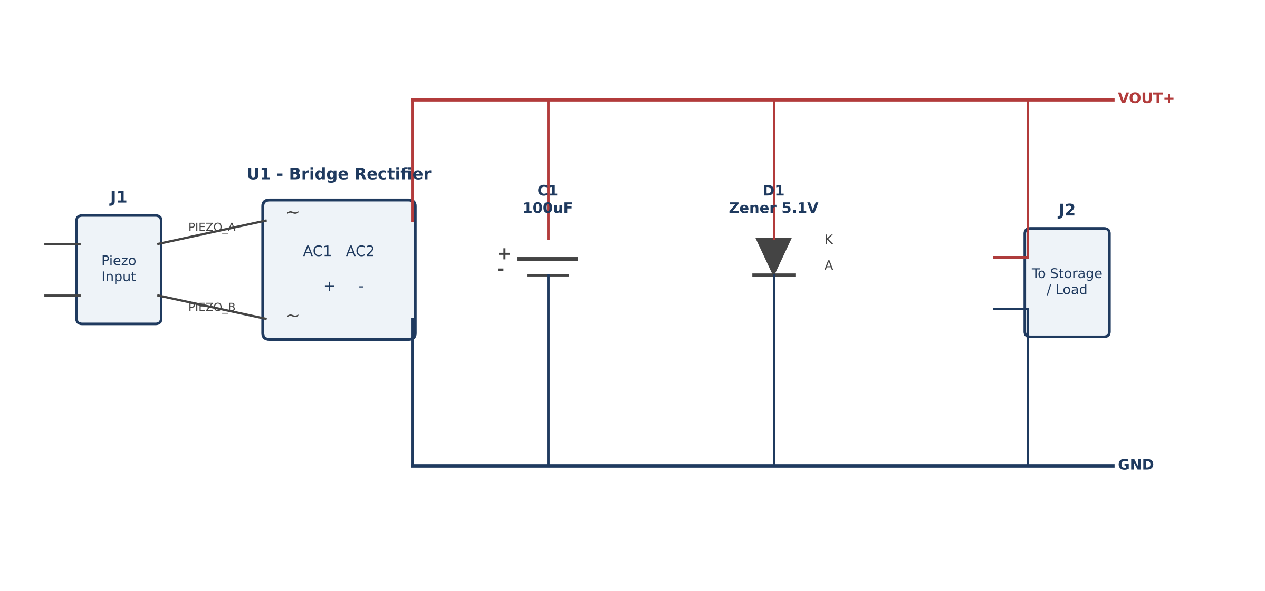
Figure 3 -- Full schematic. PIEZO_A/PIEZO_B carry the raw AC input; VOUT_PLUS and GND form the rectified, clamped output rail shared by C1, D1, and J2.

5. Printed Circuit Board
The PCB is a 2-layer, through-hole-only board. Every pad is a round plated through-hole (no fine-pitch SMD footprints), and every trace is a straight or right-angle (orthogonal) segment on the front copper layer, specifically so the board can be routed entirely by hand in a PCB editor without relying on an autorouter -- a deliberate consequence of the “5 or 6 components, hand-routable 2-layer board” goal behind the whole simplification. Net-equivalent of the schematic's VOUT_PLUS/GND rails is carried as two parallel horizontal copper rails, with each component tapped into the appropriate rail by a short vertical trace stub, which keeps every connection a simple, visually traceable two-segment path.

6. Bill of Materials
Ref | Qty | Value | Role | Example Part | Package
J1 | 1 | Piezo_Input | Piezo element input | Generic 5.08 mm THT terminal block | TerminalBlock_Phoenix_MKDS-1.5-2-5.08
U1 | 1 | Bridge_Rectifier | Full-wave AC→DC rectification | HD01 / MB10S (or 4x 1N5817) | Diode_Bridge_DIP-4_W7.62mm
C1 | 1 | 100 μF | Smoothing / energy storage | 100 μF, 16 V radial electrolytic | CP_Radial_D8.0mm_P3.50mm
D1 | 1 | 5.1 V Zener | Overvoltage clamp | 1N5231B | D_DO-35_SOD27_P7.62mm
J2 | 1 | To_Storage/Load | Output to storage / load | Generic 5.08 mm THT terminal block | TerminalBlock_Phoenix_MKDS-1.5-2-5.08

7. Verification and Testing
Before relying on the board for a real build, the following checks are recommended:
- Run Schematic ERC and PCB DRC inside KiCad (Inspect menu) and resolve any reported warnings.
- Visually confirm silkscreen text and footprint courtyards do not overlap once parts are placed.
- Confirm the exact footprint pad sizes/pitches match the specific parts purchased -- the values used here are reasonable defaults, not pulled from a single manufacturer's datasheet.
- Bench-test with a multimeter: tap or flex the piezo element and measure AC across J1, then measure the DC voltage accumulating across C1 / at J2 after several taps.
- Confirm the Zener clamp: drive VOUT_PLUS from a current-limited bench supply through a series resistor and verify the rail does not rise meaningfully above roughly 5.1-5.3 V.

8. Conclusion
This design demonstrates, with only five components, the complete signal chain required to turn ambient mechanical vibration into usable stored electrical energy: a piezoelectric transducer generates an AC signal, a bridge rectifier converts it to a one-directional pulsed DC signal, a smoothing capacitor accumulates that energy into a steadier voltage, a Zener diode protects the downstream storage element from voltage spikes, and a terminal block exposes the result for charging a supercapacitor, a small battery, or driving a low-current load. It intentionally gives up the maximum-power-point tracking and regulated USB output of a production-grade harvester in exchange for a circuit that is fully hand-traceable, hand-solderable, and hand-routable -- making the underlying energy-harvesting principles, rather than IC-level implementation detail, the focus of the project.

