ESTIMATE
Construction Services
ESTIMATE #: | {{estimate_number}}
Date: | {{estimate_date}}
Prepared For: | {{prepared_for}}
Managed By:  Point of Contact: | {{managed_by}}  {{contact_name}}  {{contact_email}}
Project Location: | {{project_location}}
Prepared By: | KG Construction Corp  License Number: 611502
Quote: | ${{quote}}

Project Name: {{project_name}}

SCOPE OF WORK
The following work will be performed by KG Construction Corp at the above-referenced project location:
{%p for section in sections %}
{{section.num}} | {{section.title}} | ${{section.price}}

{%p for line in section.lines %}
{{line.lineNum}} {{line.text}}
{%p endfor %}

{%p endfor %}
TOTAL ESTIMATED COST | ${{total}}
Additional Notes
{{additional_notes}}

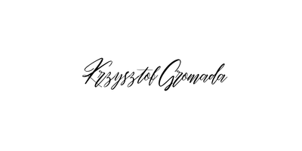
Should you have any questions related to the above-mentioned, please contact the undersigned.

Sincerely,
Krzysztof (Chris) Gromada
KG Construction Corp.
718 – 704 – 3242
kgconstructioncorp@gmail.com

TERMS AND CONDITIONS
1. PAYMENT TERMS
{{payment_terms}}

2. CHANGE ORDERS
Any changes to the original scope of work must be documented and approved by both parties. Additional costs resulting from changes will be billed accordingly.

3. MATERIALS
All materials provided by KG Construction Corp are subject to availability. Substitutions of equal or greater quality may be made at the contractor's discretion with client notification.

4. LIABILITY
KG Construction Corp maintains general liability insurance. The contractor shall not be liable for delays caused by weather, material shortages, or other conditions beyond reasonable control.

5. ACCEPTANCE
This proposal is valid for 30 days from the date of issue. Accepting constitutes agreement to terms and conditions outlined in this document.

6. SITE ACCESS
The client agrees to provide reasonable access to the property during normal working hours for the duration of the project. Delays caused by restricted access, scheduling conflicts, or inability to access the work area may result in schedule adjustments and additional costs.

7. PAYMENET DELAYS
Payments not received within the agreed payment terms shall accrue interest at a rate of 1.5% per month (18% annually) on the unpaid balance, or the maximum rate permitted under New York law. Interest will begin accruing immediately after the payment due date and will continue until the balance is paid in full.

7. PERMITS AND CODE COMPLIANCE
KG Construction Corp will perform work in accordance with applicable local building codes and regulations. Responsibility for obtaining permits may rest with the contractor or client depending on the agreed scope, and any permit-related fees or required inspections will be billed accordingly.

7. RIGHT TO SUSPEND WORK
KG Construction Corp reserves the right to suspend work if agreed payments are overdue.

