STUDENT LEARNING PORTAL
PROG211 | OBJECT-ORIENTED PROGRAMMING 1
Individual Assignment Report
Python Object-Oriented Programming Project

Abstract
This report describes a Student Learning Portal built with Python and Object-Oriented Programming (OOP). It stores sample student details in objects, displays them, and checks examination results using 50 as the pass mark.
The program demonstrates a class, constructor, attributes, methods and conditional logic. It is a prototype without a database, login or permanent storage.

Table of Contents
1. Introduction
2. Problem Statement
3. Aim and Objectives
4. Scope and Requirements
5. System Design
6. Object-Oriented Programming Concepts
7. Main Features and Implementation
7.1 Screenshots of the Program
8. Testing and Results
9. Digital Public Goods Considerations
10. Advantages, Limitations and Future Improvements
11. Conclusion
References

1. Introduction
Manual student records can be slow to search and may contain errors. A small application demonstrates how student information and marks can be organised consistently.
The Python program displays student names, IDs and courses, then determines pass or fail.
The examples are Abdul Kamara (75, Pass) and Fatmata Sesay (45, Fail). This is a learning project, not a complete institutional portal.

2. Problem Statement
Manual or inconsistent records can make student information difficult to retrieve and marks harder to check.
The application groups student data into objects and applies one rule: 50 or above passes; below 50 fails.

3. Aim and Objectives

3.1 Aim
Develop a Python Student Learning Portal that displays student information and checks examination results using OOP.

3.2 Objectives
- Create a Student class.
- Create student objects.
- Initialise attributes with a constructor.
- Store name, ID, course and mark.
- Display student information.
- Check examination results.
- Apply pass/fail conditions.
- Explain OOP concepts.
- Discuss Digital Public Goods.

4. Scope and Requirements
The system displays student details and checks results. Sample data is entered directly in the source code.

4.1 Features included
- Student data: name, ID, course, mark.
- Two Student objects.
- display_details() shows student details.
- check_result() shows the mark and result.
- Pass mark: 50.

4.2 Requirements
Type | Requirement
Software | Python 3 and PyCharm or another Python editor.
Operating system | Windows, macOS or Linux.
Hardware | A computer capable of running Python, with a keyboard, display and sufficient memory.
Libraries | No external Python libraries are required.

The system lacks a menu, database, search, login and permanent storage; these are future improvements.

5. System Design

5.1 Main class and objects
The Student class defines the attributes and methods used by each student object.
Program element | Purpose
Student class | Defines the structure and behaviour of a student record.
student1 | Represents Abdul Kamara, ID ST001, course Python, mark 75.
student2 | Represents Fatmata Sesay, ID ST002, course Database, mark 45.
display_details() | Displays the student’s name, ID and course.
check_result() | Displays the mark and determines pass or fail.

5.2 Process flow
- Start.
- Define Student.
- Create two objects.
- Display the first student.
- Check and display the result.
- Repeat for the second student.
- End.

6. Object-Oriented Programming Concepts

6.1 Class and object
Student is the class, or blueprint. student1 and student2 are objects created from it.

6.2 Attributes and constructor
Attributes are name, student_id, course and mark. The __init__() constructor assigns supplied values to an object.

6.3 Instance methods
display_details() shows identifying information; check_result() displays the mark and pass/fail status.

6.4 The self keyword
self refers to the current object. self.name = name stores a name in that object.

6.5 Conditional statements
The condition self.mark >= 50 displays Pass; otherwise, it displays Fail.

7. Main Features and Implementation
The file student_learning_portal.py defines four attributes and two methods in Student. Two objects are created and their details and results displayed.

8. Testing and Results
The table gives test cases and expected results. Run each test before reporting it as completed.
Test | Test case | Expected result
T01 | Create first student object | Abdul Kamara’s information is stored in the object.
T02 | Create second student object | Fatmata Sesay’s information is stored in the object.
T03 | Display student details | Name, ID and course are displayed for each student.
T04 | Check mark 75 | The result is Pass.
T05 | Check mark 45 | The result is Fail.
T06 | Check mark 50 | The result should be Pass if the mark is changed to 50.
T07 | Try a mark outside 0–100 | The current program does not validate the range; validation should be added.

The first five tests match the example. Boundary and invalid-mark tests need changed data; report success only after checking the output.

9. Digital Public Goods Considerations
Digital Public Goods (DPGs) are digital resources intended for broad use and sustainable development. They should follow standards for openness, privacy, security and safeguards. This project is a learning example, not a formally recognised DPG. Responsible sharing, documentation and an appropriate licence could help others learn from and adapt it.

9.1 Open source and transparency
The source code may be shared for learning. Add an appropriate licence before describing it as an open-source release.

9.2 Accessibility and inclusion
Simple Python syntax and clear messages suit beginners. Accessibility with assistive technologies has not been tested.

9.3 Privacy
The program uses sample data and saves no records. Real use would require privacy protection, secure storage and access controls.

9.4 Reusability and modularity
The Student class is reusable. Combining data and methods improves readability and maintenance.

10. Advantages, Limitations and Future Improvements

10.1 Advantages
- Simple OOP learning example.
- Groups student data.
- Reusable class.
- Consistent result checking.
- Extendable design.

10.2 Limitations
- Only two objects.
- Data entered in source code.
- No permanent storage or search.
- No login or roles.
- No mark-range validation.
- Console interface only.

10.3 Future Improvements
- Add a registration menu.
- Search by ID.
- Store students in a collection.
- Validate marks from 0 to 100.
- Add permanent storage.
- Build a graphical interface.
- Add authentication and security.

11. Conclusion
This project presented a basic Student Learning Portal using Python OOP. Student stores name, ID, course and mark; methods display details and results.
The two objects demonstrate classes, constructors, attributes, methods, self and conditions. Abdul Kamara passes with 75; Fatmata Sesay fails with 45.
Real use would require registration, validation, search, storage and security features.

References
- Python Software Foundation (n.d.). The Python Tutorial. Available at: https://docs.python.org/3/tutorial/
- Python Software Foundation (n.d.). Classes in Python. Available at: https://docs.python.org/3/tutorial/classes.html
- Python Software Foundation (n.d.). Built-in Types. Available at: https://docs.python.org/3/library/stdtypes.html
- Digital Public Goods Alliance (n.d.). Digital Public Goods Standard. Available at: https://digitalpublicgoods.net/standard/

7.1 Screenshots of the Program
Screenshots show parts of the program code in the editor.
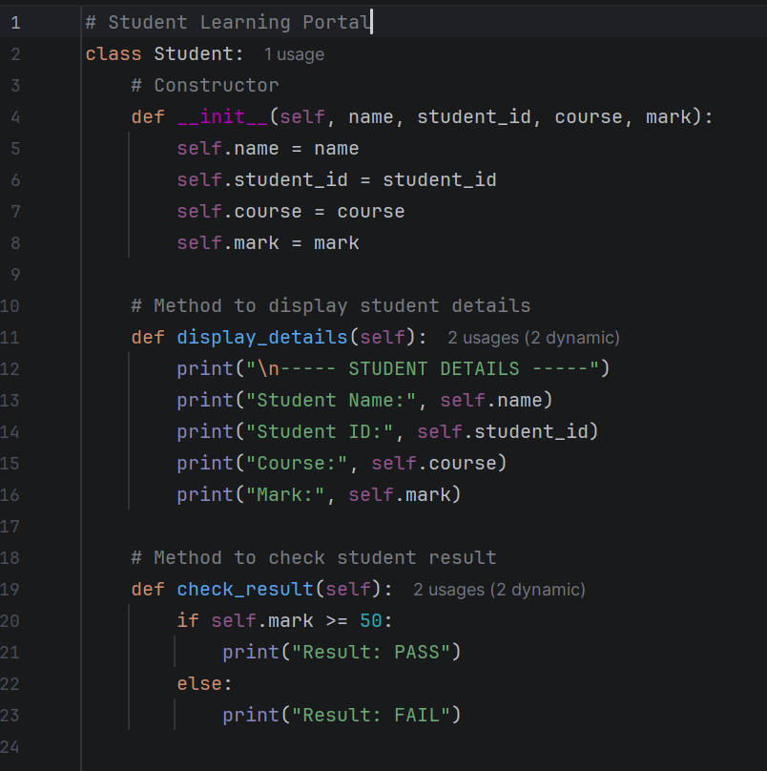
Figure 1: Student class, constructor, and methods for displaying details and checking results.
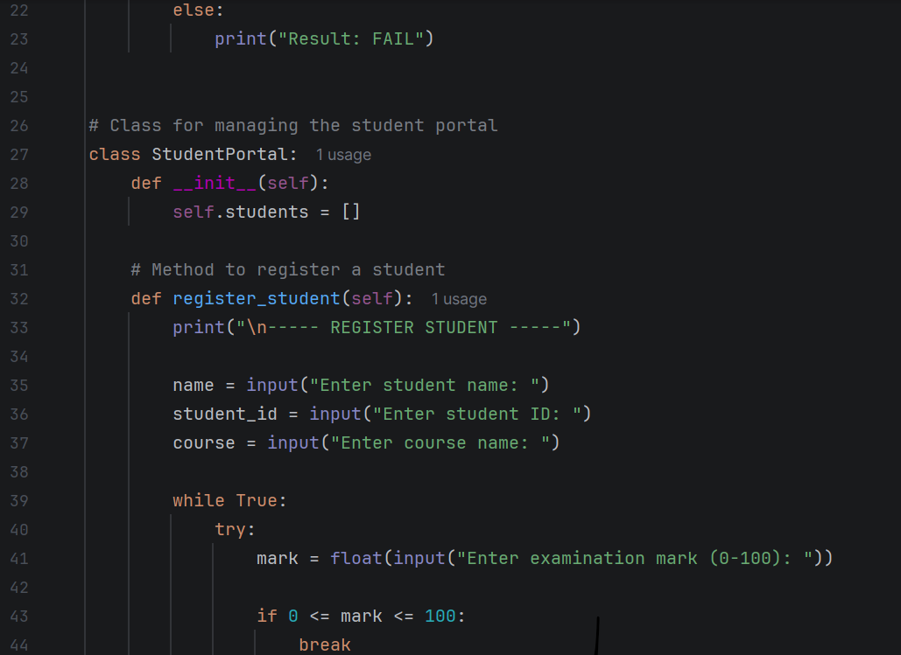
Figure 2: Student portal registration logic and input validation.
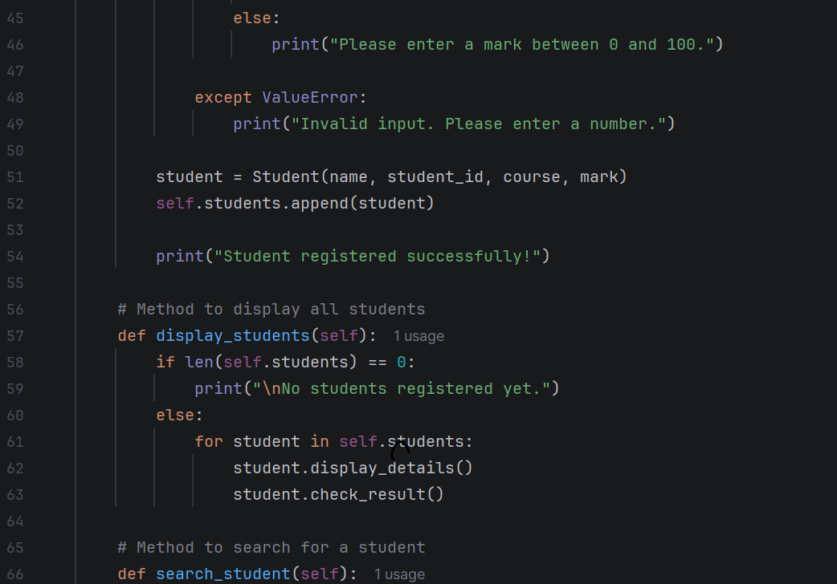
Figure 3: Student registration completion, display logic, and search method.
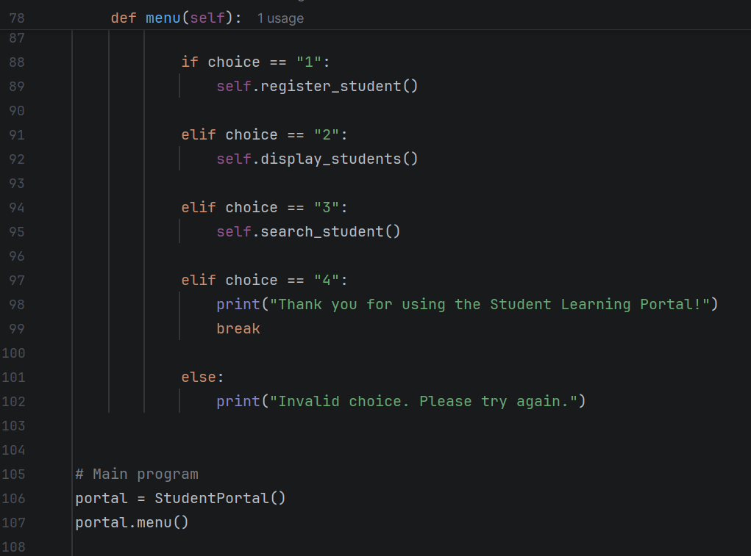
Figure 4: Menu options and main program execution.

Additional Program Screenshots
These photos show the program running in PyCharm.
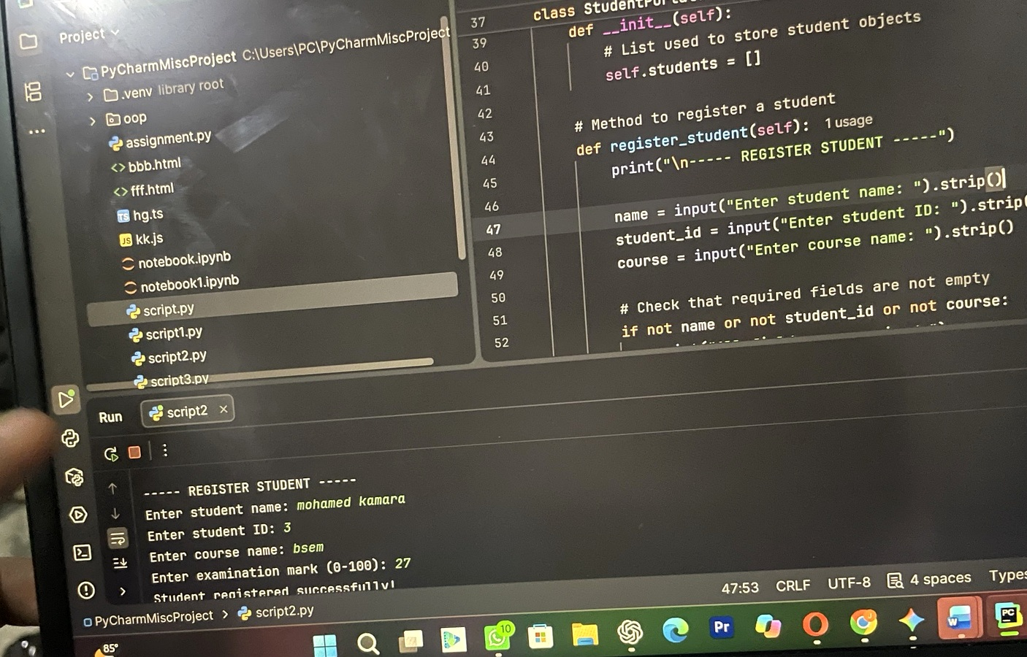
Figure 5: Student registration code and successful registration output.
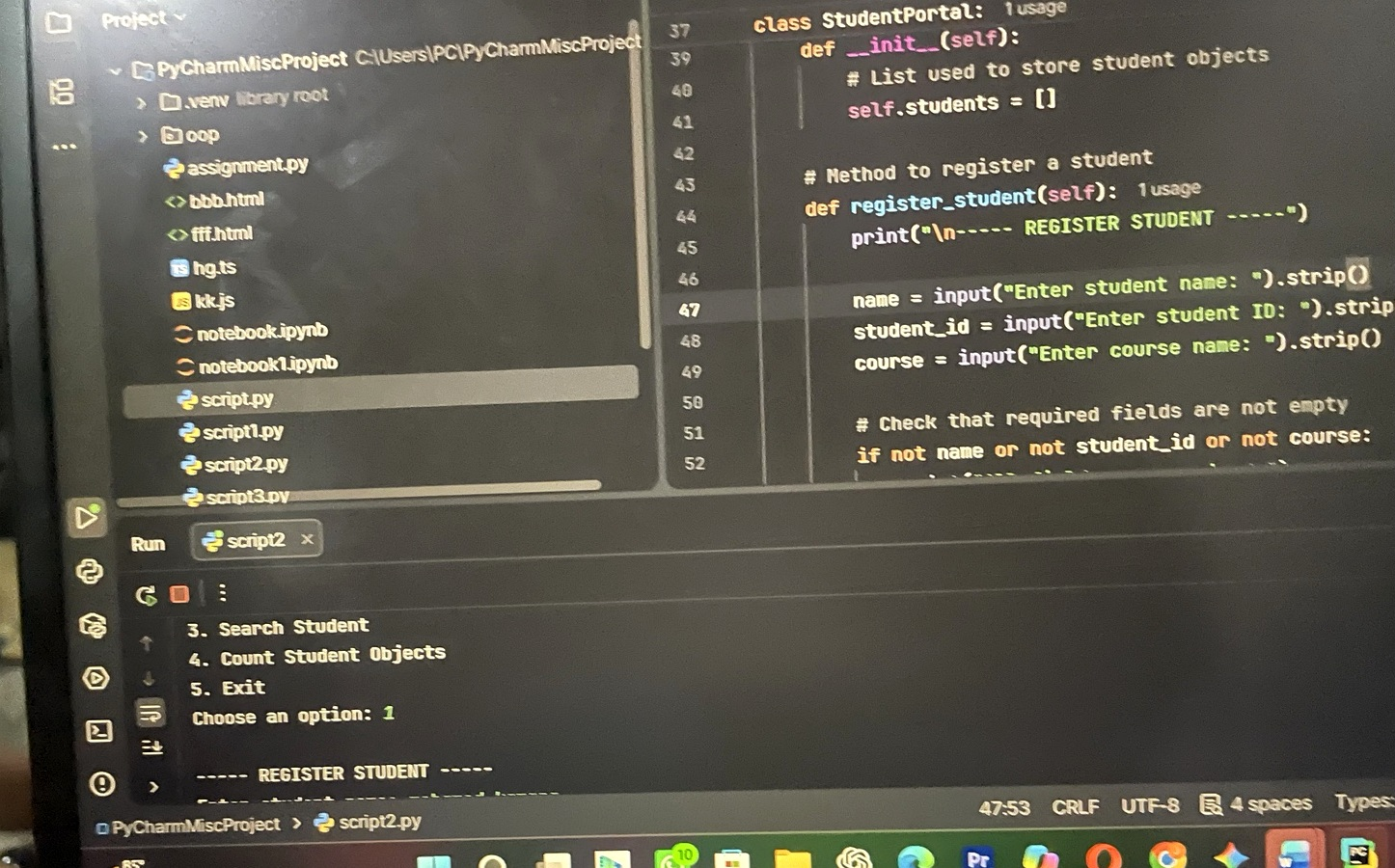
Figure 6: Student Learning Portal menu and registration process.
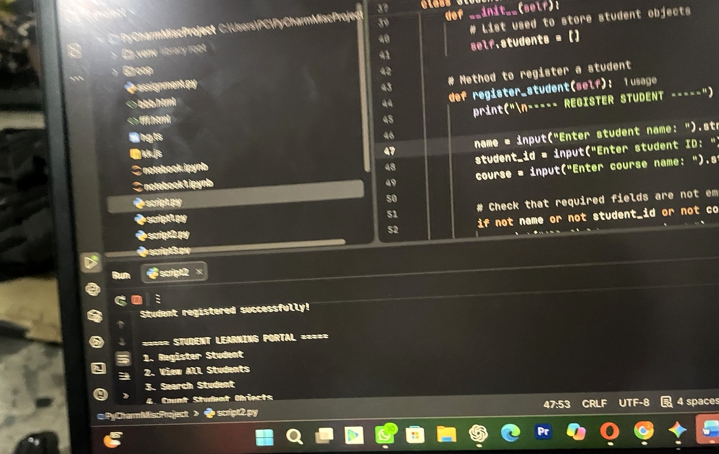
Figure 7: Successful student registration and the main menu.
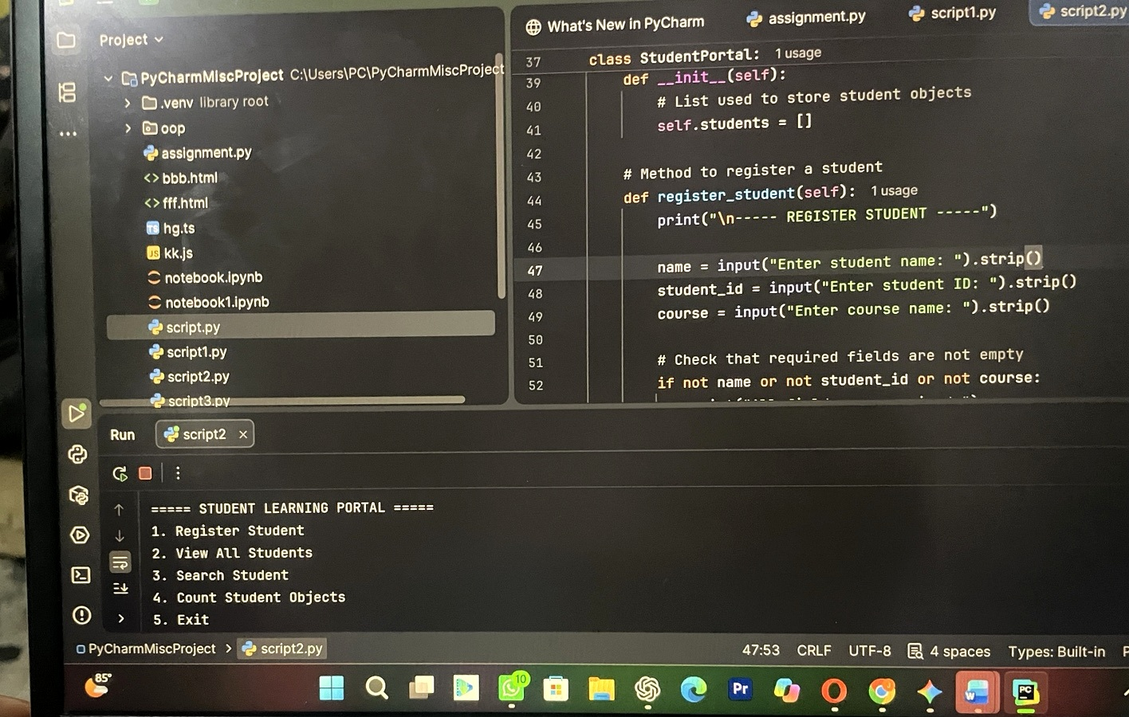
Figure 8: Student Learning Portal menu displayed in PyCharm.

