Multiple Linear versus Second-Degree Polynomial Regression for Estimating Active Caloric Expenditure: A Cross-Validated Comparison
Aneesha K Anil¹, Smitha S¹*
¹ Department of Statistics, Kuriakose Elias College, Mannanam, Kottayam, Kerala 686561, India (affiliated to Mahatma Gandhi University, Kottayam)
* Corresponding author: [email]

Abstract
Background: Accurate estimation of active caloric expenditure supports weight management, exercise prescription and wearable fitness technology. Multiple linear regression (MLR) is widely used for this task but assumes purely linear, additive effects.
Objective: To compare the predictive accuracy of MLR and polynomial regression (PR) for estimating calories burned per exercise session.
Methods: We analysed the publicly available Gym Members Exercise Tracking dataset (n = 973 sessions; 15 predictors after encoding). Body mass index was removed as a deterministic function of weight and height, and multicollinearity was checked with variance inflation factors. Data were split 80/20 into training and test sets and predictors were standardised. Polynomial degree (1–3) was selected by five-fold cross-validation. Models were evaluated on RMSE, MAE, R² and adjusted R². Fold-wise RMSE was compared with a paired t-test after the normality of the paired differences was verified with the Shapiro–Wilk test.
Results: The second-degree polynomial gave the lowest cross-validated error (mean RMSE 28.95 kcal vs 40.11 for degree 1 and 107.61 for degree 3). On the test set, PR reduced RMSE from 40.81 to 24.61 kcal and MAE from 30.39 to 19.44 kcal, and raised R² from 0.9800 to 0.9927. The fold-wise paired differences were consistent with normality (W = 0.874, p = 0.282). PR had significantly lower RMSE than MLR (mean difference 11.15 kcal, 95% CI 7.76–14.55; t(4) = 9.13, p < 0.001).
Conclusion: Second-degree polynomial regression captures curvature and interaction effects that MLR misses and estimates active caloric expenditure more accurately. Session duration was the dominant predictor.
Keywords: caloric expenditure; multiple linear regression; polynomial regression; cross-validation; paired t-test; Shapiro–Wilk test; fitness analytics

1. Introduction
Wearable devices and fitness applications now record heart rate, session duration and body composition at scale. Active caloric expenditure is one of the most used outputs of these systems. It guides weight management, exercise prescription and performance monitoring, so its accuracy matters to users and practitioners.
Multiple linear regression (MLR) is the usual statistical baseline for this task because it is simple and interpretable. It assumes that each predictor acts linearly and additively. Physiological reality is often different: energy cost can depend on interactions between duration, heart rate and fitness level, and on curvature in these effects.
Polynomial regression (PR) relaxes the linearity assumption while staying within the least-squares framework. It adds squared and cross-product terms, so it can represent curvature and pairwise interactions. The cost is many more parameters and a higher risk of overfitting, so model complexity must be chosen on held-out data.
Few studies compare MLR and PR for calorie estimation on the same data with cross-validation and a formal test of the difference, and fewer report whether the assumptions of that test hold. This study addresses that gap. Its objectives are to:
- build MLR and PR models of calories burned per session from demographic, physiological and behavioural predictors;
- select the polynomial degree by five-fold cross-validation;
- compare the models on RMSE, MAE, R² and adjusted R² on a held-out test set; and
- test whether the fold-wise difference in RMSE is statistically significant with a paired t-test, after checking the normality of the paired differences.
The hypotheses are H₀: the mean fold-wise RMSE difference between MLR and PR is zero, and H₁: it is not zero (α = 0.05).

2. Related Work
The energy cost of physical activity has traditionally been expressed through metabolic equivalents (METs). The Compendium of Physical Activities assigns MET values by activity type and intensity [1]. MET-based estimates do not use individual heart-rate or body-composition data, which motivates data-driven regression models.
Linear regression theory, its assumptions and diagnostics are well established [2, 6, 7, 9, 10]. Standard texts discuss polynomial terms for representing curvature and interactions, and warn that higher-order terms inflate variance and multicollinearity [2, 7]. Variance inflation factors are the usual diagnostic for collinearity, with values above 5–10 treated as problematic [4, 6].
Resampling methods such as k-fold cross-validation give a less biased estimate of out-of-sample error than a single split and are the standard tool for choosing model complexity, including polynomial degree [5]. Comparing two models on the same folds yields paired error estimates. A paired t-test on those estimates assumes the differences are approximately normal, which should be checked before the test is interpreted [3, 11].

3. Materials and Methods

3.1 Data
We used the Gym Members Exercise Tracking dataset, publicly available on Kaggle [URL]. It contains 973 sessions and 15 variables, with no missing values and no duplicate records. The response is calories burned per session (kcal). The sample comprises 511 males and 462 females, and four workout types (Strength 258, Cardio 255, Yoga 239, HIIT 221). Table 1 lists the variables.
Table 1. Variables in the dataset.
Variable | Description | Type
Age | Age of the participant (years) | Numerical
Gender | Male = 1, Female = 0 | Binary
Weight | Body weight (kg) | Numerical
Height | Height (m) | Numerical
Max_BPM | Maximum heart rate during session (bpm) | Numerical
Avg_BPM | Average heart rate during session (bpm) | Numerical
Resting_BPM | Resting heart rate (bpm) | Numerical
Session_Duration | Duration of session (h) | Numerical
Workout_Type | Cardio, HIIT, Strength, Yoga | Categorical
Fat_Percentage | Body fat (%) | Numerical
Water_Intake | Daily water intake (L) | Numerical
Workout_Frequency | Sessions per week | Numerical
Experience_Level | Fitness experience (1–3) | Ordinal
BMI | Body mass index (kg/m²) | Removed
Calories_Burned | Energy expended in session (kcal) | Response

3.2 Pre-processing
Gender was coded as a binary indicator. Workout_Type was dummy-coded with Cardio as the reference category, giving HIIT, Strength and Yoga indicators. BMI was dropped because it is a deterministic function of weight and height (BMI = weight/height²) and would add redundant collinearity. This left 15 predictors.
Multicollinearity was assessed with variance inflation factors, VIFⱼ = 1/(1 − Rⱼ²), where Rⱼ² comes from regressing predictor j on all others. VIF < 5 was taken as acceptable and VIF ≥ 10 as severe.
The data were split at random into a training set (80%, n = 778) and a test set (20%, n = 195) with a fixed seed (42). Predictors were standardised to zero mean and unit variance using training-set statistics only, so no test information entered model fitting.

3.3 Models
The MLR model is
Y = β₀ + Σⱼ βⱼ Xⱼ + ε, j = 1, …, p
The second-degree polynomial model adds all squared and pairwise interaction terms:
Y = β₀ + Σⱼ βⱼ Xⱼ + Σⱼ Σₖ≥ⱼ βⱼₖ Xⱼ Xₖ + ε
With p = 15 this gives 135 terms (15 linear, 15 squared and 105 interactions). Because the squares of binary predictors and the products of mutually exclusive workout-type indicators are exact linear functions of other columns, the degree-2 design has rank 127. Both models were therefore fitted by least squares using the minimum-norm solution, which gives unique predictions. The polynomial degree was chosen from {1, 2, 3} as the one with the lowest mean five-fold cross-validated RMSE on the training set.

3.4 Evaluation metrics
Models were evaluated on the test set with
RMSE = √[ (1/n) Σᵢ (yᵢ − ŷᵢ)² ], MAE = (1/n) Σᵢ |yᵢ − ŷᵢ|
R² = 1 − SS_res / SS_tot, Adjusted R² = 1 − (1 − R²)(n − 1)/(n − p − 1)
where n is the test-set size and p the number of model terms. Normality of the MLR test-set residuals was checked with the Shapiro–Wilk test and a normal Q–Q plot.

3.5 Cross-validation and statistical comparison
Both models were refitted in five-fold cross-validation on the training set, using the same shuffled folds (seed 42) for each model. This yields paired RMSE values for folds k = 1, …, 5 and the paired differences
dₖ = RMSEₖ(MLR) − RMSEₖ(PR), k = 1, …, 5
Normality of the paired differences. The paired t-test assumes that the dₖ come from a normal distribution. We tested H₀: the differences are normally distributed against H₁: they are not, with the Shapiro–Wilk test at α = 0.05, and inspected a normal Q–Q plot of the differences. Because five differences give the test low power, we also report the exact Wilcoxon signed-rank test as a distribution-free check.
Paired t-test. When normality was not rejected, the mean difference was tested with
t = d̄ / (s_d / √K), df = K − 1 = 4
where d̄ and s_d are the mean and standard deviation of the dₖ. We report the 95% confidence interval for the mean difference and the standardised effect size d_z = d̄ / s_d.

3.6 Software
All analyses were run in Python 3.11 with pandas 3.0.6, NumPy 2.4.6, scikit-learn 1.9.1, statsmodels 0.15.0, SciPy 1.17.1, Matplotlib 3.11.2 and seaborn 0.13.2. The complete code is given in Appendix A.

4. Results

4.1 Descriptive and exploratory analysis
Mean calories burned was 905.42 kcal per session (SD 272.64), with an approximately symmetric, unimodal distribution (Figure 1). Mean session duration was 1.26 h (SD 0.34). Table 2 summarises the numerical variables.
Table 2. Descriptive statistics of numerical variables (n = 973).
Variable | Mean | SD
Age (years) | 38.68 | 12.18
Weight (kg) | 73.85 | 21.21
Height (m) | 1.72 | 0.13
Max_BPM (bpm) | 179.88 | 11.53
Avg_BPM (bpm) | 143.77 | 14.35
Resting_BPM (bpm) | 62.22 | 7.33
Session_Duration (h) | 1.26 | 0.34
Fat_Percentage (%) | 24.98 | 6.26
Water_Intake (L) | 2.63 | 0.60
Workout_Frequency (days/week) | 3.32 | 0.91
Experience_Level | 1.81 | 0.74
Calories_Burned (kcal) | 905.42 | 272.64

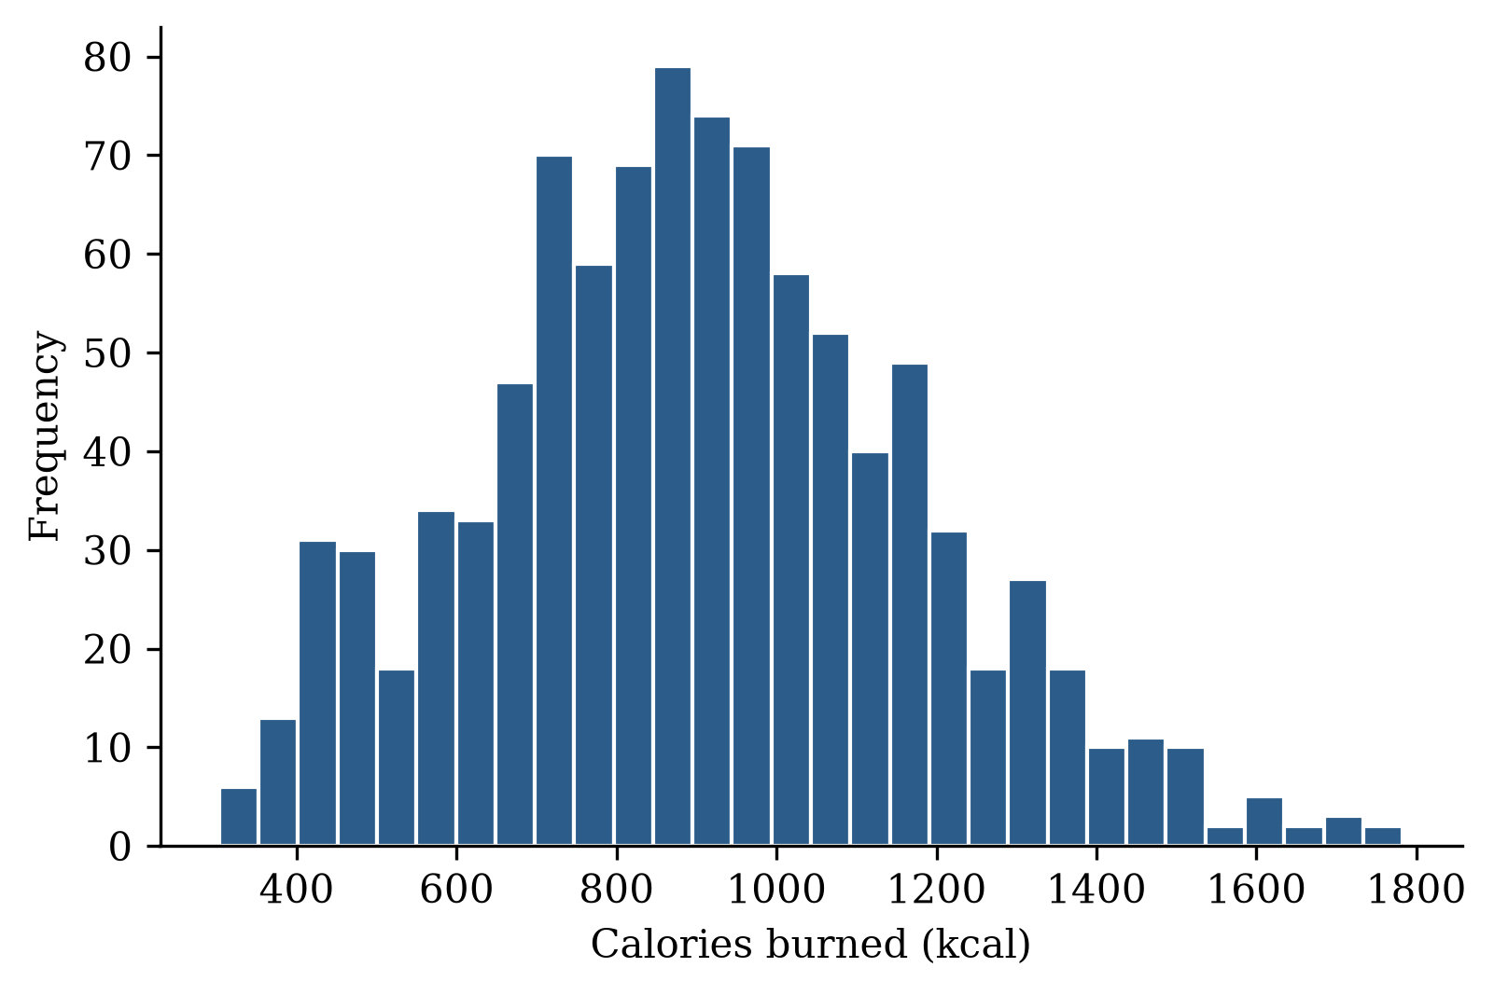
Figure 1. Distribution of calories burned per session (n = 973).
Session duration had the strongest correlation with calories burned (r = 0.908; Figure 2), followed by experience level (r = 0.694), fat percentage (r = −0.598), workout frequency (r = 0.576), water intake (r = 0.357) and average heart rate (r = 0.340). Workout-type indicators and maximum and resting heart rate were almost uncorrelated with the response (|r| < 0.05). Figure 3 shows the full correlation matrix.
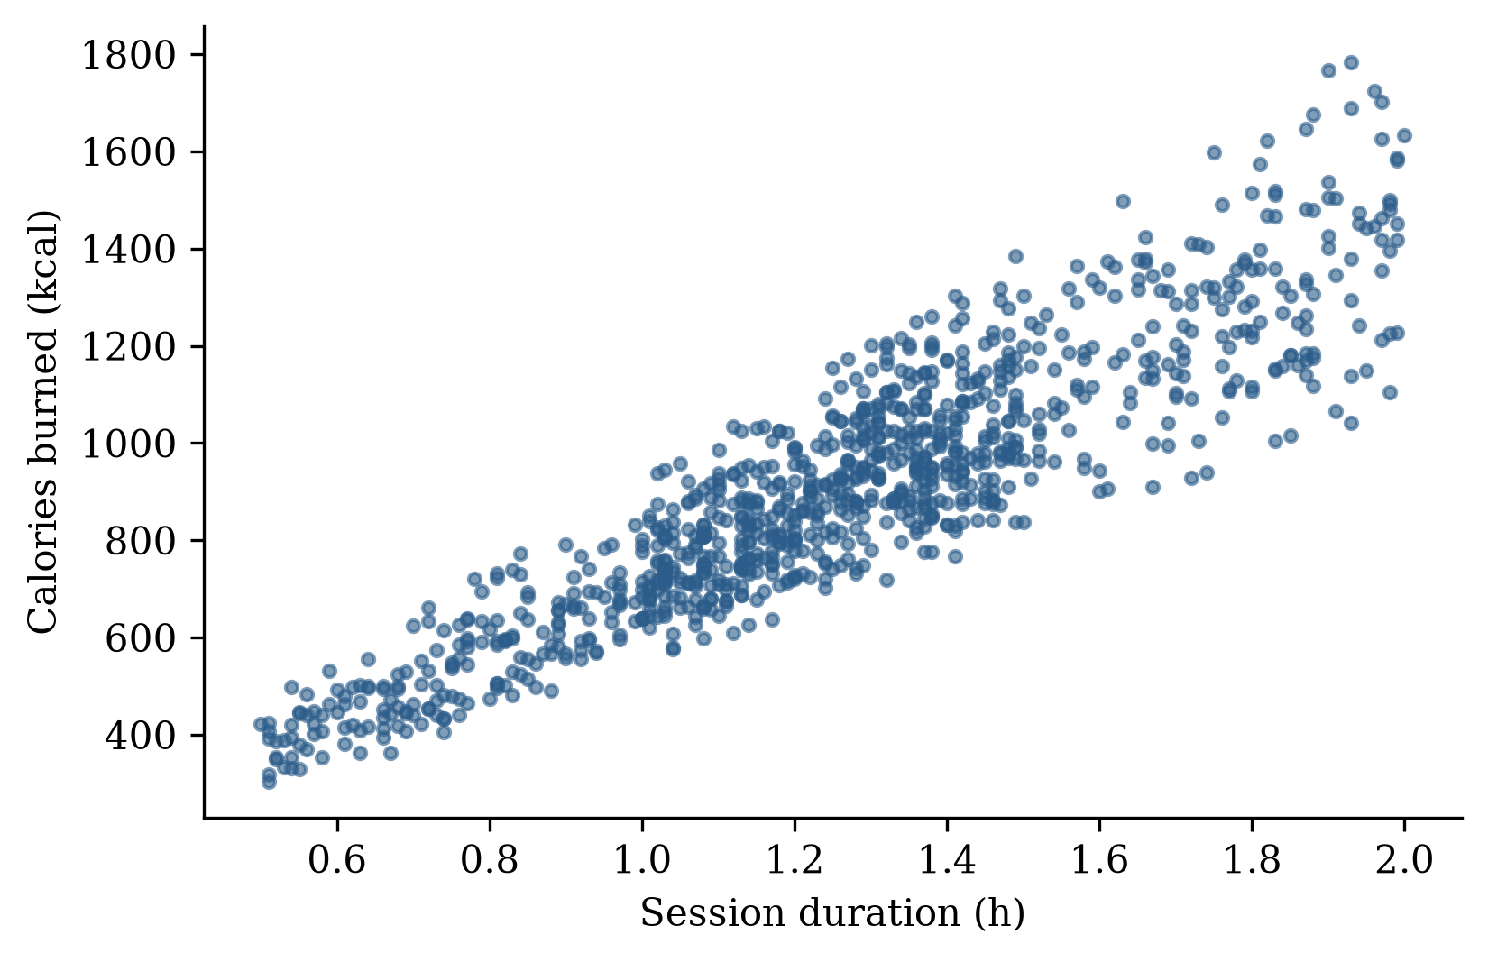
Figure 2. Session duration versus calories burned.
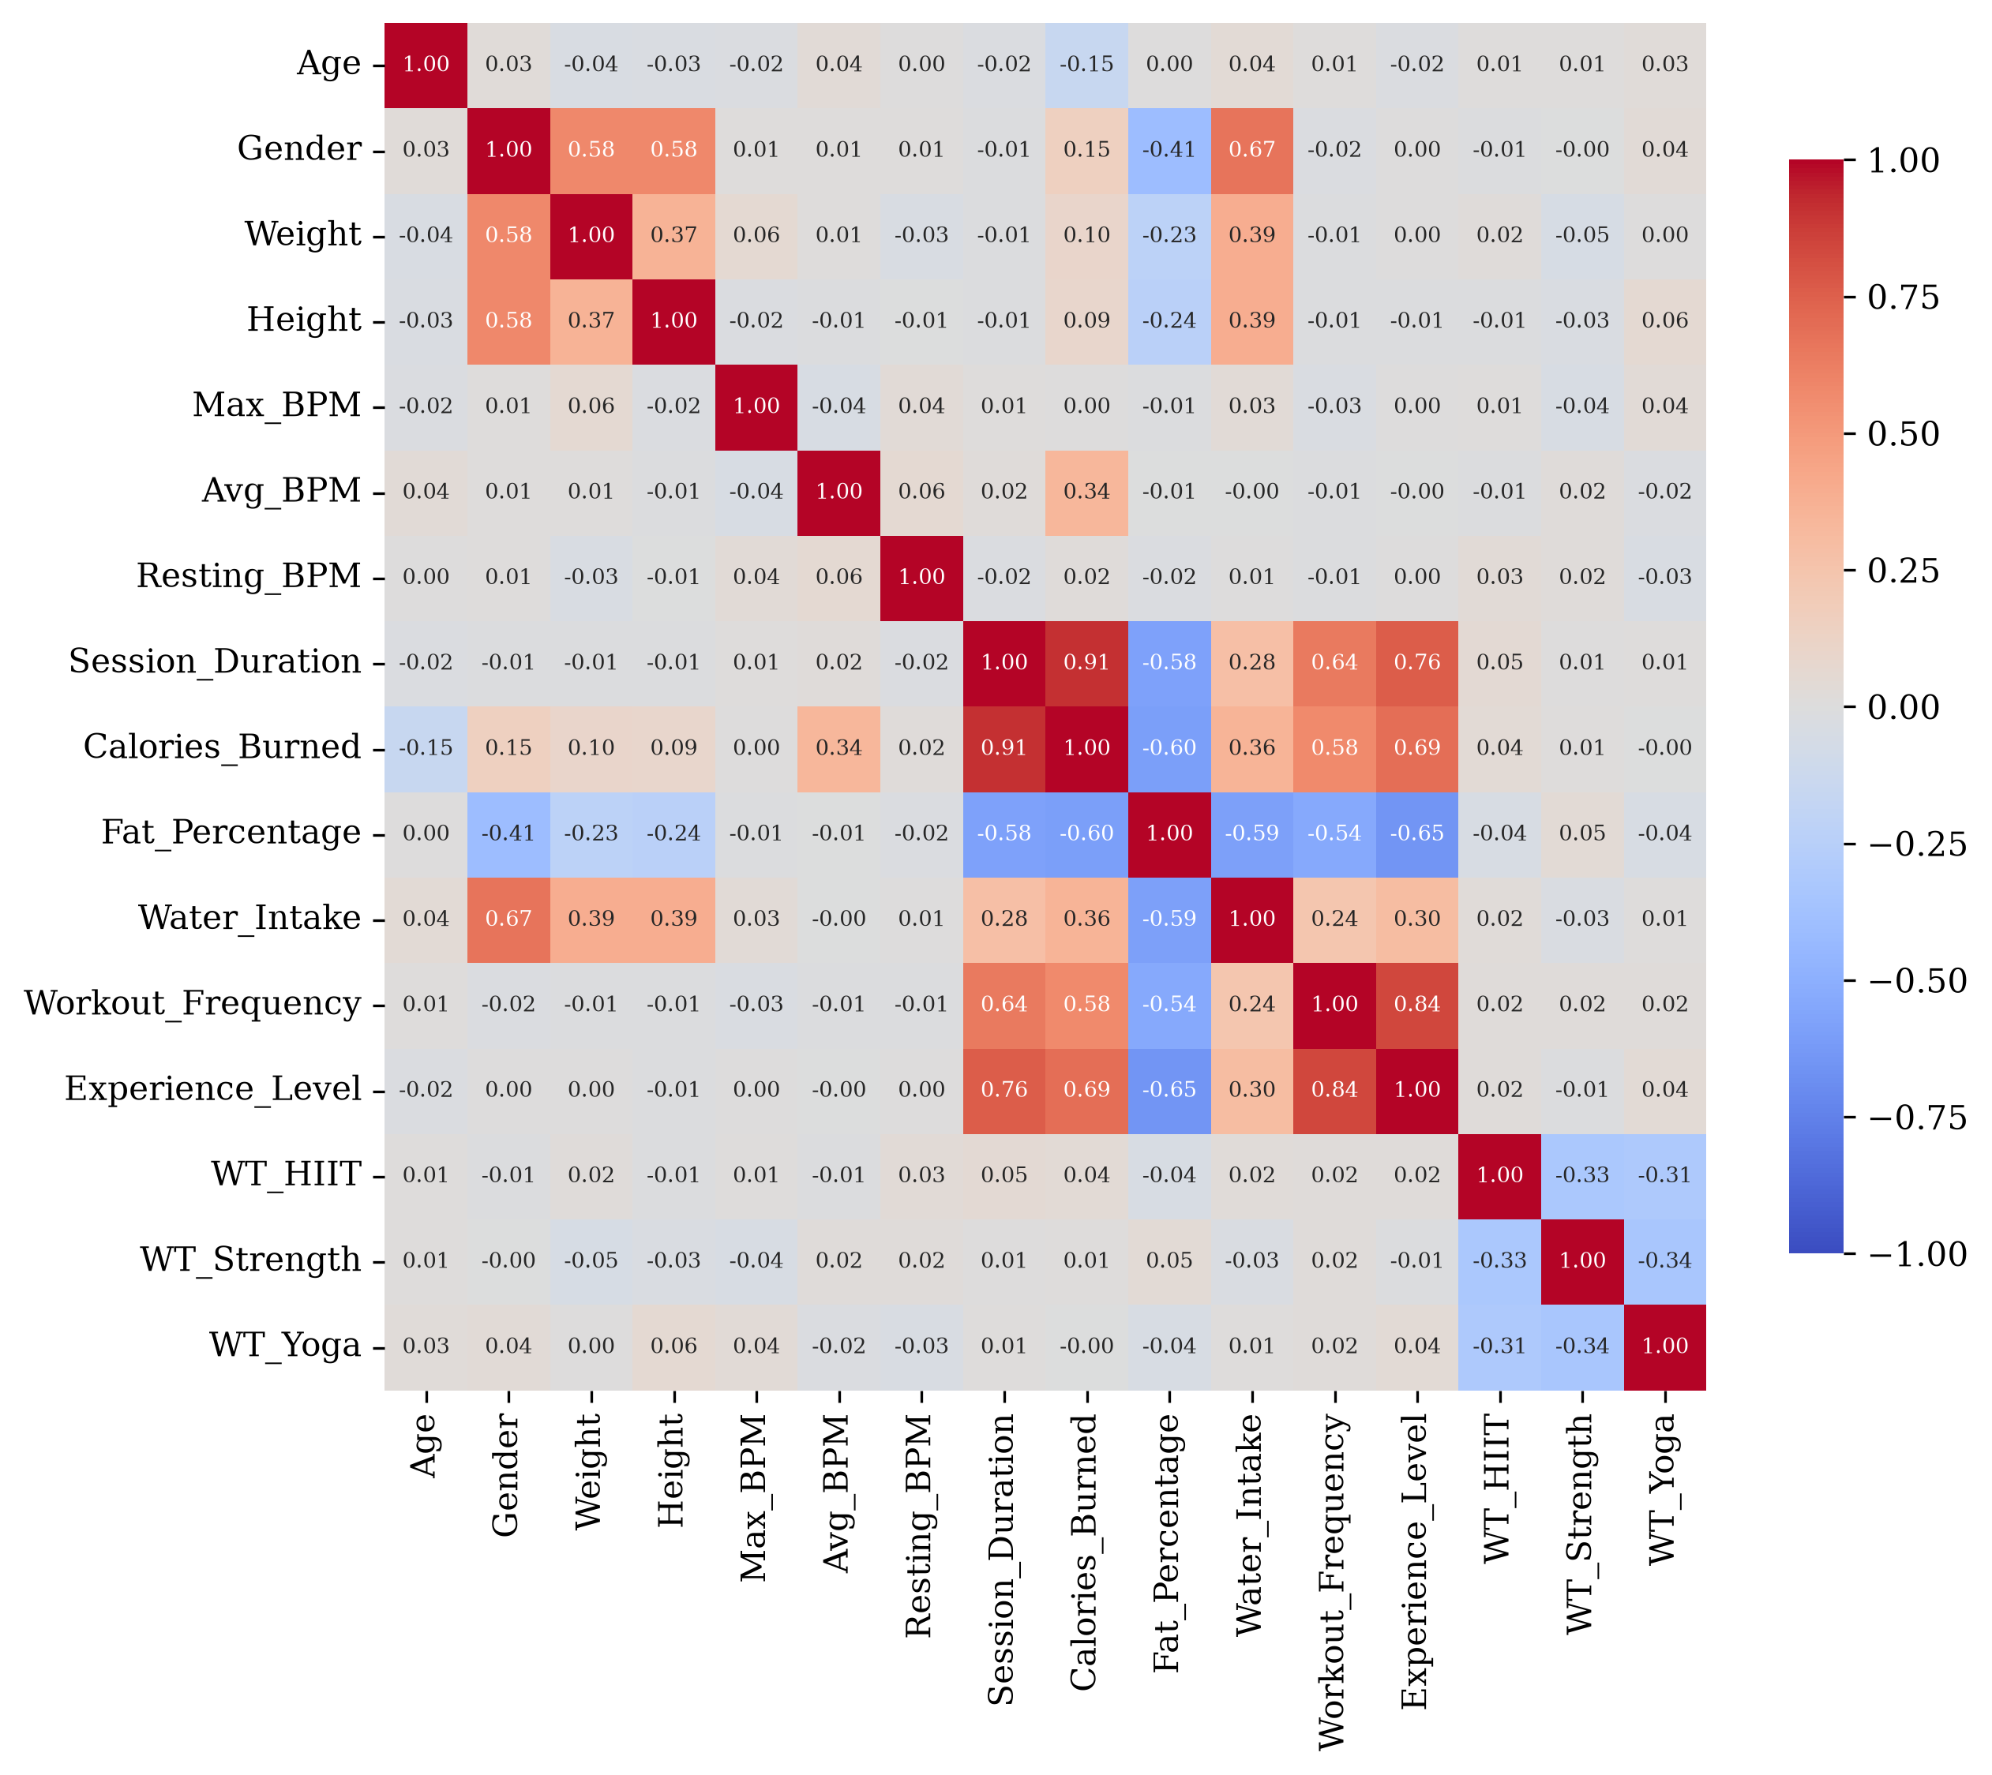
Figure 3. Pearson correlation matrix of all variables after encoding (WT = Workout_Type).

4.2 Multicollinearity
All VIFs were below 10 (Table 3). Only experience level exceeded 5 (VIF = 5.41), reflecting its correlation with workout frequency (r = 0.84) and session duration (r = 0.76). The other values ranged from 1.01 to 3.38, so no predictor was removed.
Table 3. Variance inflation factors.
Variable | VIF
Experience_Level | 5.41
Workout_Frequency | 3.38
Gender | 3.15
Fat_Percentage | 2.76
Session_Duration | 2.56
Water_Intake | 2.37
Weight | 1.53
Height | 1.53
Workout_Type_Strength | 1.50
Workout_Type_Yoga | 1.48
Workout_Type_HIIT | 1.45
Age | 1.02
Max_BPM | 1.02
Resting_BPM | 1.01
Avg_BPM | 1.01

4.3 Multiple linear regression
On standardised predictors, session duration had by far the largest coefficient (240.00 kcal per SD), followed by average heart rate (88.64), gender (42.22) and age (−40.13). All other coefficients were below 5 kcal per SD in absolute value (Table 4).
Table 4. MLR coefficients on standardised predictors, ordered by absolute size.
Predictor | Coefficient (kcal per SD)
Session_Duration | 240.00
Avg_BPM | 88.64
Gender (male) | 42.22
Age | −40.13
Resting_BPM | 4.44
Fat_Percentage | −3.86
Workout_Type_Yoga | −3.69
Workout_Frequency | 3.68
Experience_Level | −2.50
Water_Intake | −2.16
Workout_Type_HIIT | −1.98
Weight | 1.67
Workout_Type_Strength | −1.53
Height | 1.42
Max_BPM | 1.27

The MLR test-set residuals departed slightly from normality (Shapiro–Wilk W = 0.983, p = 0.016; n = 195), with some curvature visible against the fitted values (Figure 4). This pattern indicates nonlinearity that the linear model does not capture. It does not bias the least-squares predictions, and the model comparison below does not rely on residual normality.
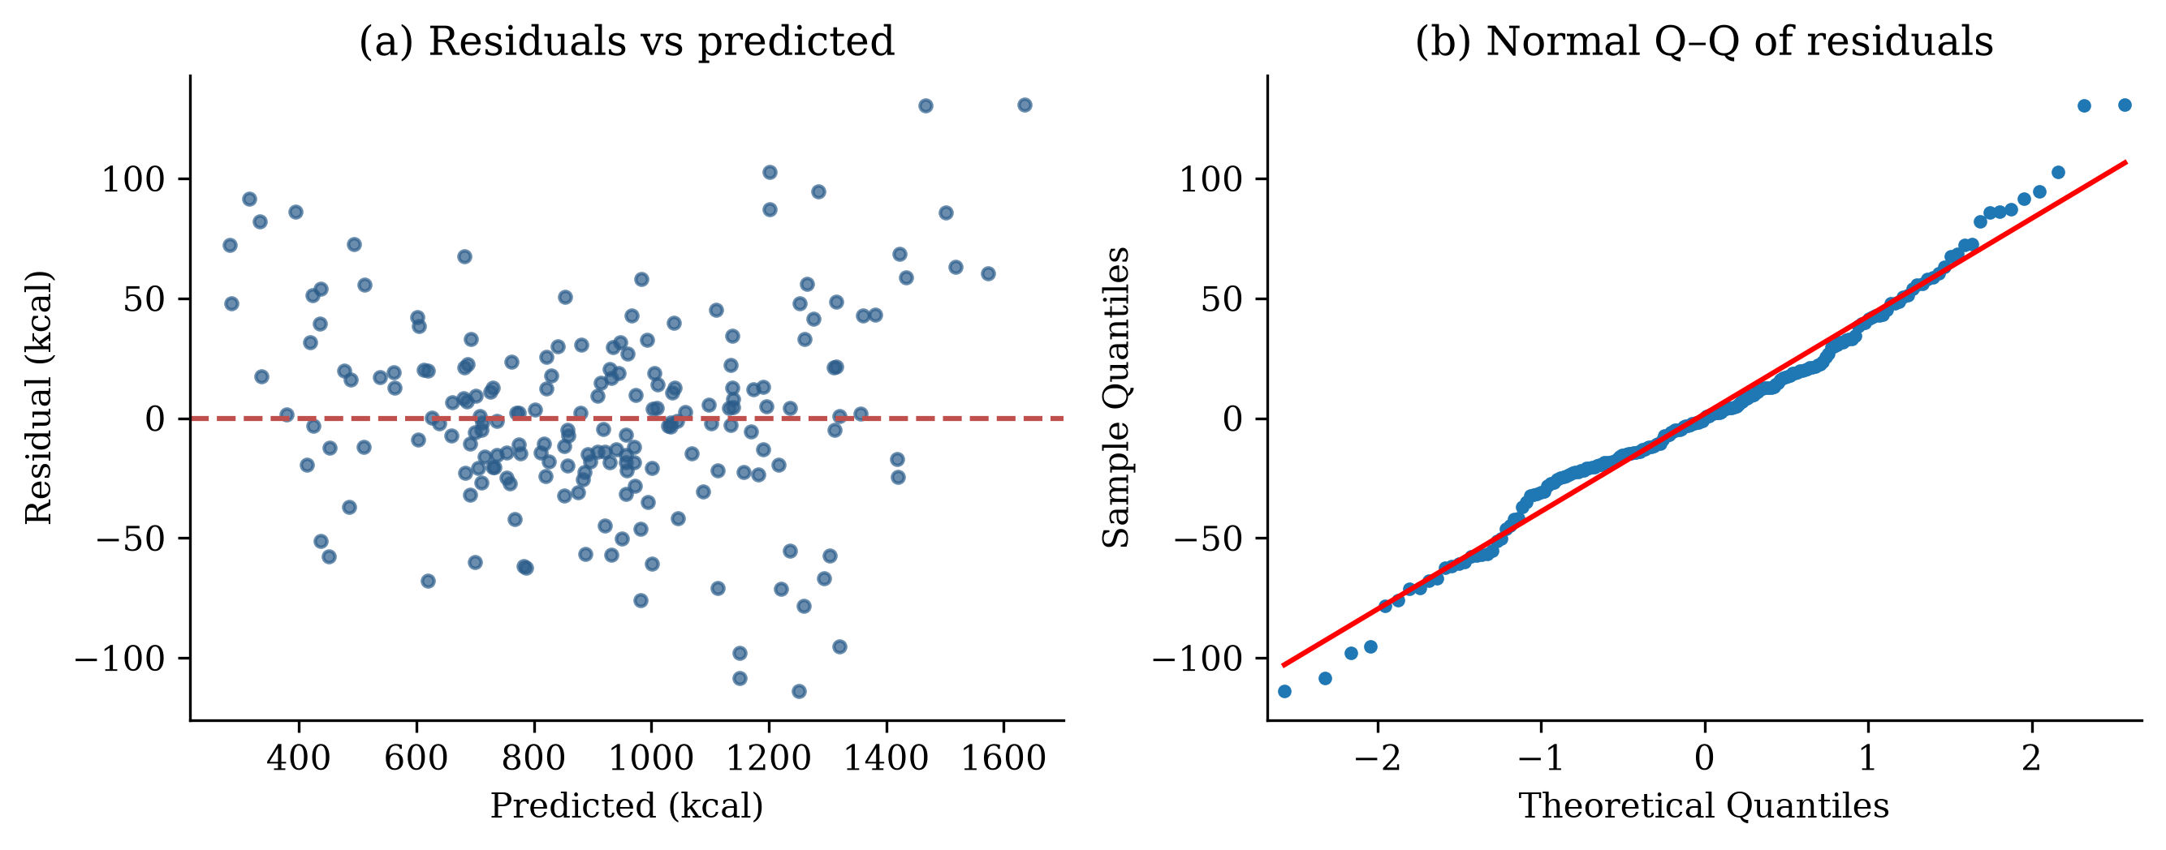
Figure 4. MLR test-set residuals: (a) residuals versus predicted values; (b) normal Q–Q plot.

4.4 Polynomial degree selection
The second-degree model gave the lowest cross-validated error (Table 5, Figure 5). Moving to degree 3 increased mean RMSE almost fourfold, a clear sign of overfitting with 815 terms and about 622 training rows per fold.
Table 5. Five-fold cross-validated RMSE by polynomial degree (training set, n = 778).
Degree | Terms | Mean CV RMSE (kcal) | SD (kcal)
1 | 15 | 40.11 | 3.05
2 | 135 | 28.95 | 1.37
3 | 815 | 107.61 | 9.09
SD is the population standard deviation of the five fold RMSEs.
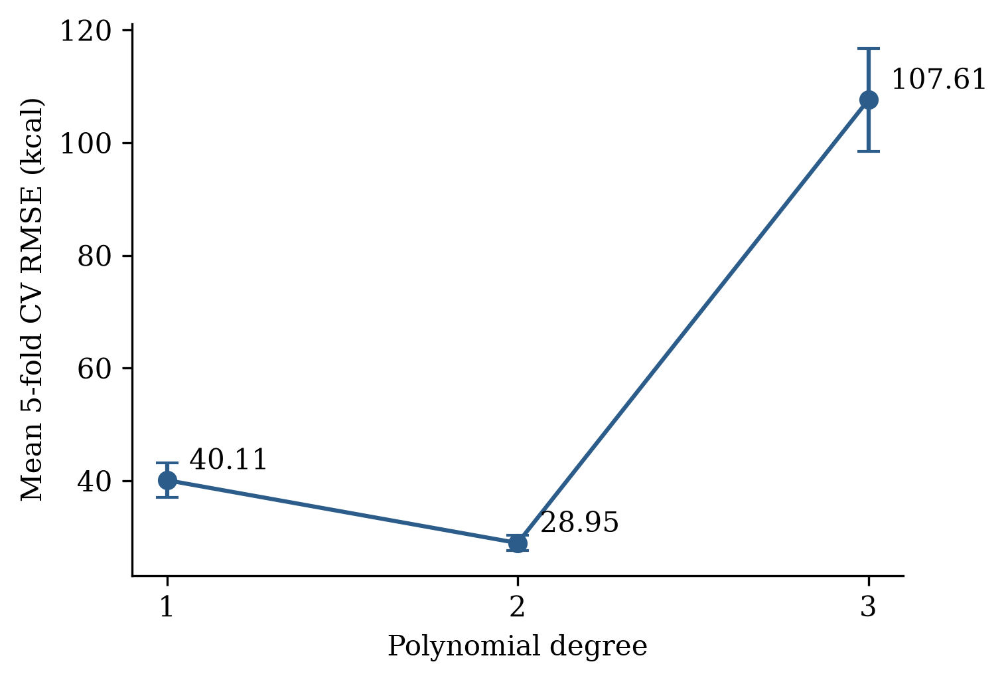
Figure 5. Mean five-fold cross-validated RMSE by polynomial degree (error bars: ±1 SD).

4.5 Test-set performance
The degree-2 PR model reduced test RMSE by 39.7% and MAE by 36.0% compared with MLR (Table 6). Predictions from PR lie closer to the identity line across the full range of calories burned (Figure 6). Adjusted R² was slightly lower for PR because it penalises the 135 terms against only 195 test observations.
Table 6. Test-set performance (n = 195).
Metric | MLR | PR (degree 2)
RMSE (kcal) | 40.81 | 24.61
MAE (kcal) | 30.39 | 19.44
R² | 0.9800 | 0.9927
Adjusted R² | 0.9784 | 0.9761

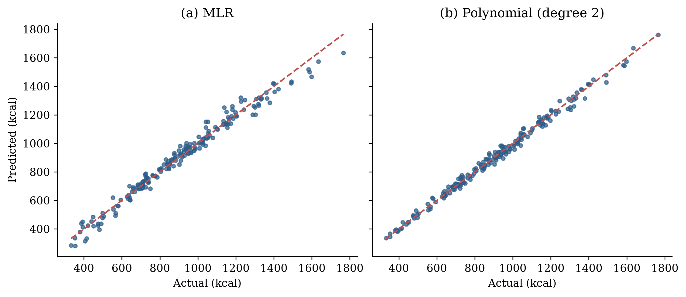
Figure 6. Actual versus predicted calories burned on the test set: (a) MLR; (b) degree-2 polynomial regression. Dashed line: perfect prediction.

4.6 Cross-validated comparison
PR had lower RMSE than MLR in every fold (Table 7, Figure 7). The paired differences ranged from 8.41 to 14.28 kcal.
Table 7. Fold-wise RMSE and paired differences dₖ = MLR − PR (kcal).
Fold | MLR RMSE | PR RMSE | Difference dₖ
1 | 37.89 | 29.48 | 8.41
2 | 42.89 | 28.61 | 14.28
3 | 35.17 | 26.71 | 8.46
4 | 42.10 | 30.93 | 11.17
5 | 42.48 | 29.03 | 13.46
Mean (SD) | 40.11 (3.42) | 28.95 (1.53) | 11.15 (2.73)
SD in the last row is the sample standard deviation (n − 1).
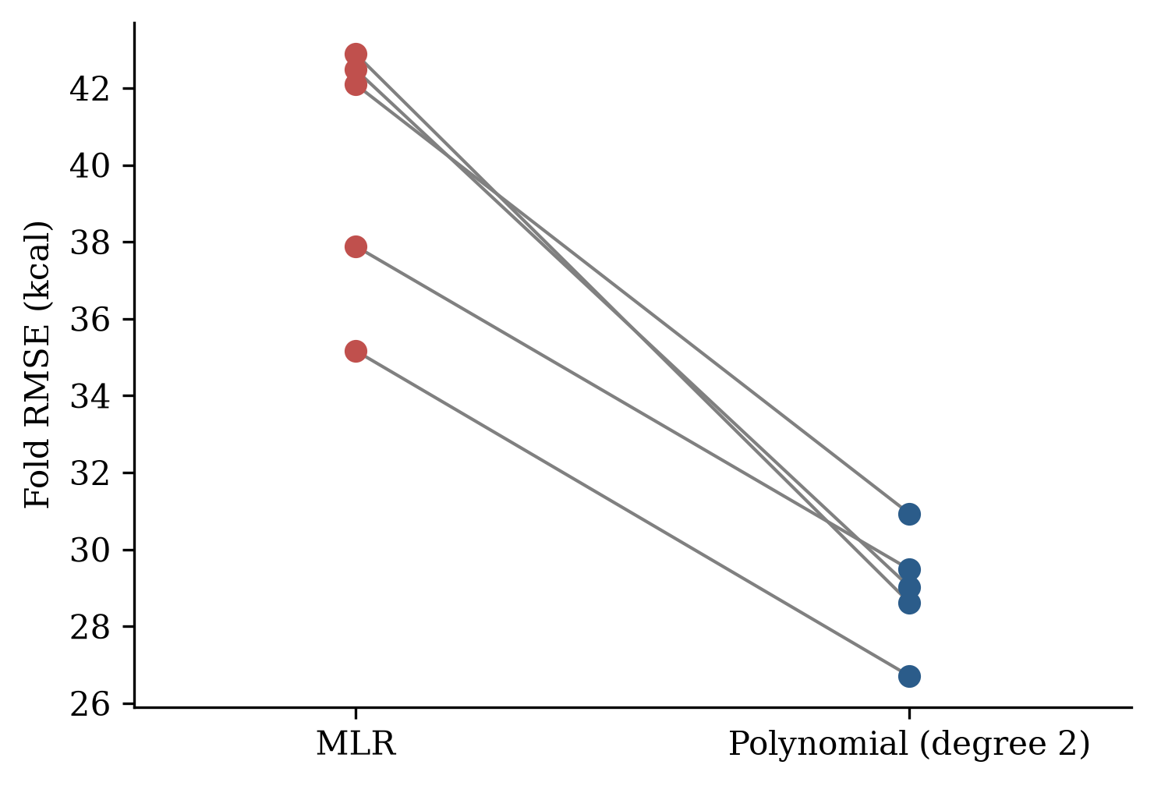
Figure 7. Fold-wise RMSE of MLR and polynomial regression; lines join the same fold.

4.7 Normality of the paired differences
The paired differences were consistent with a normal distribution (Shapiro–Wilk W = 0.874, p = 0.282 > 0.05; Table 8). The null hypothesis of normality was therefore not rejected, and the paired t-test is appropriate. The Q–Q plot showed no marked departure from the reference line (Figure 8), and no difference was an outlier: all five lay within ±1.15 SD of their mean.
Table 8. Shapiro–Wilk test of normality on the paired RMSE differences.
Statistic | Value
Number of differences (K) | 5
Shapiro–Wilk W | 0.874
p-value | 0.282
Decision (α = 0.05) | Normality not rejected

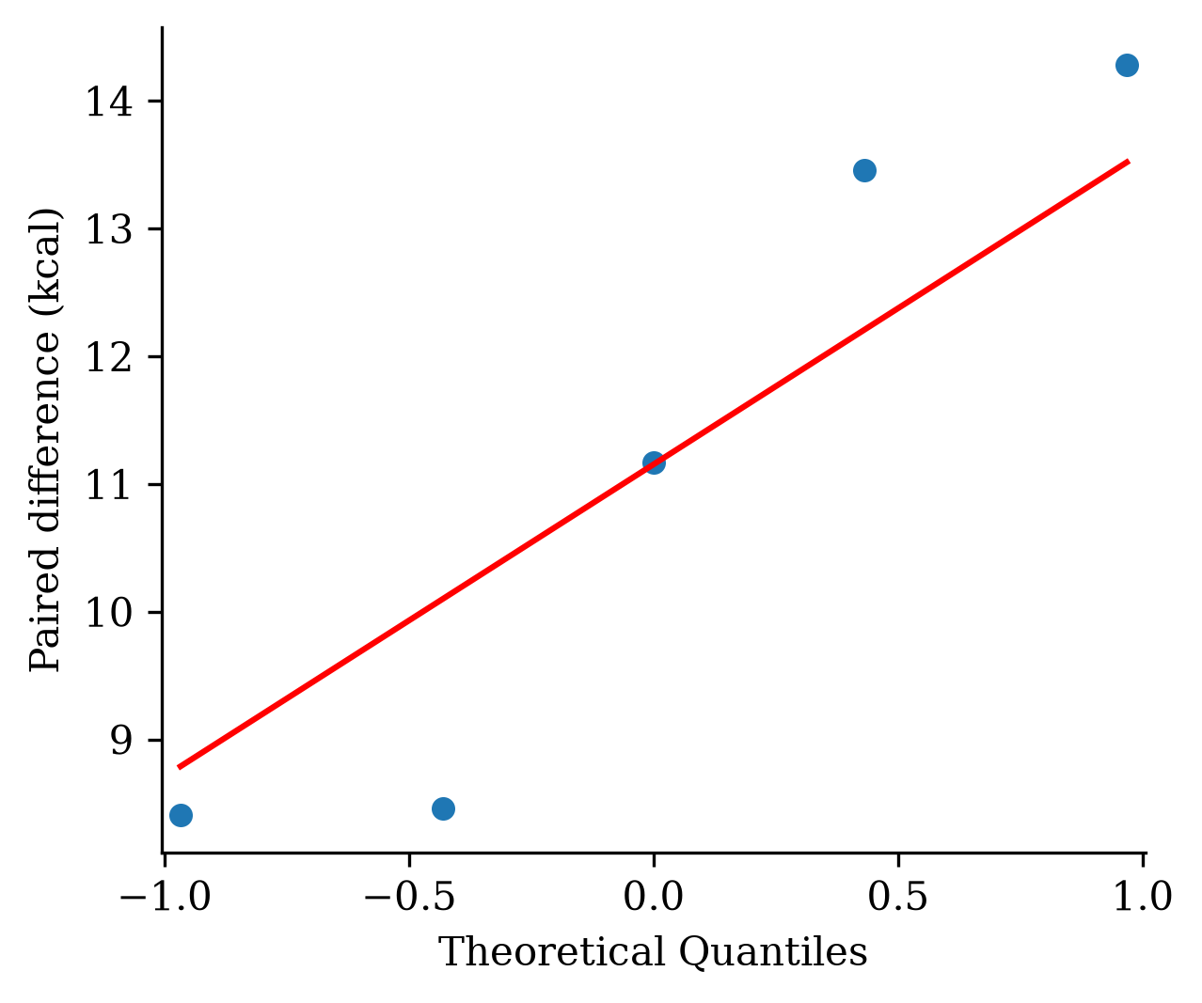
Figure 8. Normal Q–Q plot of the five paired RMSE differences (MLR − PR).

4.8 Paired t-test
The mean RMSE of PR was significantly lower than that of MLR (t(4) = 9.13, p = 0.0008; Table 9). The mean difference was 11.15 kcal (95% CI 7.76 to 14.55), and the standardised effect was very large (d_z = 4.08). The null hypothesis of equal predictive accuracy was rejected.
Table 9. Paired t-test on fold-wise RMSE (MLR − PR).
Statistic | Value
Mean difference d̄ (kcal) | 11.15
SD of differences (kcal) | 2.73
t (df = 4) | 9.13
p-value (two-sided) | 0.0008
95% CI of mean difference (kcal) | 7.76 to 14.55
Effect size d_z | 4.08

The exact Wilcoxon signed-rank test agreed in direction: PR was better in all five folds (W = 0, p = 0.0625). This p-value is the smallest two-sided value the test can produce with five pairs, so it cannot fall below 0.05 for any data with K = 5. Because normality of the differences was not rejected, the paired t-test is the primary result.

5. Discussion
Second-degree polynomial regression estimated active caloric expenditure more accurately than MLR. It cut test RMSE from 40.81 to 24.61 kcal and was better in all five cross-validation folds. The fold-wise gain of 11.15 kcal was statistically significant, and the paired differences met the normality assumption of the t-test, so this inference is valid.
The gain shows that caloric expenditure is not purely additive in its predictors. Energy cost depends on how long and how hard a person exercises together, which the polynomial model can represent through duration × heart-rate and squared terms, whereas MLR can only add the two effects. The curvature in the MLR residuals (Figure 4a) points the same way. The large positive MLR coefficients for session duration and average heart rate agree with the physiology of energy expenditure and with MET-based approaches [1].
The degree-selection results illustrate the bias–variance trade-off. Degree 2 reduced error, whereas degree 3, with 815 terms for about 622 training rows per fold, overfitted badly. Choosing complexity by cross-validation rather than by training fit was therefore essential.
Some exploratory correlations did not carry over to the multivariable model. Experience level and fat percentage were strongly correlated with calories burned but had small MLR coefficients. This is consistent with their correlation with session duration and workout frequency (VIF up to 5.41): once duration is in the model, they add little unique information.
Adjusted R² was slightly lower for PR (0.9761 vs 0.9784) even though its test RMSE was much lower. Adjusted R² here is computed on the test set with 135 terms against 195 observations, so its penalty is heavy. Out-of-sample RMSE and MAE are the more relevant measures of predictive accuracy.

5.1 Limitations
- Single dataset. All results come from one public dataset of 973 sessions whose collection protocol and calorie measurement method are not documented, so external validity is unknown.
- Few folds for the test. The paired t-test rests on K = 5 differences. The Shapiro–Wilk test has low power at this size, so passing it is weak evidence of normality. Fold RMSEs also share training data, which can make the t-test somewhat liberal [11]. Repeated cross-validation with a corrected resampled t-test would give a more robust comparison.
- Interpretability. The 135-term polynomial model is harder to interpret than MLR.
- Model scope. Regularised regression (ridge, lasso) and machine-learning methods such as random forests or gradient boosting were not compared.
- Residual normality. MLR test residuals deviated slightly from normality (p = 0.016). This affects inference on individual coefficients, not the predictive comparison.

6. Conclusion
A second-degree polynomial regression model estimated active caloric expenditure more accurately than multiple linear regression. Test RMSE fell from 40.81 to 24.61 kcal, and the polynomial model was better in every cross-validation fold. The paired RMSE differences were consistent with normality (Shapiro–Wilk p = 0.282), and the paired t-test confirmed a significant mean gain of 11.15 kcal (p < 0.001).
Session duration was the dominant predictor, followed by average heart rate. Calorie-estimation tools in fitness applications and wearables could gain accuracy by modelling interactions and curvature among these predictors instead of relying on a purely linear model. Because a third-degree model overfitted, model complexity should be chosen by cross-validation. Future work should validate these findings on independent datasets, use repeated cross-validation, and compare against regularised and machine-learning regressors.

Declarations
- Funding: This research received no external funding. [Confirm.]
- Conflicts of interest: The authors declare no conflict of interest.
- Data availability: The Gym Members Exercise Tracking dataset is publicly available on Kaggle [URL].
- Code availability: The Python code that reproduces all analyses is given in Appendix A.
- Author contributions: A.K.A.: data analysis, software, writing – original draft. S.S.: supervision, methodology, writing – review and editing. [Confirm.]
- Ethics: Not applicable; the study uses a public, anonymised secondary dataset.

References
[1] Ainsworth, B. E., Haskell, W. L., Herrmann, S. D., Meckes, N., Bassett, D. R., Tudor-Locke, C., Greer, J. L., Vezina, J., Whitt-Glover, M. C., & Leon, A. S. (2011). 2011 Compendium of physical activities: A second update of codes and MET values. Medicine & Science in Sports & Exercise, 43(8), 1575–1581.
[2] Draper, N. R., & Smith, H. (1998). Applied regression analysis (3rd ed.). John Wiley & Sons.
[3] Field, A. (2018). Discovering statistics using IBM SPSS statistics (5th ed.). Sage Publications.
[4] Hair, J. F., Black, W. C., Babin, B. J., & Anderson, R. E. (2019). Multivariate data analysis (8th ed.). Cengage Learning.
[5] James, G., Witten, D., Hastie, T., & Tibshirani, R. (2021). An introduction to statistical learning: With applications in R (2nd ed.). Springer.
[6] Kutner, M. H., Nachtsheim, C. J., Neter, J., & Li, W. (2005). Applied linear statistical models (5th ed.). McGraw-Hill.
[7] Montgomery, D. C., Peck, E. A., & Vining, G. G. (2021). Introduction to linear regression analysis (6th ed.). John Wiley & Sons.
[8] Pedhazur, E. J. (1997). Multiple regression in behavioral research: Explanation and prediction (3rd ed.). Harcourt Brace.
[9] Seber, G. A. F., & Lee, A. J. (2012). Linear regression analysis (2nd ed.). John Wiley & Sons.
[10] Weisberg, S. (2014). Applied linear regression (4th ed.). John Wiley & Sons.
[11] Nadeau, C., & Bengio, Y. (2003). Inference for the generalization error. Machine Learning, 52(3), 239–281.
[12] Shapiro, S. S., & Wilk, M. B. (1965). An analysis of variance test for normality (complete samples). Biometrika, 52(3–4), 591–611.

Appendix A. Python code
The complete analysis script. The section NORMALITY OF PAIRED DIFFERENCES and the lines after the paired t-test add the normality check, Wilcoxon test, confidence interval and effect size.
# ================================
# IMPORT LIBRARIES
# ================================
import pandas as pd
import numpy as np
import matplotlib.pyplot as plt
import seaborn as sns
from sklearn.model_selection import (
train_test_split,
KFold,
cross_val_score
)
from sklearn.preprocessing import (
StandardScaler,
PolynomialFeatures
)
from sklearn.linear_model import LinearRegression
from sklearn.metrics import (
mean_squared_error,
mean_absolute_error,
r2_score
)
from scipy import stats
import statsmodels.api as sm
from statsmodels.stats.outliers_influence import variance_inflation_factor
# ================================
# LOAD DATA
# ================================
df = pd.read_excel("gym_members_exercise_tracking.xlsx")
print("\nDATA SHAPE")
print(df.shape)
print("\nFIRST 5 ROWS")
print(df.head())
# ================================
# BASIC INSPECTION
# ================================
print("\nINFO")
print(df.info())
print("\nMISSING VALUES")
print(df.isnull().sum())
print("\nDESCRIPTIVE STATISTICS")
print(df.describe())
# ================================
# PREPROCESSING
# ================================
if 'BMI' in df.columns:
df.drop('BMI', axis=1, inplace=True)
df['Gender'] = (df['Gender'] == 'Male').astype(int)
df = pd.get_dummies(
df,
columns=['Workout_Type'],
drop_first=True,
dtype=int
)
print("\nDATA TYPES AFTER PREPROCESSING")
print(df.dtypes)
# ================================
# EDA
# ================================
plt.figure(figsize=(8,5))
plt.hist(df['Calories_Burned'], bins=30)
plt.title('Distribution of Calories Burned')
plt.xlabel('Calories Burned')
plt.ylabel('Frequency')
plt.show()
corr = df.corr(numeric_only=True)
plt.figure(figsize=(12,8))
sns.heatmap(
corr,
annot=True,
cmap='coolwarm',
fmt='.2f'
)
plt.title('Correlation Heatmap')
plt.show()
print("\nCORRELATION WITH TARGET")
print(
corr['Calories_Burned']
.sort_values(ascending=False)
)
plt.figure(figsize=(7,5))
plt.scatter(
df['Session_Duration (hours)'],
df['Calories_Burned']
)
plt.xlabel('Session Duration')
plt.ylabel('Calories Burned')
plt.title('Session Duration vs Calories Burned')
plt.show()
# ================================
# DEFINE X AND y
# ================================
X = df.drop('Calories_Burned', axis=1)
y = df['Calories_Burned']
# ================================
# VIF ANALYSIS
# ================================
X_vif = sm.add_constant(X)
vif_df = pd.DataFrame()
vif_df["Variable"] = X_vif.columns
vif_df["VIF"] = [
variance_inflation_factor(
X_vif.values,
i
)
for i in range(X_vif.shape[1])
]
print("\nVIF TABLE")
print(
vif_df.sort_values(
'VIF',
ascending=False
)
)
# ================================
# TRAIN TEST SPLIT
# ================================
X_train, X_test, y_train, y_test = train_test_split(
X,
y,
test_size=0.20,
random_state=42
)
# ================================
# STANDARDIZATION
# ================================
scaler = StandardScaler()
X_train_sc = scaler.fit_transform(X_train)
X_test_sc = scaler.transform(X_test)
# ================================
# MULTIPLE LINEAR REGRESSION
# ================================
mlr = LinearRegression()
mlr.fit(
X_train_sc,
y_train
)
y_pred_mlr = mlr.predict(
X_test_sc
)
# ================================
# MLR EVALUATION
# ================================
rmse_mlr = np.sqrt(
mean_squared_error(
y_test,
y_pred_mlr
)
)
mae_mlr = mean_absolute_error(
y_test,
y_pred_mlr
)
r2_mlr = r2_score(
y_test,
y_pred_mlr
)
n = len(y_test)
p = X_test.shape[1]
adj_r2_mlr = 1 - (
(1-r2_mlr)*(n-1)
/(n-p-1)
)
print("\nMLR RESULTS")
print("RMSE =", rmse_mlr)
print("MAE =", mae_mlr)
print("R2 =", r2_mlr)
print("Adjusted R2 =", adj_r2_mlr)
# ================================
# COEFFICIENT TABLE
# ================================
coef_df = pd.DataFrame({
'Variable': X.columns,
'Coefficient': mlr.coef_
})
coef_df = coef_df.sort_values(
'Coefficient',
key=abs,
ascending=False
)
print("\nCOEFFICIENT TABLE")
print(coef_df)
# ================================
# RESIDUAL ANALYSIS
# ================================
residuals_mlr = y_test - y_pred_mlr
plt.figure(figsize=(7,5))
plt.scatter(
y_pred_mlr,
residuals_mlr
)
plt.axhline(
y=0,
color='red',
linestyle='--'
)
plt.xlabel('Predicted')
plt.ylabel('Residuals')
plt.title('Residual Plot')
plt.show()
plt.figure(figsize=(7,5))
sns.histplot(
residuals_mlr,
kde=True
)
plt.title('Distribution of Residuals')
plt.show()
sm.qqplot(
residuals_mlr,
line='45'
)
plt.show()
w_stat, p_shapiro = stats.shapiro(
residuals_mlr
)
print("\nSHAPIRO-WILK TEST")
print("W =", w_stat)
print("p-value =", p_shapiro)
# ================================
# DEGREE SELECTION
# ================================
kf = KFold(
n_splits=5,
shuffle=True,
random_state=42
)
degree_results = []
for degree in [1,2,3]:
poly = PolynomialFeatures(
degree=degree,
include_bias=False
)
X_poly = poly.fit_transform(
X_train_sc
)
model = LinearRegression()
cv_rmse = np.sqrt(
-cross_val_score(
model,
X_poly,
y_train,
cv=kf,
scoring='neg_mean_squared_error'
)
)
degree_results.append([
degree,
cv_rmse.mean(),
cv_rmse.std()
])
degree_df = pd.DataFrame(
degree_results,
columns=[
'Degree',
'Mean RMSE',
'SD'
]
)
print("\nDEGREE SELECTION")
print(degree_df)
plt.figure(figsize=(6,4))
plt.plot(
degree_df['Degree'],
degree_df['Mean RMSE'],
marker='o'
)
plt.xlabel('Degree')
plt.ylabel('Mean RMSE')
plt.title('Polynomial Degree Selection')
plt.show()
# ================================
# POLYNOMIAL REGRESSION
# ================================
poly = PolynomialFeatures(
degree=2,
include_bias=False
)
X_train_poly = poly.fit_transform(
X_train_sc
)
X_test_poly = poly.transform(
X_test_sc
)
pr = LinearRegression()
pr.fit(
X_train_poly,
y_train
)
y_pred_pr = pr.predict(
X_test_poly
)
# ================================
# POLYNOMIAL EVALUATION
# ================================
rmse_pr = np.sqrt(
mean_squared_error(
y_test,
y_pred_pr
)
)
mae_pr = mean_absolute_error(
y_test,
y_pred_pr
)
r2_pr = r2_score(
y_test,
y_pred_pr
)
p_poly = X_test_poly.shape[1]
adj_r2_pr = 1 - (
(1-r2_pr)*(n-1)
/(n-p_poly-1)
)
print("\nPOLYNOMIAL RESULTS")
print("RMSE =", rmse_pr)
print("MAE =", mae_pr)
print("R2 =", r2_pr)
print("Adjusted R2 =", adj_r2_pr)
# ================================
# ACTUAL VS PREDICTED
# ================================
plt.figure(figsize=(6,5))
plt.scatter(
y_test,
y_pred_mlr
)
plt.plot(
[y_test.min(), y_test.max()],
[y_test.min(), y_test.max()],
'r--'
)
plt.xlabel("Actual")
plt.ylabel("Predicted")
plt.title("MLR: Actual vs Predicted")
plt.show()
plt.figure(figsize=(6,5))
plt.scatter(
y_test,
y_pred_pr
)
plt.plot(
[y_test.min(), y_test.max()],
[y_test.min(), y_test.max()],
'r--'
)
plt.xlabel("Actual")
plt.ylabel("Predicted")
plt.title("Polynomial Regression: Actual vs Predicted")
plt.show()
# ================================
# CROSS VALIDATION COMPARISON
# ================================
rmse_mlr_folds = np.sqrt(
-cross_val_score(
LinearRegression(),
X_train_sc,
y_train,
cv=kf,
scoring='neg_mean_squared_error'
)
)
rmse_pr_folds = np.sqrt(
-cross_val_score(
LinearRegression(),
X_train_poly,
y_train,
cv=kf,
scoring='neg_mean_squared_error'
)
)
cv_results = pd.DataFrame({
'Fold': range(1,6),
'MLR_RMSE': rmse_mlr_folds,
'PR_RMSE': rmse_pr_folds
})
print("\nCROSS VALIDATION RESULTS")
print(cv_results)
# ================================
# NORMALITY OF PAIRED DIFFERENCES
# (assumption of the paired t-test)
# ================================
diff_folds = rmse_mlr_folds - rmse_pr_folds
w_diff, p_diff = stats.shapiro(
diff_folds
)
print("\nNORMALITY OF PAIRED DIFFERENCES (SHAPIRO-WILK)")
print("Differences =", diff_folds)
print("W =", w_diff)
print("p-value =", p_diff)
sm.qqplot(
diff_folds,
line='s'
)
plt.title('Q-Q Plot of Paired Differences')
plt.show()
# Distribution-free check: Wilcoxon signed-rank test
w_wil, p_wil = stats.wilcoxon(
rmse_mlr_folds,
rmse_pr_folds
)
print("\nWILCOXON SIGNED-RANK TEST")
print("Statistic =", w_wil)
print("P Value =", p_wil)
# ================================
# PAIRED T TEST
# ================================
t_stat, p_value = stats.ttest_rel(
rmse_mlr_folds,
rmse_pr_folds
)
print("\nPAIRED T TEST")
print("T Statistic =", t_stat)
print("P Value =", p_value)
mean_diff = diff_folds.mean()
sd_diff = diff_folds.std(ddof=1)
k = len(diff_folds)
t_crit = stats.t.ppf(0.975, k - 1)
ci_low = mean_diff - t_crit * sd_diff / np.sqrt(k)
ci_high = mean_diff + t_crit * sd_diff / np.sqrt(k)
print("Mean Difference =", mean_diff)
print("SD of Differences =", sd_diff)
print("95% CI =", (ci_low, ci_high))
print("Effect Size d_z =", mean_diff / sd_diff)
# ================================
# FINAL COMPARISON
# ================================
comparison = pd.DataFrame({
'Metric': [
'RMSE',
'MAE',
'R2',
'Adjusted R2'
],
'MLR': [
rmse_mlr,
mae_mlr,
r2_mlr,
adj_r2_mlr
],
'Polynomial': [
rmse_pr,
mae_pr,
r2_pr,
adj_r2_pr
]
})
print("\nFINAL MODEL COMPARISON")
print(comparison)

