INSTITUTO TECNOLÓGICO SUPERIOR TECSUP
SOFTWARE DESIGN AND DEVELOPMENT

COURSE: CLOUD SOLUTIONS DEVELOPMENT
PROJECT:
LeGrandHotel – Web-based hotel management system
DELIVERY No. 1 (25%)
AREQUIPA, 2026
Lecturer:
VÍCTOR CALVO
Presented by:
- Huacca Ccaso, Diego Armando
- Marcani Leyva, Joseph Fredy
- Pinto Garate, Leo Mathiu
- Quispe Encarnación, Rusell
Arequipa – Peru
2026

Table of contents
1. Scope of the 25% delivery 3
2. Project description 3
2.1 Technologies 3
3. Architecture and cloud environment 4
3.1 Environment resources (Terraform) 4
3.2 Estimated cost 5
4. Defined endpoints 5
4.1 Single response format 6
4.2 HTTP status codes 7
5. Separate registration and login 8
5.1 Automated tests for registration and login 12
6. Incident log 12
7. Delivery conclusions 13
8. EXTRAS (beyond what is graded at 25%) 14
8.1 EXTRA: Database diagram (UML) 14
8.2 EXTRA: Performance and stress tests with k6 (several runs) 15
8.3 Analysis and bottleneck found 18
8.4 EXTRA: Code encryption (obfuscation) 18
8.5 EXTRA: Developer view 19
8.6 EXTRA: Security and quality ahead of schedule 19
8.7 EXTRA: Mobile app design (Android and iOS) 20
9. Next steps (80% delivery) 24

1. Scope of the 25% delivery
This delivery presents only the items graded for week 9, according to the document «Steps for presenting deliverables, weeks 9-11-13». Everything else already completed is presented at the end, in section 8, marked as EXTRA, as the lecturer requested.
Graded item (25%) | How it is met | Evidence in this report | Status
Cloud environment ready (AWS account, VPC, EC2, RDS) | Infrastructure as code with Terraform: VPC with public and private subnets, EC2, RDS MySQL 8, Security Groups and SSM | Section 3: diagram, resources and estimated cost | Defined as code (Terraform)
Endpoints defined | Routes in api/routes/api.php under /api/v1, single JSON format and OpenAPI specification | Section 4 | Done
Separate, working registration and login | POST /auth/register (internal registration: only the Administrator creates accounts) and POST /auth/login, each with its own validation and separate /registro and /login screens | Section 5 (flow, screenshots and automated tests) | Done

Repository: https://github.com/Josephml23/LeGrandHotel

2. Project description
LeGrandHotel is a web-based hotel management system. It covers rooms and room types, bookings and stays (check-in and check-out), parking, guests, staff and inventory. It is an internal system: only the hotel staff use it, with four roles (Administrator, Receptionist, Storekeeper and Developer). There is no public sign-up: the Administrator creates the accounts, and guests never log in; they only exist as records filled in by the front desk. Besides the website, a mobile app for Android and iOS was designed that will use the same API (section 8.7).

2.1 Technologies
Layer | Technology
Backend (API) | Laravel 12 · PHP 8.3 (Docker) · Sanctum (tokens) · Socialite (Google) · Pest (tests)
Frontend | React 18 · TypeScript · Vite · React Router · TanStack Query · Axios · Vitest
Database and cache | MySQL 8 on Amazon RDS · Redis (ElastiCache, 80% delivery)
Containers | Docker + docker-compose (Nginx, PHP-FPM, MySQL, Redis locally)
Cloud | AWS: VPC, EC2, RDS, S3, CloudFront, ALB, CloudWatch, SSM, ECR
Load testing | k6 with HTML report and charts
Repository | Monorepo: api/, web/, infra/, tests/k6/, docs/

3. Architecture and cloud environment
Users only reach CloudFront (website) and the load balancer (API). The API runs on EC2 and the database cannot be reached from the internet: it lives in private subnets and only accepts connections from the API instances.
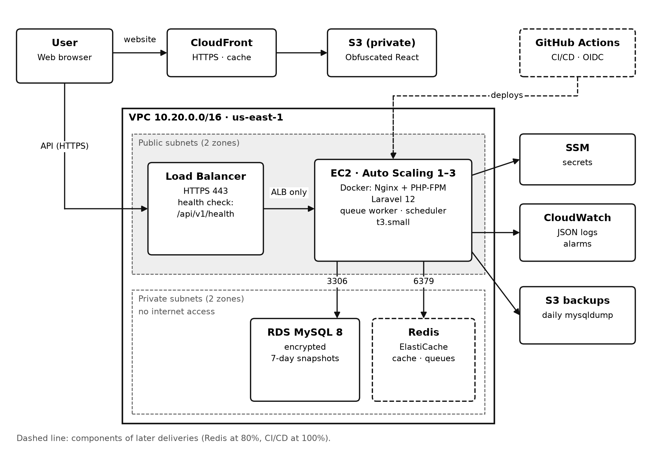
Figure 1. LeGrandHotel architecture on AWS (us-east-1).

3.1 Environment resources (Terraform)
The whole environment is described as code in infra/terraform, so it can be created, reviewed and destroyed repeatably and without manual steps.
Resource | Configuration | File
VPC | 10.20.0.0/16, 2 public and 2 private subnets in 2 availability zones | network.tf
EC2 | t3.small with Docker (Nginx + PHP-FPM), Auto Scaling from 1 to 3 instances | compute.tf
RDS | MySQL 8, db.t3.micro, 20 GB encrypted gp3, private subnet, 7-day automatic snapshots | data.tf
Security Groups | ALB: 443/80 · EC2: only from the ALB · RDS: 3306 only from EC2 | network.tf
SSM Parameter Store | Production secrets and variables (DB password as SecureString) | data.tf
Budget | USD 10 alert from day one | monitoring.tf

Snippet 1. infra/terraform/data.tf and network.tf (summary)
resource "aws_db_instance" "main" {
engine = "mysql"
engine_version = "8.0"
instance_class = var.db_instance_class # db.t3.micro
storage_encrypted = true
publicly_accessible = false # no public IP
db_subnet_group_name = aws_db_subnet_group.main.name # private subnets
vpc_security_group_ids = [aws_security_group.db.id]
backup_retention_period = 7 # daily snapshots, 7 days
}

resource "aws_security_group" "db" {
ingress {
from_port = 3306
to_port = 3306
protocol = "tcp"
security_groups = [aws_security_group.app.id] # only from the API EC2s
}
}
Why it was used: the database is the most sensitive part of the system. With publicly_accessible = false and private subnets it has no internet address; the Security Group only lets traffic into port 3306 from the API instances. The disk is also encrypted and there are 7 days of automatic backups. Because it is written in Terraform, the same environment can be created or destroyed with one command and reviewed before it is applied.

3.2 Estimated cost
Resource | USD/month (24/7)
EC2 t3.small | ≈ 15
RDS db.t3.micro + 20 GB | ≈ 15
Public IPv4 addresses | ≈ 4–8
Total 25% (no ALB or Redis) | ≈ 35; ≈ 12 stopping EC2 and RDS outside working hours

4. Defined endpoints
All routes live under /api/v1 and respond with JSON. Except for authentication and health, they require a Sanctum token. Listings accept ?page= and ?per_page= (maximum 50). The full specification is in docs/endpoints/openapi.yaml and can be opened at editor.swagger.io.
Module | Method and route | Access
Health | GET /health | Public
Authentication | POST /auth/register (internal registration) | Admin only (3/min)
Authentication | POST /auth/login | Public (5/min)
Authentication | GET /auth/me · POST /auth/logout · POST /auth/refresh | Authenticated
Authentication | GET /auth/google/redirect · GET /auth/google/callback | Public
Room types | GET, POST /room-types · GET, PUT, DELETE /room-types/{id} | Admin (write), Front desk (read)
Rooms | GET, POST /rooms · GET, PUT, DELETE /rooms/{id} · PATCH /rooms/{id}/status | Admin, Front desk
Rooms | GET /rooms/available?from=&to= | Admin, Front desk
Guests (guest records) | CRUD /clients | Admin, Front desk
Bookings and stays | CRUD /reservations · POST /reservations/{id}/check-in · POST /stays/{id}/check-out | Admin, Front desk
Parking | CRUD /parking-spots · CRUD /parking-assignments | Admin, Front desk
Inventory | CRUD /inventory-items · POST /inventory-items/{id}/movements | Admin, Storekeeper
Staff and users | CRUD /staff · CRUD /users · PUT /users/{id}/roles | Admin
Reports | GET /reports/occupancy · GET /reports/income | Admin
Developer | GET /dev/overview · /dev/routes · /dev/requests · /dev/errors | Developer, Admin

Snippet 2. api/routes/api.php (extract)
Route::get('health', HealthController::class);

// Public: only login (there is no public sign-up).
Route::post('auth/login', [AuthController::class, 'login'])
->middleware('throttle:login');

Route::middleware(['auth:sanctum', 'throttle:api'])->group(function () {
Route::get('auth/me', [AuthController::class, 'me']);
// Internal registration: only the Administrator creates accounts.
Route::post('auth/register', [AuthController::class, 'register'])
->middleware(['role:admin', 'throttle:register']);
Route::middleware('role:admin')->group(function () {
Route::post('room-types', [RoomTypeController::class, 'store']);
// ...
});
});
Why it was used: all routes are declared in one file, grouped by who can use them. The only public route is login, with its own attempt limit. Registration sits inside the protected group and also requires the Administrator role, so nobody from outside can create an account. Everything else requires a Sanctum token and, where needed, a role. Laravel adds the /api/v1 prefix, so a future API version can live alongside this one without breaking the frontend.

4.1 Single response format
Success: { "success": true, "data": {...}, "meta": { "page": 1, "per_page": 15, "total": 120 } }
Error: { "success": false, "error": { "code": "ROOM_ALREADY_BOOKED", "message": "...", "details": {...} } }

Snippet 3. api/app/Support/ApiResponse.php (extract)
public static function success(mixed $data = null, int $status = 200,
array $meta = []): JsonResponse
{
$body = ['success' => true, 'data' => $data];
if ($meta !== []) { $body['meta'] = $meta; }
return response()->json($body, $status);
}

public static function error(string $code, string $message, int $status,
mixed $details = null): JsonResponse
{
$error = ['code' => $code, 'message' => $message];
if ($details !== null) { $error['details'] = $details; }
return response()->json(['success' => false, 'error' => $error], $status);
}
Why it was used: if each controller built its response by hand, the frontend would have to guess the format of every endpoint. With a single class every response has the same shape, and the frontend handles errors in one place by reading error.code.

4.2 HTTP status codes
Code | When it is returned
200 / 201 / 204 | Successful read, creation and deletion
400 | Malformed JSON body
401 | No token, expired token or wrong credentials
403 | The role is not allowed (even if the route is typed by hand)
404 | Resource or route does not exist (e.g. ROOM_NOT_FOUND)
409 | Conflict: room already booked for those dates
422 | Validation failed (details per field)
429 | Too many requests, with a Retry-After header
500 / 503 | Internal error or service down: clear message and incident code, no stack traces
Snippet 4. api/app/Exceptions/ApiExceptionRenderer.php (extract)
return match (true) {
$e instanceof ValidationException => ApiResponse::error(..., 422),
$e instanceof AuthenticationException => ApiResponse::error(..., 401),
$e instanceof AuthorizationException => ApiResponse::error(..., 403),
$e instanceof ModelNotFoundException => $this->modelNotFound($e), // 404
$e instanceof ThrottleRequestsException => ApiResponse::error(..., 429),
$this->isDatabaseDown($e) => $this->serviceUnavailable($e), // 503
default => $this->internalError($e), // 500
};
Why it was used: it is the central point that maps any error to an HTTP code and to the single format. This way no error comes out as an HTML page or shows server stack traces; 500 responses include an incident code that is also written to the log, so the exact error can be found without showing internal details to the user.

5. Separate registration and login
LeGrandHotel is an internal hotel system, so registration is not public: the Administrator does it from their panel to add a staff member. Registration and login are two endpoints, two validations (FormRequest) and two different screens:
 | Registration | Login
Endpoint | POST /api/v1/auth/register | POST /api/v1/auth/login
Who uses it | Only the Administrator (signed in) | Any staff member
Screen | /registro, inside the administration panel | /login, public
Data | Name, email, password (twice) and role: Receptionist, Storekeeper, Developer or Administrator | Email and password
Validation | Unique email; password ≥ 8 with letters and numbers; internal role | Credentials checked against the bcrypt hash; the account must have a hotel role
Result | Creates the account with its role and sends the verification email. It does not sign in on the person's behalf | Returns a 60-minute Bearer token and the user's roles
Errors | 401 not signed in; 403 not an Administrator; 422 per field; 429 on the 4th registration per minute | 401 wrong credentials; 403 account without a hotel role; 429 on the 6th attempt per minute

The password is never stored in plain text: the User model uses the «hashed» cast (bcrypt, 12 rounds). After signing in, each role lands on its own home: Administration, Front desk and Storeroom go to the Dashboard, and the Developer to their diagnostics view. Google sign-in only lets in emails that already belong to staff accounts: it never creates new accounts.
Note: the screenshots show the real web interface, which is in Spanish.
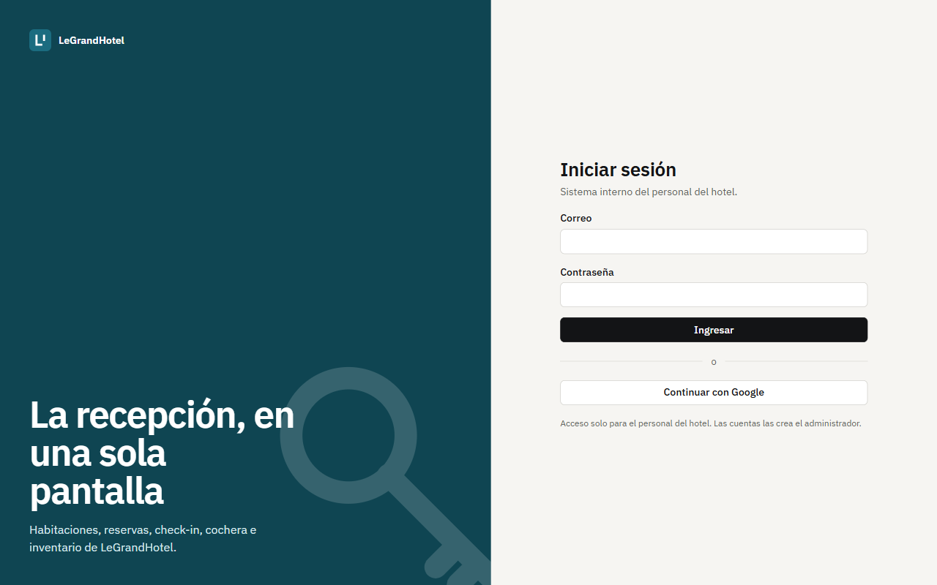
Figure 2. Sign-in screen (/login).
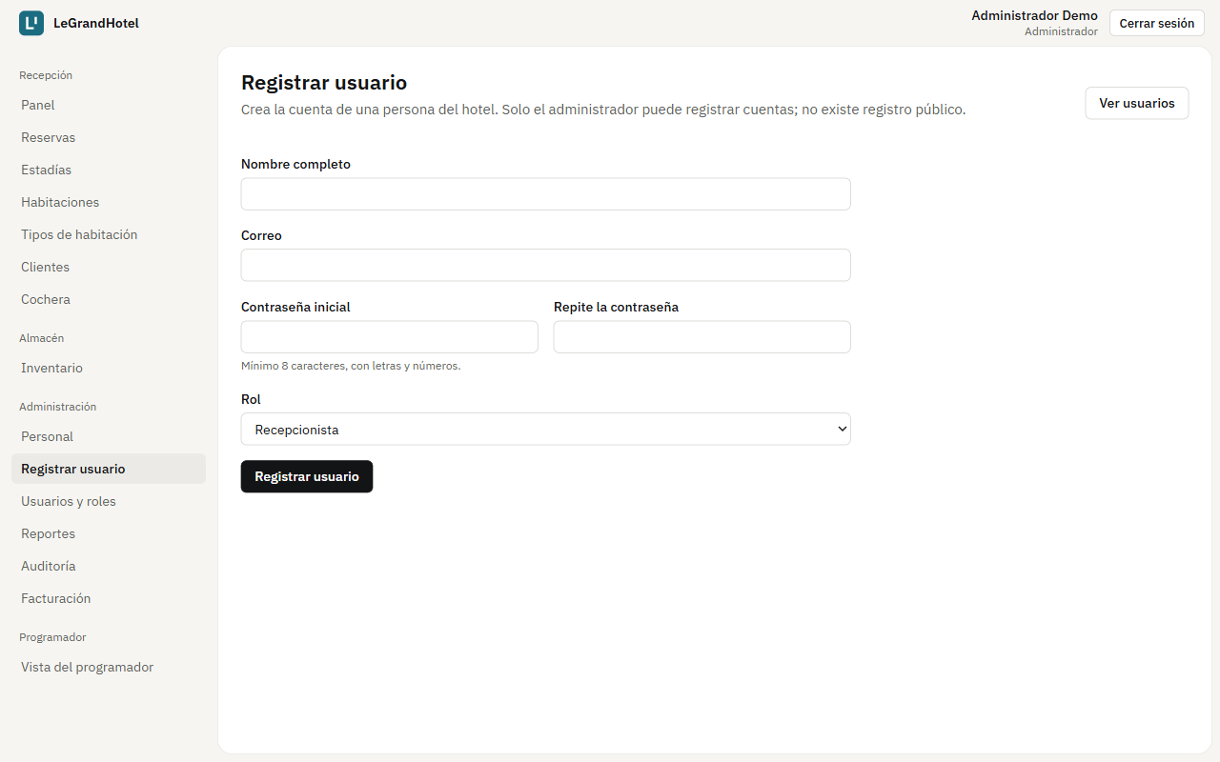
Figure 3. Staff user registration (/registro), Administrator only and separate from login.
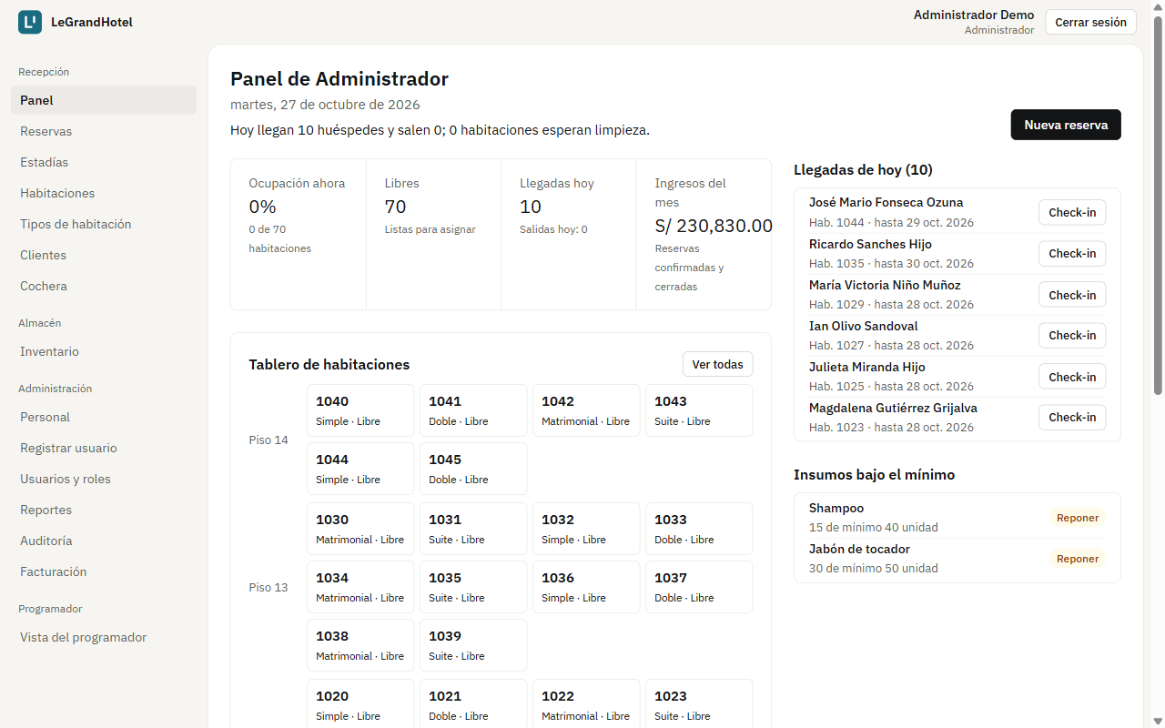
Figure 4. Front desk dashboard after signing in as Administrator.
Snippet 5. api/app/Http/Requests/Auth/RegisterRequest.php
public function rules(): array
{
return [
'name' => ['required', 'string', 'max:120'],
'email' => ['required', 'email', 'unique:users,email'],
'password' => ['required', 'confirmed',
Password::min(8)->letters()->numbers()],
'role' => ['required', Rule::in(Role::INTERNAL)], // hotel roles only
];
}
Why it was used: registration has its own validation, different from login. It is validated before reaching the controller: if a field fails, Laravel responds 422 with a message per field and the form shows it next to the field. The Rule::in(Role::INTERNAL) rule only accepts staff roles, so no kind of external account can be created.
Snippet 6. api/app/Http/Controllers/Api/AuthController.php (extract)
public function register(RegisterRequest $request): JsonResponse
{
$user = DB::transaction(function () use ($data) {
$user = User::create([...]); // password stored with bcrypt
$user->assignRole($data['role']); // staff role chosen by the admin
return $user;
});
event(new Registered($user)); // sends the verification email
return ApiResponse::created(self::userPayloadFor($user)); // no token
}

public function login(LoginRequest $request): JsonResponse
{
$user = User::where('email', $request->string('email'))->first();
if (! $user || ! Hash::check($request->password, $user->password)) {
throw new ApiException('INVALID_CREDENTIALS', '...', 401);
}
if (! $user->hasRole(...Role::INTERNAL)) { // hotel staff only
throw new ApiException('ACCOUNT_WITHOUT_ACCESS', '...', 403);
}
return ApiResponse::success($this->tokenPayload($user, ...));
}
Why it was used: they are two separate actions with different responsibilities. Registration is run by the Administrator: it creates the account and its role in one transaction (if anything fails, nothing is left half done) and returns no token, because registering someone is not signing in for them. Login compares the password with the bcrypt hash and returns the same message whether the email or the password is wrong, so it does not reveal which emails exist. It also rejects any account without a hotel role. Only login issues a Sanctum Bearer token, which expires after 60 minutes.
Snippet 7. api/app/Models/User.php and AppServiceProvider.php (extracts)
protected function casts(): array
{
return [
'email_verified_at' => 'datetime',
'password' => 'hashed', // automatic bcrypt
];
}

RateLimiter::for('login', fn (Request $r) => Limit::perMinute(5)
->by(Str::lower($r->input('email')).'|'.$r->ip()));
RateLimiter::for('register', fn (Request $r) => Limit::perMinute(3)
->by($r->user()?->id ?: $r->ip()));
Why it was used: with the hashed cast, any password assigned to a user is hashed with bcrypt before it is saved, without relying on each developer remembering to do it. The attempt limits stop brute-force attacks: login allows 5 attempts per minute per email and IP, and registration 3 per minute per administrator; beyond that the API responds 429.
Snippet 8. web/src/App.tsx (extract)
<Route element={<GuestRoute />}>
<Route path="/login" element={<LoginPage />} />
</Route>

<Route element={<ProtectedRoute />}>
<Route element={<ProtectedRoute roles={['admin']} />}>
<Route path="/registro" element={<RegisterPage />} />
<Route path="/personal" element={<StaffPage />} />
</Route>
</Route>
Why it was used: in the frontend, login and registration are two screens with their own route. Login is the only public screen. Registration sits inside the Administrator's protected routes: without a session it redirects to login, and with another role it shows the 403 screen even if the address is typed by hand. The backend enforces the same rules on every endpoint, so hiding the screen is not the only protection.

5.1 Automated tests for registration and login
Test (api/tests/Feature/AuthTest.php) | Result
The Administrator registers a staff account with a bcrypt password (no token) | Pass
Nobody from outside can register: without a session it responds 401 | Pass
The front desk cannot register accounts: responds 403 | Pass
Only hotel roles are accepted; invalid data or a repeated email respond 422 | Pass
Registration limited to 3 per minute (429 with Retry-After) | Pass
An account without a hotel role cannot sign in (403) | Pass
Login with valid credentials returns a token and roles | Pass
Login with a wrong password responds 401 | Pass
Login limited to 5 attempts per minute | Pass
No token or an expired token responds 401 | Pass
Frontend (Vitest): login and registration are separate screens; login offers no public sign-up; /registro without a session redirects to login and with another role shows 403 | Pass

Overall result: 89 API tests (376 assertions) and 14 frontend tests pass. Static analysis with PHPStan reports no errors and the GitHub Actions pipeline is green.

6. Incident log
Every outage, even in development, is logged the same day (docs/incidentes.md).
Date | What failed | Cause | Fix | Time
10/26/2026 | Login returned 500 with incident code XG1R7UASWT | «php artisan serve» launched PHP without the pdo_sqlite extension | Local server with php -S loading the extension | ≈ 2 min
10/26/2026 | The frontend showed the 503 screen | The server pointed to a non-existent index.php | Use api/public/index.php as the router; the 503 screen retried on its own | ≈ 1 min
10/27/2026 | First k6 run: 100% failed requests | PHP listened only on IPv6 (::1) and k6 resolved localhost to IPv4 | BASE_URL=http://[::1]:8000; the runs were repeated | ≈ 5 min

7. Delivery conclusions
- The three 25% items are implemented: endpoints defined and documented, registration and login separated and tested, and the cloud environment described as code.
- The local load tests (section 8.2) show that the development server saturates with few users. In the 80% delivery they will be repeated on AWS with Nginx + PHP-FPM, which serves several requests at once.

8. EXTRAS (beyond what is graded at 25%)
Everything in this section is EXTRA: it is not part of what is graded at 25% and is presented as additional progress.

8.1 EXTRA: Database diagram (UML)
UML class diagram of the 13 entities (Laravel models on MySQL 8) with attributes, methods and multiplicities. The role_user join table is the many-to-many association between User and Role; AuditLog and InventoryMovement store which user performed each action. Indexes required by the plan: rooms(status), reservations(check_in, check_out), reservations(client_id), unique clients(document_number) and inventory_items(name). Editable sources: docs/diagramas/uml-clases.puml (PlantUML) and docs/diagramas/legrandhotel.dbml (dbdiagram.io).
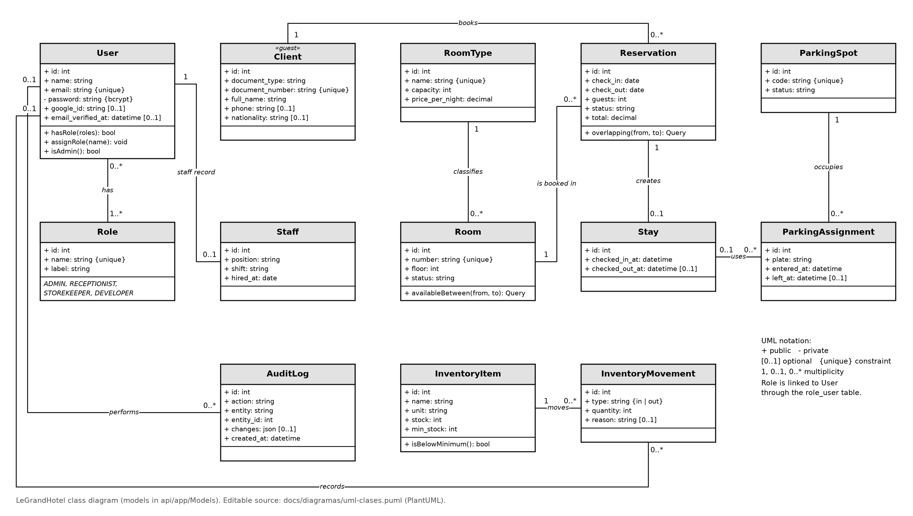
Figure 5. LeGrandHotel UML class diagram.

8.2 EXTRA: Performance and stress tests with k6 (several runs)
Five k6 runs were made against the API on the development machine (Windows, PHP 8.2, PHP built-in server that serves one request at a time, SQLite and file cache). It is not the production server: the runs are used to compare load between runs and to find bottlenecks before moving to AWS.
Scenario (front desk): 70% reads (available rooms, bookings, room types), 20% login and 10% booking creation. Each step ramps up for 10 s, holds the load for 45 s and ramps down for 5 s. Plan target: p95 below 500 ms and 0% errors.
Run | Requests | Errors | p50 | p95 | Result
Smoke (5 VU, 30 s): health, DB, cache and 401 | 222 | 0.00% | 203 ms | 321 ms | Met (100% of checks)

VU | Requests | Req./s | p50 | p95 | Max. | Errors | p95 < 500 ms
5 | 350 | 4.4 | 288 ms | 528 ms | 1,804 ms | 0.00% | Not met
10 | 413 | 5.2 | 910 ms | 1,309 ms | 1,598 ms | 0.00% | Not met
25 | 438 | 5.2 | 3,361 ms | 3,952 ms | 4,197 ms | 0.00% | Not met
50 | 483 | 5.3 | 7,016 ms | 7,885 ms | 8,195 ms | 0.00% | Not met

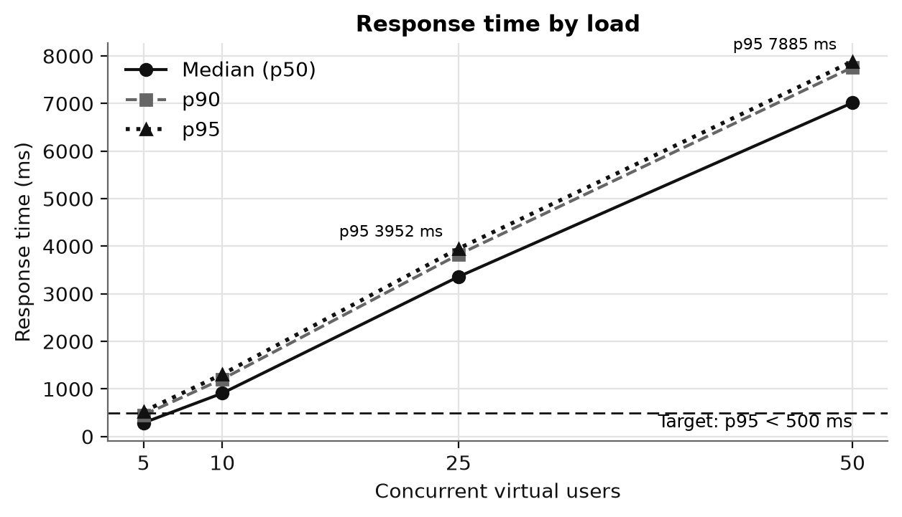
Figure 6. Response time (p50, p90, p95) by number of virtual users.
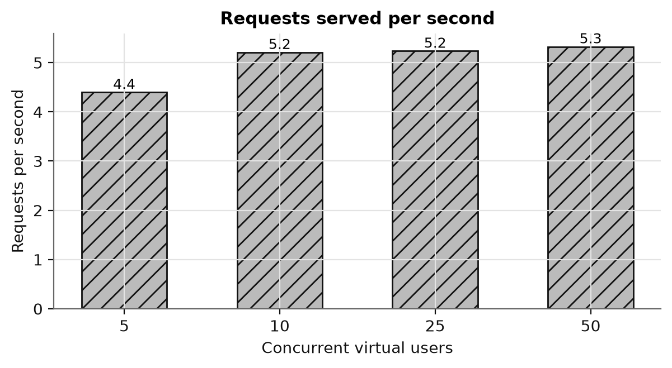
Figure 7. Requests served per second in each run.
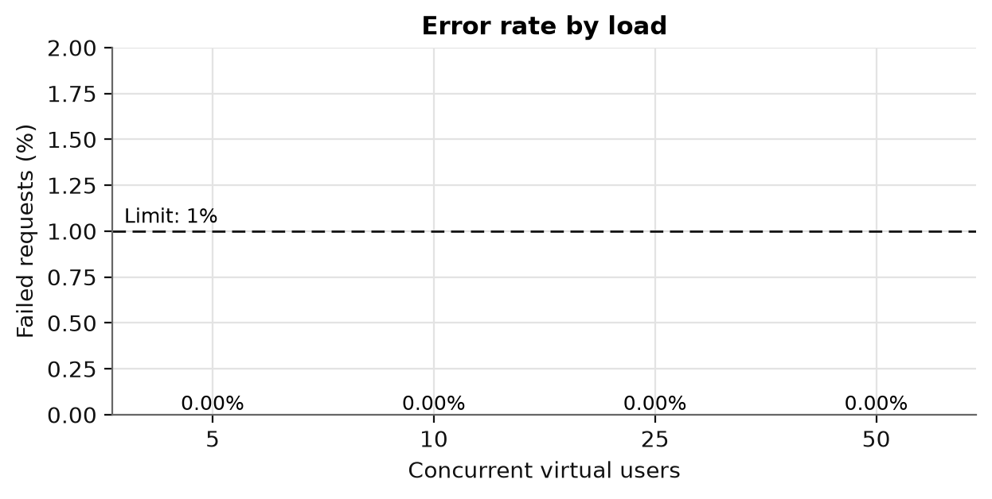
Figure 8. Percentage of failed requests in each run.
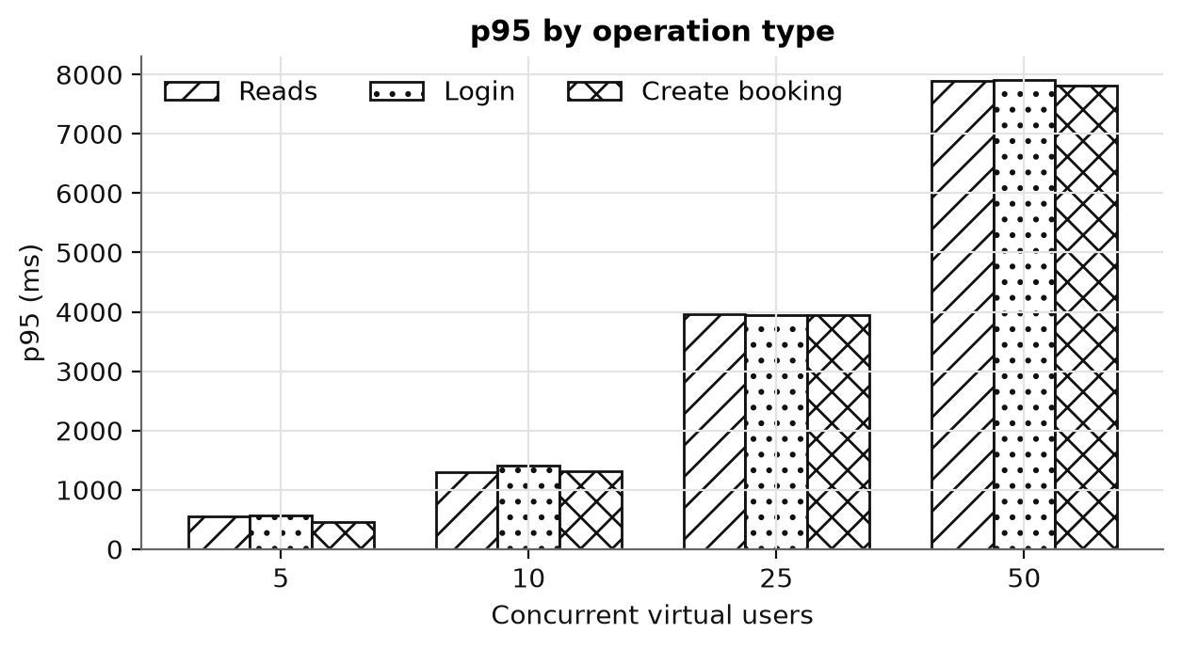
Figure 9. p95 by operation type (reads, login, create booking).
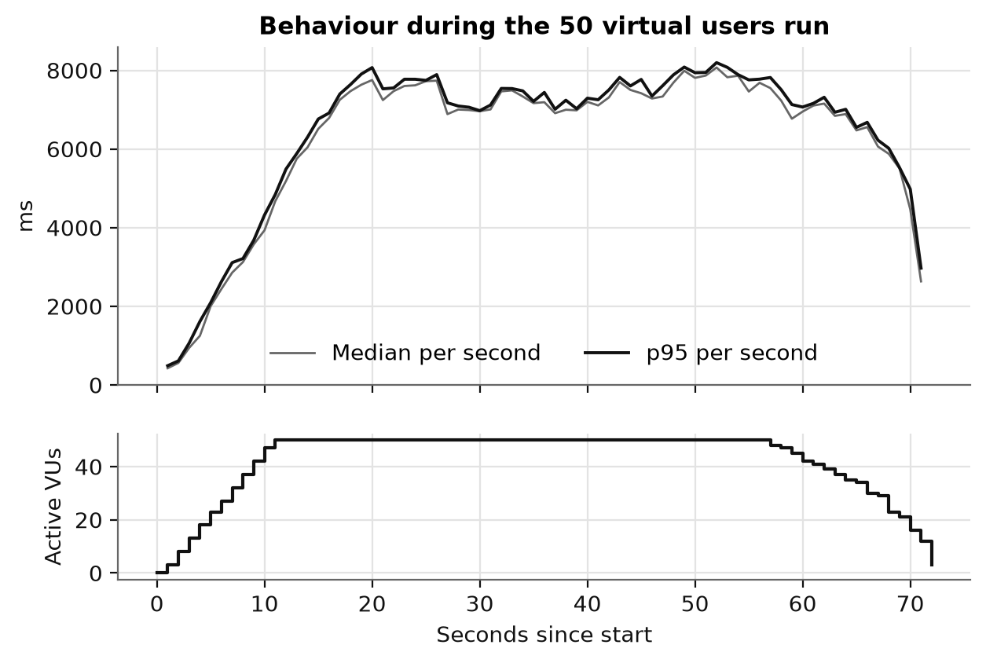
Figure 10. Latency second by second in the 50-user run.
Snippet 9. tests/k6/reservas.js (extract)
escalon: {
stages: [
{ duration: '10s', target: VUS }, // ramp up to VUS users
{ duration: '45s', target: VUS }, // hold the load
{ duration: '5s', target: 0 }, // ramp down
],
thresholds: {
http_req_duration: ['p(95)<500'], // target: p95 below 500 ms
http_req_failed: ['rate<0.01'], // less than 1% errors
},
},
Why it was used: the same script is run with a different number of users (VUS) to compare runs with each other. The thresholds turn the plan target (p95 below 500 ms and less than 1% errors) into a rule: if it is not met, k6 marks the test as failed without interpreting the numbers by hand.

8.3 Analysis and bottleneck found
- With 5 users the p95 was 528 ms; with 50 users it reached 7,885 ms. Requests per second barely rise (4.4 → 5.3): the server was already at the limit of what it can serve.
- Cause: the PHP built-in server on Windows handles one request at a time. When more users arrive, requests wait in a queue and the response time grows almost linearly, even though each endpoint's code is fast (in the Pest bulk test, the listing of 5,000 bookings responds in under 500 ms).
- With 50 VU, reads, login and booking creation have almost the same p95 (7,890, 7,905 and 7,820 ms). The time is dominated by waiting in the server queue, not by each endpoint's work.
- Despite the saturation there were no errors (0% in every run): the API responds more slowly, but it does not go down or lose requests.
- Fix planned for 80%: Docker with Nginx + PHP-FPM (20 processes), OPcache, MySQL on RDS and Redis for cache and rate limiting. The same runs will be repeated on AWS with 50–100 and then 1,000–5,000 users, to compare before and after.
The interactive HTML reports of each run (generated by k6) are in docs/pruebas/local-*.html and the raw data in docs/pruebas/datos/.

8.4 EXTRA: Code encryption (obfuscation)
The frontend production build is obfuscated with javascript-obfuscator: names are replaced with hexadecimal identifiers and strings are stored base64-encoded. Comparison of the same interface text («No tienes acceso», "You do not have access"):
Build | Command | Times it appears readable
Normal | npm run build:plain | 1
Obfuscated (production) | npm run build | 0

The backend is not published: it runs on a private server with no access to the code.
Snippet 10. web/vite.config.ts (extract)
renderChunk(code, chunk) {
const result = JavaScriptObfuscator.obfuscate(code, {
identifierNamesGenerator: 'hexadecimal', // unreadable names
stringArray: true, stringArrayEncoding: ['base64'], // encoded strings
splitStrings: true, compact: true,
})
return { code: result.getObfuscatedCode(), map: null }
}
Why it was used: a web application's code is downloaded to the browser, so anyone can read it. Obfuscation is applied to the final production bundle to make it harder to copy or study its logic, without changing what it does. Development uses the normal code (npm run build:plain).

8.5 EXTRA: Developer view
The Developer role has a diagnostics screen (/programador) that shows, without logging into the server: the status of the application, the database and the cache; version and configuration (token lifetime, rate limits, CORS); p50/p95/p99 latencies computed from the JSON log; slowest routes; latest requests; errors searchable by incident code, the same one the user sees on the 500 screen; and the list of every API route with its access role. It shows no passwords or keys, and an automated test checks this.
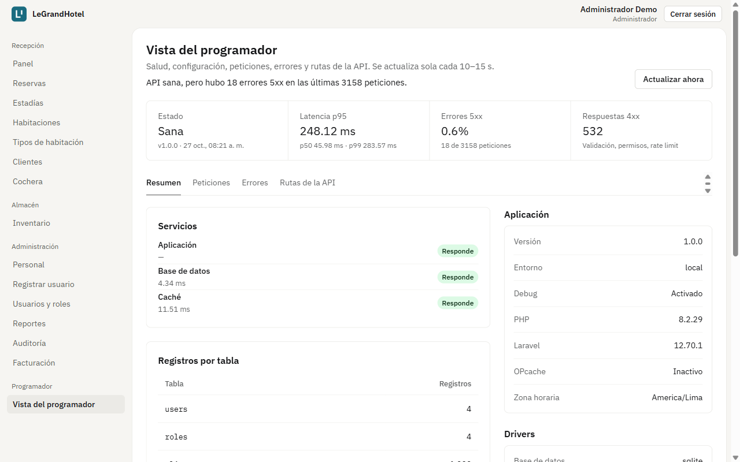
Figure 11. Developer view.

8.6 EXTRA: Security and quality ahead of schedule
- Rate limits: login 5/min, registration 3/min and API 60/min, with a 429 response and Retry-After (an 80% item).
- Roles and permissions: the role is checked before looking up the record, so a route typed by hand responds 403 without revealing whether the id exists.
- Error screens in React: 404, «Under construction», 403, session expired, 500 with incident code, 503 retrying every 30 s, offline and 429 with a countdown.
- CI/CD on GitHub Actions: style (Pint), analysis (PHPStan), tests (Pest and Vitest), dependency audit and Semgrep on every change. Current audit: 0 vulnerabilities in composer and npm and 0 Semgrep findings.
- Structured JSON logs (one line per request with request_id, route, status code and duration), ready for CloudWatch.

8.7 EXTRA: Mobile app design (Android and iOS)
LeGrandHotel will also have an app for Android and iOS phones. This delivery presents its design: the technology, the architecture, the screens and the build plan. The app code is developed in the 80% and 100% deliveries. Like the web app, it is an internal tool: only hotel staff use it, it has no sign-up and no guest or outsider can get in. It does not replace the web app: it covers the tasks that are better done on the move and uses the same API, without duplicating business logic.
Staff role | What the app will be used for
Receptionist | See the day's arrivals and departures, check guests in and out from the lobby, record the booking of a guest who walks in or calls, change a room's status, record license plates in the parking lot
Storekeeper | Record inventory ins and outs in the storeroom and see supplies below the minimum
Administrator | See the summary dashboard (occupancy, income, alerts). Full management stays on the web

Chosen technology: React Native with Expo and TypeScript. A single codebase produces both apps and reuses what the team already uses on the web: React, TypeScript, TanStack Query, Axios and the same data types.
Option | Pros | Cons | Decision
React Native + Expo | One codebase for Android and iOS; same language and libraries as the web; builds iOS in the cloud without a Mac (EAS Build) | Very specific native features need custom modules | Chosen
Flutter | Good performance and consistent design | Another language (Dart): nothing from the web is reused | Discarded
Native (Kotlin + Swift) | Full access to the system | Two different apps: double the work for 4 people | Discarded
Installable web app (PWA) | No new code | Notifications and secure storage limited on iOS; not in the stores | Complement

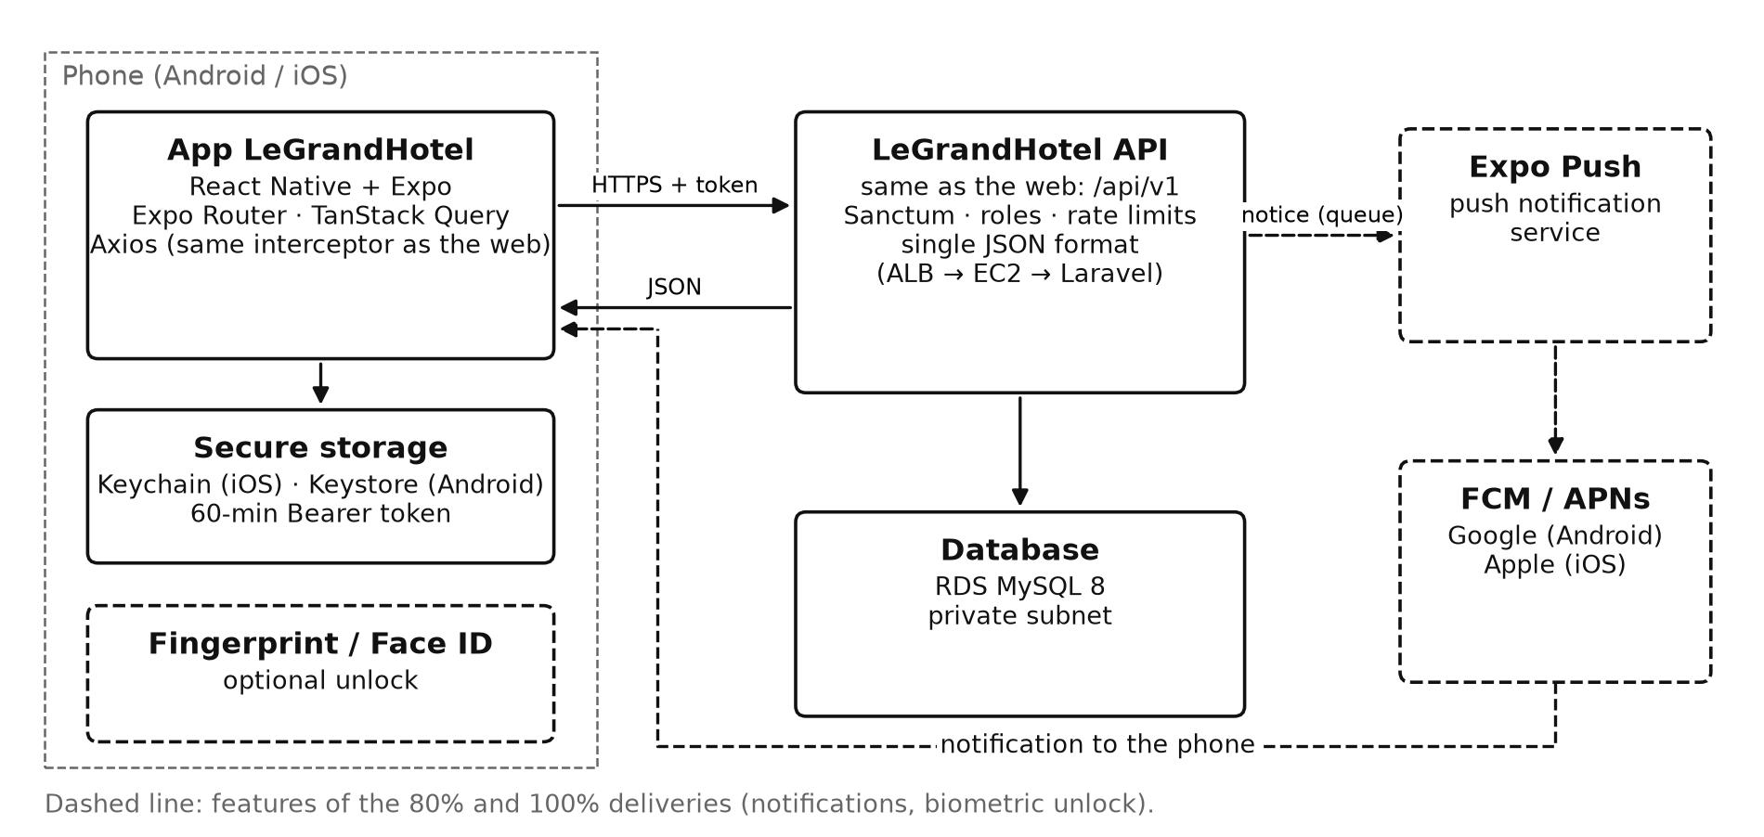
Figure 12. Mobile app architecture: same API and notifications through FCM (Android) and APNs (iOS).
Need | In the app | Web equivalent
Navigation | Expo Router (tab bar per role) | React Router
API calls and cache | TanStack Query + Axios with the same interceptor | Same
Session storage | expo-secure-store: Keychain (iOS) and Keystore (Android) | sessionStorage
Google sign-in (staff accounts only) | expo-auth-session and legrandhotel://auth/callback link | Socialite with redirect
Notifications | expo-notifications → FCM / APNs | —
Unlock | Fingerprint or Face ID (expo-local-authentication) | —
Tests | Jest + Testing Library; Maestro for end-to-end flows | Vitest; Playwright

Changes the API will need (few, because the app uses the same endpoints):
- Register each phone's notification token (POST /devices) and send notices to staff: the day's arrivals, room ready after cleaning and supply below the minimum.
- Google sign-in that returns to the app (deep link) as well as to the web.
- X-App-Version header to ask for an app update if the API changes (426 response).
- Nothing else: login already accepts a device name so each phone has its own token; CORS does not apply to native apps; roles and attempt limits are the same.
Security: the token is kept in the system's secure storage and never in plain text. It is renewed automatically before it expires, with the same POST /auth/refresh as the web. Staff can turn on fingerprint or face unlock. The app only uses HTTPS and contains no secrets: every secret stays on the server.
Delivery | App scope
25% (this one) | Design: technology, architecture, screens per role and sketches
80% | Expo project in mobile/; staff login; front desk («Today» with check-in and check-out, new booking, rooms); notifications; Android test build
100% | Inventory, parking and administrator dashboard; iOS test build on TestFlight; end-to-end flow tests with Maestro; test release on Google Play and the App Store

Publishing: test builds are distributed through Google Play (internal testing) and Apple TestFlight. Publishing requires a Google Play Console account (one-time fee of USD 25) and an Apple Developer Program account (USD 99 per year). The full design is in docs/movil/diseno-app-movil.md.
Mobile app sketches
Main screens in grayscale. They use the same data and rules as the web app; the bottom bar changes with the user's role.
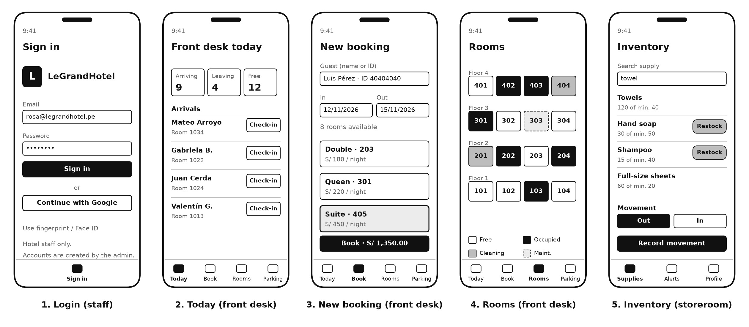
Figure 13. Sketches: staff login; front desk «Today», new booking and rooms; storeroom inventory.

9. Next steps (80% delivery)
- Deploy with the pipeline: Docker image in ECR, frontend on S3 + CloudFront, ALB with HTTPS.
- Repeat the k6 tests on AWS with 50–100 and 1,000–5,000 users, with HTML reports and a before/after comparison.
- Set up Google sign-in (OAuth credentials) and automatic RDS and S3 backups.
- Mobile app: create the Expo project, build the login and front desk screens, enable notifications and produce the first Android test build.

