INSTITUTO TECNOLÓGICO SUPERIOR TECSUP
SOFTWARE DESIGN AND DEVELOPMENT

COURSE: CLOUD SOLUTIONS DEVELOPMENT
PROJECT:
LeGrandHotel – Web-based hotel management system
LeGrandHotel Week11
Features, tests and mobile design
AREQUIPA, 2026
Lecturer:
VÍCTOR CALVO
Presented by:
- Huacca Ccaso, Diego Armando
- Marcani Leyva, Joseph Fredy
- Pinto Garate, Leo Mathiu
- Quispe Encarnación, Rusell
Arequipa – Peru
2026

Table of contents
1. Project description 3
1.1 Objectives 3
1.2 Modules 3
1.3 Technologies 3
1.4 How the parts connect 4
1.5 Database diagram 5
2. Defined endpoints 8
2.1 Single response format 8
3. Separate registration and login 9
3.1 Code excerpts 10
3.2 Registration screens 11
4. What each role can do 11
4.1 Receptionist 12
4.2 Storekeeper 21
4.3 Administrator 24
4.4 Developer 42
4.5 Guest 47
5. Error screens 49
6. Incident log 51
7. Performance and stress tests with k6 52
7.1 Smoke test 53
7.2 Login attempt limit 54
7.3 Guest steps (5, 10, 25 and 50 at once) 55
7.4 k6 HTML report (50-guest step) 58
7.5 Test conclusions 59
8. Android and iOS app design 59
8.1 Technology 62
8.2 Security and API changes 62
8.3 Build plan 62
9. Conclusions 63

1. Project description
LeGrandHotel is a web system to manage a hotel. It brings together the staff’s daily work (reservations, check-in and check-out, rooms, guests, parking and inventory) and online booking for guests, who choose a room type, see what it includes and the total, and the hotel assigns them a free room.
The system has two parts: a REST API that stores the data and enforces every business rule, and a web page (single-page application) that uses it. The same API will also serve the Android and iOS mobile app designed in section 8.

1.1 Objectives
- Prevent operational errors: a room cannot be booked twice for the same dates, two guests cannot be in the same room and inventory cannot go negative.
- Each person sees only what their role allows, and the API enforces it even if someone types an address by hand.
- Leave a trail: every change is recorded in the audit log with who made it and when, and every error has an incident code to find it in the log.
- Measure performance with load tests before publishing the system.

1.2 Modules
Module | What it covers
Reservations and stays | Reservations with the total calculated on the server, check-in (creates the stay and occupies the room) and check-out (the room goes to cleaning)
Rooms and room types | Rooms by floor and status; types with price per night, capacity and amenities
Guests | Guest records with document, phone and nationality; linked to the web account if the guest has one
Parking | Parking spots, vehicle entry and exit, with or without a related stay
Inventory | Supplies with stock and minimum; stock in and out with a reason
Staff and accounts | Staff records, account registration and role changes
Reports and audit | Occupancy, income for the last 6 months and who changed what
Guest portal | Google sign-in, guest details, online booking and their reservations
Developer view | API health, latencies, requests, errors and routes, without logging into the server

1.3 Technologies
Part | Technology | What it is used for
API (backend) | PHP 8.2 and Laravel 12 | REST routes, validation, business rules and data access
Authentication | Laravel Sanctum | Bearer tokens that expire (60 minutes) for the web and the mobile app
Google sign-in | Laravel Socialite (OAuth 2.0) | Guest accounts without a password
Database | MySQL 8.4 | Hotel data with foreign keys, indexes and transactions
Web page (frontend) | React 18, TypeScript and Vite | Fast, typed single-page interface
Data on the web | TanStack Query and Axios | Query cache, pagination and a single handler for 401/403/429/5xx errors
Navigation | React Router | Role-protected routes and error screens
API tests | Pest (PHPUnit) | 121 automated tests of rules, permissions and errors
Web tests | Vitest and Testing Library | 25 tests of routes, forms and permissions
Code quality | PHPStan level 5, Laravel Pint, ESLint and strict TypeScript | Catch errors before running and keep one style
Load tests | k6 (Grafana) | Measure response times and errors with many users at once
Local environment | Docker Compose | The same MySQL database for the whole team
Mobile app (design) | React Native with Expo and TypeScript | One codebase for Android and iOS
Version control | Git and GitHub | History and teamwork

Note: the server where the system will be published has not been defined yet. Everything in this report was run in the team’s local environment.

1.4 How the parts connect
The web page and the mobile app do not store data: they request everything from the API in JSON with the session token. The API validates every request (FormRequest), checks the role (role: middleware) and the per-record rules (policies), and always answers in the same format, whether success or error. The MySQL database has 16 system tables related by 13 foreign keys; the diagram in section 1.5 was generated by reading the real database schema.

1.5 Database diagram
The diagram is split into three parts so it is easy to read. When a table relates to one in another part, that table appears in a dashed box with only its id. Each line shows the foreign key column and what MySQL does when the parent record is deleted (CASCADE, SET NULL or RESTRICT). Table and column names are the real ones in the database.
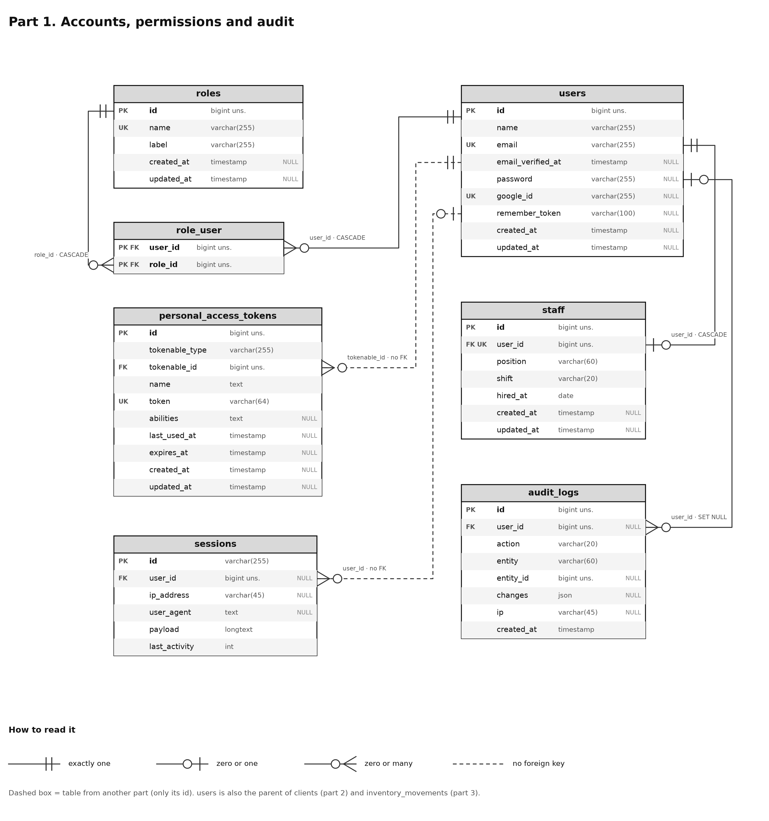
Figure 1. Database diagram, part 1: accounts, permissions and audit.
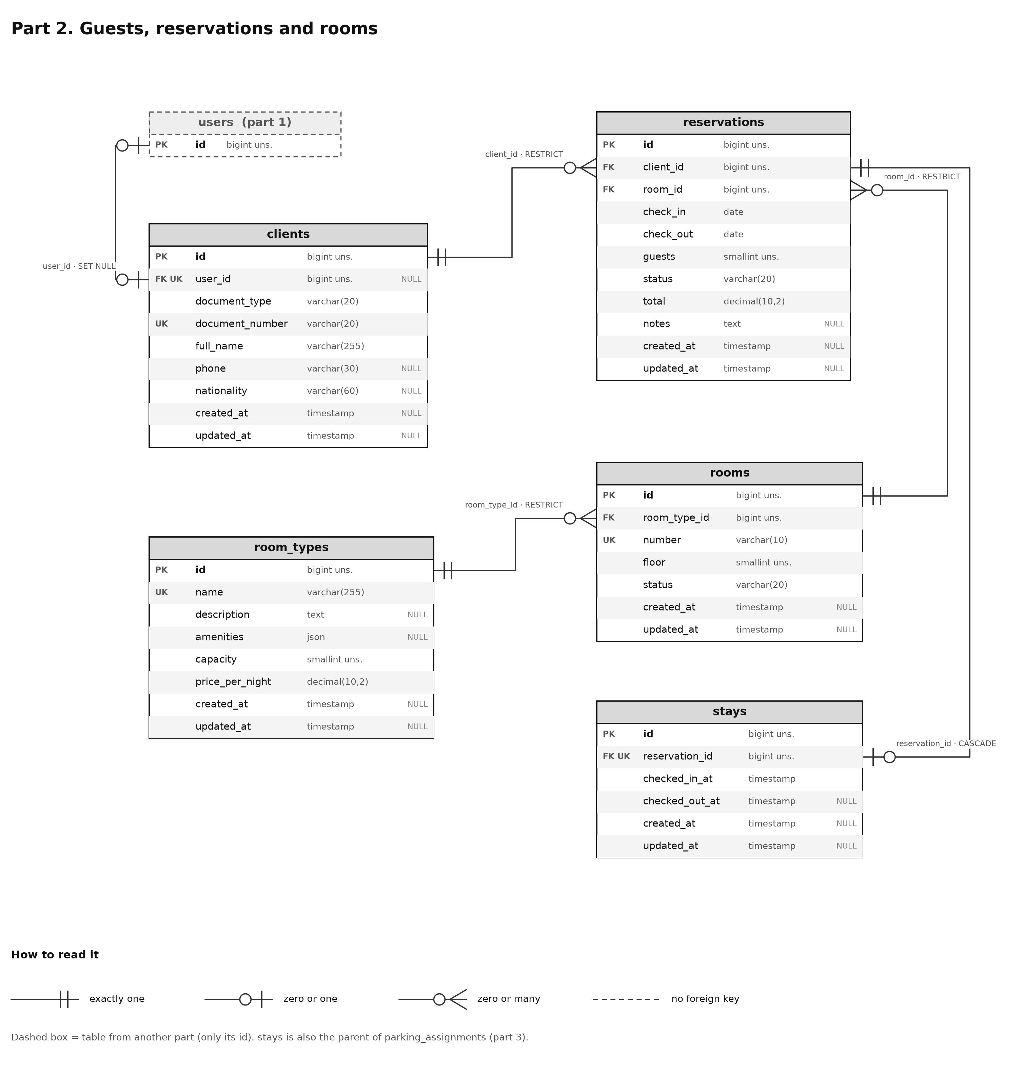
Figure 2. Database diagram, part 2: guests, reservations and rooms.
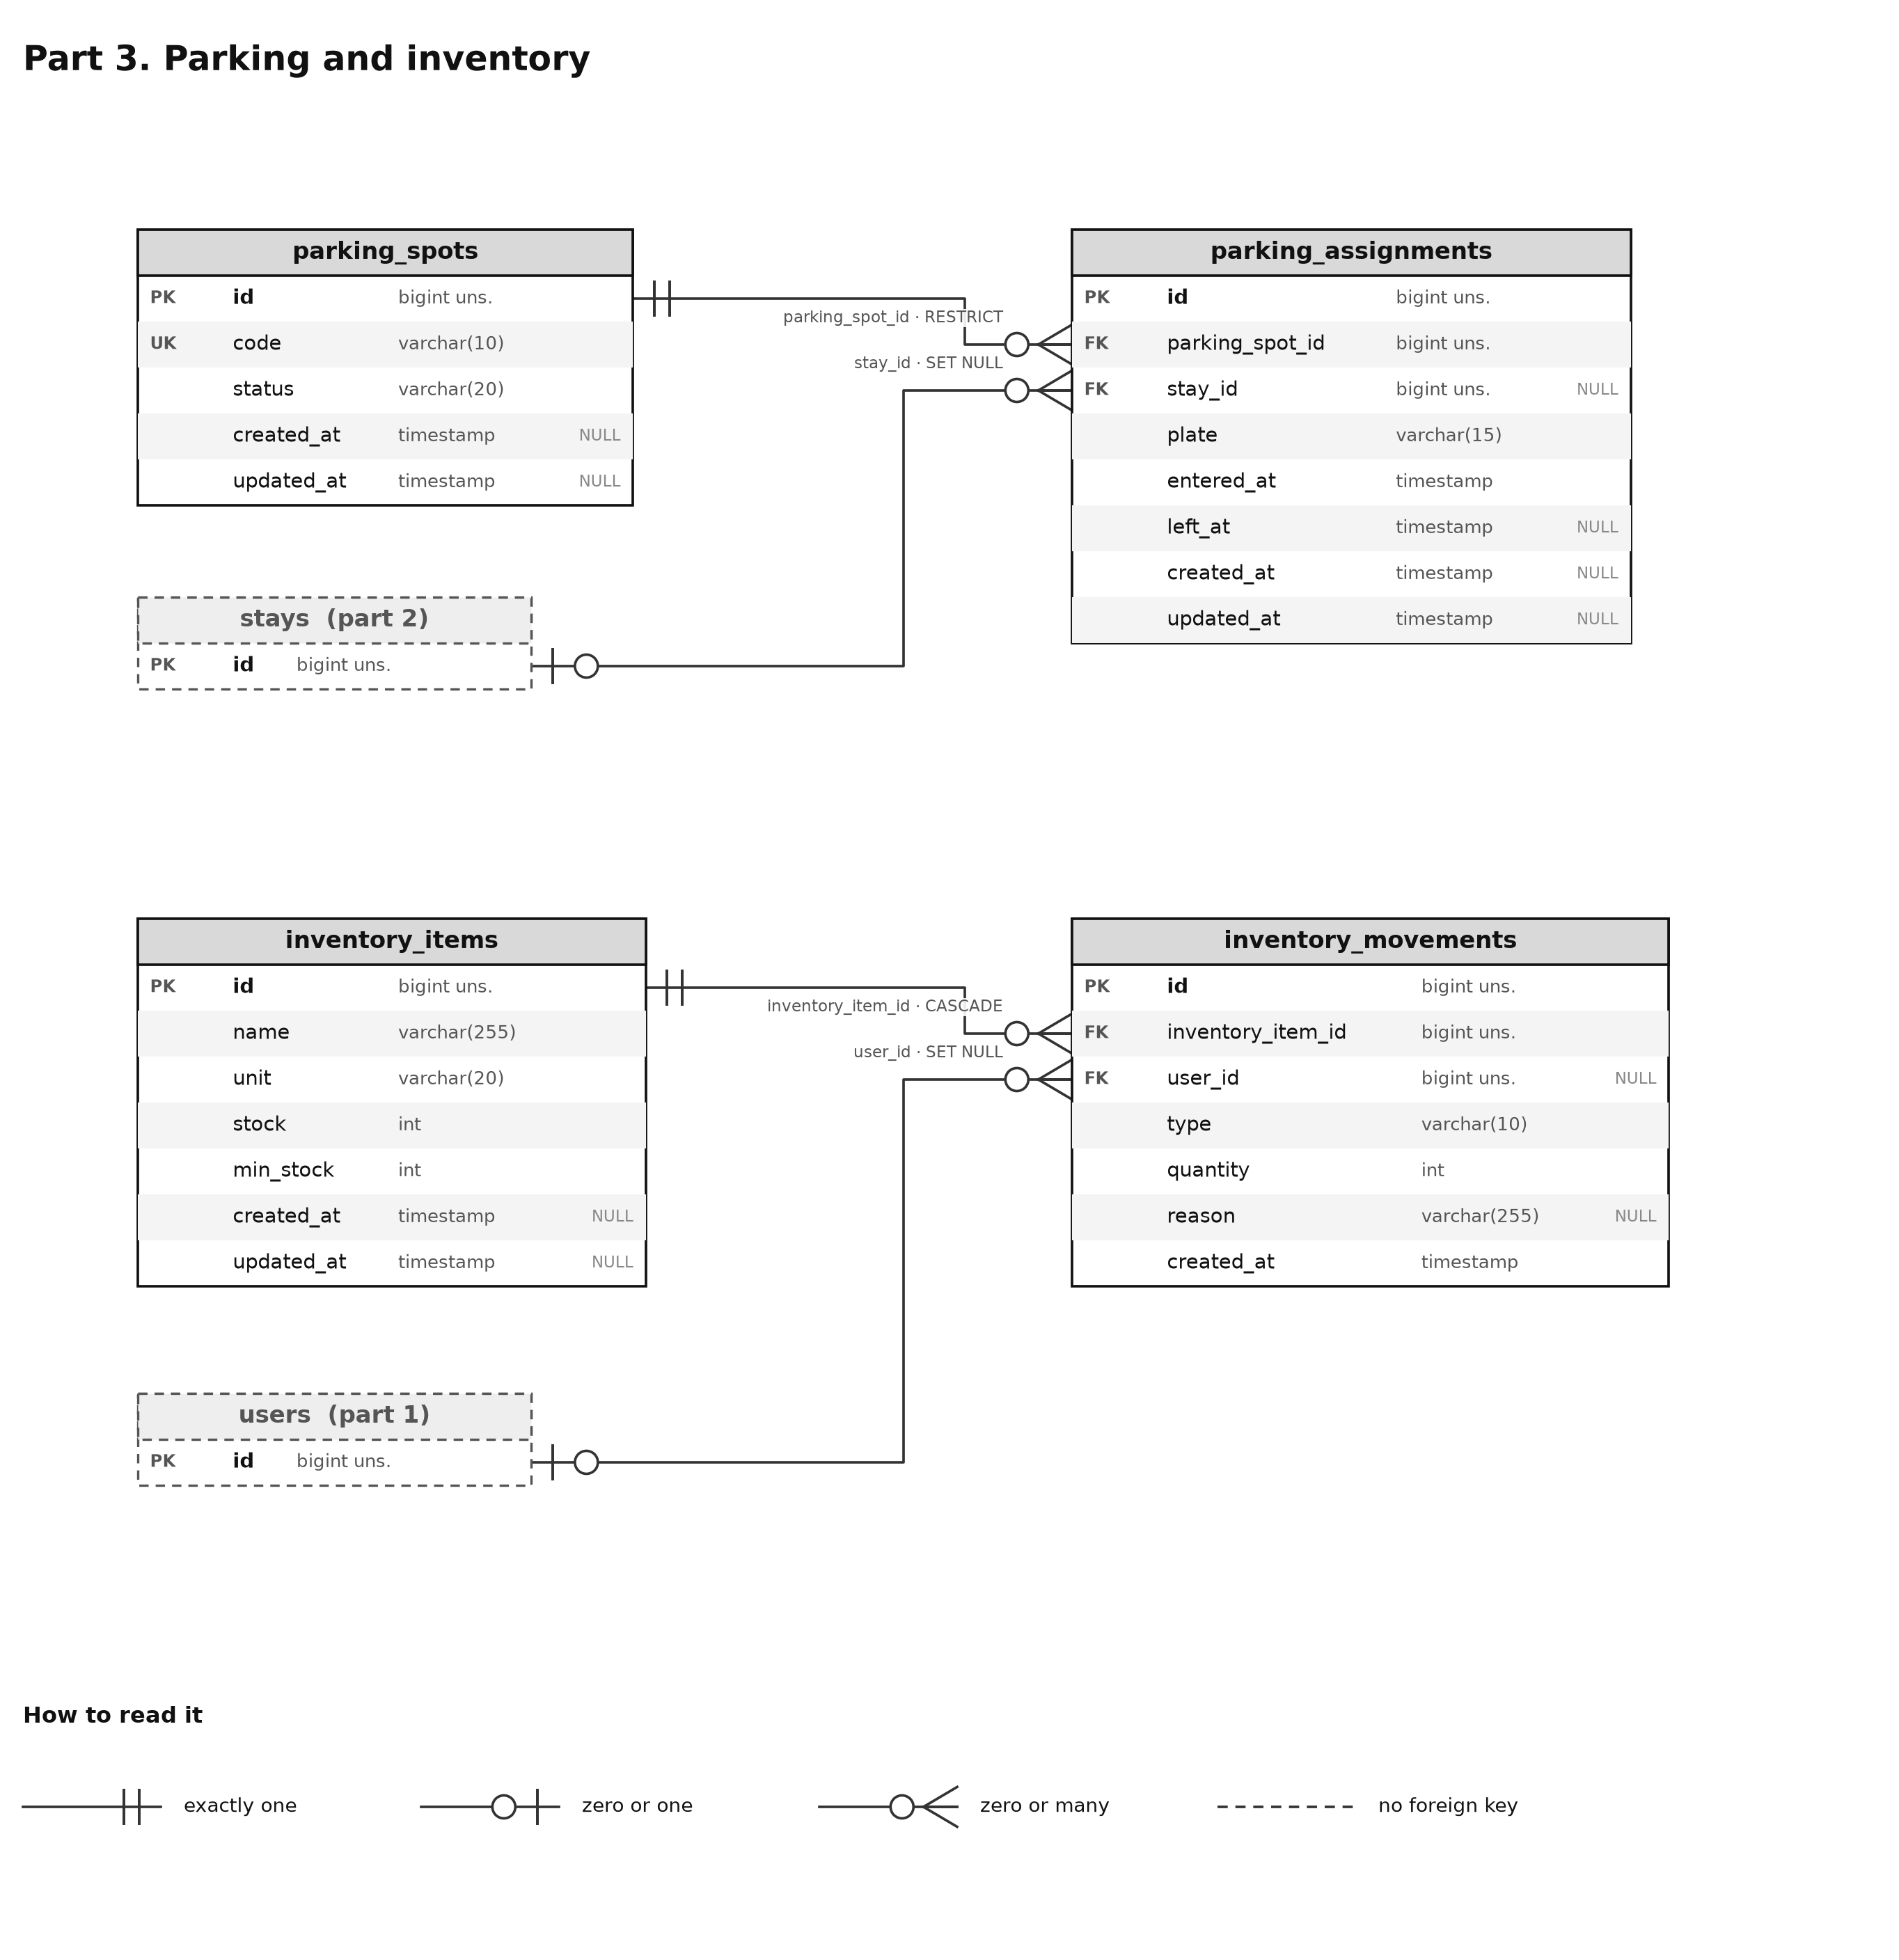
Figure 3. Database diagram, part 3: parking and inventory.

2. Defined endpoints
All routes live under /api/v1 and answer JSON. There are 77 routes (counted with php artisan route:list). In the table, “CRUD” means list (GET), create (POST), show (GET /{id}), update (PUT/PATCH) and delete (DELETE).
Group | Method and route | Who can use it
Health | GET /health | Public
Authentication | POST /auth/login | Public (5 attempts per minute)
 | GET /auth/google/redirect · /auth/google/callback | Public (guests)
 | GET /auth/me · POST /auth/logout · POST /auth/refresh | Any session
 | POST /auth/register | Administrator and Developer (3 per minute)
Email | GET /email/verify/{id}/{hash} · POST /email/verification-notification | Signed link · session
Guest portal | PUT /portal/profile | Guest
 | GET /portal/room-types | Guest
 | GET · POST /portal/reservations | Guest
 | POST /portal/reservations/{id}/cancel | Guest (own reservations only)
Dashboard | GET /dashboard | Administrator, Receptionist, Storekeeper, Developer
Room types | GET /room-types · /room-types/{id} | Administrator and Receptionist
 | POST · PUT · DELETE /room-types | Administrator
Reservations | CRUD /reservations · POST /reservations/{id}/check-in | Administrator and Receptionist
Stays | GET /stays · /stays/{id} · POST /stays/{id}/check-out | Administrator and Receptionist
Rooms | CRUD /rooms · GET /rooms/available · PATCH /rooms/{id}/status | Administrator and Receptionist
Guests | CRUD /clients | Administrator and Receptionist
Parking | CRUD /parking-spots · CRUD /parking-assignments | Administrator and Receptionist
Inventory | CRUD /inventory-items · GET · POST /inventory-items/{id}/movements | Administrator and Storekeeper
Staff | CRUD /staff | Administrator
Users | CRUD /users · PUT /users/{id}/roles | Administrator
Reports | GET /reports/occupancy · /reports/income | Administrator
Audit | GET /audit-logs | Administrator
Developer | GET /dev/overview · /dev/requests · /dev/errors · /dev/routes | Developer and Administrator

2.1 Single response format
Every response uses App\Support\ApiResponse. A success carries success and data (plus meta in paginated lists, with at most 50 per page); an error carries a stable code that the web uses to decide what to show, never HTML or server traces. Messages are in Spanish because the system is for a Peruvian hotel.
Error response (real example: double booking)
{
"success": false,
"error": {
"code": "ROOM_ALREADY_BOOKED",
"message": "La habitación ya está reservada en esas fechas."
}
}
HTTP code | When the API returns it | What the web shows
401 | No session or expired token | “Your session ended” screen and back to login
403 | The role is not allowed | “You do not have access to this section” screen
404 | The record or route does not exist | “We could not find this page” screen
409 | Business rule: double booking, occupied room, insufficient stock, single Developer… | Message in the form
422 | Invalid data (FormRequest) | Error next to each field
429 | Too many attempts (Retry-After) | Screen with a countdown
500 | Unexpected error, with an incident code | 500 screen with the code for support
503 | Service unavailable or offline | Screen that retries by itself

3. Separate registration and login
There are two kinds of account with separate paths, both on screen and in the API. The rules are validated on the server: even if someone modifies the page, the API rejects what is not allowed.
 | Hotel staff | Guest
Roles | Administrator, Receptionist, Storekeeper, Developer | Client (guest)
How they sign in | Email and password (POST /auth/login) | Only with Google (OAuth); no password
Who creates the account | The Administrator or the Developer, from “Register staff”. There is no public sign-up | Created automatically the first time they sign in with Google
Extra data | Staff record: position, shift and start date | DNI (8 digits) and phone (9 digits), only once
Protection | 5 login attempts per minute; bcrypt-hashed password; at least 8 characters with letters and numbers | Google verifies the email; a DNI cannot be linked to two accounts
Where they land | Their role’s dashboard | “Complete registration”, then “Book”

There is only one Developer. Neither the Administrator nor the Developer can create another Developer account, give that role to someone else, remove it from the existing one or delete it. The API answers 409 DEVELOPER_UNIQUE or DEVELOPER_LOCKED if someone tries.
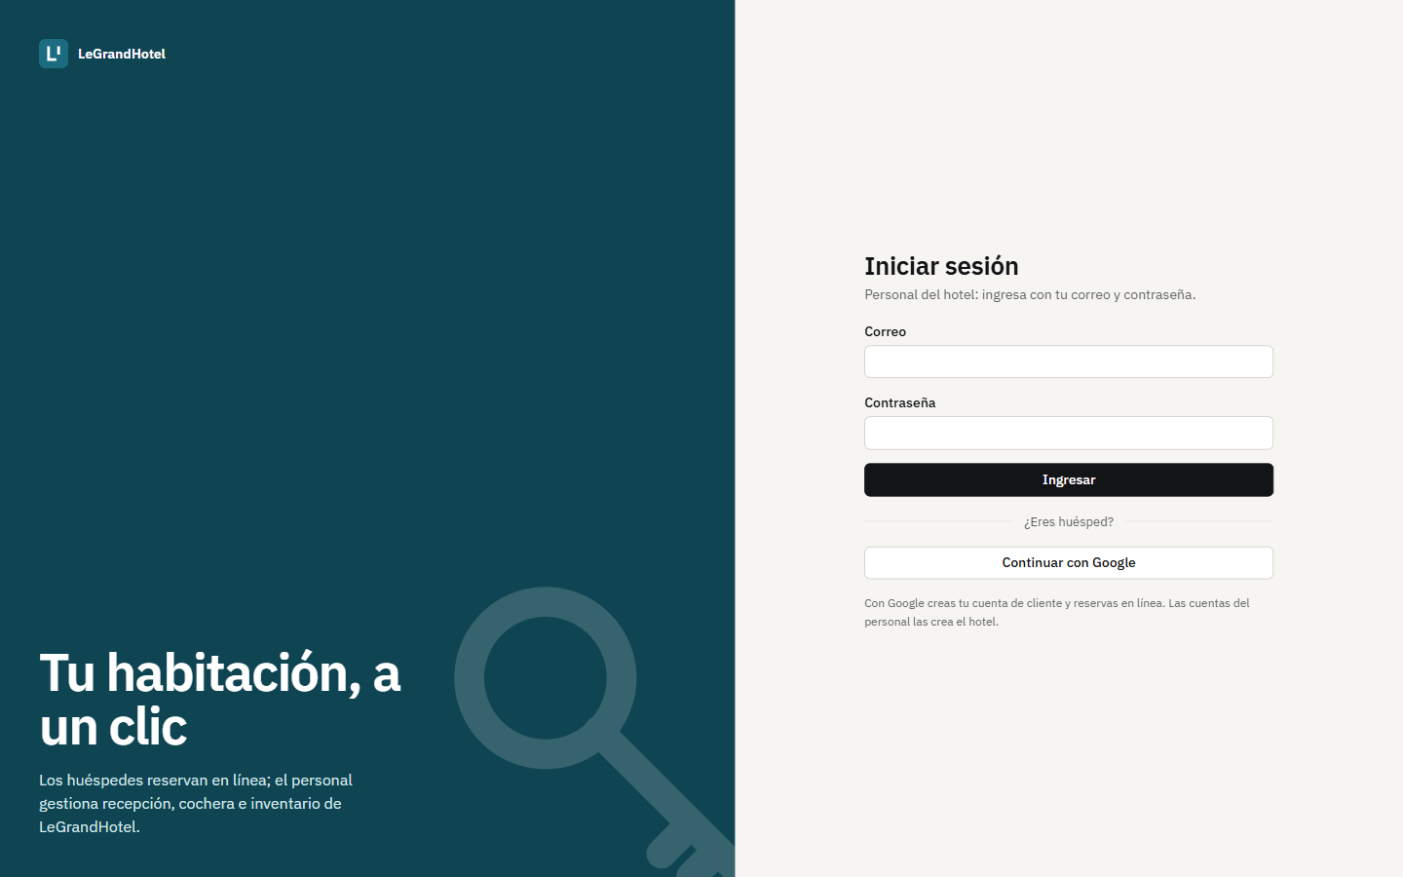
Figure 4. Login: staff sign in with email and password; guests with “Continuar con Google”. The interface is in Spanish.

3.1 Code excerpts
Password login only lets staff in; a guest who tries it gets 403:
api/app/Http/Controllers/Api/AuthController.php
if (! $user || ! $user->password || ! Hash::check($request->string('password'), $user->password)) {
throw new ApiException('INVALID_CREDENTIALS', 'Correo o contraseña incorrectos.', 401);
}
// Only staff sign in with a password; guests sign in with Google (they have no password).
if (! $user->hasRole(...Role::INTERNAL)) {
throw new ApiException('ACCOUNT_WITHOUT_ACCESS', 'Esta cuenta no tiene acceso al sistema del hotel.', 403);
}
Staff registration only accepts the allowed roles, and the route is protected by role and by an attempt limit:
api/routes/api.php and api/app/Http/Requests/Auth/RegisterRequest.php
Route::post('register', [AuthController::class, 'register'])
->middleware(['role:admin,developer', 'throttle:register']);

'password' => ['required', 'confirmed', Password::min(8)->letters()->numbers()],
'role' => ['required', Rule::in(Role::ASSIGNABLE)], // Front desk, Storeroom or Administration
Google is only for guests: if the email already belongs to a staff member, they are sent back to the login with a warning:
api/app/Http/Controllers/Api/GoogleAuthController.php
$user = User::where('google_id', $googleUser->getId())->orWhere('email', $googleUser->getEmail())->first();
// Google is only for guests: staff sign in with their email and password.
if ($user && ! $user->hasRole(Role::CLIENT)) {
return redirect()->away("{$frontend}/login?error=google_personal");
}
On the web, each route declares which roles can open it; otherwise the 403 screen is shown (and the API also answers 403):
web/src/auth/ProtectedRoute.tsx
export function ProtectedRoute({ roles }: { roles?: RoleName[] }) {
const { user, hasRole } = useAuth()
if (!user) return <Navigate to="/login" replace />
if (roles && !hasRole(...roles)) return <ForbiddenPage />
return <Outlet />
}

3.2 Registration screens
The “Register staff” and the guest’s “Complete registration” screens are shown with their description in sections 4.3 and 4.5.

4. What each role can do
Each role sees only its options in the menu. For each role, its menu is shown first and then each menu view separately, without the side bar, with a description of what it is for above each screenshot. When a view opens a pop-up window (form), only that window is shown. The screenshots were taken on October 27, 2026 with the page running on the project’s MySQL database (70 rooms, 1,000 guests and 5,000 demo reservations). The application interface is in Spanish; the menu option names are given in English with the Spanish label in quotes.
Menu option | Admin | Front desk | Storeroom | Developer | Guest
Dashboard («Panel») | ✓ | ✓ | ✓ | — | —
Reservations, Stays, Rooms, Guests, Parking | ✓ | ✓ | — | — | —
Room types | edits | views | — | — | —
Inventory | ✓ | — | ✓ | — | —
Staff, Users and roles, Reports, Audit, Billing | ✓ | — | — | — | —
Register staff | ✓ | — | — | ✓ | —
Developer view | ✓ | — | — | ✓ | —
Book, My bookings | — | — | — | — | ✓

If someone types the address of an option that is not in their menu, they see the 403 screen (section 5) and the API also answers 403.

4.1 Receptionist
Serves guests day to day: books for them, does check-in and check-out, and manages parking and room status.
Receptionist menu
It has the “Inicio” group with the Dashboard and the “Recepción” group with its six work views. It does not see Inventory or the Administration options.
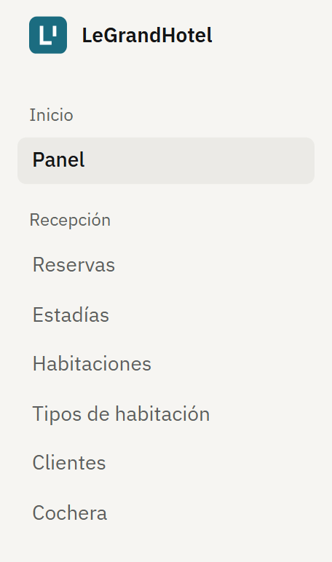
Figure 5. Receptionist menu.
Front desk dashboard («Panel»)
Summary of the day: occupancy, free rooms, today’s arrivals and departures and rooms being cleaned. On the right, today’s arrivals with their check-in button and the supplies below the minimum; below, the room board by floor with each room’s status.
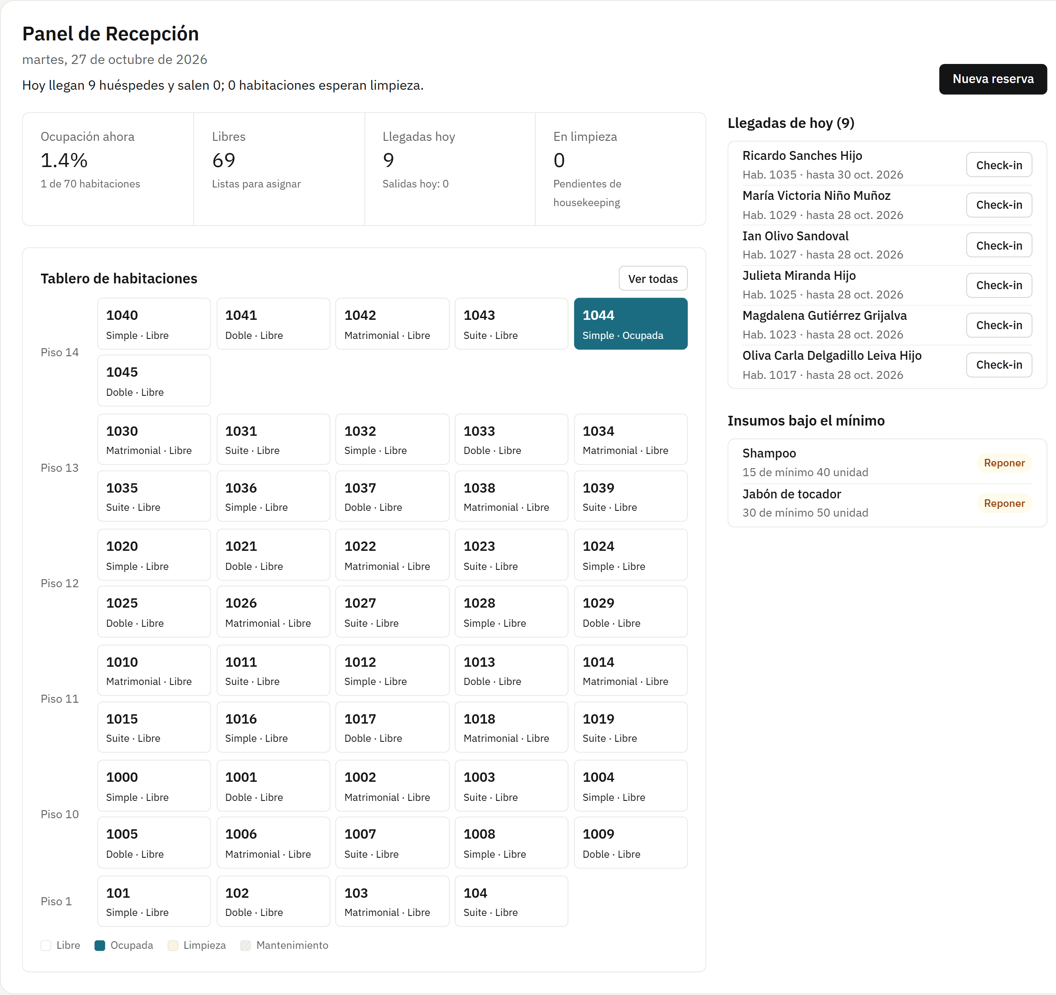
Figure 6. Front desk dashboard («Panel»)
Reservations («Reservas»)
Reservation list paginated on the server, with tabs by status (confirmed, pending, checked in, completed and cancelled) and search by guest or document. From each row you can check in or cancel the reservation.
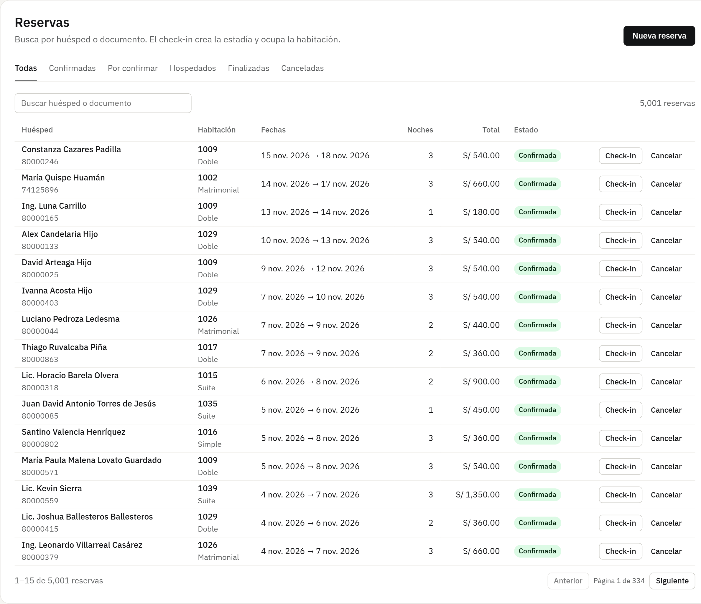
Figure 7. Reservations («Reservas»)
Pop-up window: New reservation
You search for the guest, choose the dates and number of guests, and only the rooms free for those dates appear. The server calculates the total; if someone else takes the same room at the same moment, the API answers 409.
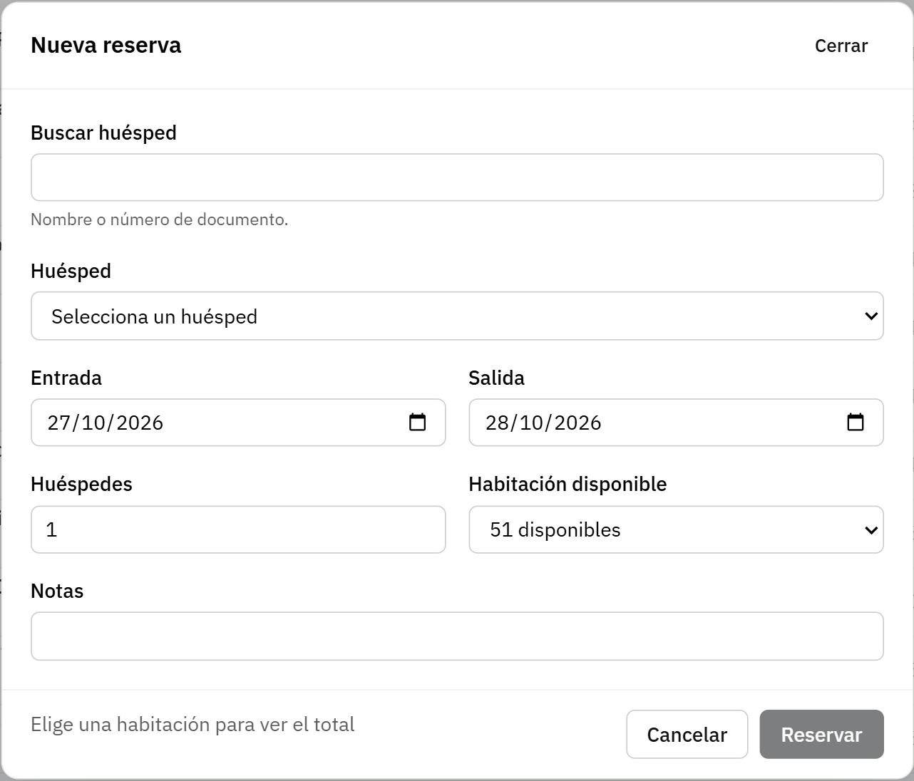
Figure 8. Pop-up window: New reservation
Stays («Estadías»)
Guests currently in the hotel and the stay history. Check-out closes the stay, sends the room to cleaning and frees its parking spot.
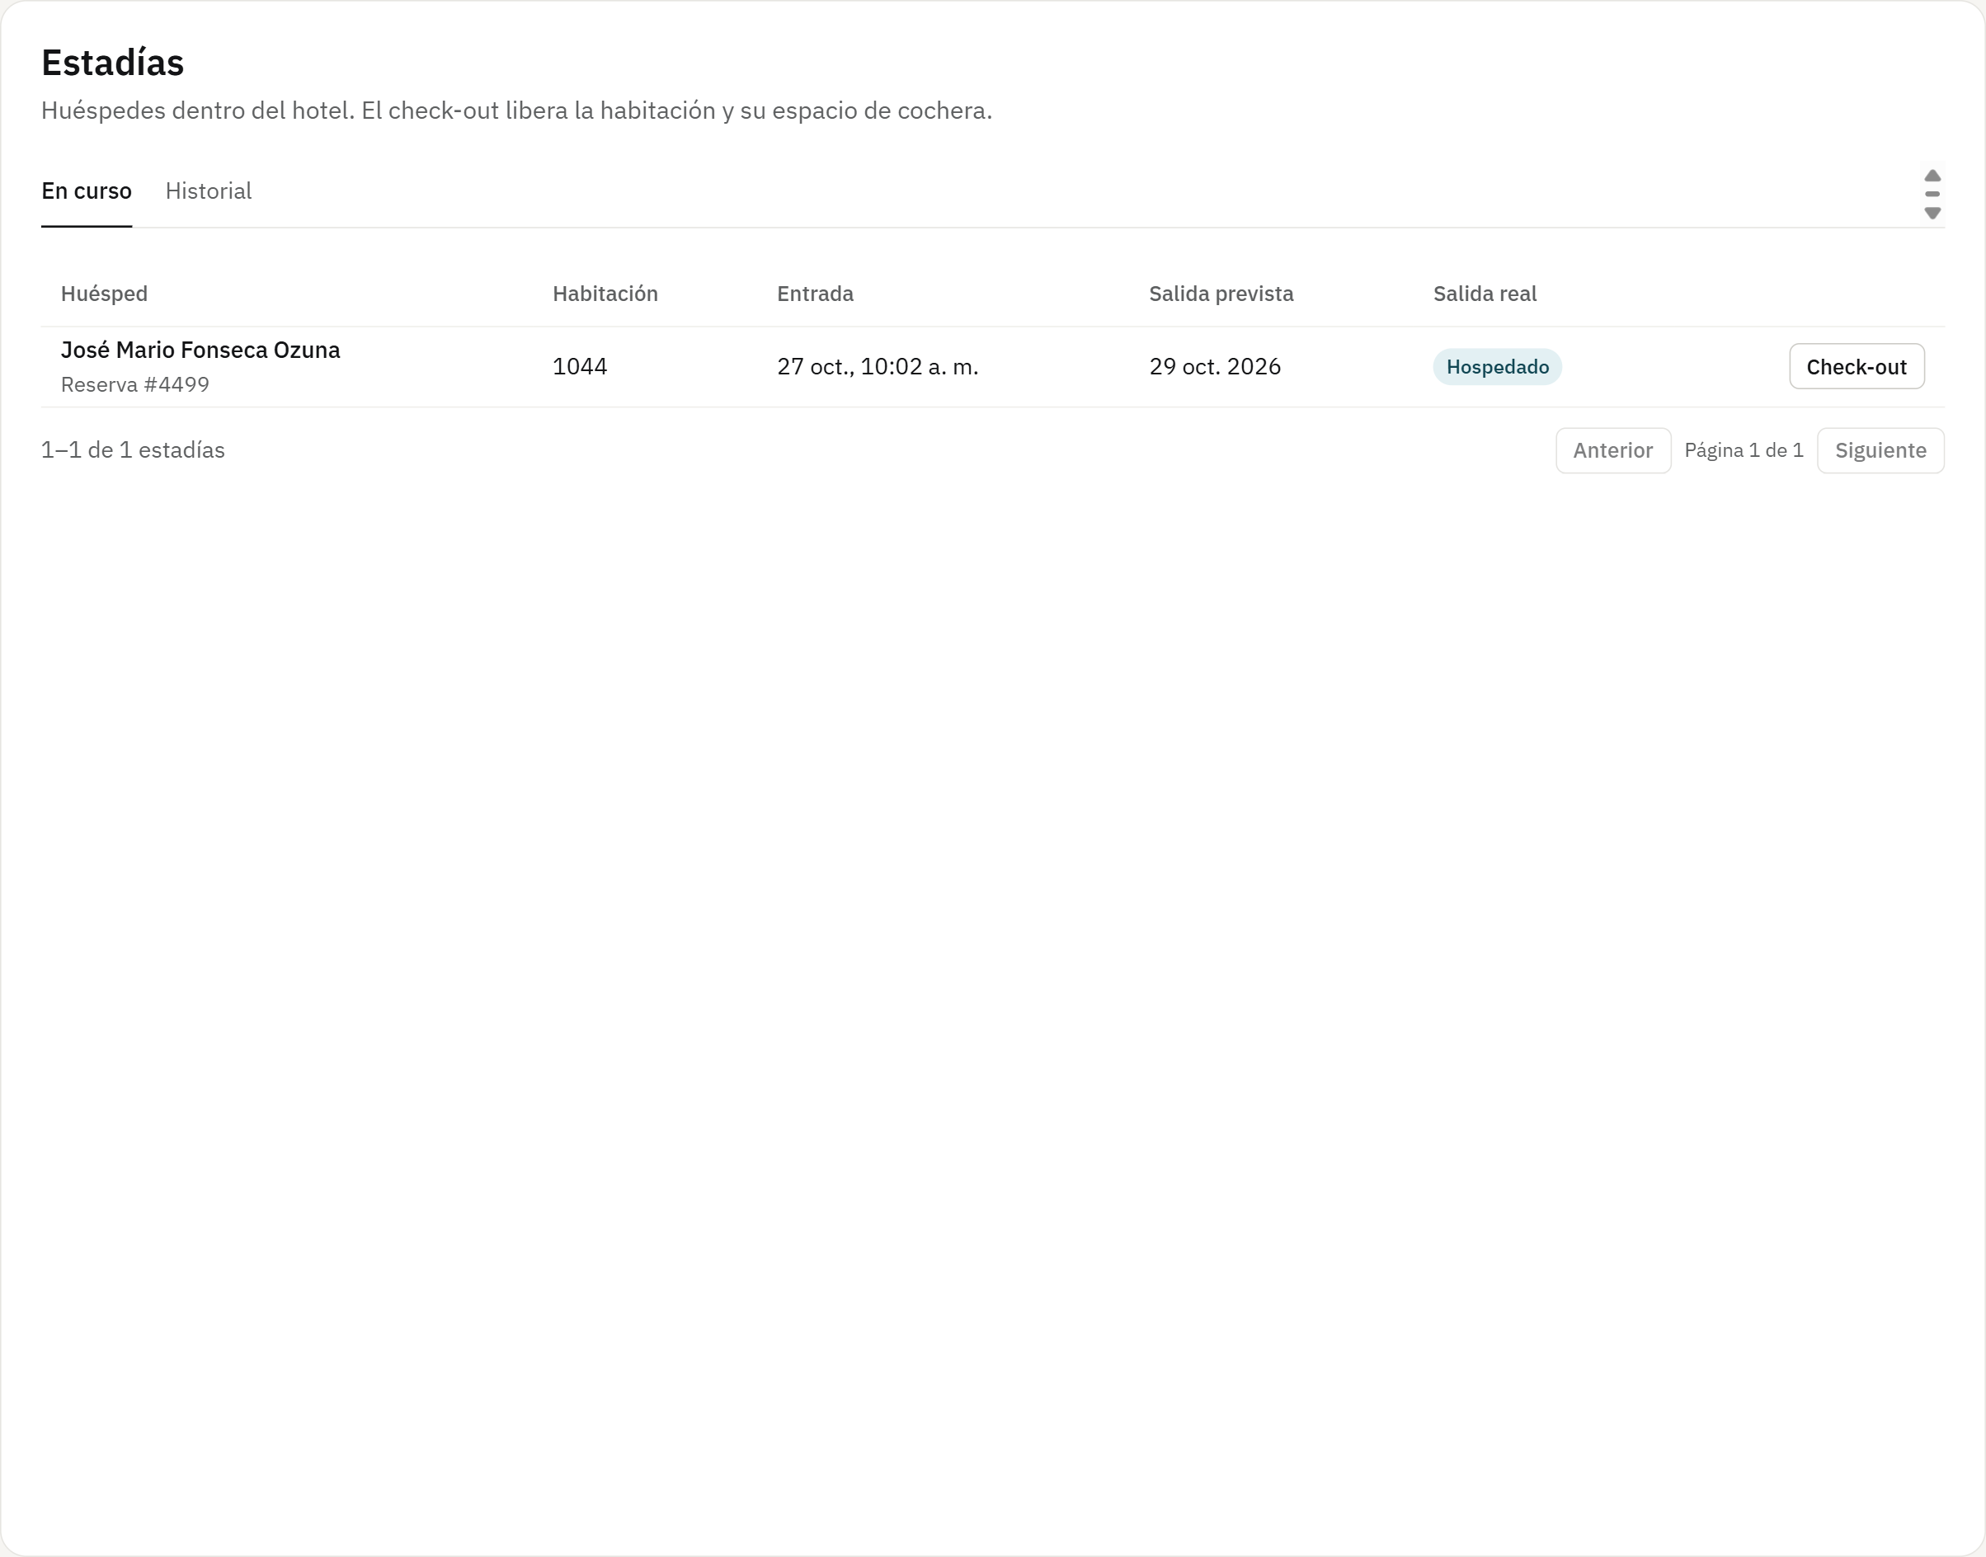
Figure 9. Stays («Estadías»)
Rooms («Habitaciones»)
Rooms with their floor, type, capacity, price and status, filterable by status. The front desk marks them as “ready” after cleaning.
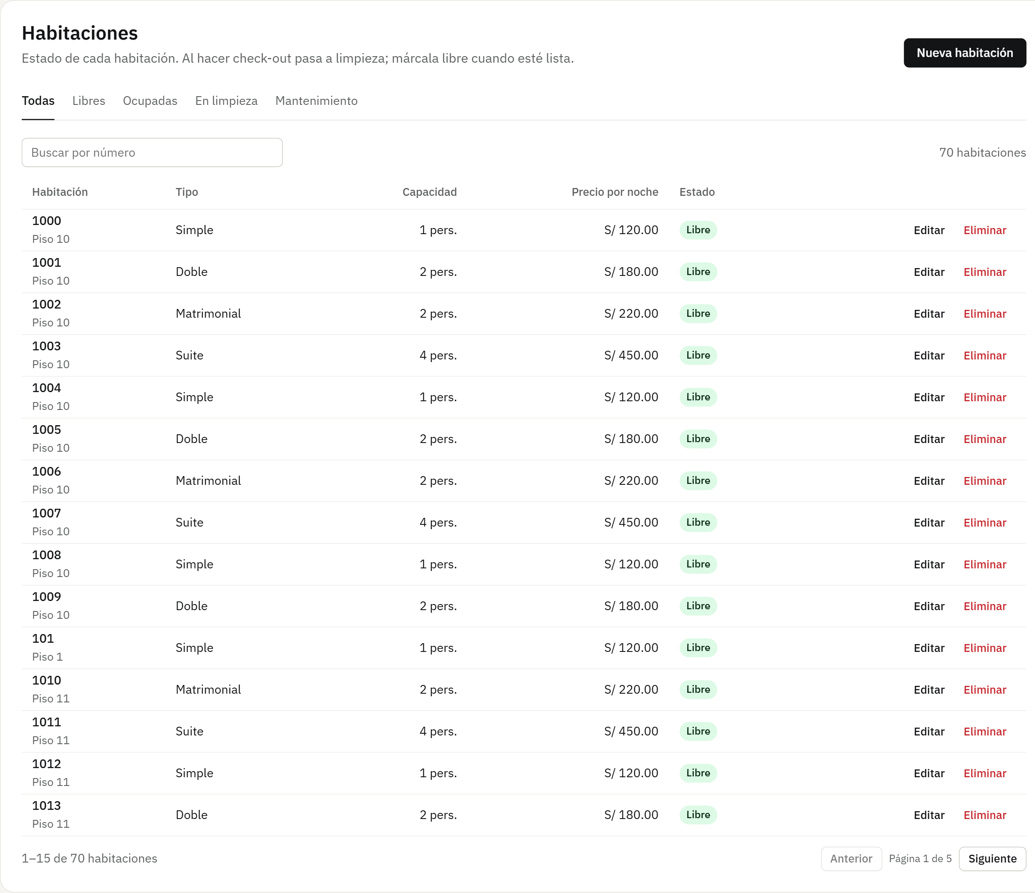
Figure 10. Rooms («Habitaciones»)
Room types (read only)
The front desk checks the price per night, capacity and amenities of each type to inform guests, but cannot create or change them.
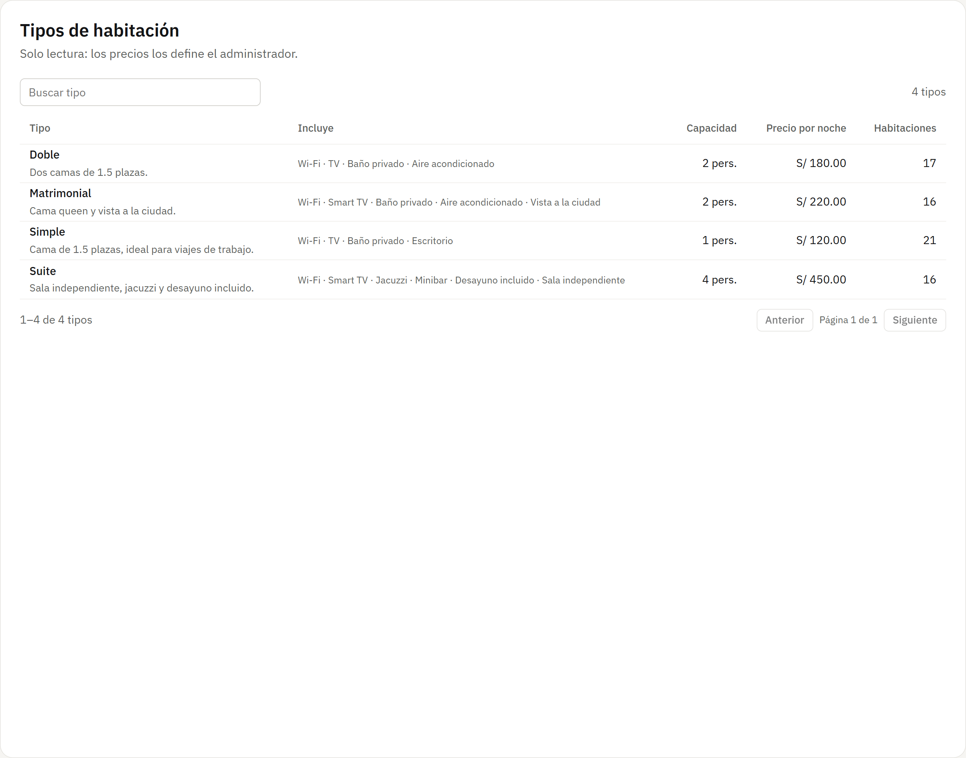
Figure 11. Room types (read only)
Guests («Clientes»)
Guest records with their document, phone, whether they have a web account and how many reservations they have. Only a guest without reservations can be deleted.
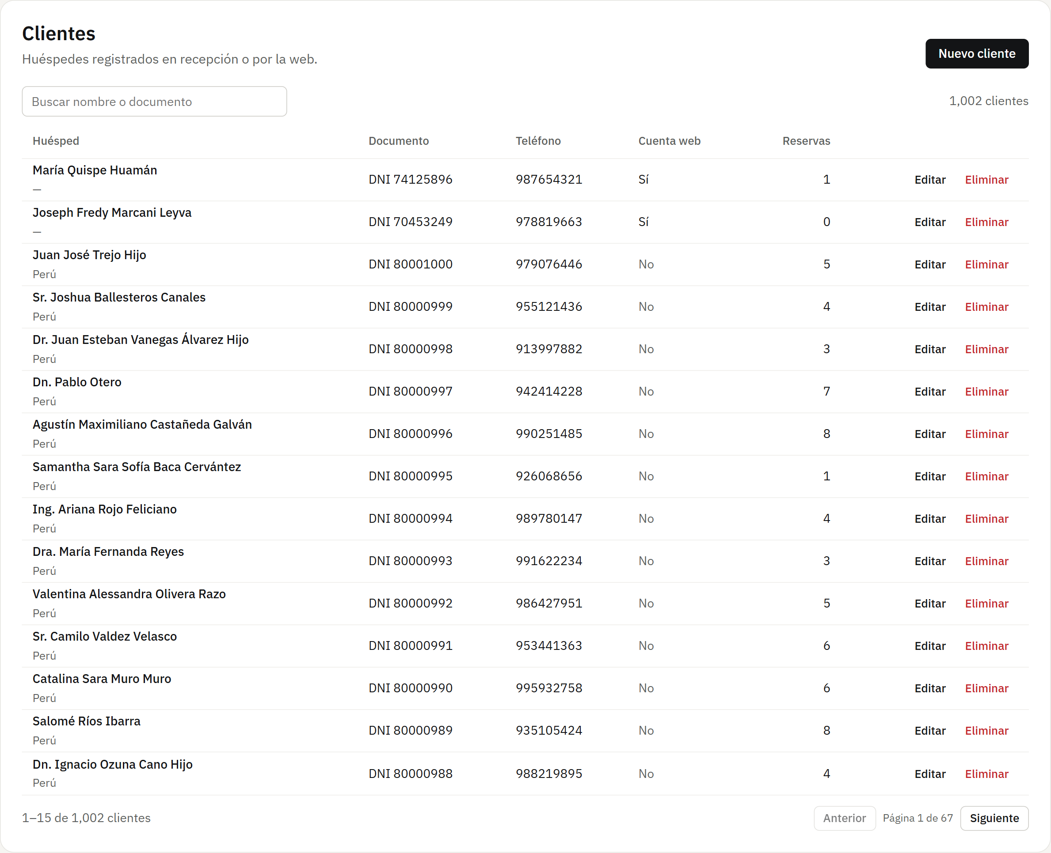
Figure 12. Guests («Clientes»)
Pop-up window: New guest
Registers a guest who arrives or calls: name, document type and number (cannot repeat), phone and nationality.
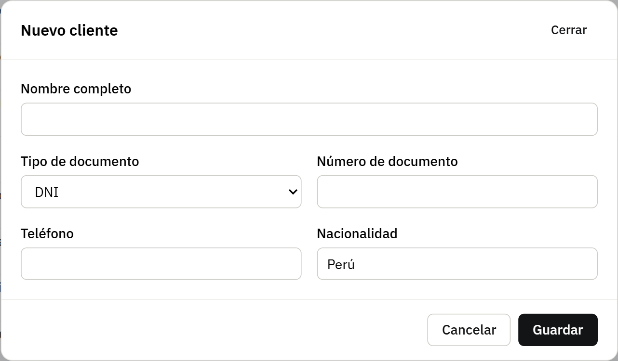
Figure 13. Pop-up window: New guest
Parking («Cochera»)
Vehicles currently inside and the parking spots with their status.
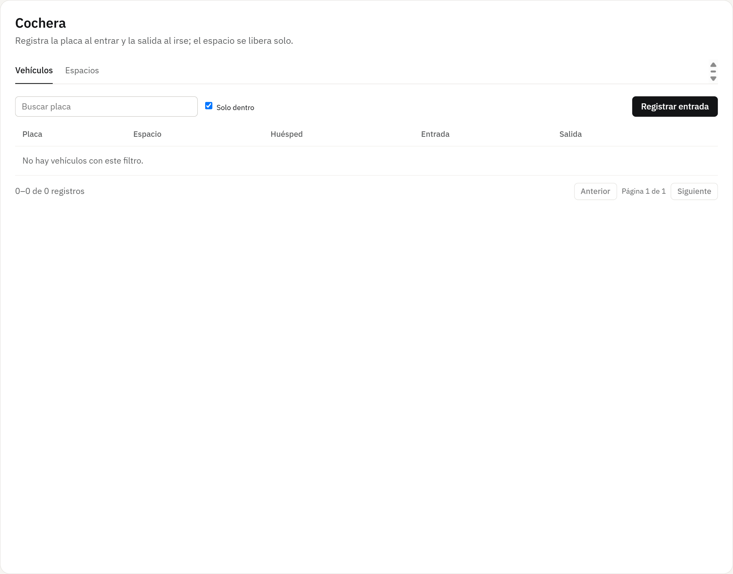
Figure 14. Parking («Cochera»)
Pop-up window: Record parking entry
You enter the plate, the free spot and, if applicable, the guest’s stay. If the spot is already taken, the API answers 409 PARKING_SPOT_NOT_FREE.
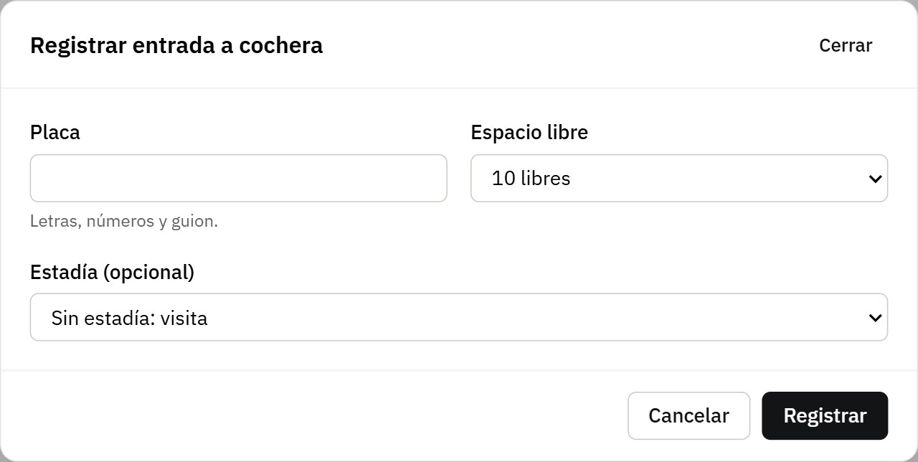
Figure 15. Pop-up window: Record parking entry

4.2 Storekeeper
Manages the hotel’s supplies: what comes in, what goes out and what needs restocking.
Storekeeper menu
It has only two options: the Dashboard and Inventory.
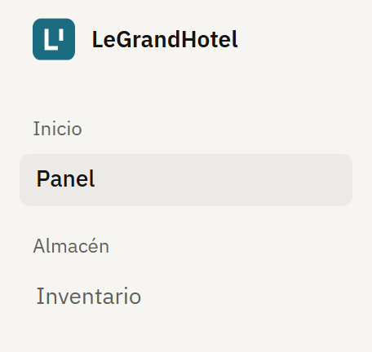
Figure 16. Storekeeper menu.
Storeroom dashboard («Panel»)
Shows the supplies below the minimum, to restock them in time, and the button to record a movement.
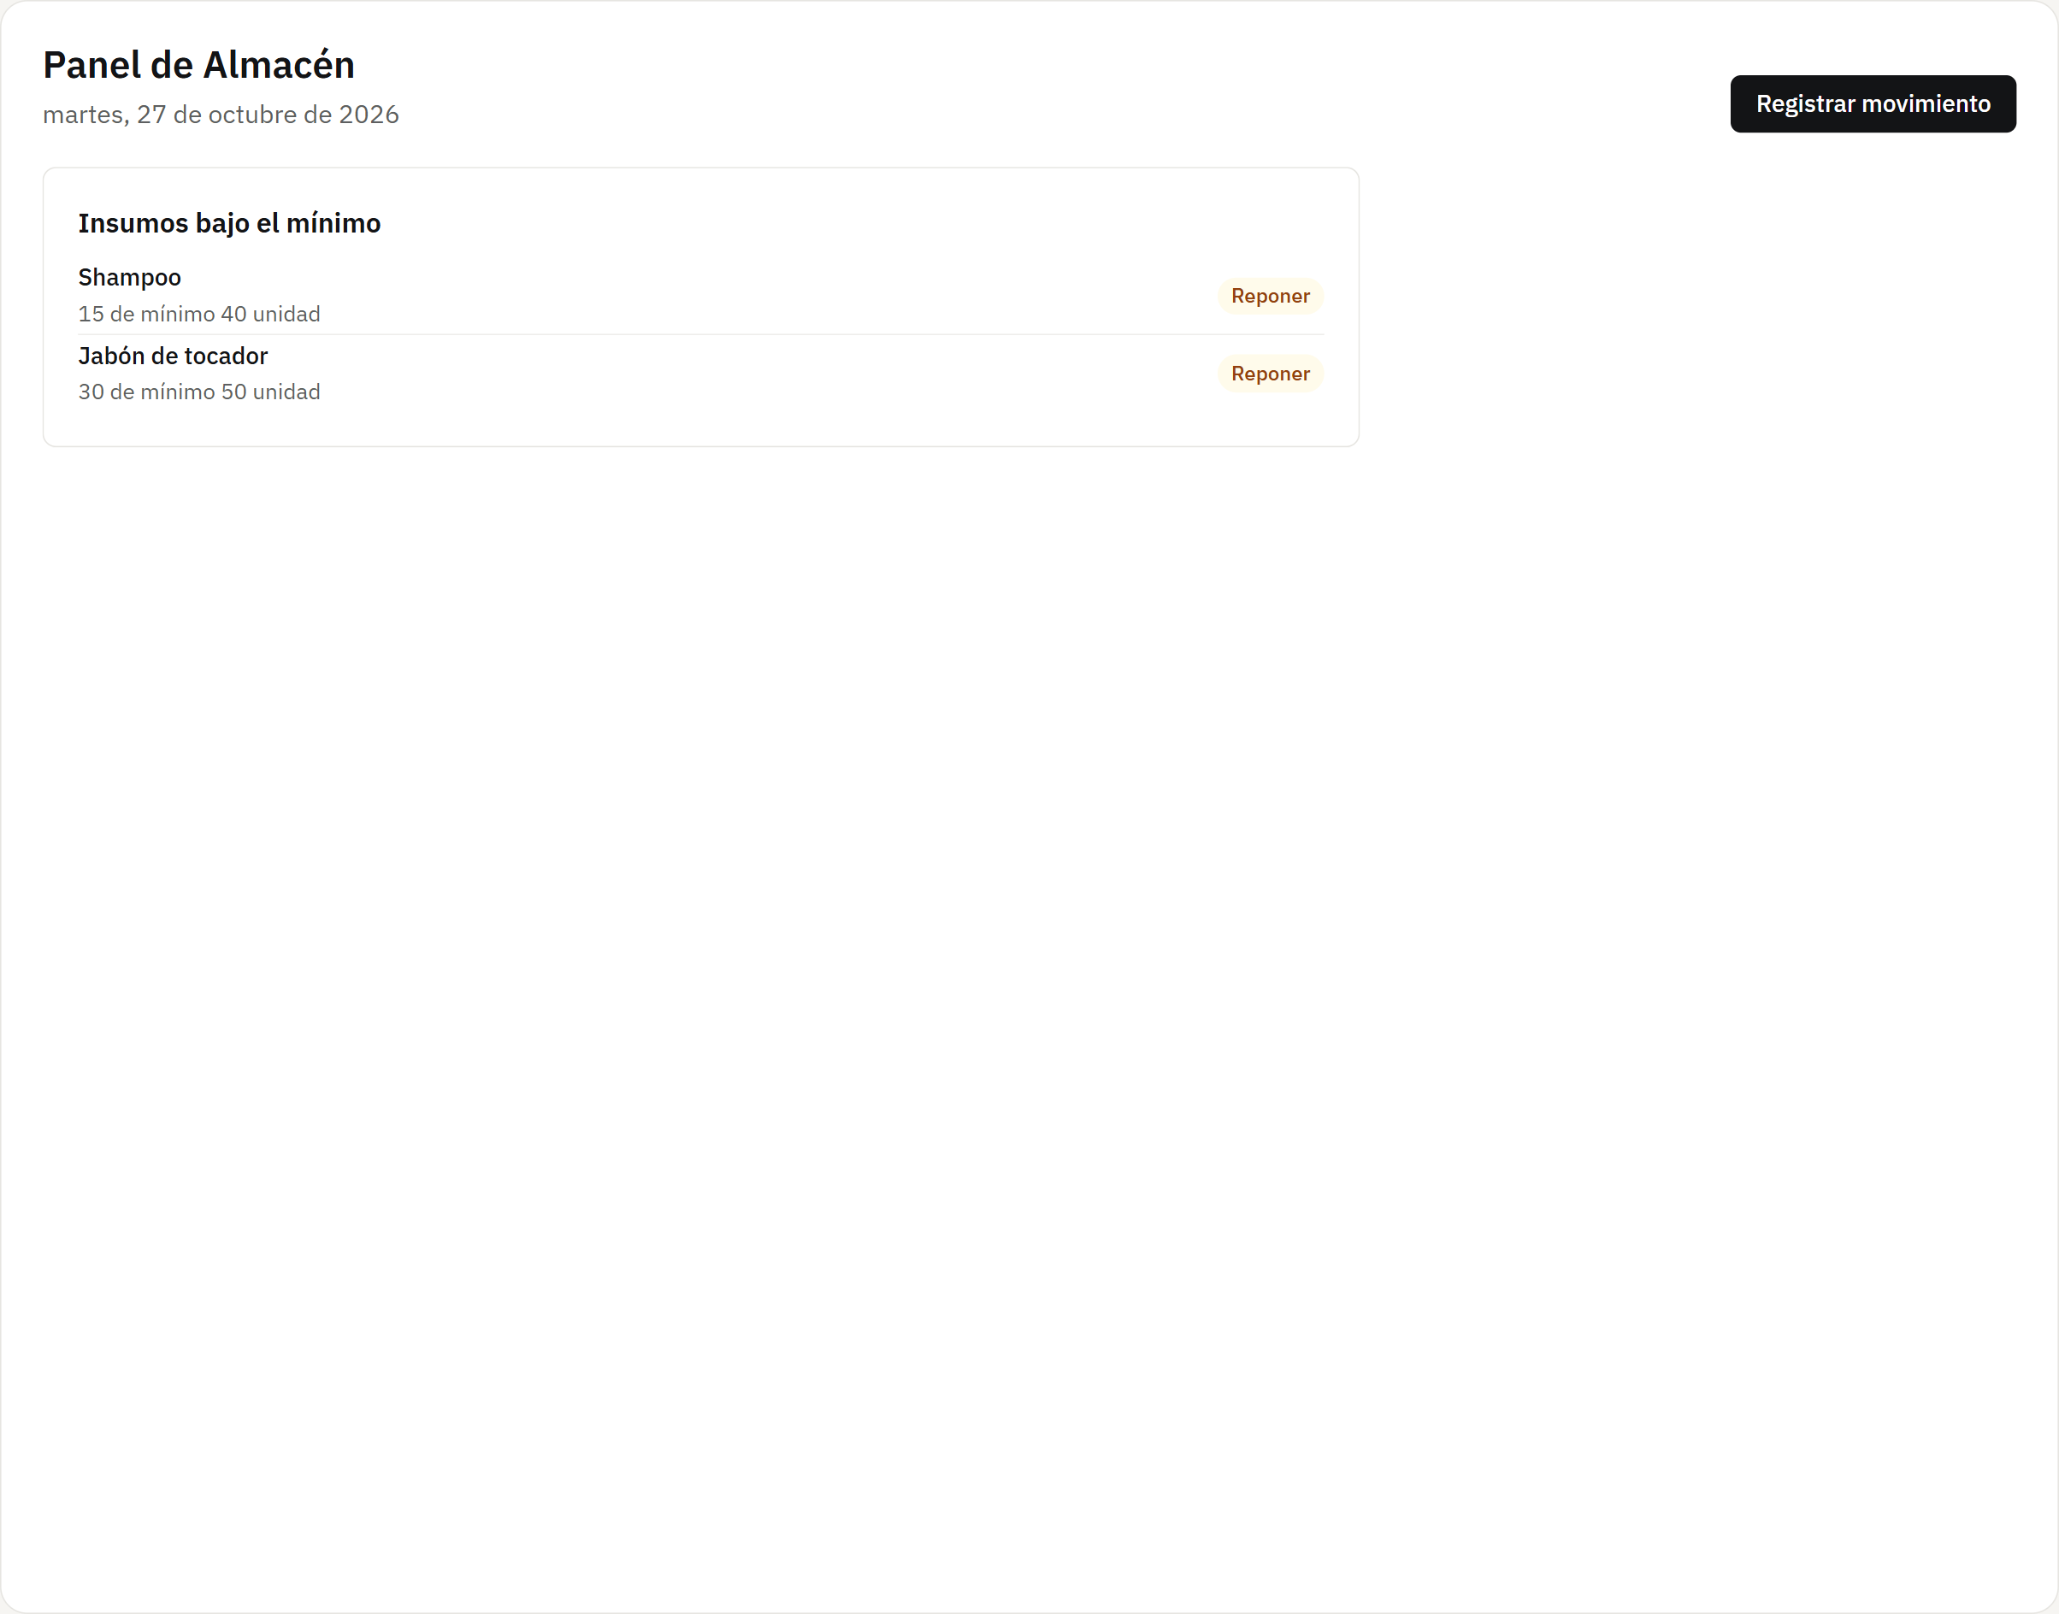
Figure 17. Storeroom dashboard («Panel»)
Inventory («Inventario»)
Each supply with its unit, stock, minimum and a level bar; you can show only those below the minimum. From each row you record a movement or edit the supply.
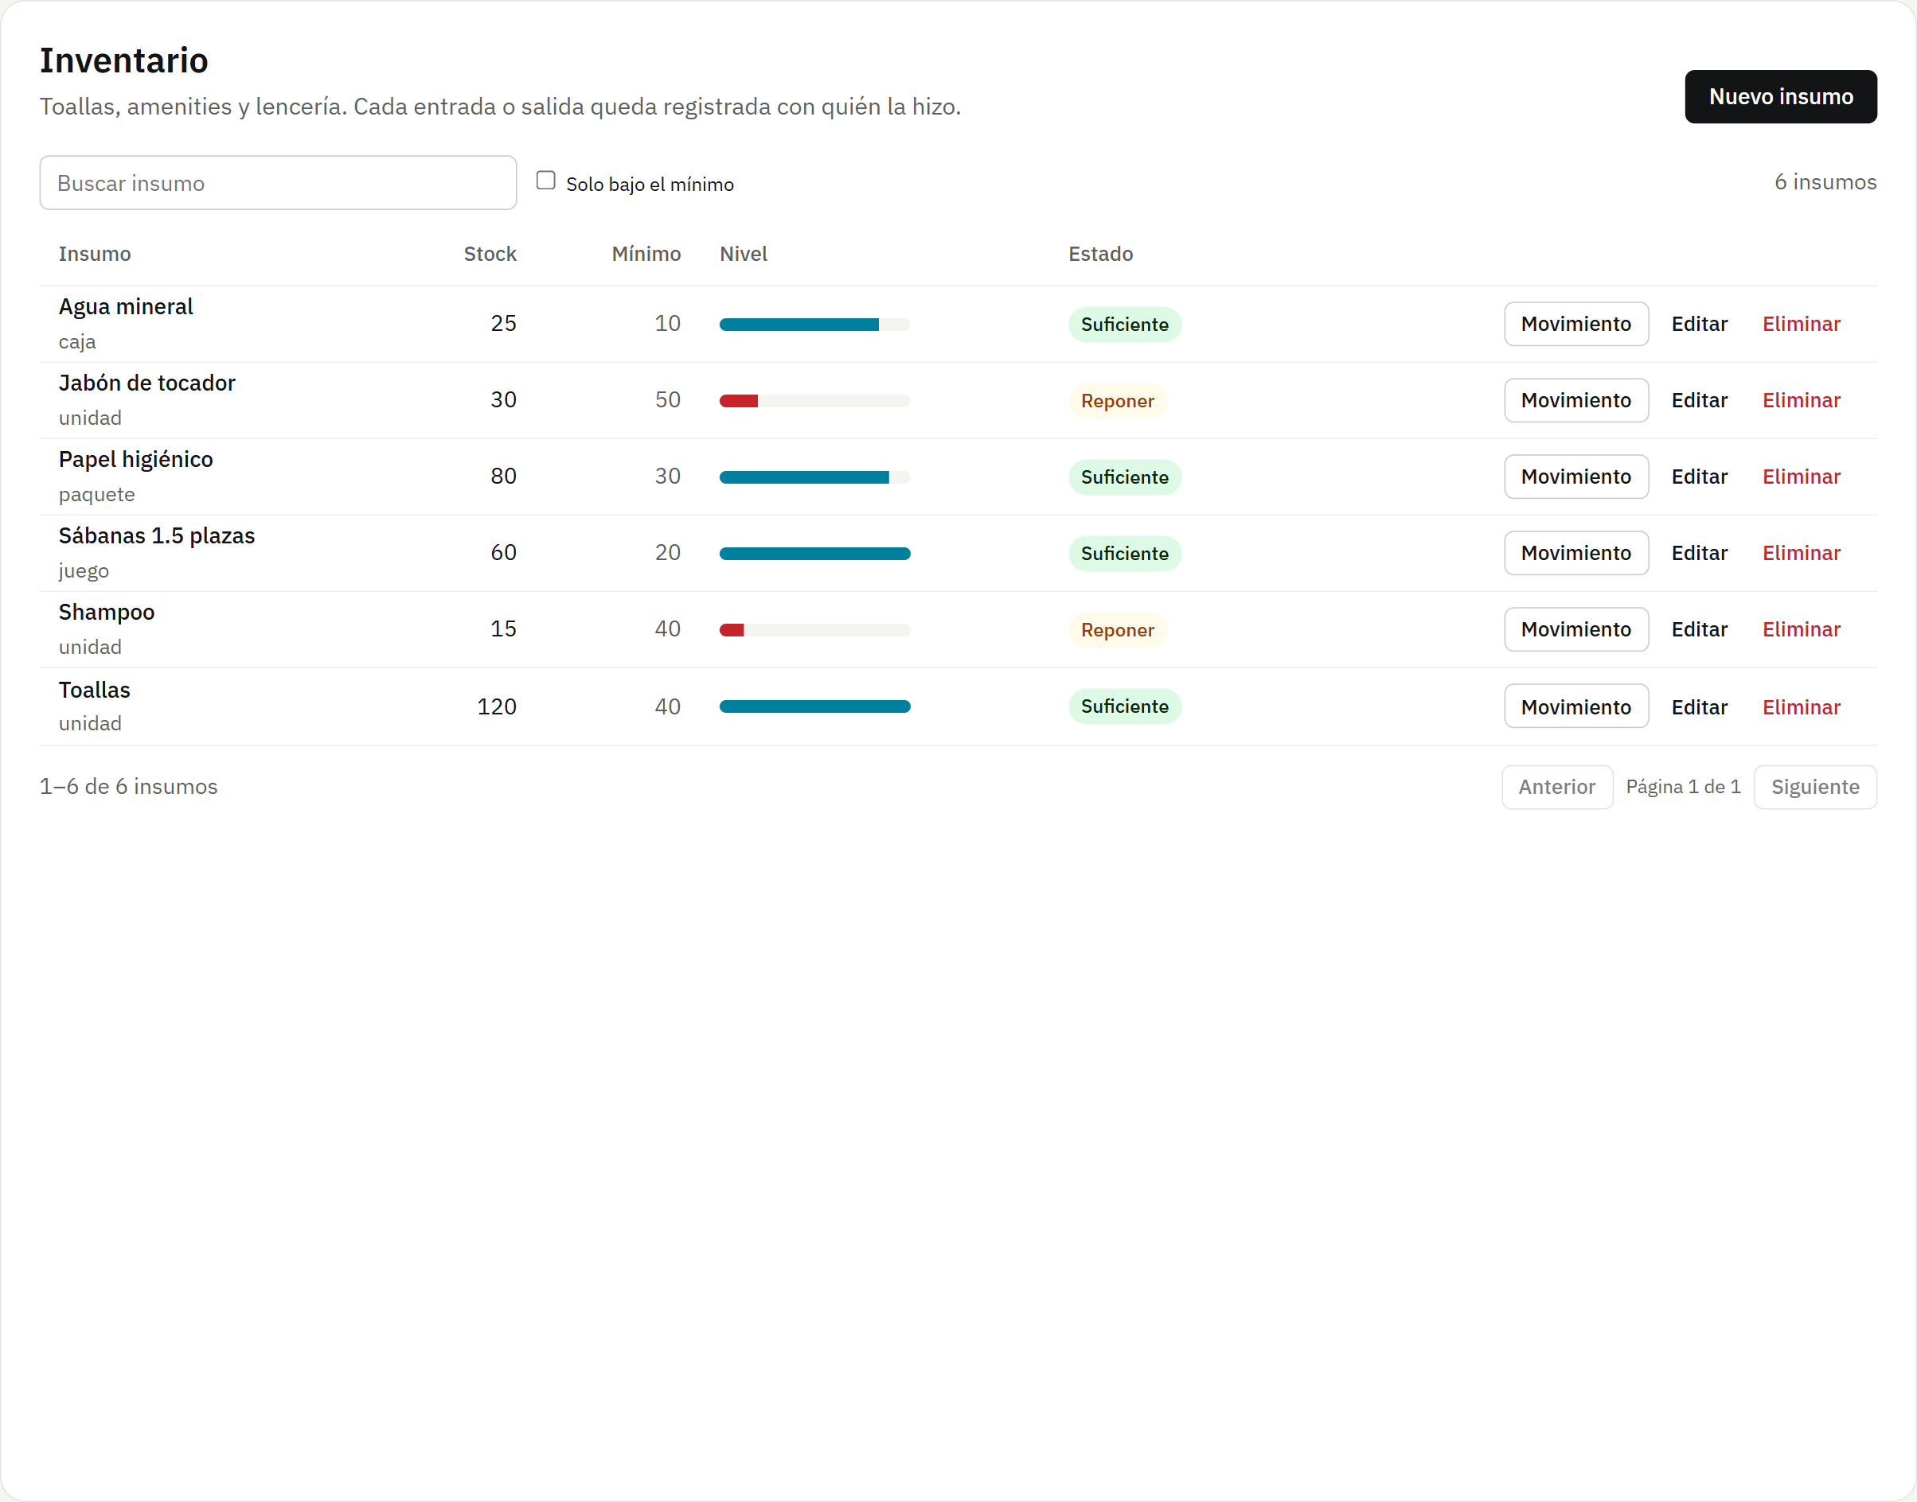
Figure 18. Inventory («Inventario»)
Pop-up window: Record movement
Stock in or out with quantity and reason; the latest movements of the supply appear below. The API does not allow taking out more than there is (409 INSUFFICIENT_STOCK).
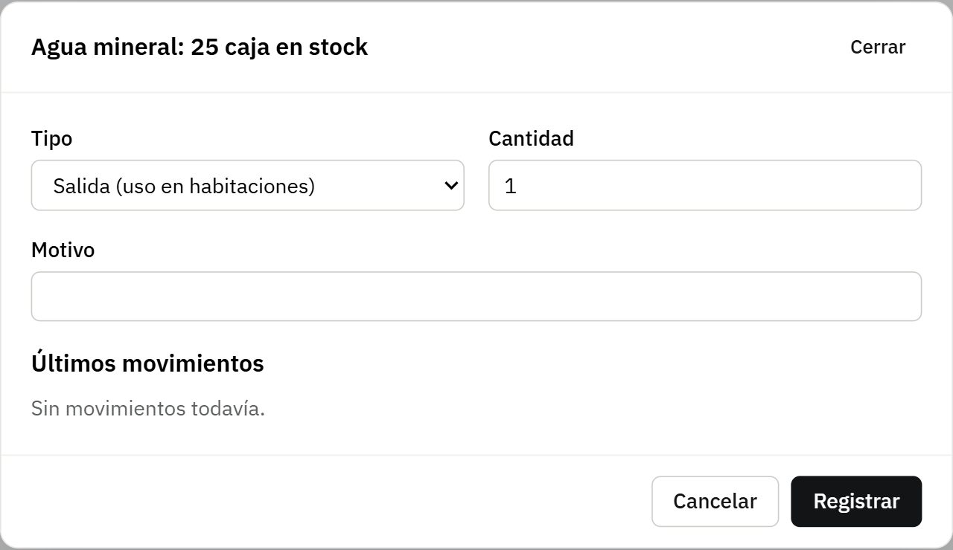
Figure 19. Pop-up window: Record movement
Pop-up window: New supply
Name, unit, initial stock and minimum. After that, stock only changes through movements, so everything is recorded.
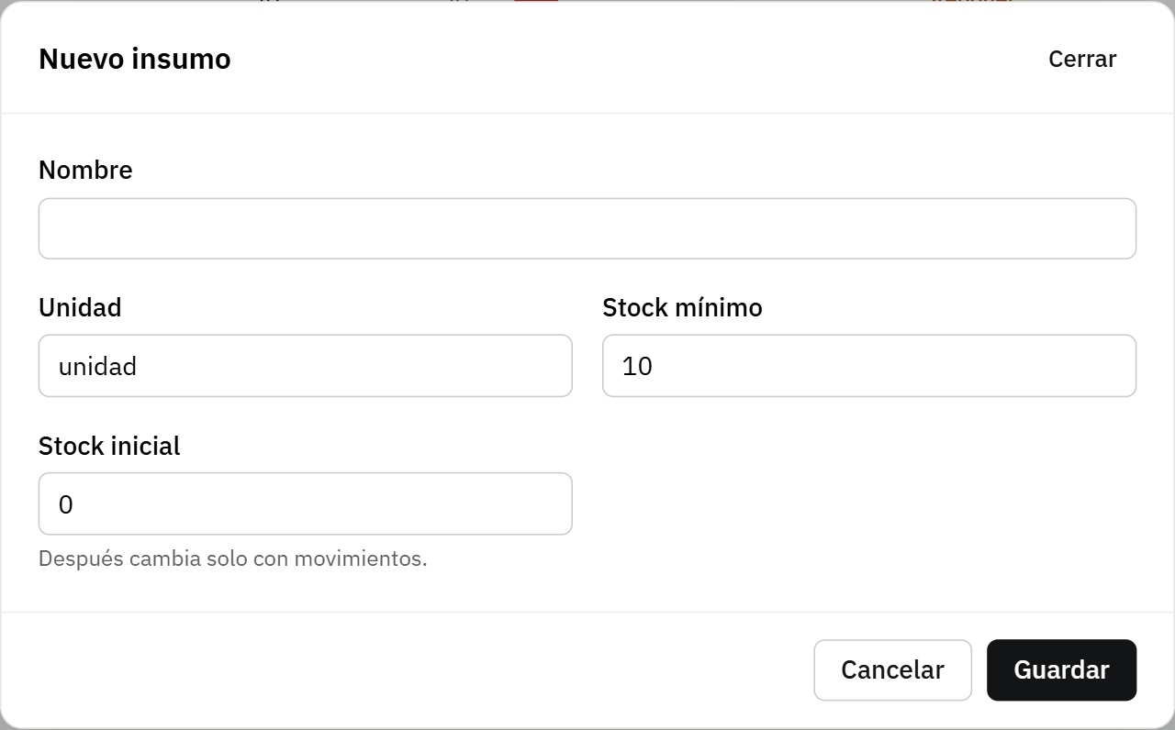
Figure 20. Pop-up window: New supply

4.3 Administrator
Responsible for the system: has every staff option, defines room types and prices, manages staff and their accounts, and reviews reports and the audit log.
Administrator menu
It is the full menu: Inicio, Recepción, Almacén, Administración and Programador.
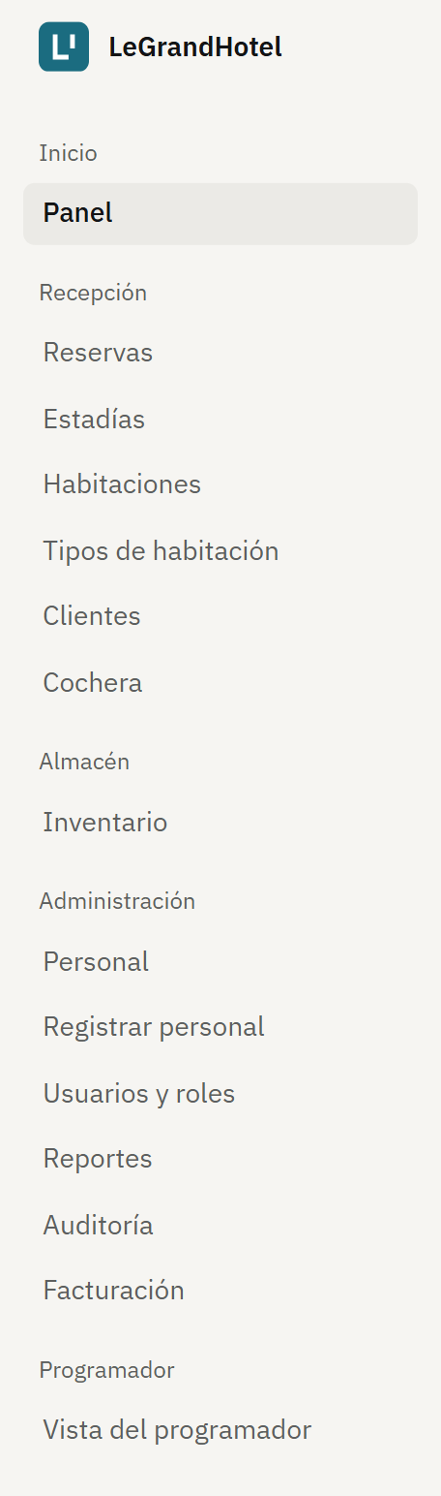
Figure 21. Administrator menu.
Administrator dashboard («Panel»)
The same daily summary as the front desk, plus the month’s income.
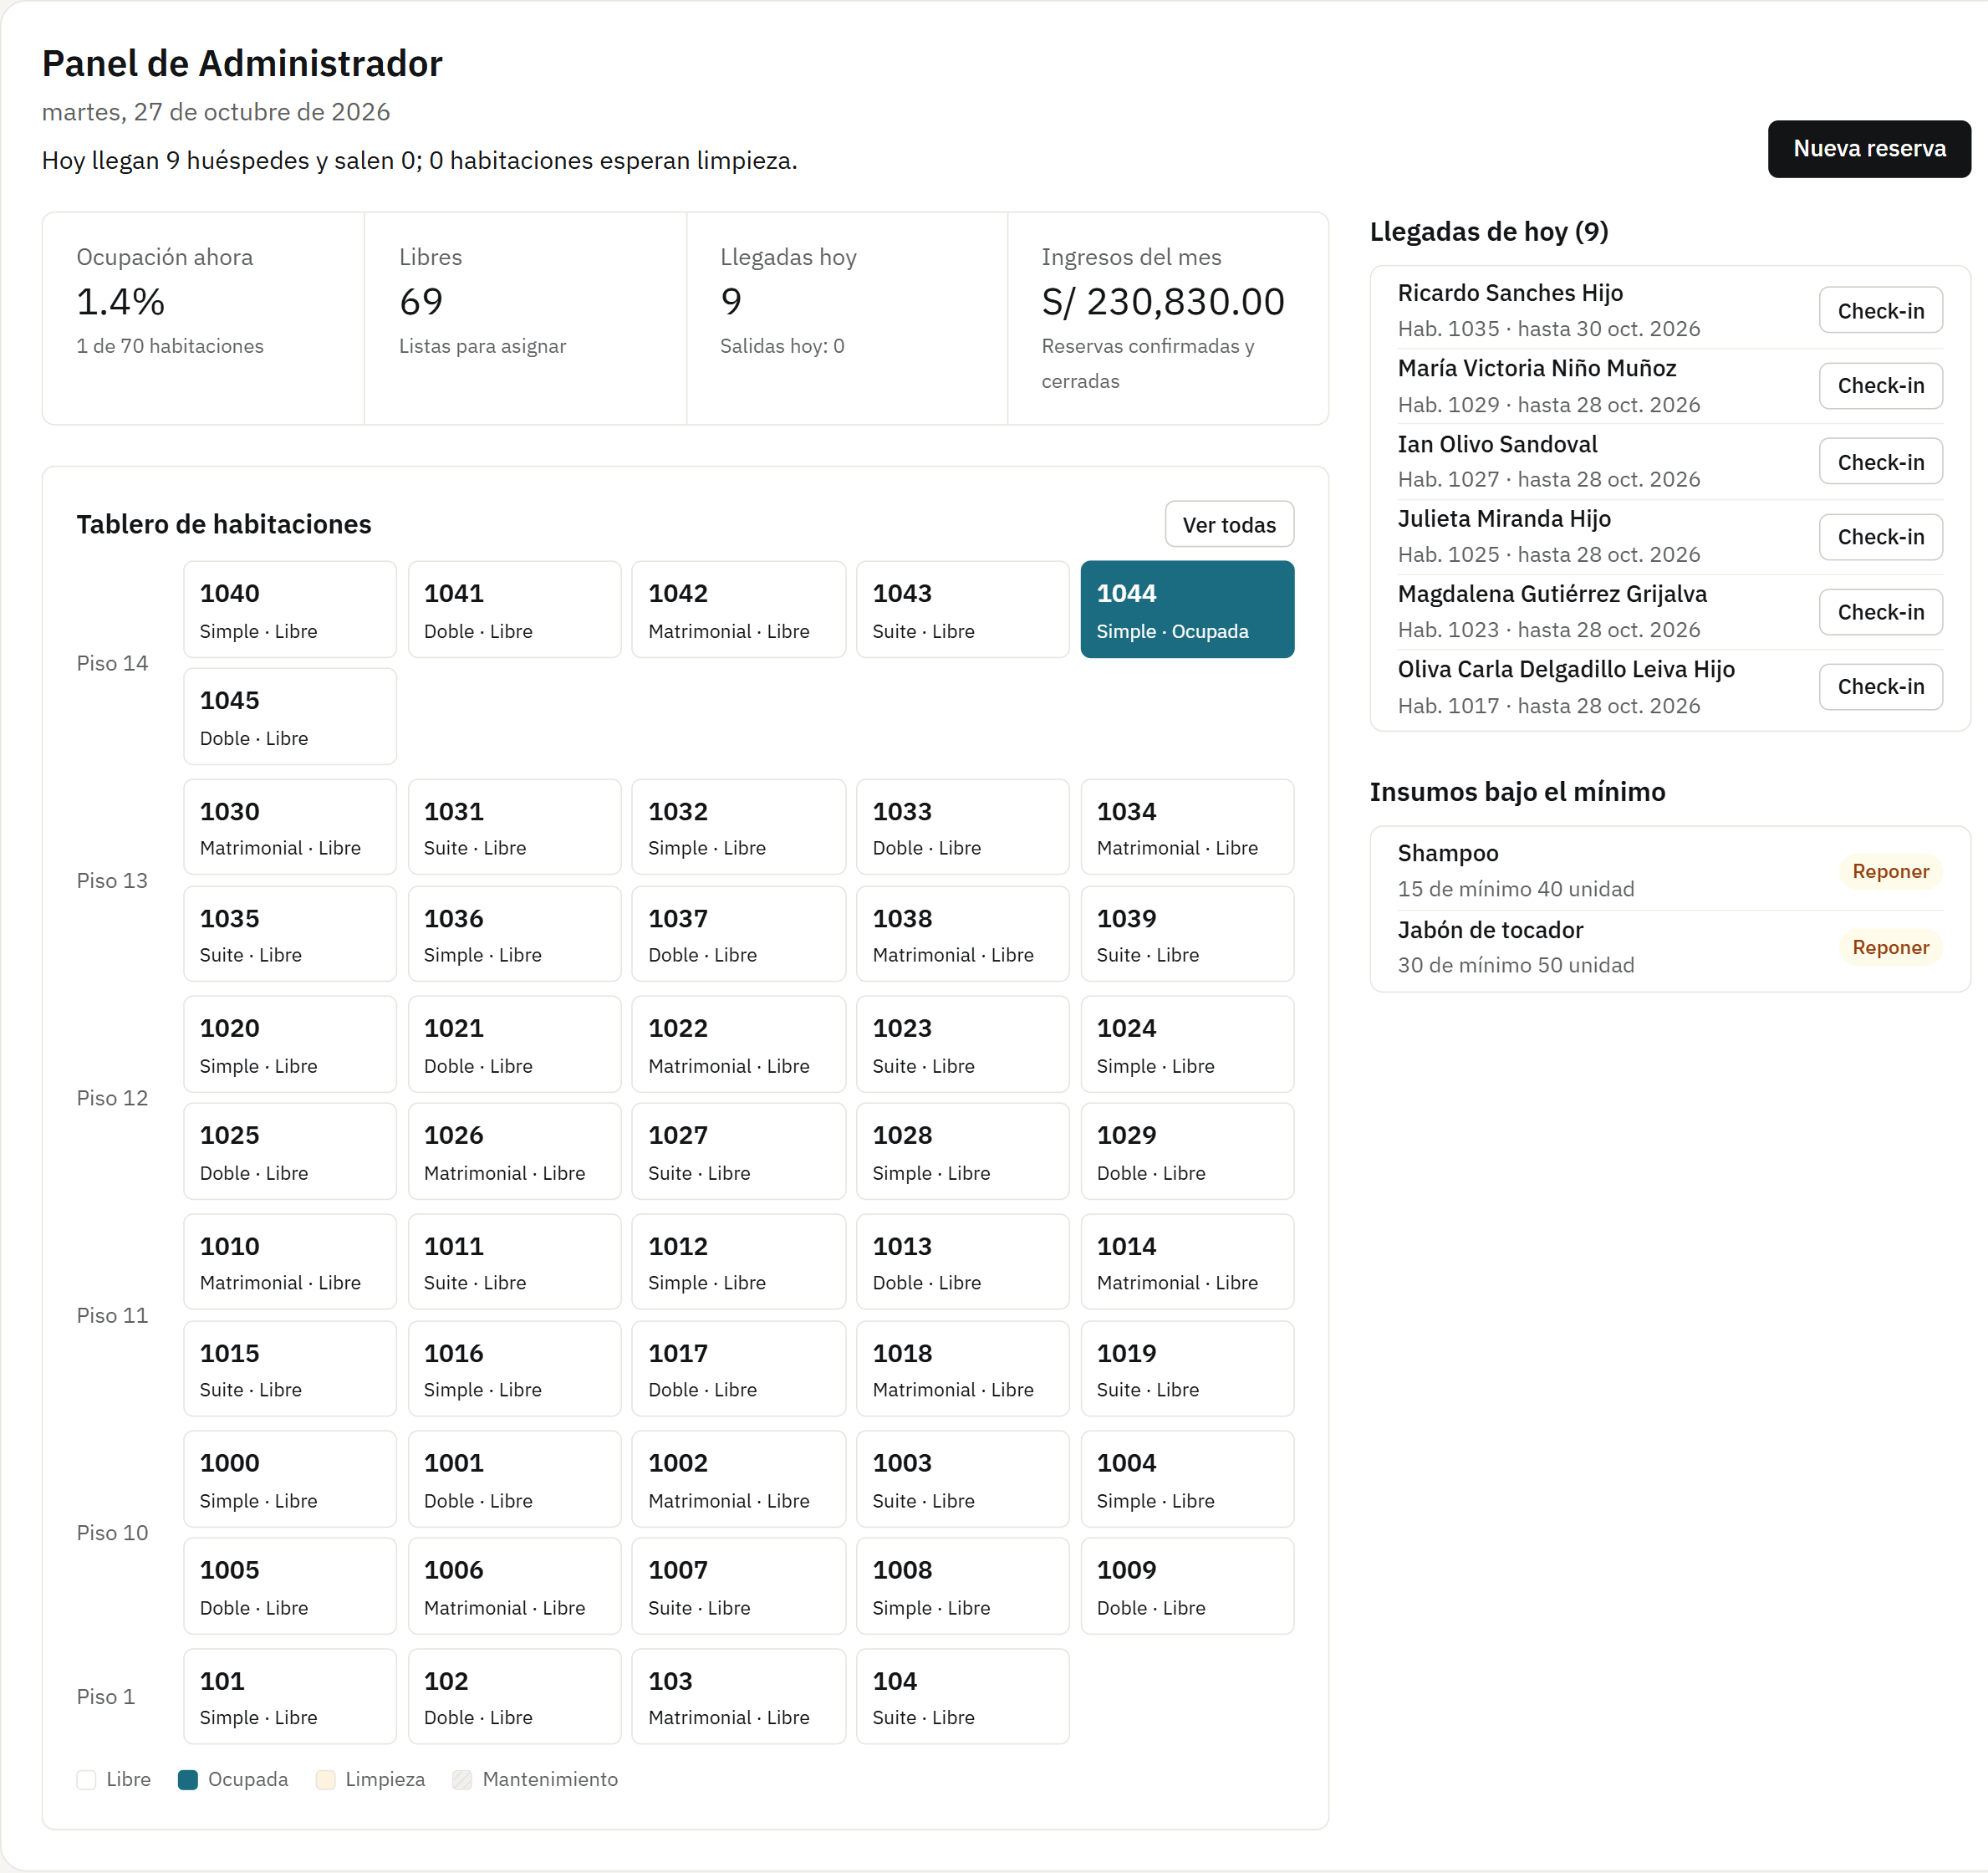
Figure 22. Administrator dashboard («Panel»)
Reservations
The same reservations the front desk manages: the Administrator can also create, check in and cancel.
Figure 23. Reservations
Stays
Guests in the hotel and the history, with check-out.
Figure 24. Stays
Rooms
Rooms by status; the Administrator also creates and edits rooms.
Figure 25. Rooms
Pop-up window: New room
Number (unique), floor, type and initial status of the room.
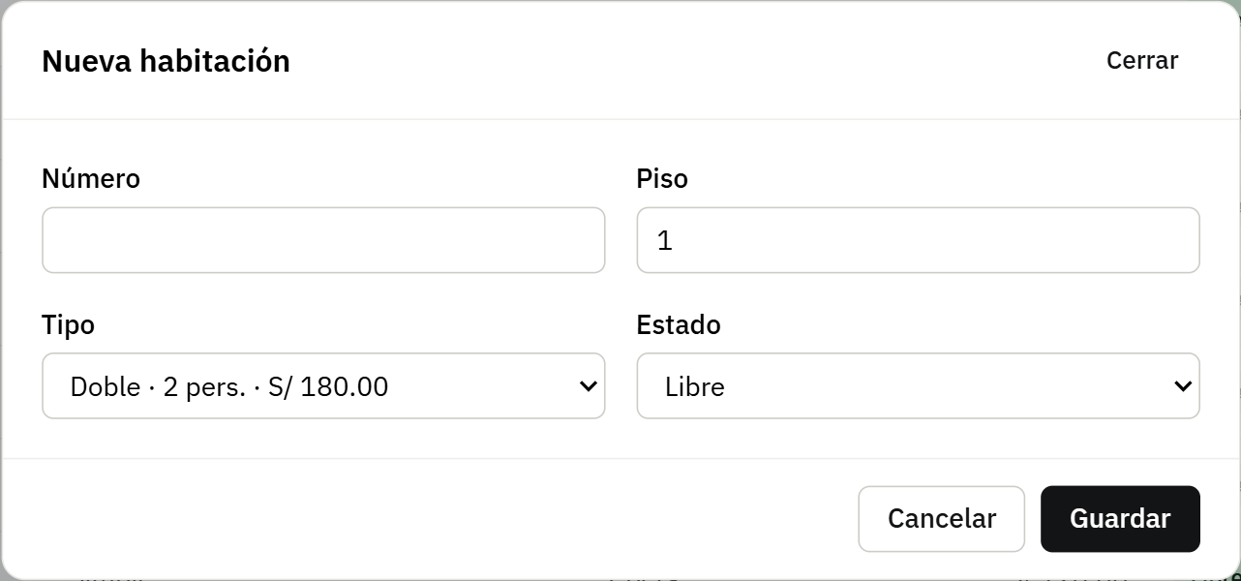
Figure 26. Pop-up window: New room
Room types
Unlike the front desk, the Administrator creates, edits and deletes room types.
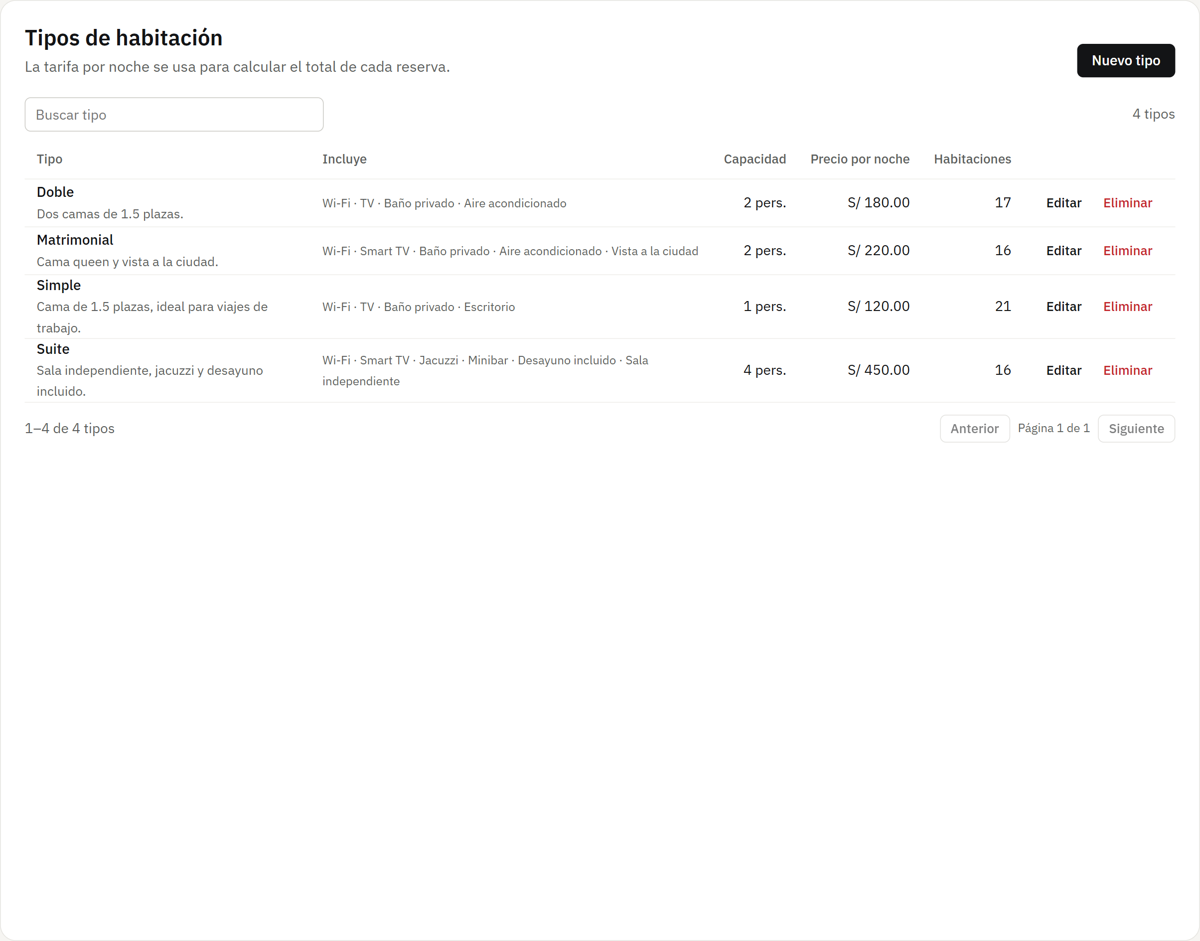
Figure 27. Room types
Pop-up window: New room type
Name, capacity, price per night, description and amenities, comma-separated. This is what the guest sees when booking.
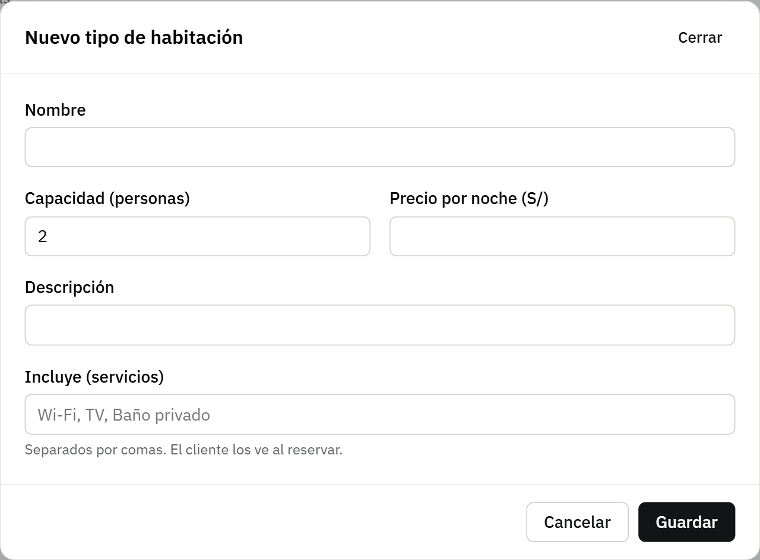
Figure 28. Pop-up window: New room type
Guests
The guest records, same as the front desk.
Figure 29. Guests
Parking
Vehicles and spots; the Administrator also adds spots.
Figure 30. Parking
Inventory
The same inventory as the Storekeeper, with the same permissions.
Figure 31. Inventory
Staff («Personal»)
Staff records with position, shift and start date, each linked to its account.
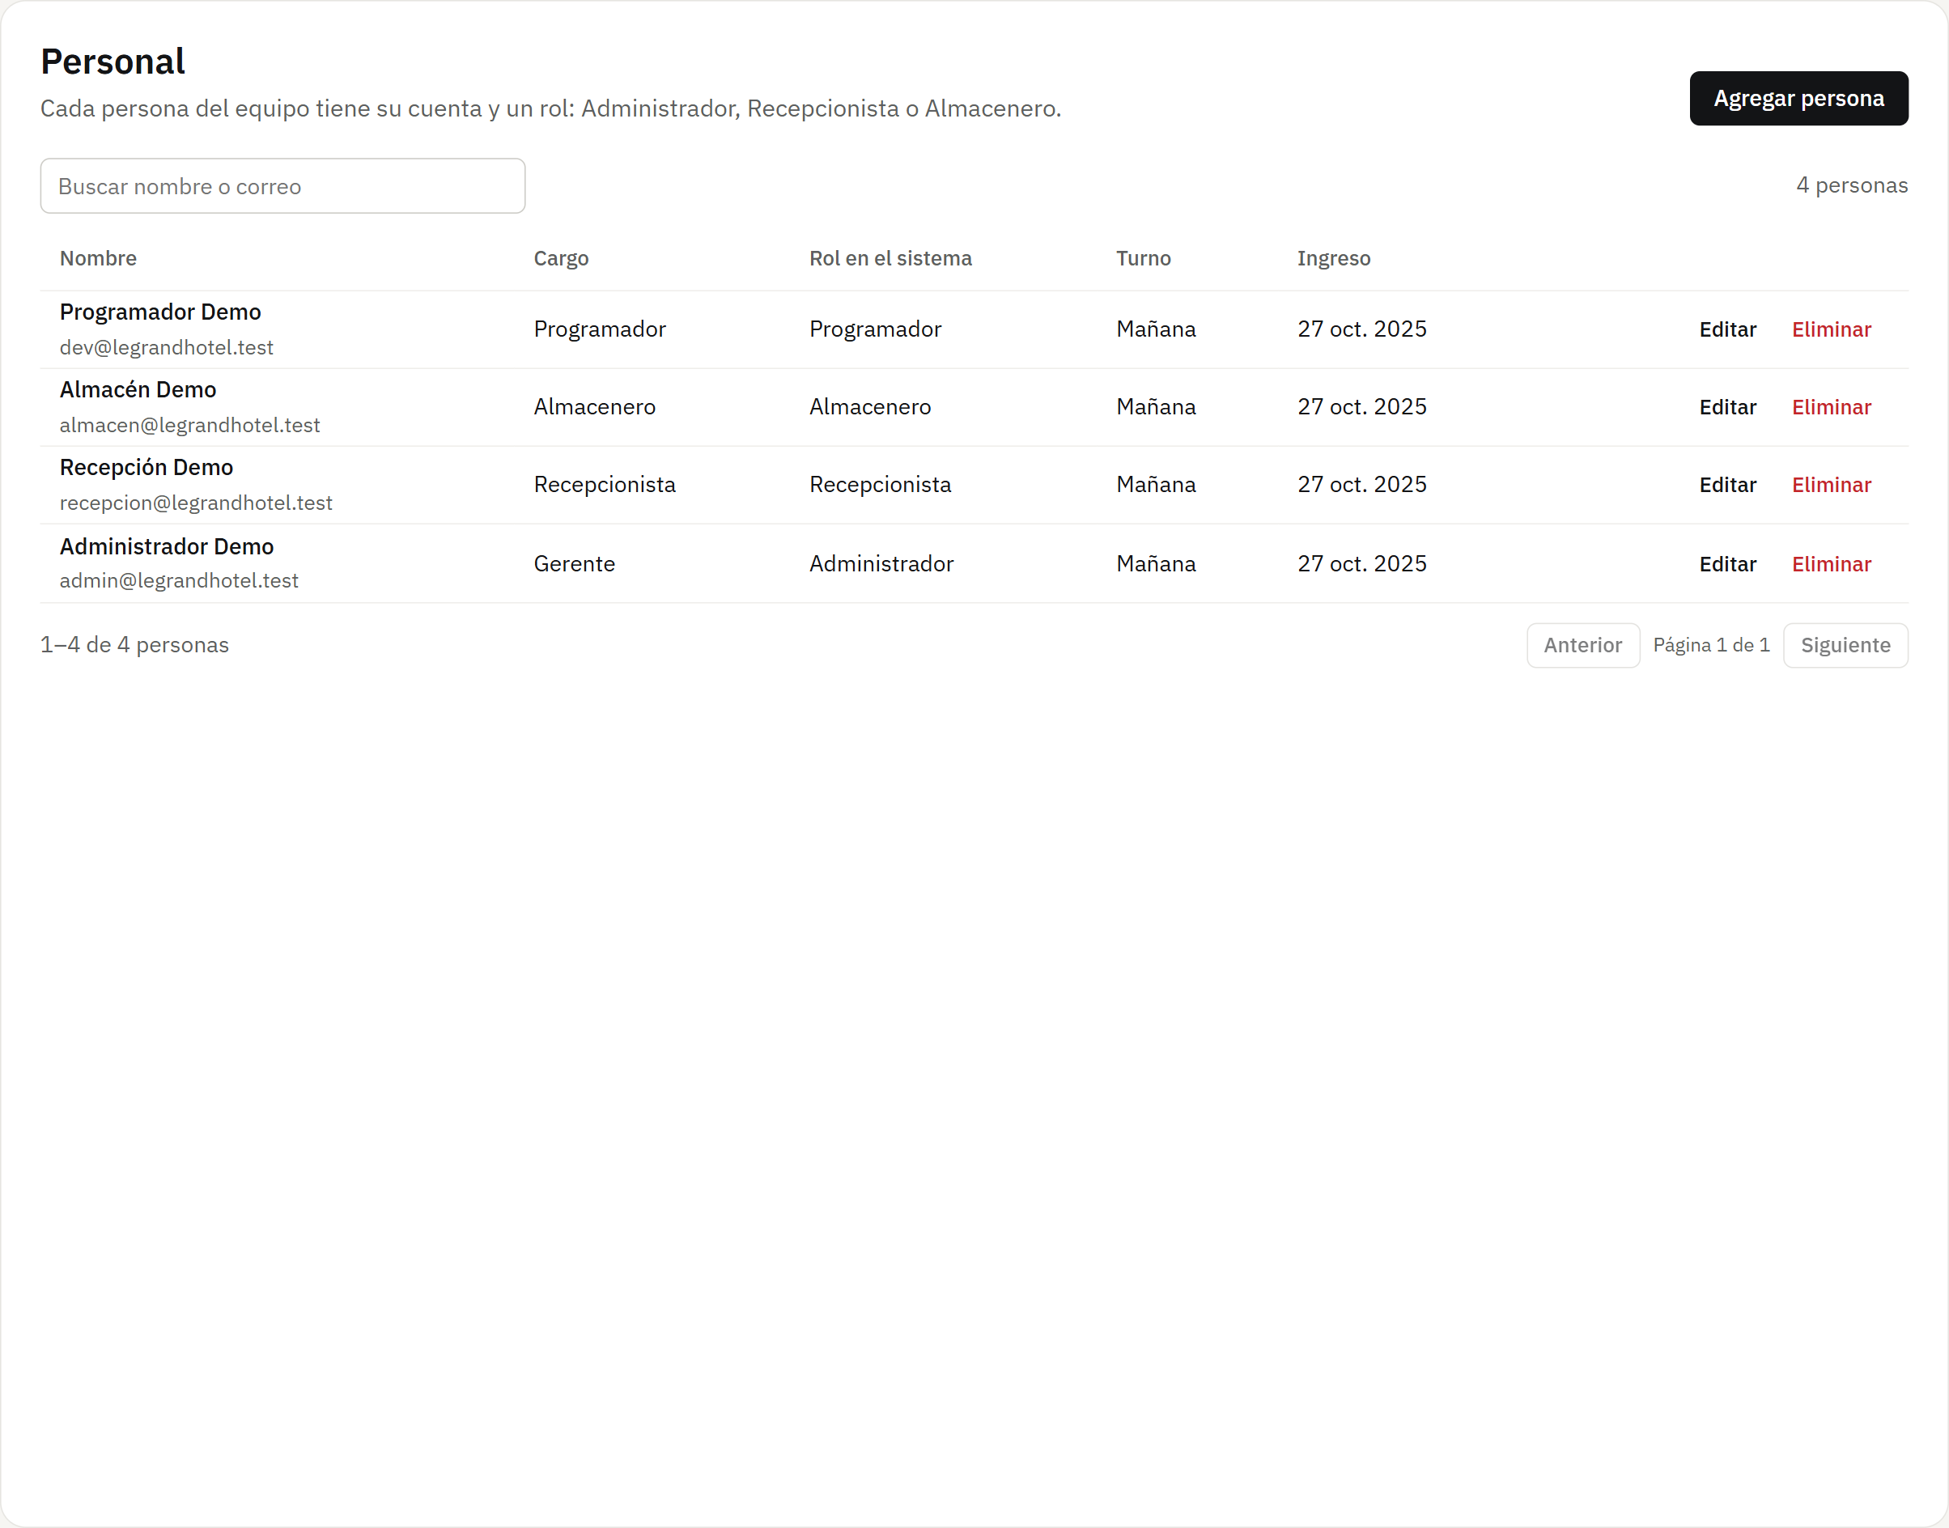
Figure 32. Staff («Personal»)
Pop-up window: Add staff member
Creates the record and the account in one step. The Developer role does not appear because the hotel has only one.
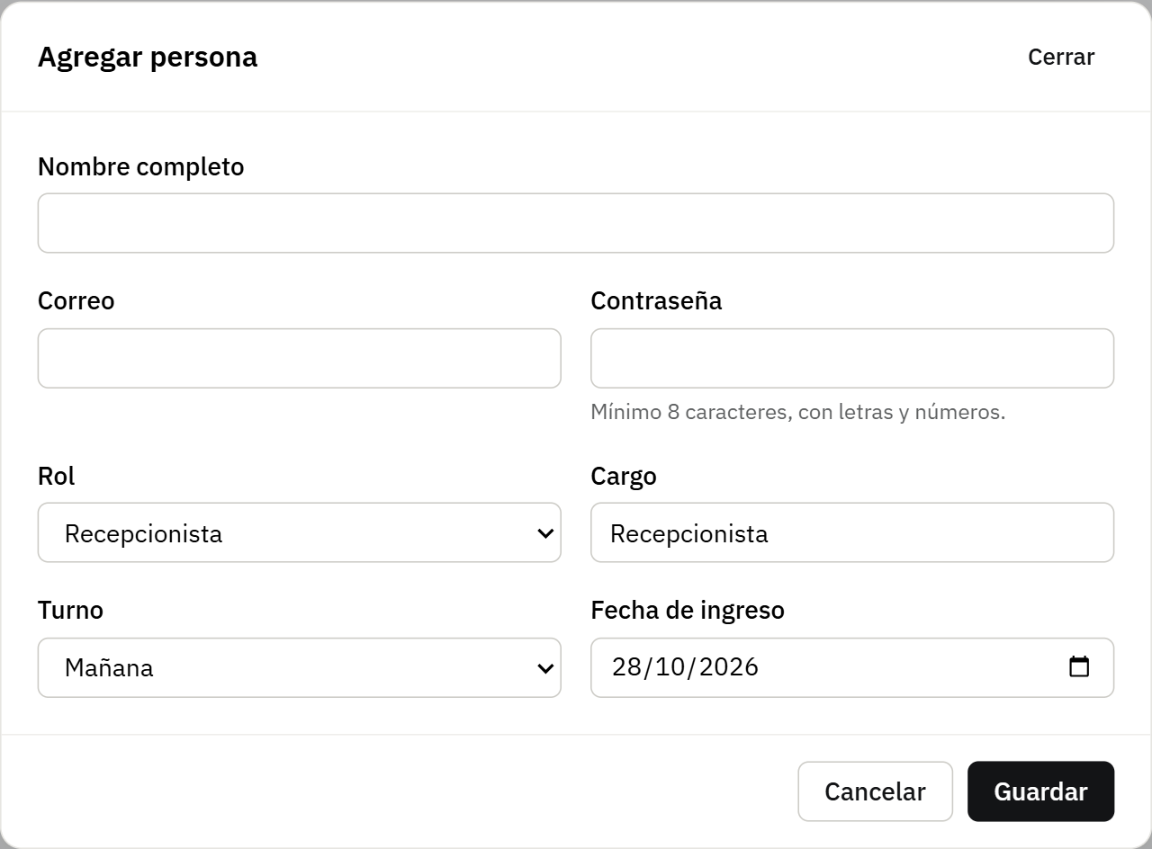
Figure 33. Pop-up window: Add staff member
Register staff («Registrar personal»)
Creates the account of a hotel staff member with an initial password. It only offers Receptionist, Storekeeper and Administrator; the new account receives an email to verify it.
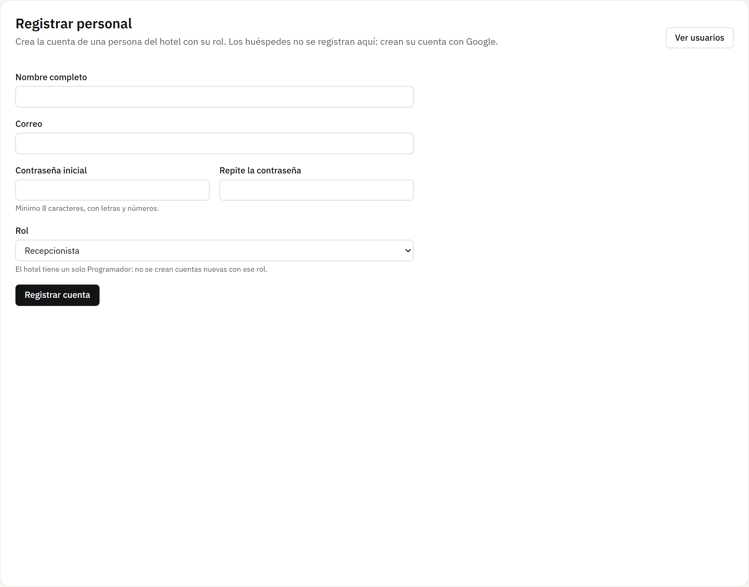
Figure 34. Register staff («Registrar personal»)
Users and roles («Usuarios y roles»)
Every account with its role and whether the email was verified, with role filters and search by name or email.
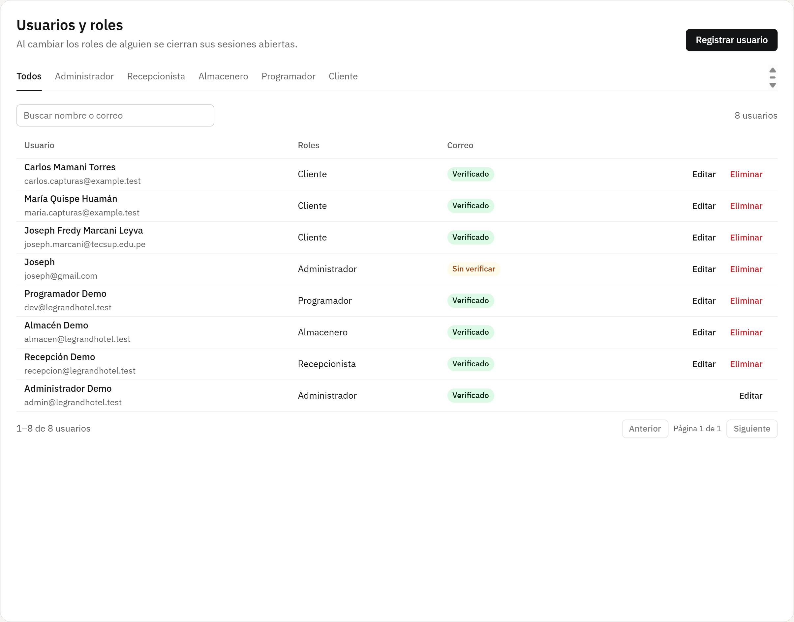
Figure 35. Users and roles («Usuarios y roles»)
Pop-up window: Edit the Developer account
The Developer checkbox is locked: the role cannot be given to another account or removed from the Developer. Their name, email and password can be changed.
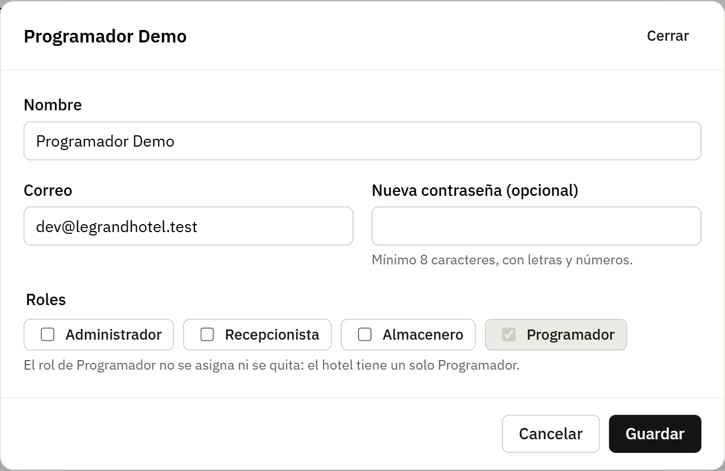
Figure 36. Pop-up window: Edit the Developer account
Reports («Reportes»)
Occupancy for a date range and income for the last 6 months in a bar chart.
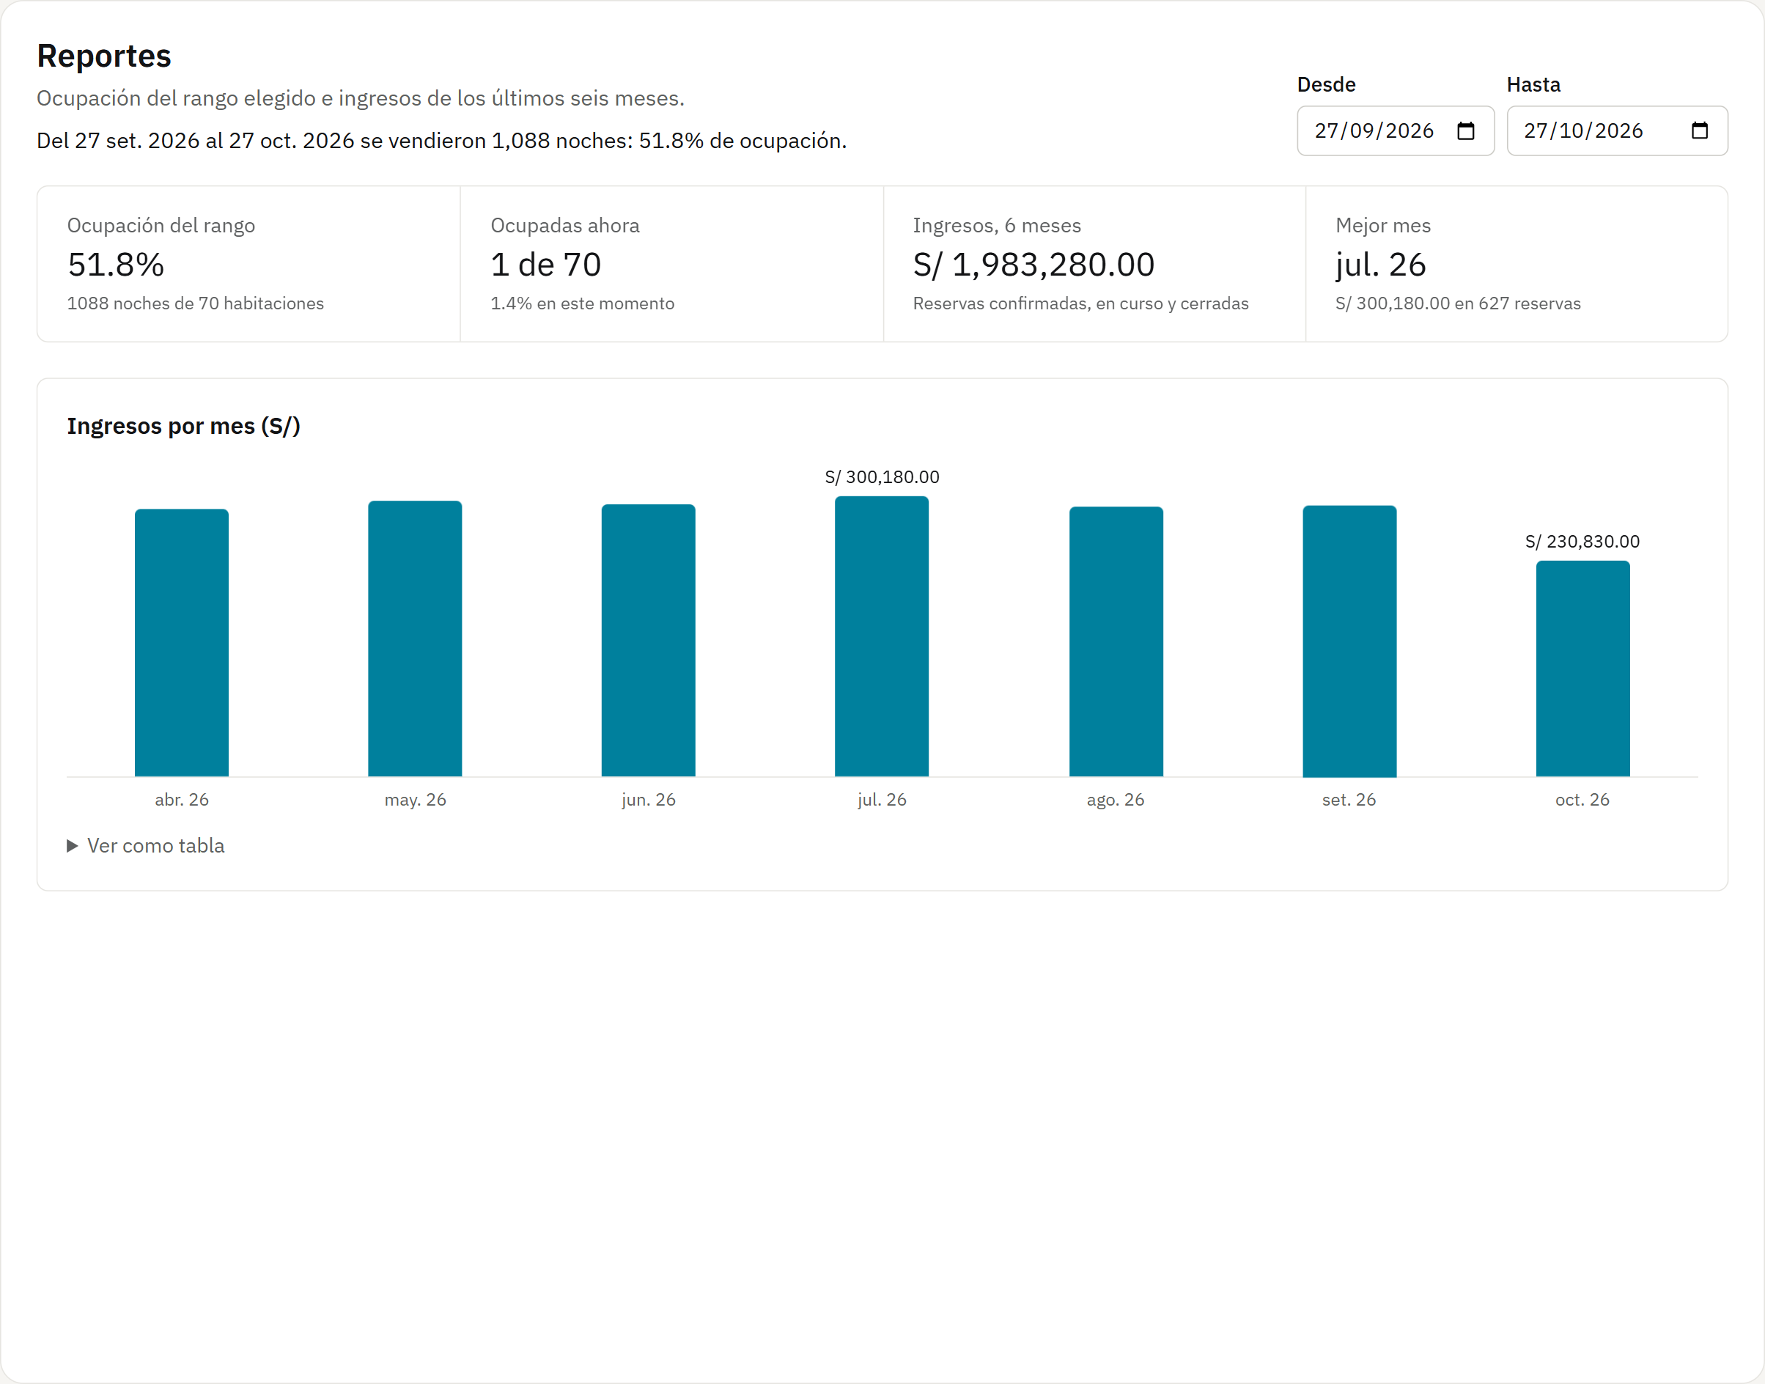
Figure 37. Reports («Reportes»)
Audit («Auditoría»)
Who created, edited or deleted each record, when and from which IP, with the values before and after the change.
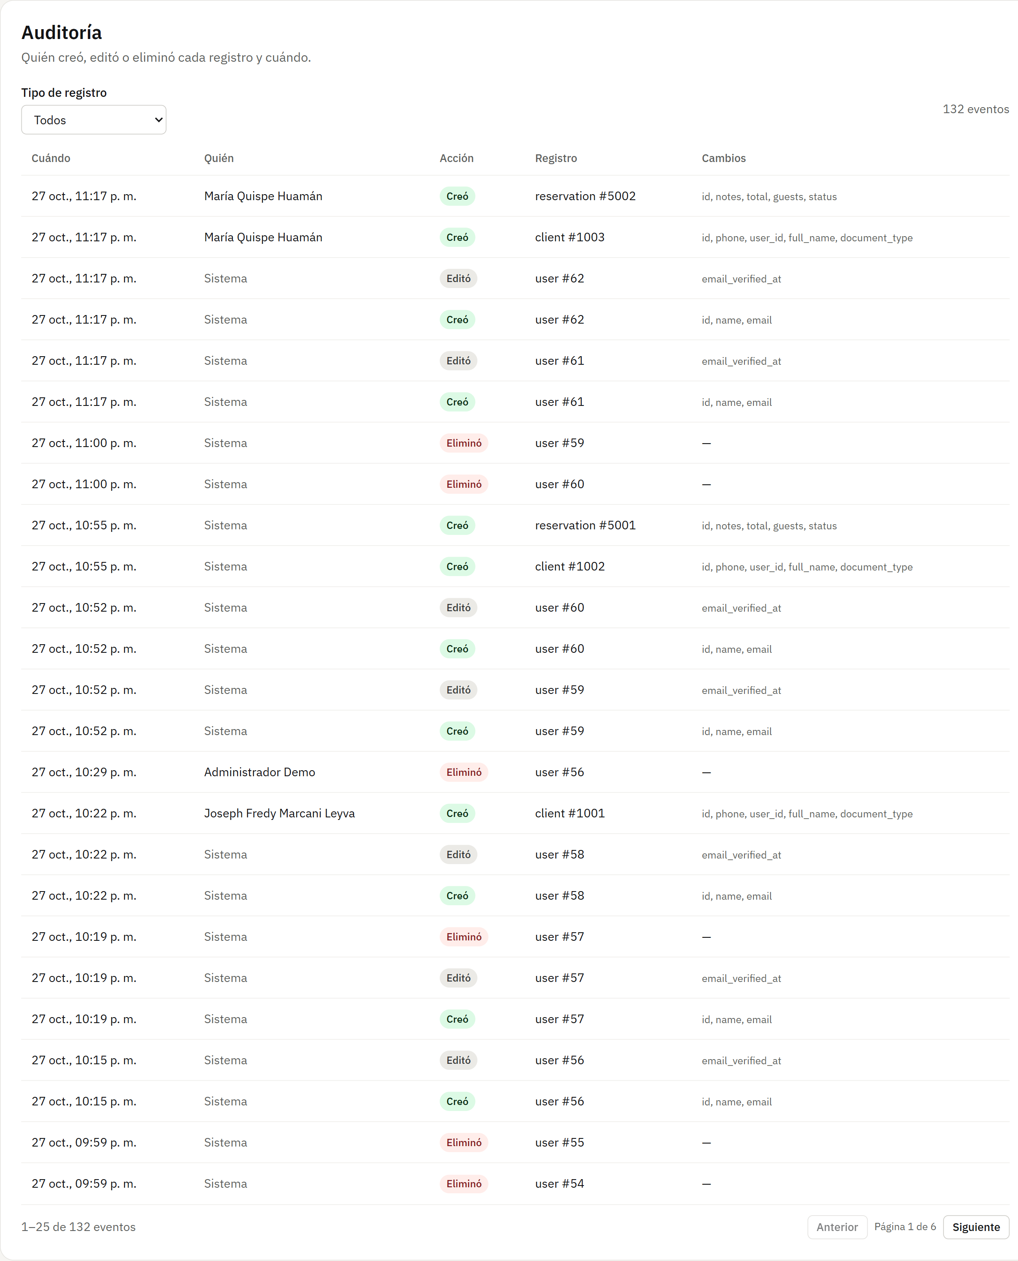
Figure 38. Audit («Auditoría»)
Billing («Facturación»)
A planned module that is not built yet: it shows “Under construction” instead of an error.
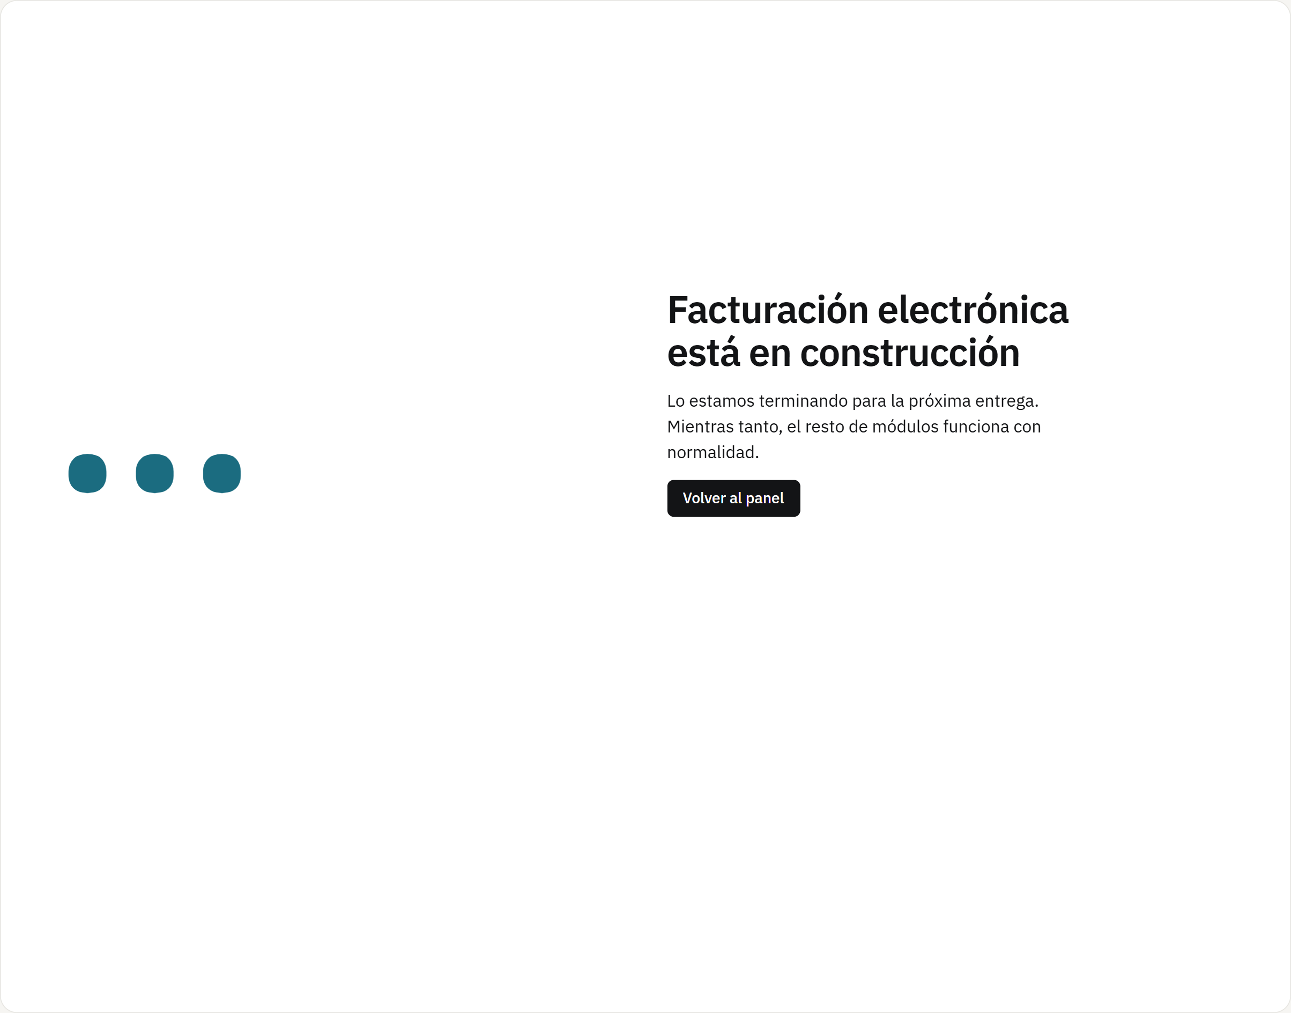
Figure 39. Billing («Facturación»)
Developer view
The Administrator also sees the API diagnostics (details in section 4.4).
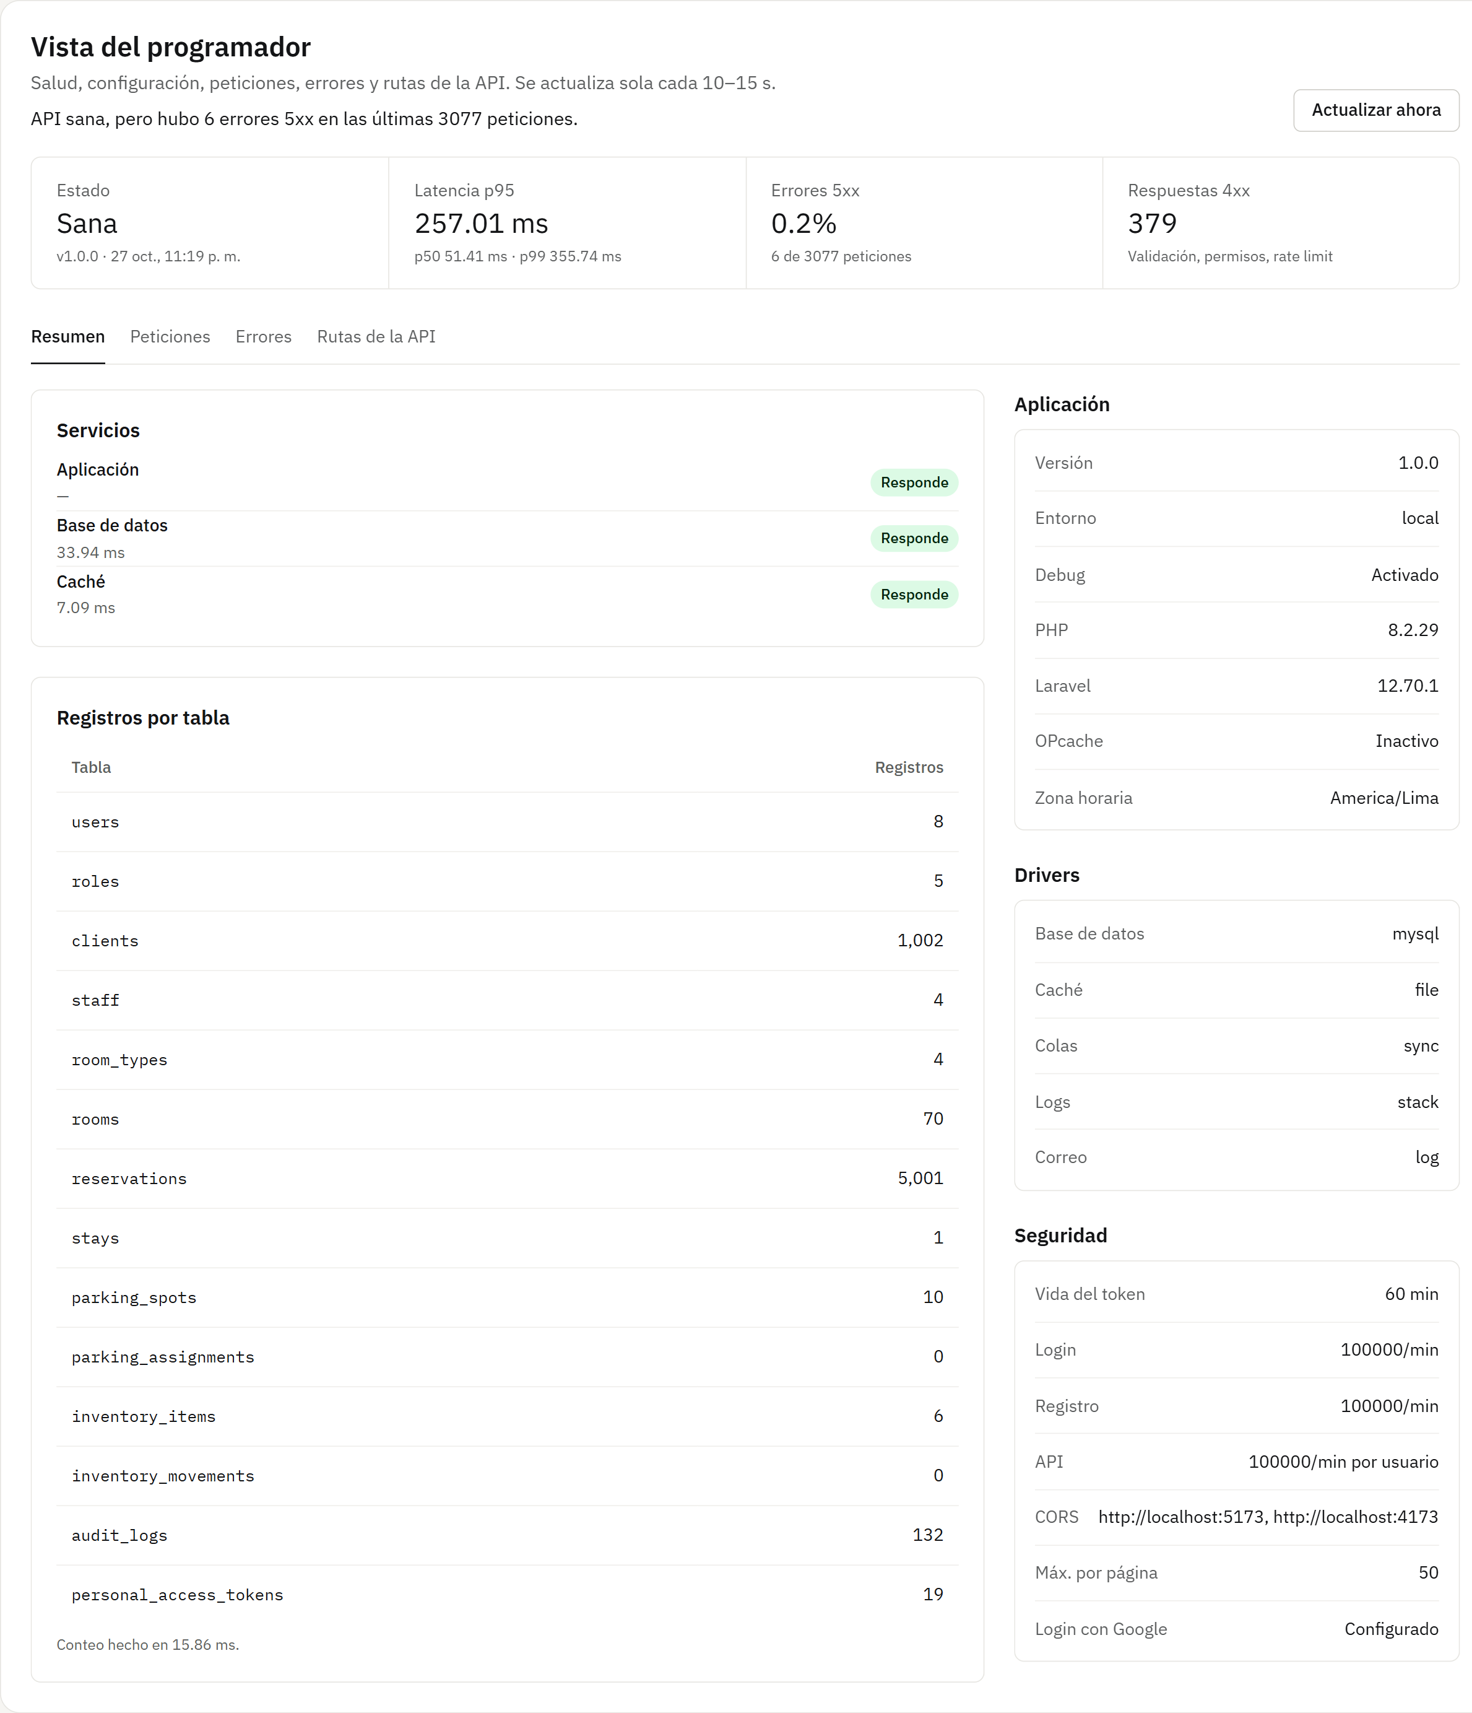
Figure 40. Developer view

4.4 Developer
Provides technical support: checks the API status without logging into the server and registers staff accounts when needed.
Developer menu
It has two options: Register staff and the Developer view.
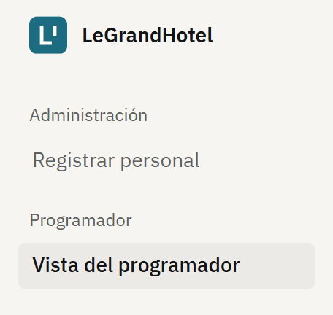
Figure 41. Developer menu.
Register staff
Like the Administrator, creates Front desk, Storeroom and Administration accounts, but not Developer accounts.
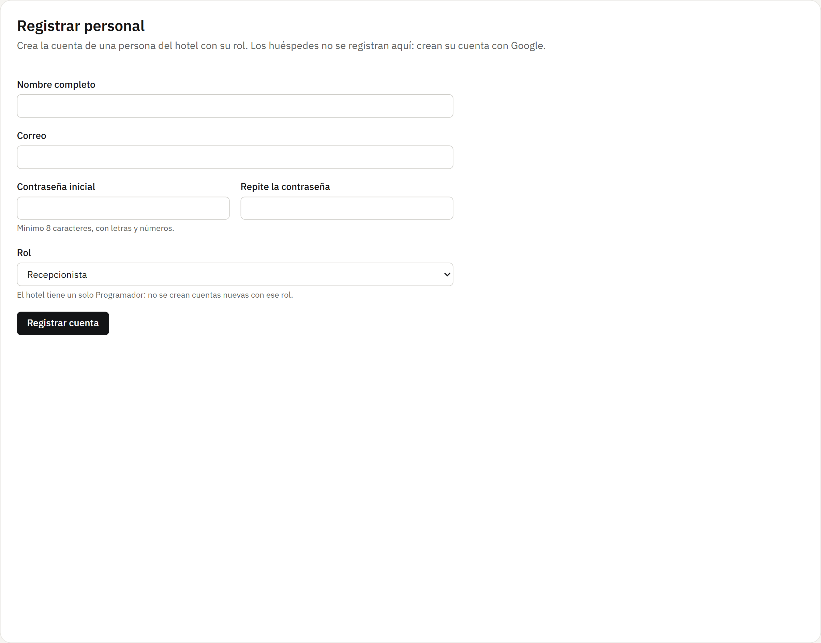
Figure 42. Register staff
Developer view · Summary
API status, p50, p95 and p99 latencies, percentage of 5xx errors and 4xx responses, and the configuration without showing secrets. It refreshes by itself every 10 to 15 seconds.
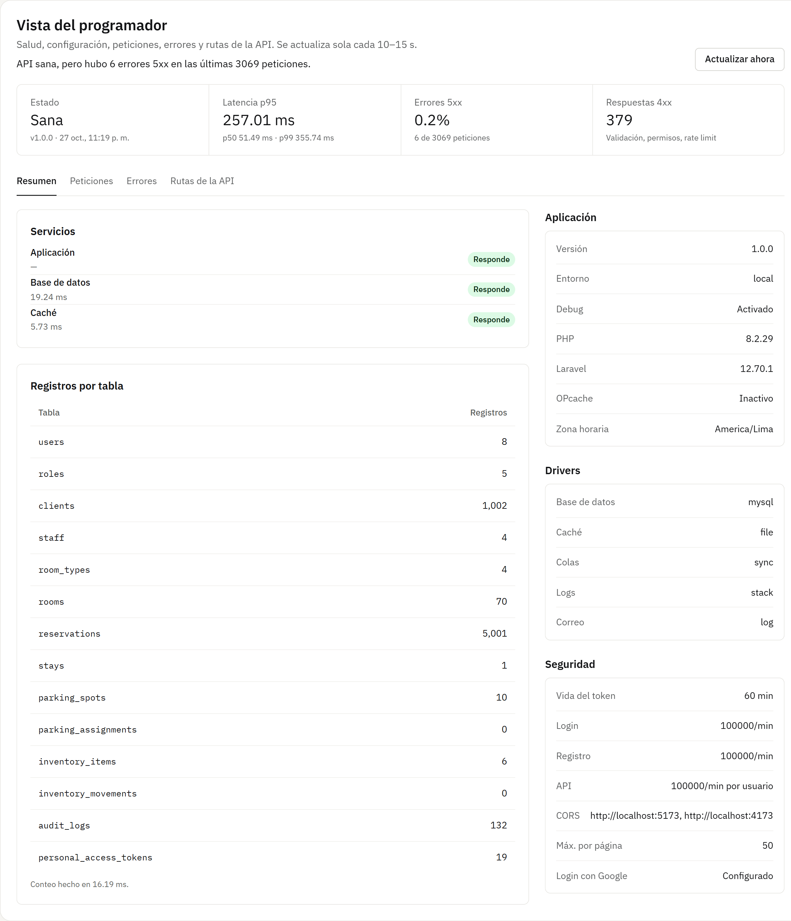
Figure 43. Developer view · Summary
Developer view · Requests
The slowest routes by p95 and the latest requests with their code and duration (the top part is shown).
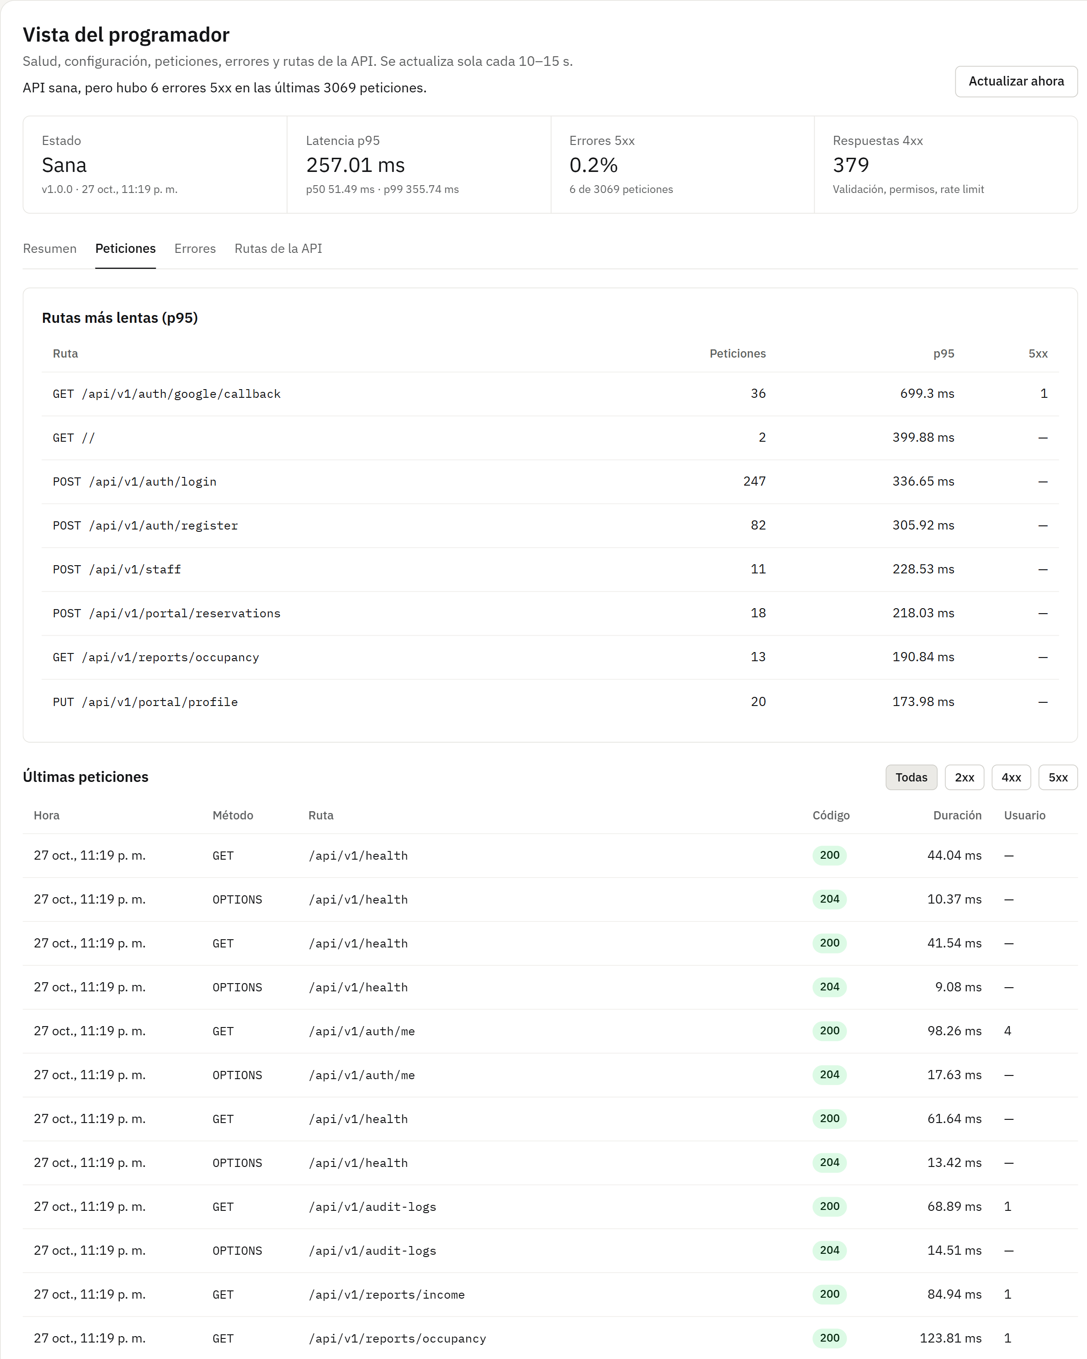
Figure 44. Developer view · Requests
Developer view · Errors
Server errors, searchable by the incident code the user sees on the 500 screen. The real incident JJA05WR4CG from section 6 appears here.
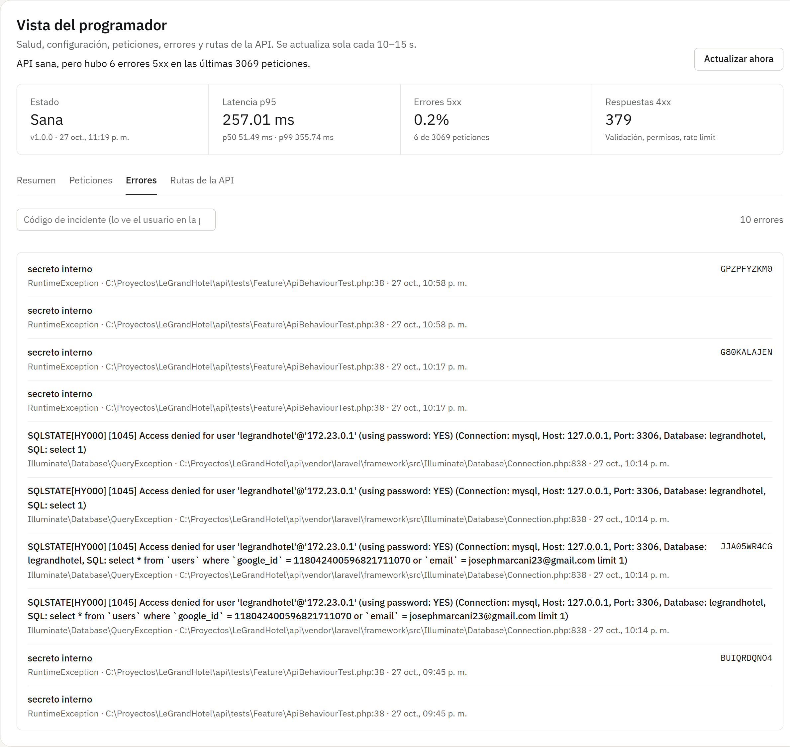
Figure 45. Developer view · Errors
Developer view · API routes
The 77 routes with their method, whether they require a session, the roles that can use them and their rate limit (the top part is shown).
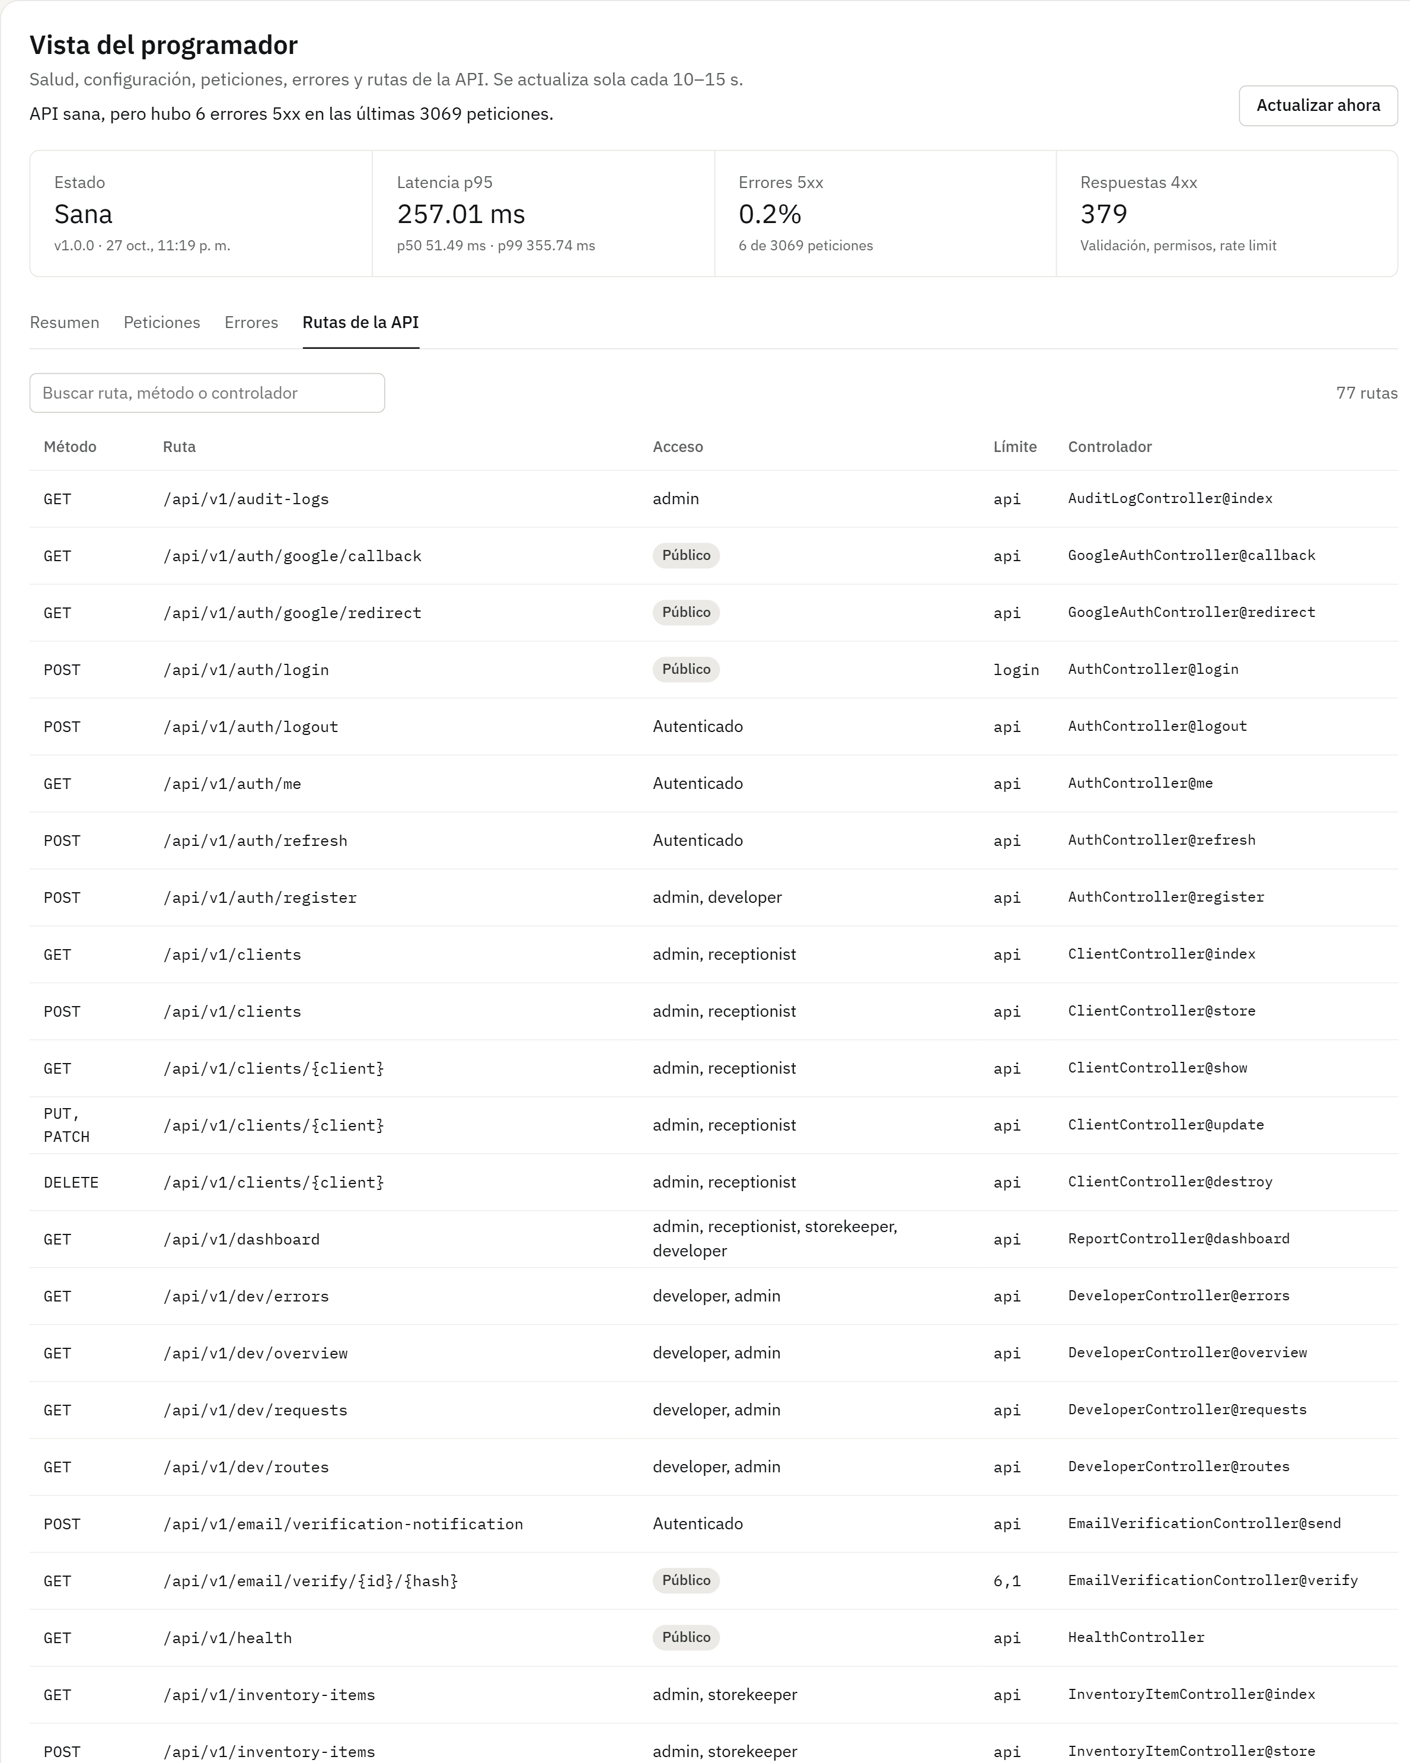
Figure 46. Developer view · API routes

4.5 Guest
The guest with their own account: signs in with Google, completes their DNI and phone once and books online. They see nothing of the staff panel.
Complete registration (before the menu)
The first time they sign in with Google this screen appears, still without a menu. Name and email come from Google; the guest enters their DNI (8 digits) and phone (9 digits). If their DNI was already registered at the front desk, that record is linked.
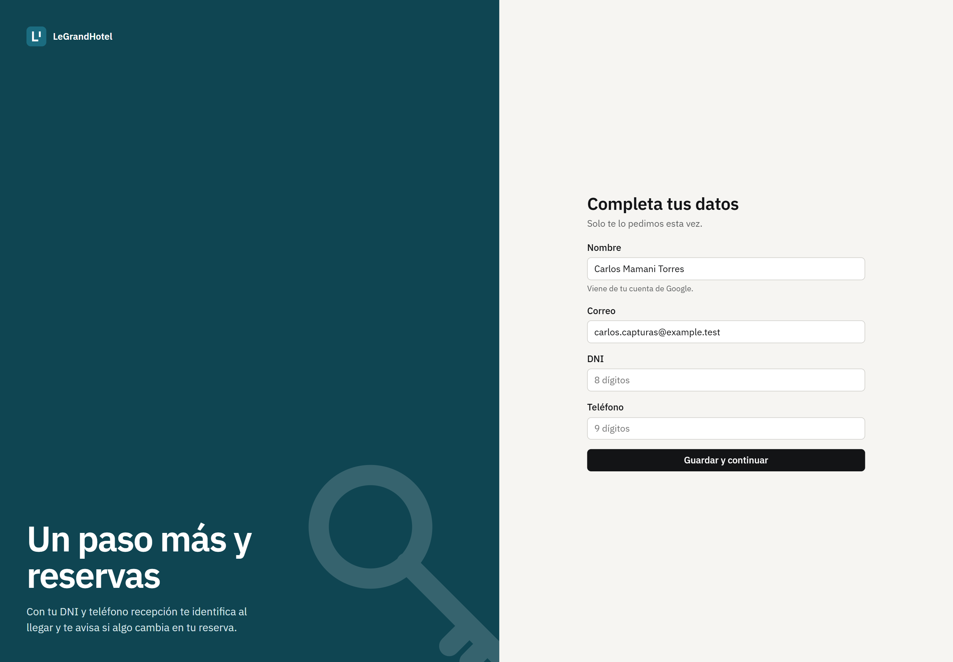
Figure 47. Complete registration (before the menu)
Guest menu
Their “Mi cuenta” menu has two options: Book («Reservar») and My bookings («Mis reservas»).
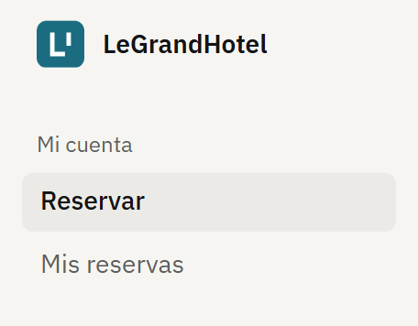
Figure 48. Guest menu.
Book («Reservar»)
They choose arrival, departure and number of guests; they see each room type with its amenities, how many are free and the total of their stay. Types that do not fit that many guests do not appear.
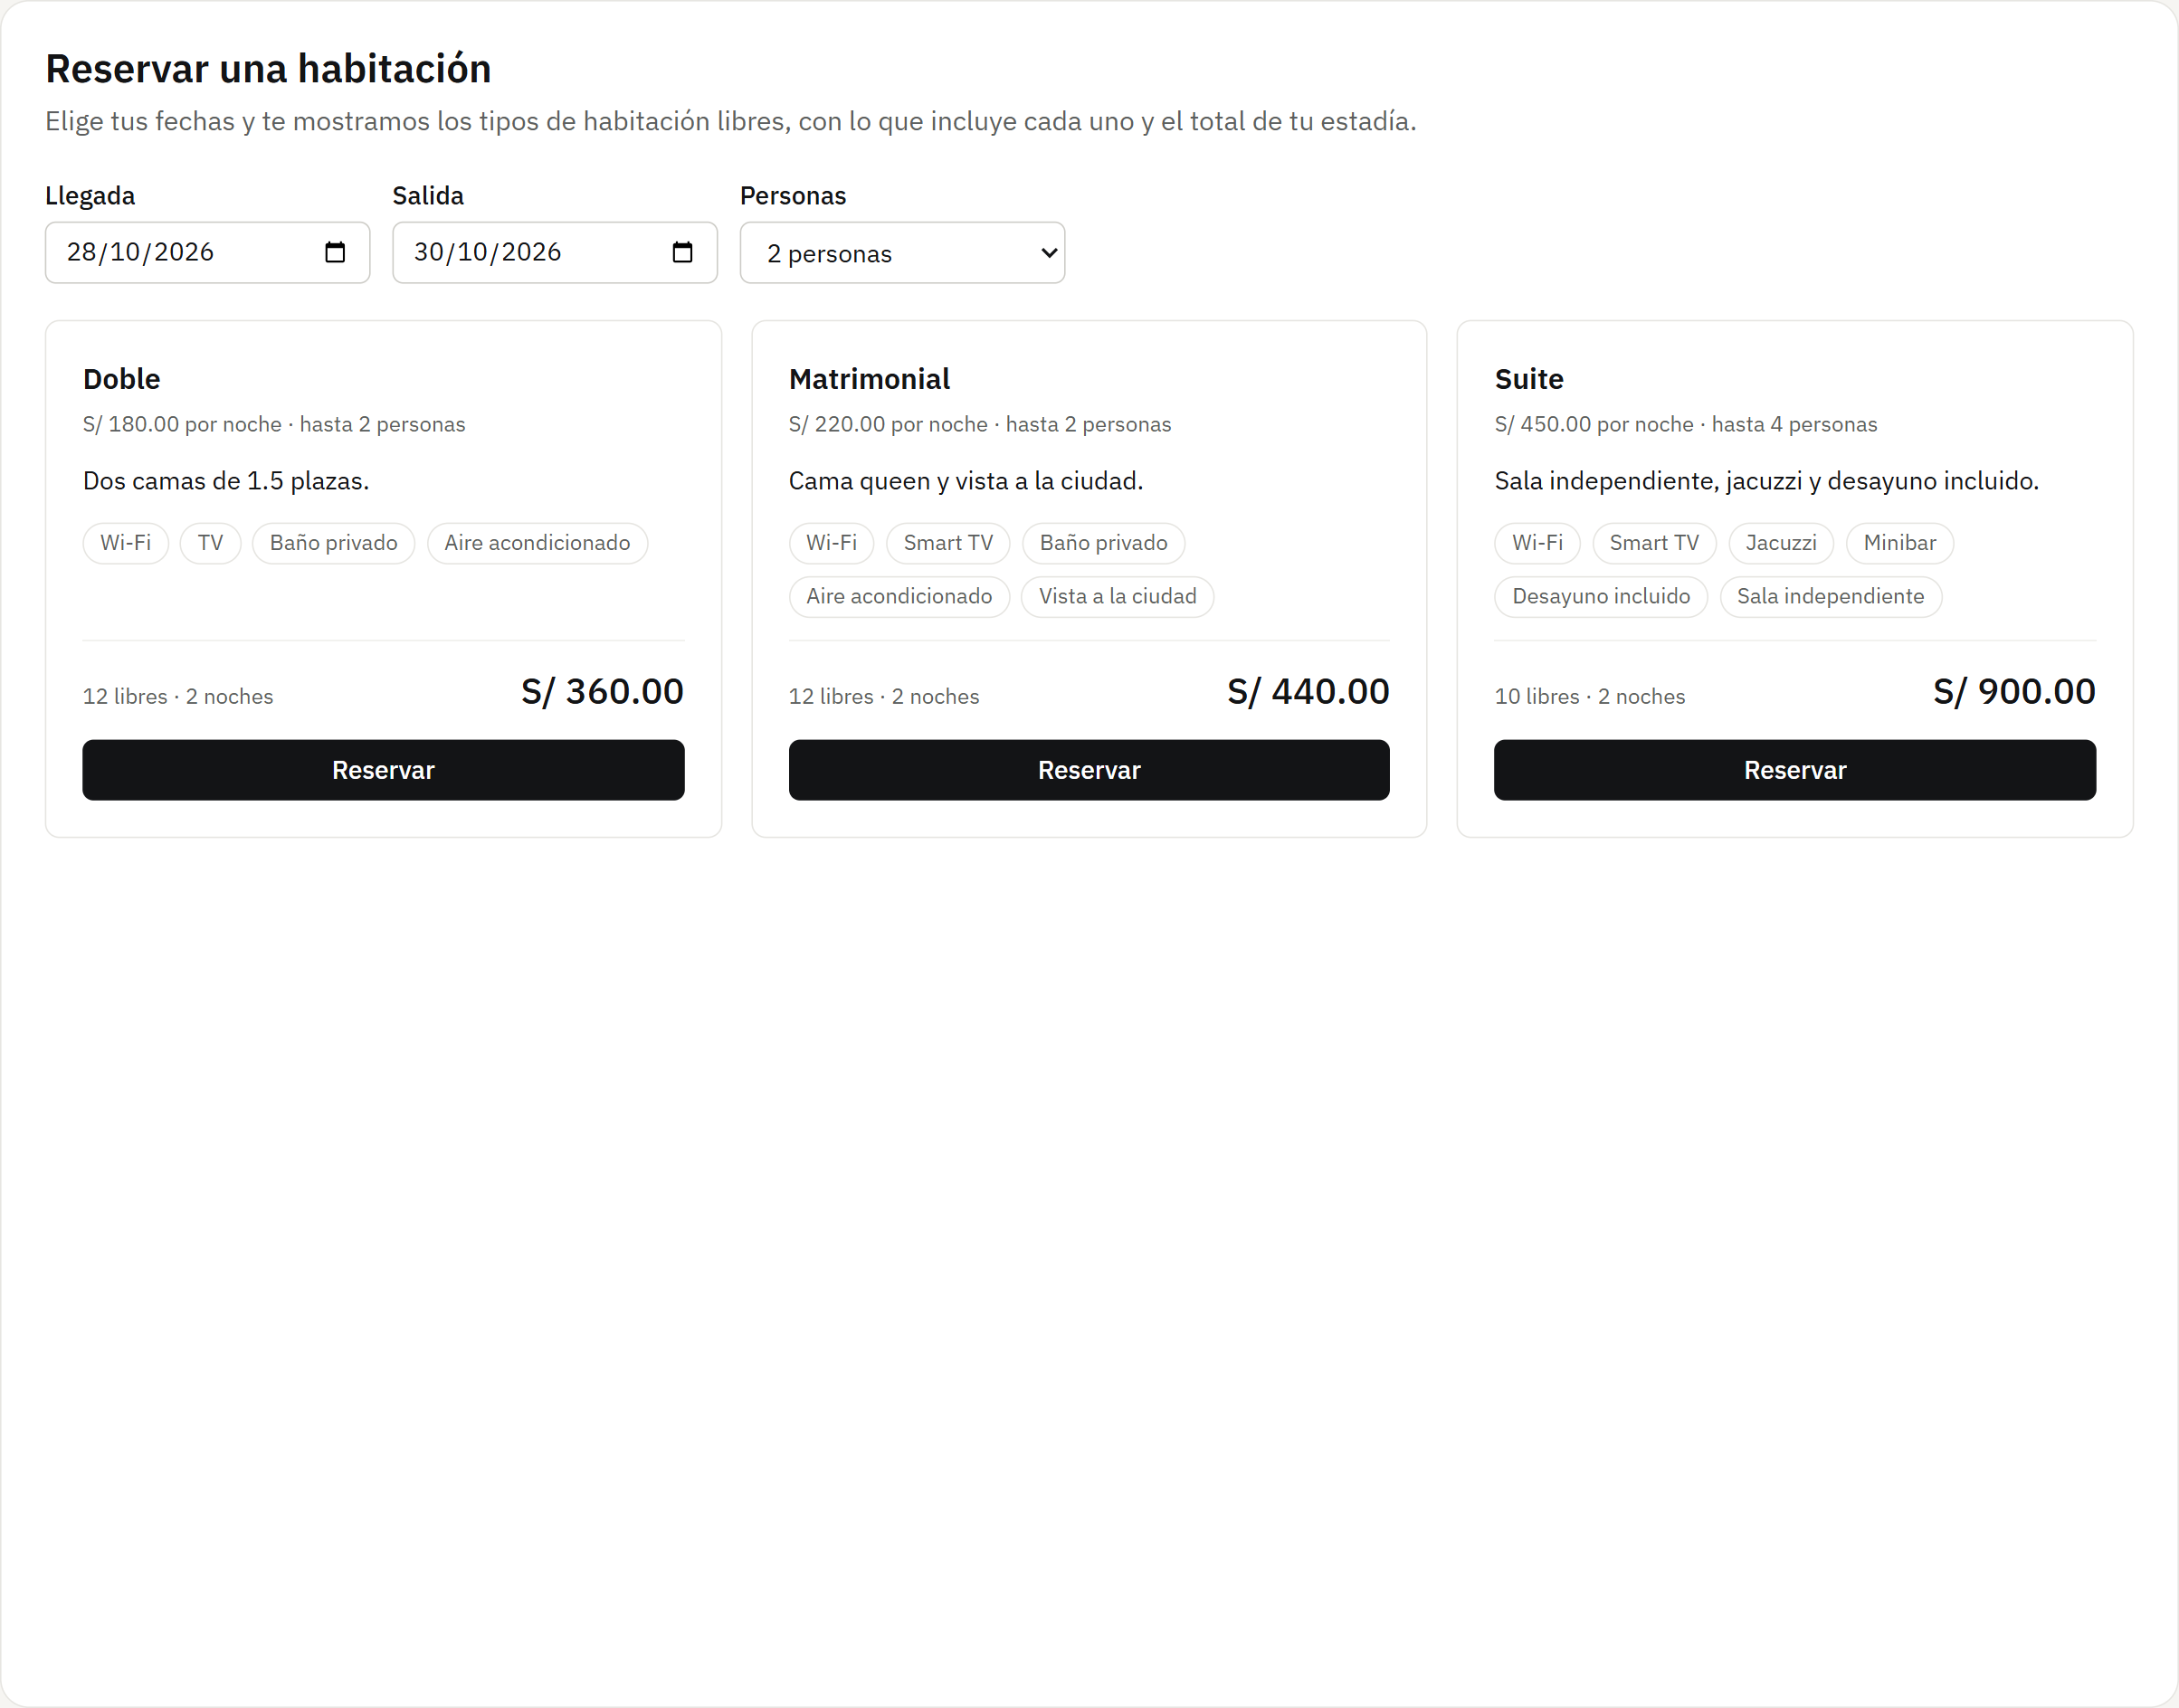
Figure 49. Book («Reservar»)
Pop-up window: Confirm reservation
Summary with the type, dates, nights and total before confirming. On confirmation, the hotel assigns a free room of that type.
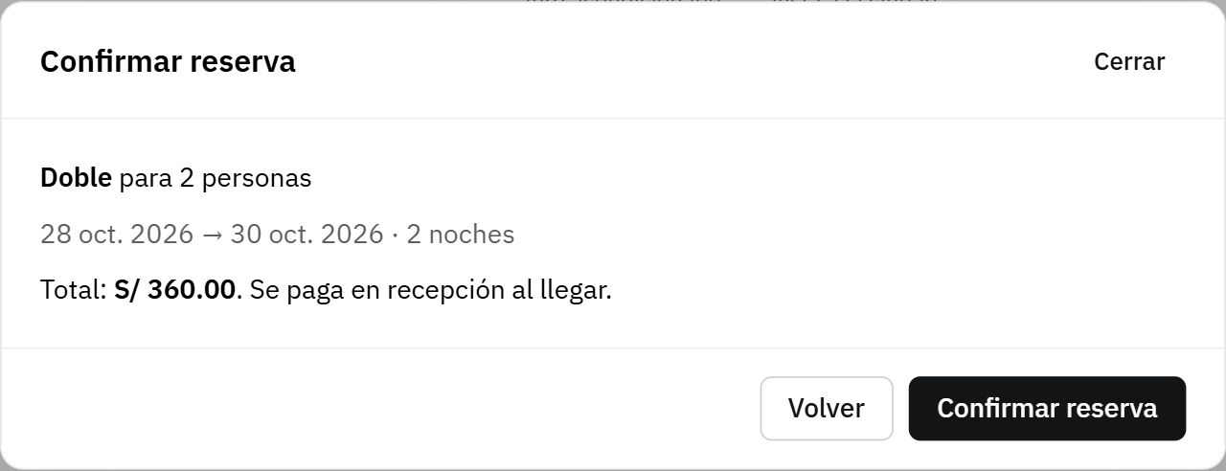
Figure 50. Pop-up window: Confirm reservation
My bookings («Mis reservas»)
Their reservations with room, dates, nights, total and status. They can cancel a confirmed reservation as long as at least one day remains before arrival.
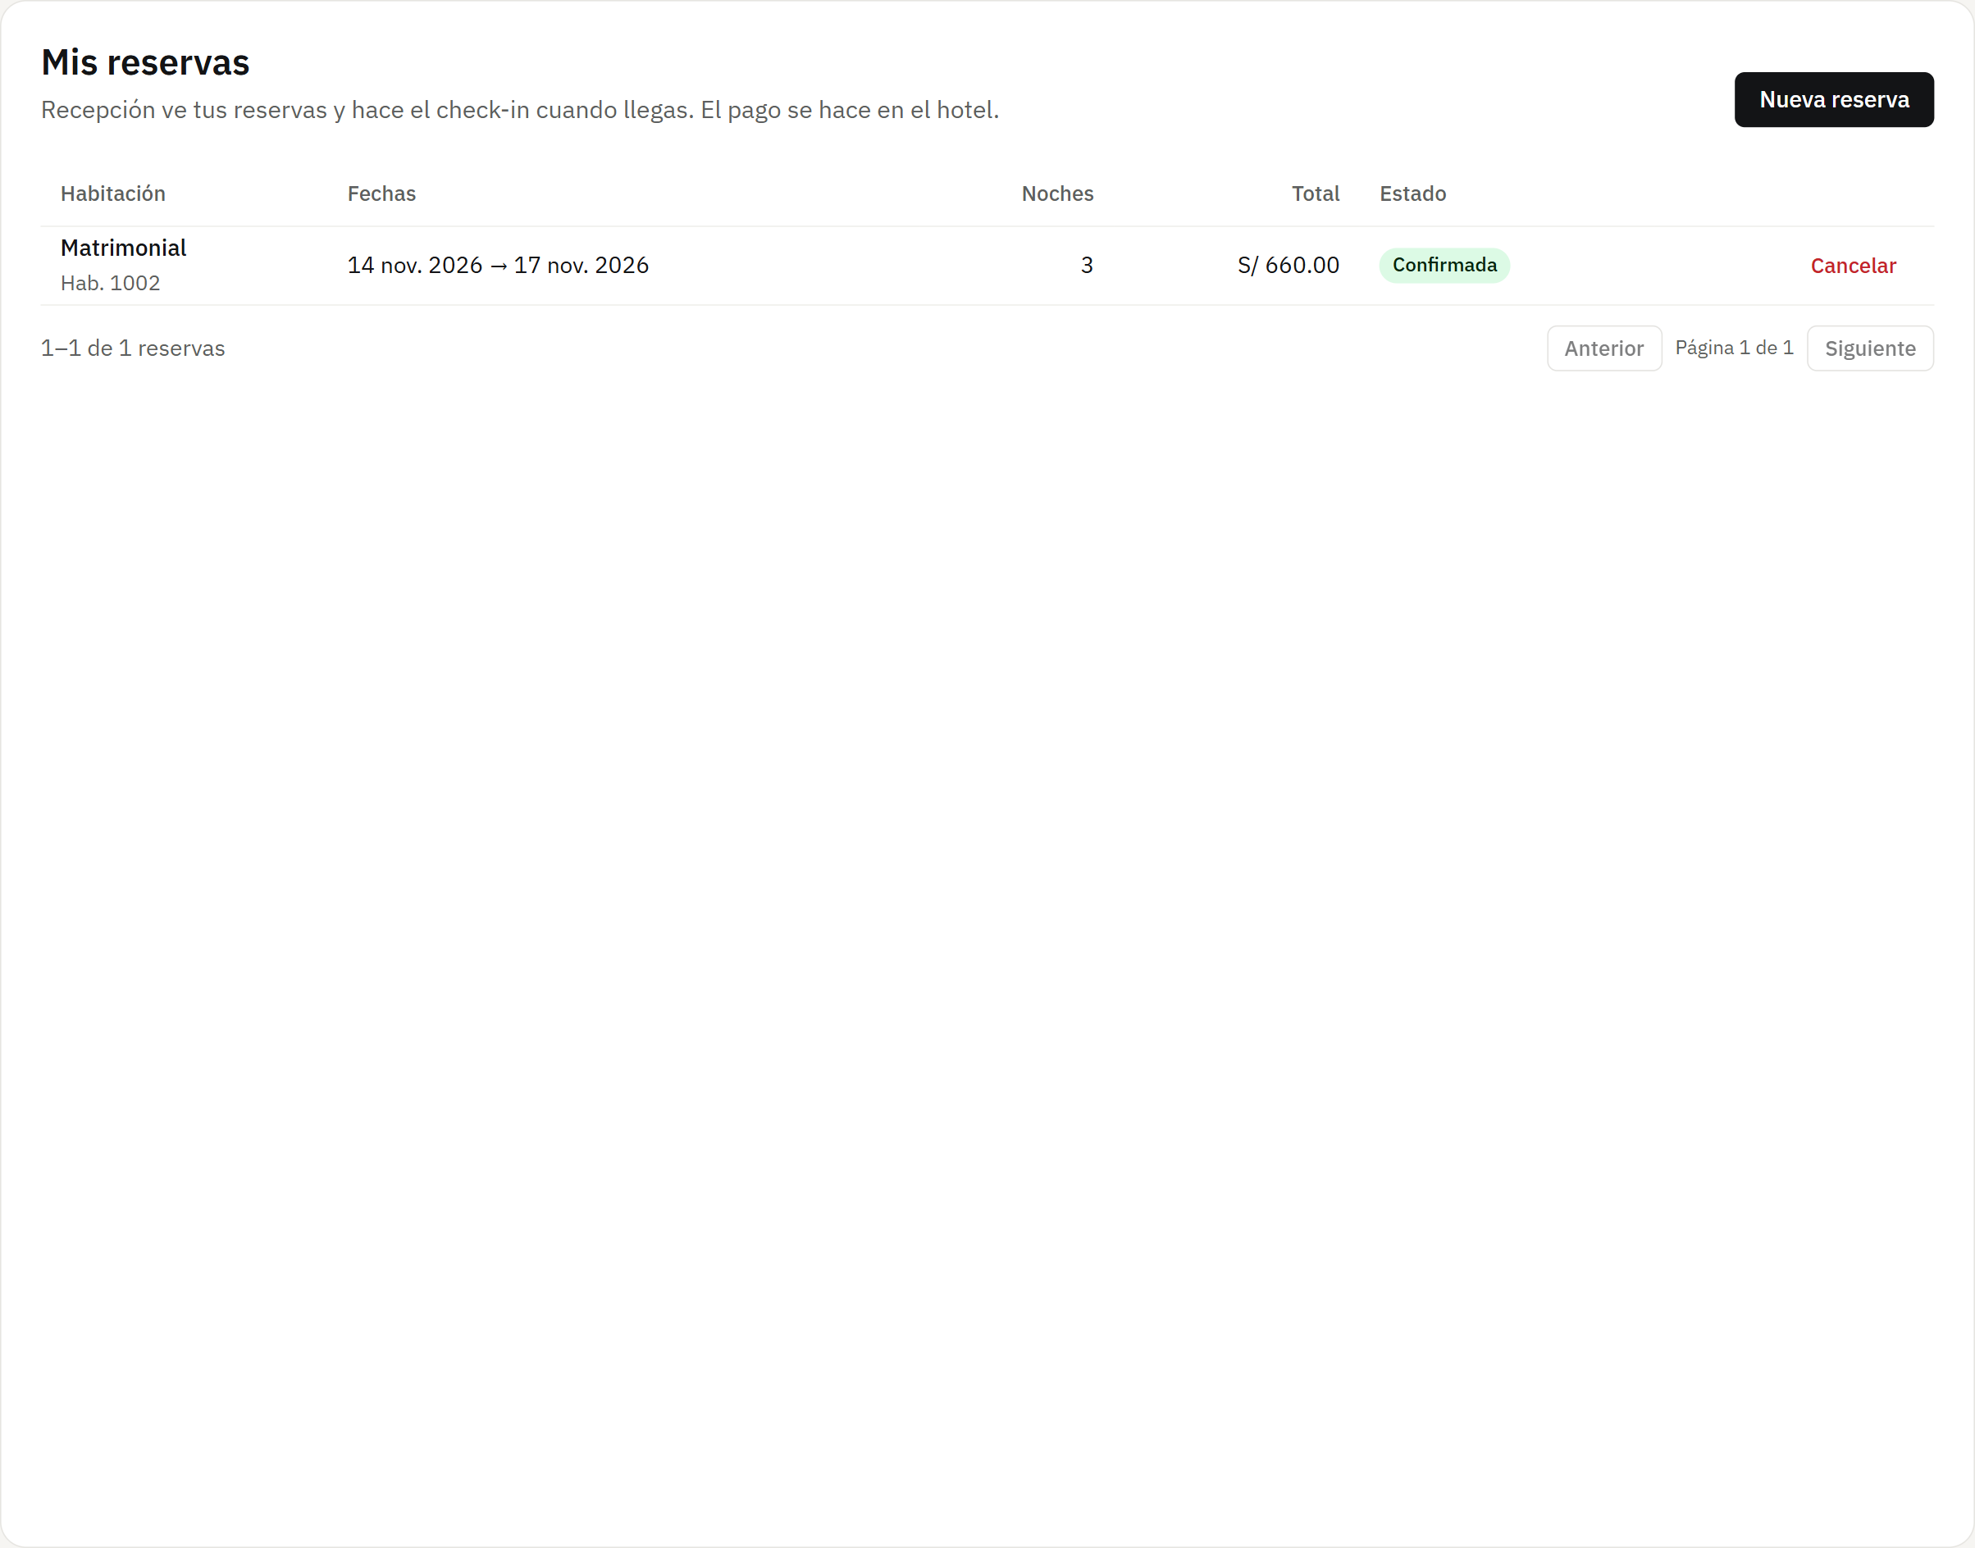
Figure 51. My bookings («Mis reservas»)

5. Error screens
Every API error response has its own screen, with the same style as the page, a clear message and a way out (go home, reload or sign in). A single interceptor in web/src/lib/api.ts decides which one to show, so they behave the same in every view.
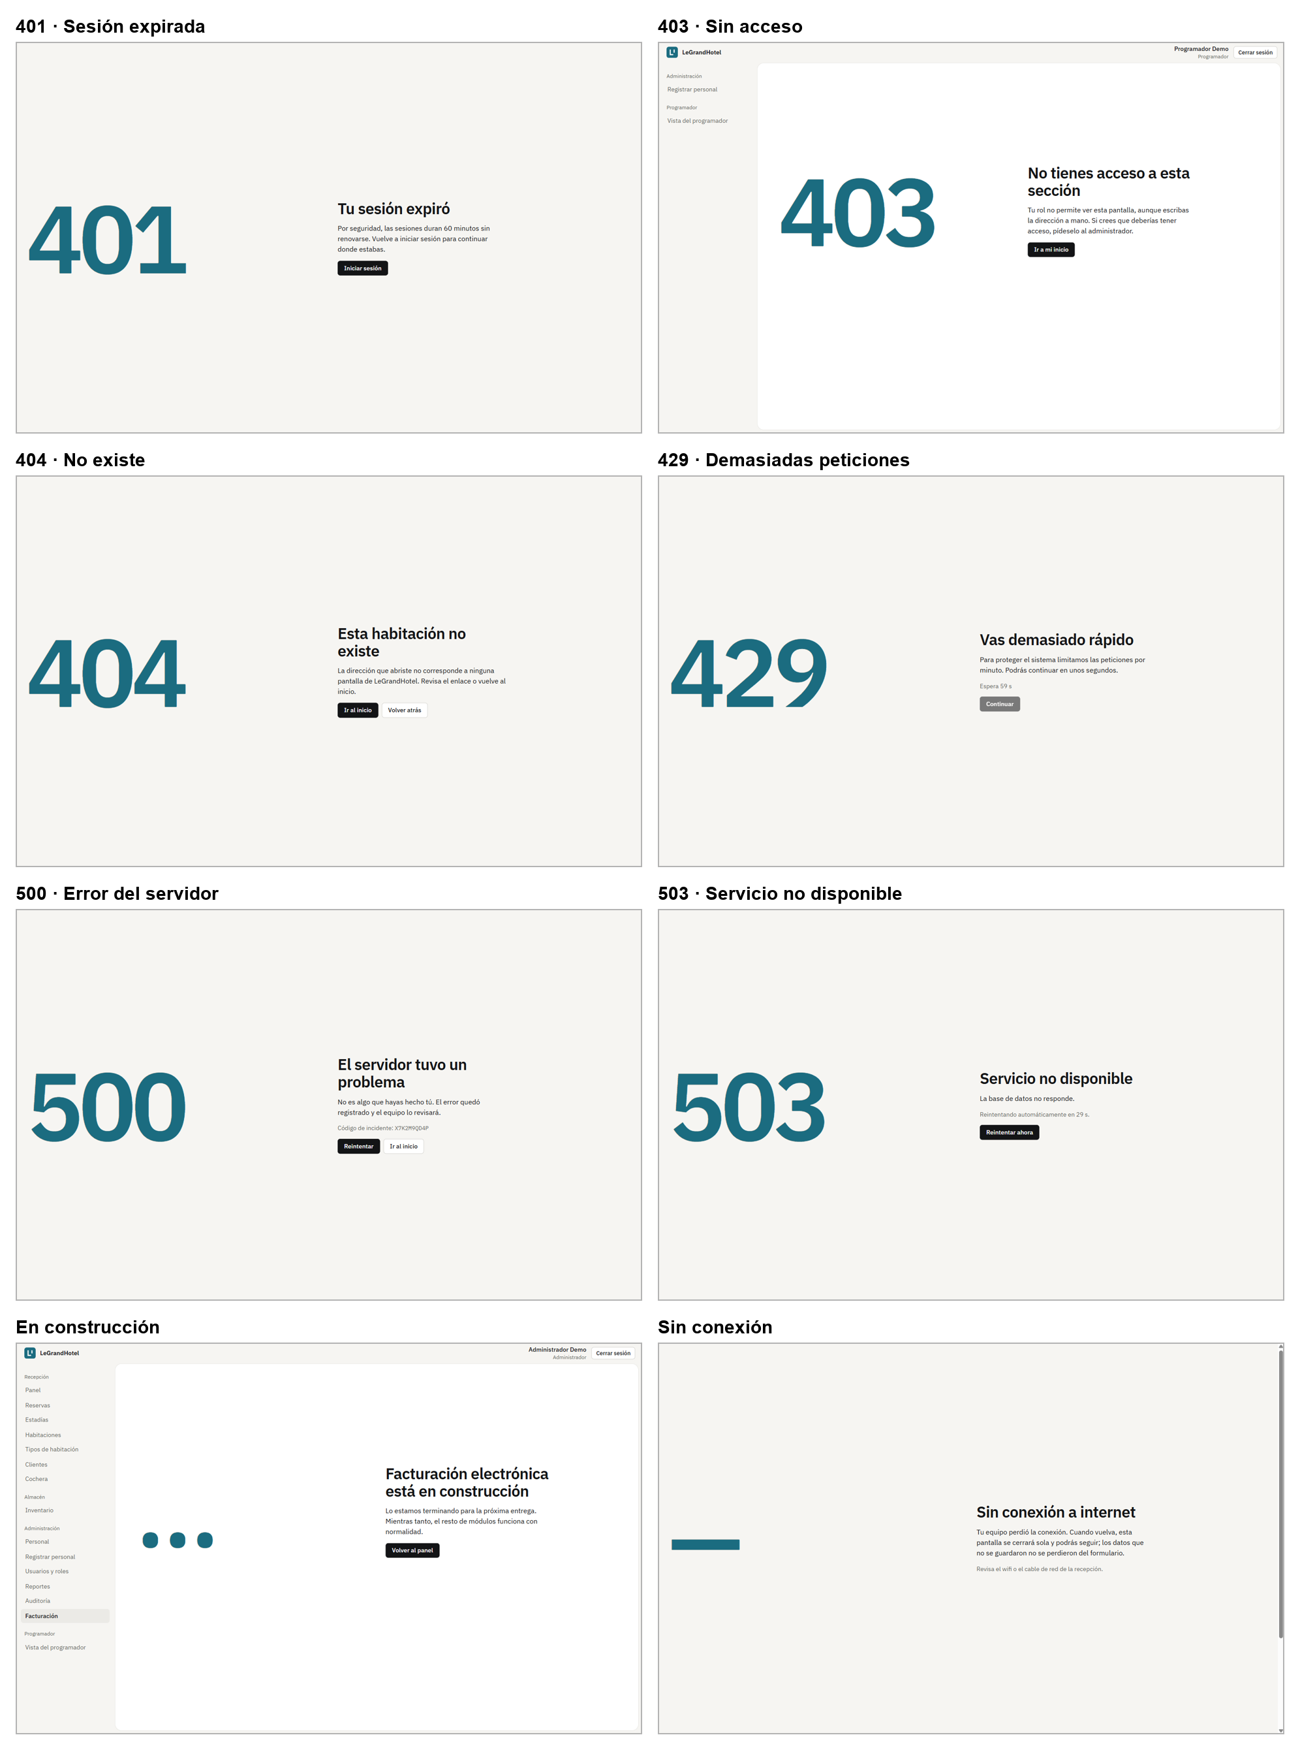
Figure 52. 401, 403, 404, 429, 500, 503, under construction and offline screens (Spanish interface).
Screen | When it appears
401 · Session expired | The token expired (60 minutes) or the session was closed elsewhere
403 · No access | The role is not allowed to open that view or do that action
404 · Not found | The address does not exist or the record was deleted
429 · Too many requests | The limit was exceeded (for example 5 logins per minute); it shows how long to wait
500 · Server error | Something failed; it shows the incident code to look it up in the Developer view
503 · Unavailable | The API does not respond; it retries by itself every 30 seconds
Under construction | A planned module that is not built yet (Billing)
Offline | The computer lost internet; it comes back by itself when reconnected

6. Incident log
Every outage or failure, even in the local environment or in tests, is recorded the same day in docs/incidentes.md with its cause and solution. The log now has 8 incidents; 6 are from October 27, while repeating the load tests, setting up Google sign-in and reviewing the Developer view.
Date | What failed | Cause | Solution | Time
2026-10-26 | Login returned 500 INTERNAL_ERROR with incident code XG1R7UASWT | php artisan serve starts child PHP processes without the pdo_sqlite extension, which was loaded with -d only in the parent ("could not find driver") | The local server is started with php -d extension=pdo_sqlite -S … (.claude/launch.json). The error came back as JSON without traces, as the plan requires | ~2 min
2026-10-26 | The frontend showed the 503 screen "Could not reach the server" | During the previous change the PHP server pointed to a server.php that looked for index.php in the wrong folder | api/public/index.php is used as the server router. The 503 screen retried by itself every 30 s | ~1 min
2026-10-27 | First k6 series: 100% failed requests | The PHP server listened only on IPv6 (::1) and k6 resolved localhost to IPv4 (127.0.0.1) | BASE_URL=http://[::1]:8000/api/v1; the invalid results were deleted and the 5 runs repeated | ~5 min
2026-10-27 | The first Google sign-in returned 500 INTERNAL_ERROR (incident JJA05WR4CG) and /health reported the database as down | While editing api/.env to add GOOGLE_CLIENT_ID and GOOGLE_CLIENT_SECRET, one character of DB_PASSWORD was deleted: MySQL answered "Access denied for user legrandhotel" | DB_PASSWORD was restored to match MYSQL_PASSWORD in docker-compose.yml; /health went back to ok. The incident code located the cause in storage/logs in seconds | ~1 min
2026-10-27 | After signing in with Google the browser showed ERR_INVALID_REDIRECT | FRONTEND_URL lists two comma-separated domains (for CORS) and the Google callback and email verification used the whole value as the return address | New App\Support\Frontend::url() redirects to the first domain; covered by a test in ClientPortalTest | ~3 min
2026-10-27 | k6 stopped in setup() with "The API is not healthy before the test: 503" | The nginx container from docker compose was using port 8000, so k6 talked to that Nginx (with no PHP behind it) instead of the API | docker compose down and start only MySQL (docker compose up -d mysql); the k6 tutorial explains it in step 2 | ~10 min
2026-10-27 | After coming back from Google the page stayed blank with #token=… in the address | The application did not start in that Brave tab (the API never received /auth/me), probably because of its Shields; the same flow worked in Chrome | Use Chrome or turn off Shields for localhost; the whole flow was verified with a test account | ~15 min
2026-10-27 | The "Errors" tab of the Developer view showed the 500 screen with code WEB-MVRL1WBX | Laravel stores some exceptions in the log as an object (class, message, file) and the screen tried to show them as text (React error) | RequestLogReader now always returns the class as text; new test in DeveloperViewTest | ~5 min

How the incident code helped: when the API fails, it answers 500 with a code (for example JJA05WR4CG) that the user sees on screen. The same code is stored in the API’s JSON log, and the Developer view finds it in seconds (figure in section 4.4). That is how we found that the problem with the first Google sign-in was the database password, not Google.
API log (storage/logs/laravel.json), summarized
{"message": "SQLSTATE[HY000] [1045] Access denied for user 'legrandhotel'…",
"context": {"incident_id": "JJA05WR4CG", "exception": "Illuminate\\Database\\QueryException"},
"level_name": "ERROR", "datetime": "2026-10-27T22:14:14-05:00"}

7. Performance and stress tests with k6
k6 simulates many “virtual users” (VU) using the API at the same time and measures how long each response takes. Each script has goals (thresholds): if they are not met, k6 marks the test with ✗ and exits with code 99. The load tests were run with guests, as if many guests were using the booking portal at once. The runs were made on the team’s laptop, with the API on PHP’s built-in server (php -S, which handles one request at a time) and the MySQL database with 70 rooms and 5,000 demo reservations.
Test | What it does | Why
1. Smoke | 5 VU for 30 s request /health and a protected route without a token | Confirm the API, database and cache work before adding load
2. Login limit | 6 login attempts with a wrong password | Show the brute-force protection (429)
3 to 6. Guest steps | Portal guests (60% search for free rooms, 25% check their bookings and 15% book) with 5, 10, 25 and 50 VU, 1 minute each | See how many simultaneous guests the portal handles at good speed and whether errors appear

How guests are simulated. Guests only sign in with Google and k6 cannot sign in to Google. So LoadTestClientsSeeder creates 50 test guests with their DNI and phone and opens their session (one token per guest), and the tests/k6/portal.js script uses those sessions. When finished, php artisan k6:limpiar deletes those guests and the reservations they made.
tests/k6/portal.js (what each guest does on every iteration)
if (dice < 0.6) { // 60%: search for free rooms for some dates
http.get(`${BASE_URL}/portal/room-types?from=${from}&to=${to}&guests=2`, auth(token))
} else if (dice < 0.85) { // 25%: check their bookings
http.get(`${BASE_URL}/portal/reservations`, auth(token))
} else { // 15%: search and book a type with free rooms
http.post(`${BASE_URL}/portal/reservations`, JSON.stringify({ room_type_id, check_in, check_out, guests: 1 }), {
...auth(token), responseCallback: http.expectedStatuses(201, 409) }) // 409 = another guest took it first
}
sleep(1 + Math.random() * 2) // 1 to 3 s pause, like a person

7.1 Smoke test
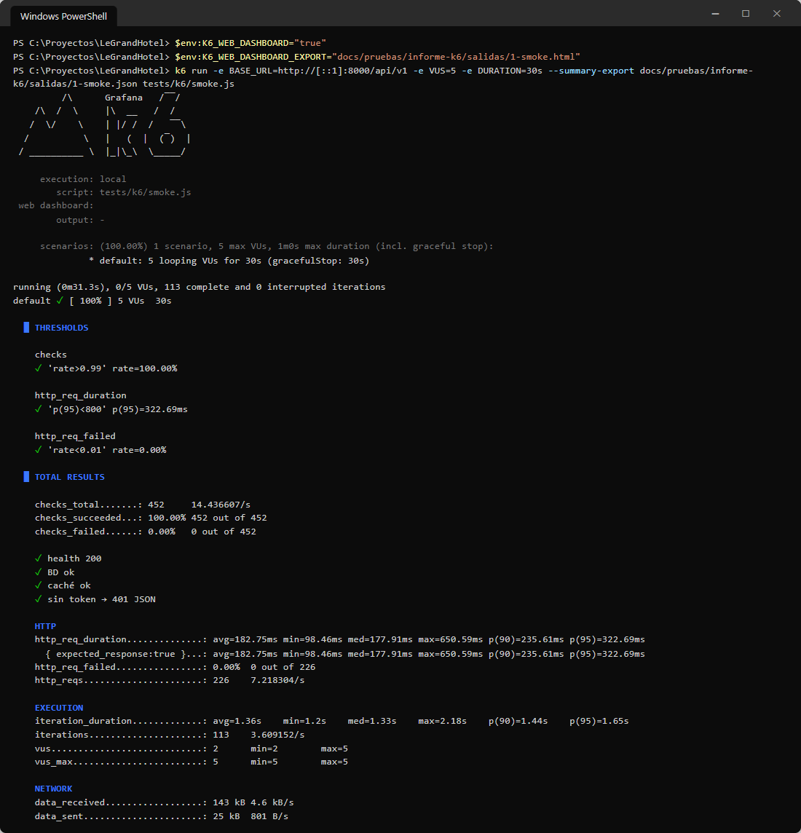
Figure 53. Smoke test command and k6 output.
Interpretation: all three goals pass with ✓. 95% of the responses took less than 323 ms (goal: 800 ms), there were no failed requests (0.00%) and all 452 checks passed: the API, database and cache respond, and a protected route without a token returns 401 in JSON.

7.2 Login attempt limit
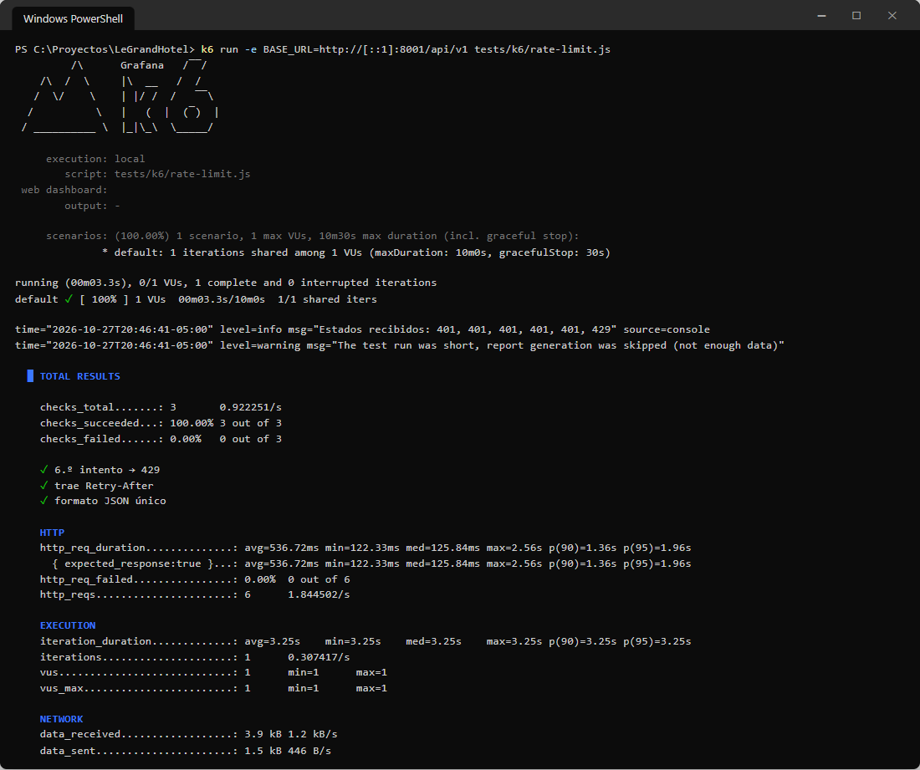
Figure 54. Login limit test: the sixth attempt gets 429.
Interpretation: “Estados recibidos: 401, 401, 401, 401, 401, 429”. The first five attempts answer 401 (wrong password) and the sixth 429, with the Retry-After header and the TOO_MANY_REQUESTS code. Nobody can try passwords without limit.

7.3 Guest steps (5, 10, 25 and 50 at once)
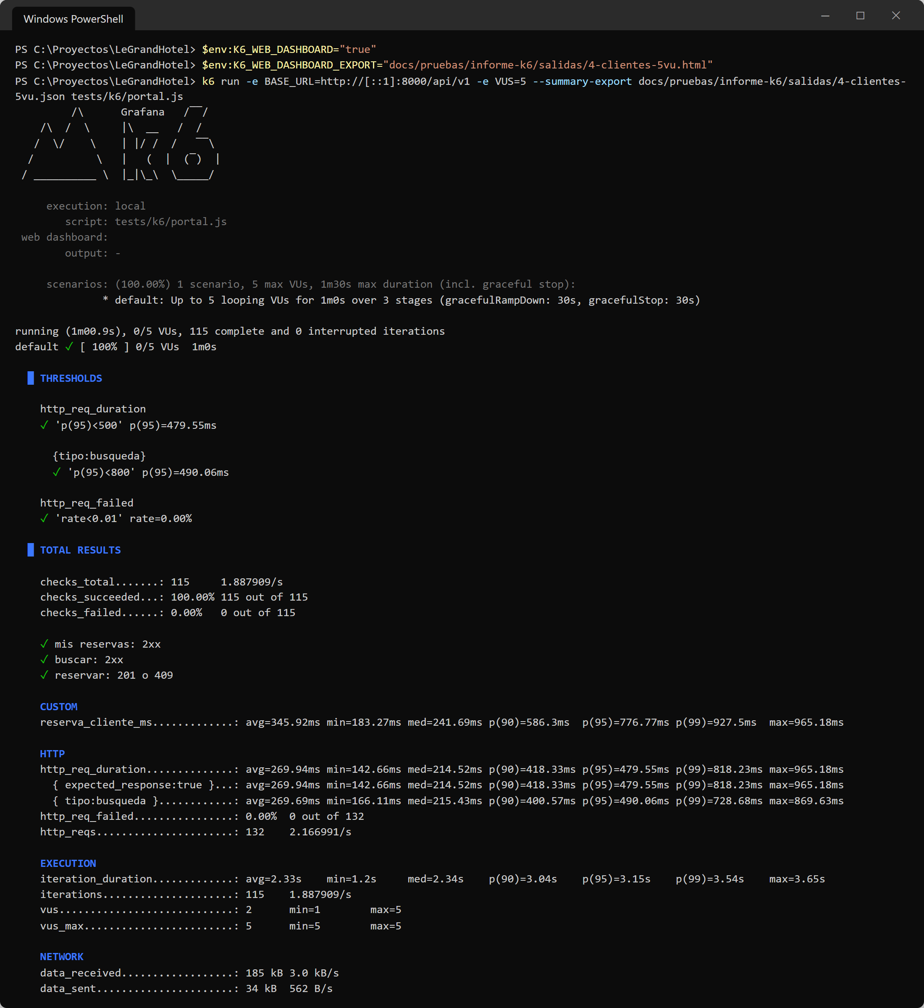
Figure 55. 5-guest step: command and output.
Interpretation: with 5 simultaneous guests the test passes completely: every goal is ✓. 95% of the responses took less than 480 ms (goal: 500 ms), searches 490 ms (goal: 800 ms), there were no errors and all 115 checks passed: search, view bookings and book (201, or 409 if another guest took the last room). Creating a booking took 777 ms at p95.
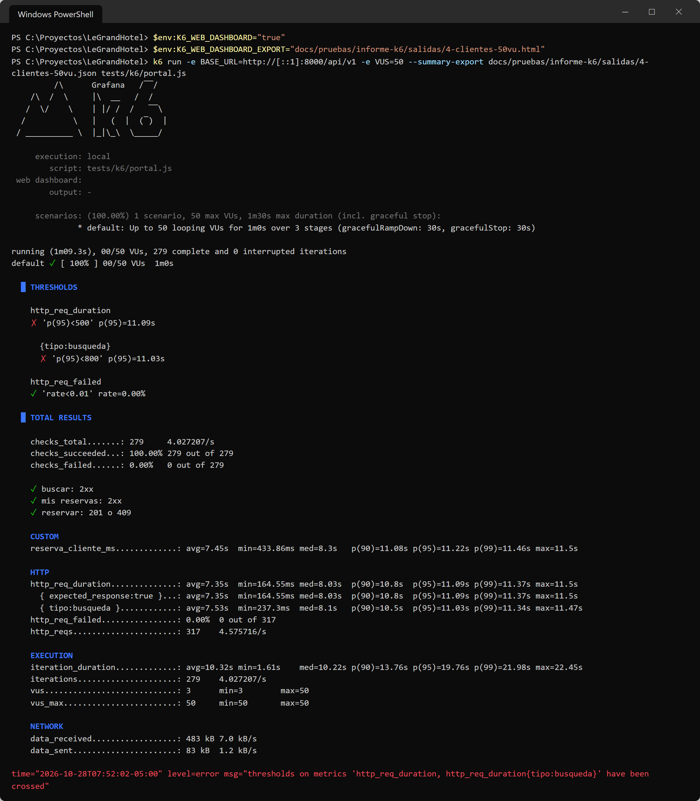
Figure 56. 50-guest step: command and output.
Interpretation: with 50 simultaneous guests every check still passes and there are no errors (0.00%), but the speed goals fail with ✗: the p95 rises to 11,099 ms and creating a booking to 11,223 ms. The final line “thresholds … have been crossed” is k6 reporting that the test did not pass because of slowness, not failures.
Guests | Requests | Req/s | Median | p95 | Book (p95) | Errors | Goal p95 < 500 ms
5 | 132 | 2.2 | 215 ms | 480 ms | 777 ms | 0.00% | ✓
10 | 236 | 3.8 | 481 ms | 1,750 ms | 1,834 ms | 0.00% | ✗
25 | 278 | 4.4 | 3,479 ms | 4,369 ms | 4,461 ms | 0.00% | ✗
50 | 317 | 4.6 | 8,031 ms | 11,099 ms | 11,223 ms | 0.00% | ✗

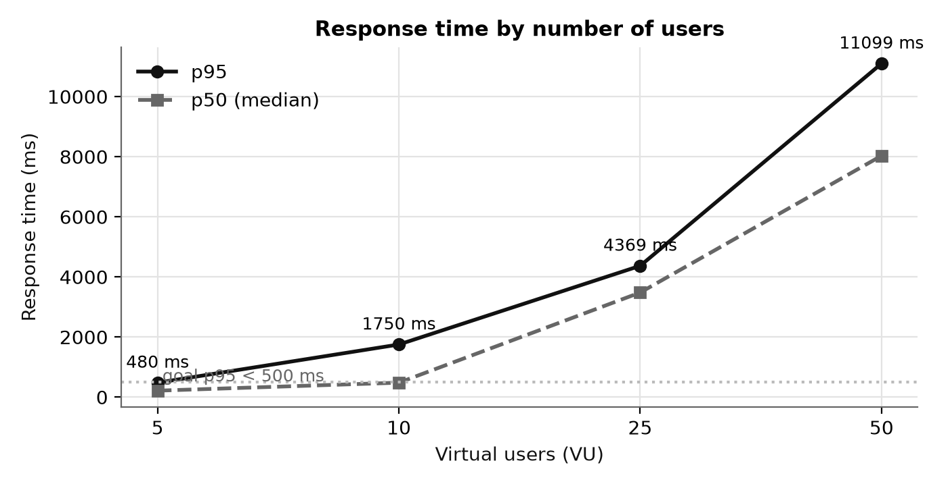
Figure 57. Response time (median and p95) by number of guests.
Chart interpretation: the horizontal axis is the number of simultaneous guests and the vertical axis the response time; the dotted line is the 500 ms goal. With 5 guests the p95 (480 ms) stays just under the goal. From 10 guests both curves rise almost in a straight line up to 11,099 ms with 50. Growing in proportion to the guests is the sign of a queue: each new guest waits for the previous ones.
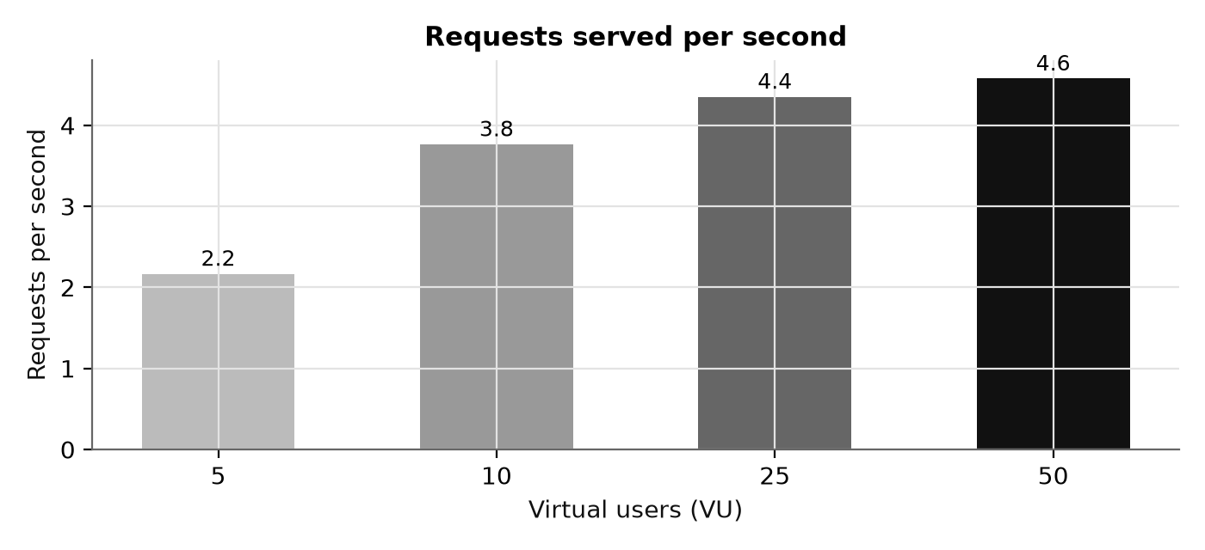
Figure 58. Requests served per second in each guest step.
Chart interpretation: from 5 to 25 guests the requests per second rise (from 2.2 to 4.4) because there is still spare capacity. From 25 to 50 they barely change (4.4 → 4.6): the API reached its ceiling of about 4.6 requests per second and the extra guests only wait longer. Together with the previous chart it confirms the bottleneck.

7.4 k6 HTML report (50-guest step)
k6 also produces a report with charts of the test (salidas/4-clientes-50vu.html). Its three charts are shown separately. The horizontal axis is the time of day (07:51:03 to 07:51:53) and each point summarizes 10 seconds.
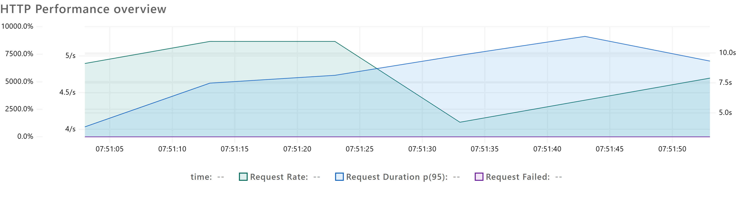
Figure 59. HTTP Performance overview: requests per second, p95 and failed requests (50 guests).
What it shows: three measures at once, each with its own axis. The green line is the number of requests per second (axis from 4/s to 5/s); the blue one, the p95 response time (right axis, in seconds); the purple one, the percentage of failed requests (left axis).
Interpretation: requests per second move in a narrow band, between about 4.1/s and 4.9/s, unable to go higher: that is the API’s ceiling. Meanwhile the p95 grows from about 4 s at the start to about 8 s at 07:51:23, when all 50 guests are in, and reaches about 11 s at 07:51:43. The purple line stays at 0% the whole time: none of the 317 requests failed. Conclusion: with 50 guests the portal slows down, but it does not go down or lose bookings.
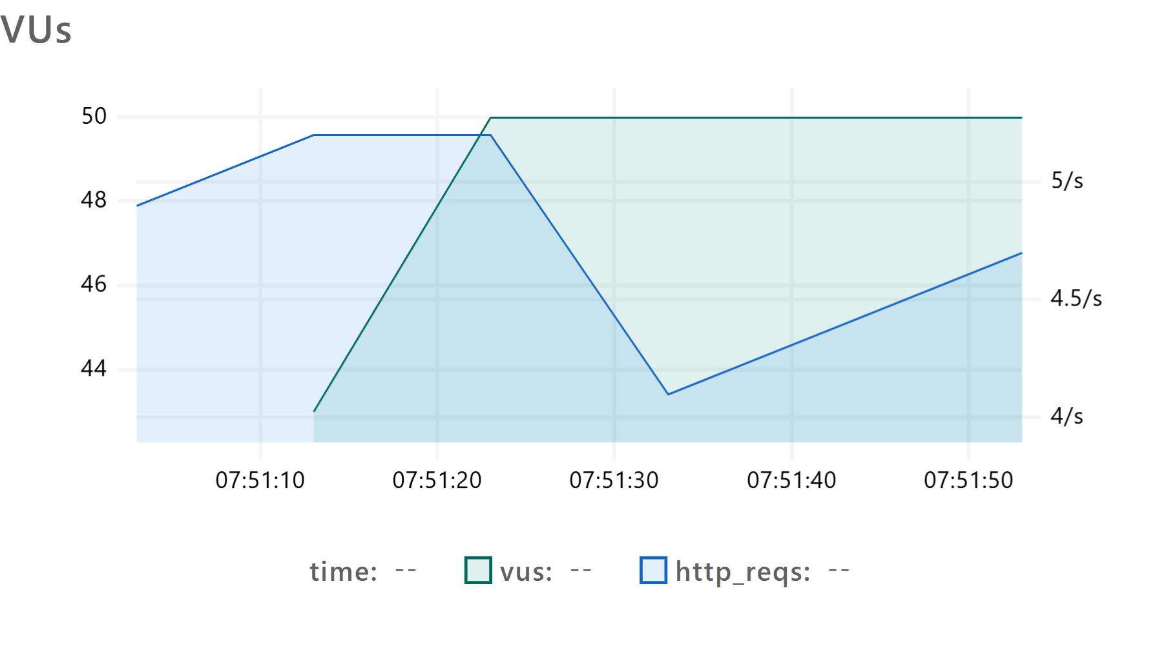
Figure 60. VUs: active guests and requests per second.
What it shows: the green line is the active guests (left axis); the blue one, requests per second (right axis). The guest axis starts at 42 to show the detail.
Interpretation: guests go from 43 to 50 between 07:51:13 and 07:51:23 and stay at 50 until the end. When they reach 50, requests per second do not rise: they drop from 4.9/s to 4.1/s at 07:51:33 and then recover to 4.6/s. More guests does not mean more work served: the API was already at its ceiling and the queue grows. Unlike the staff scenario, there are no logins at the start, because the test guests already have their session open.
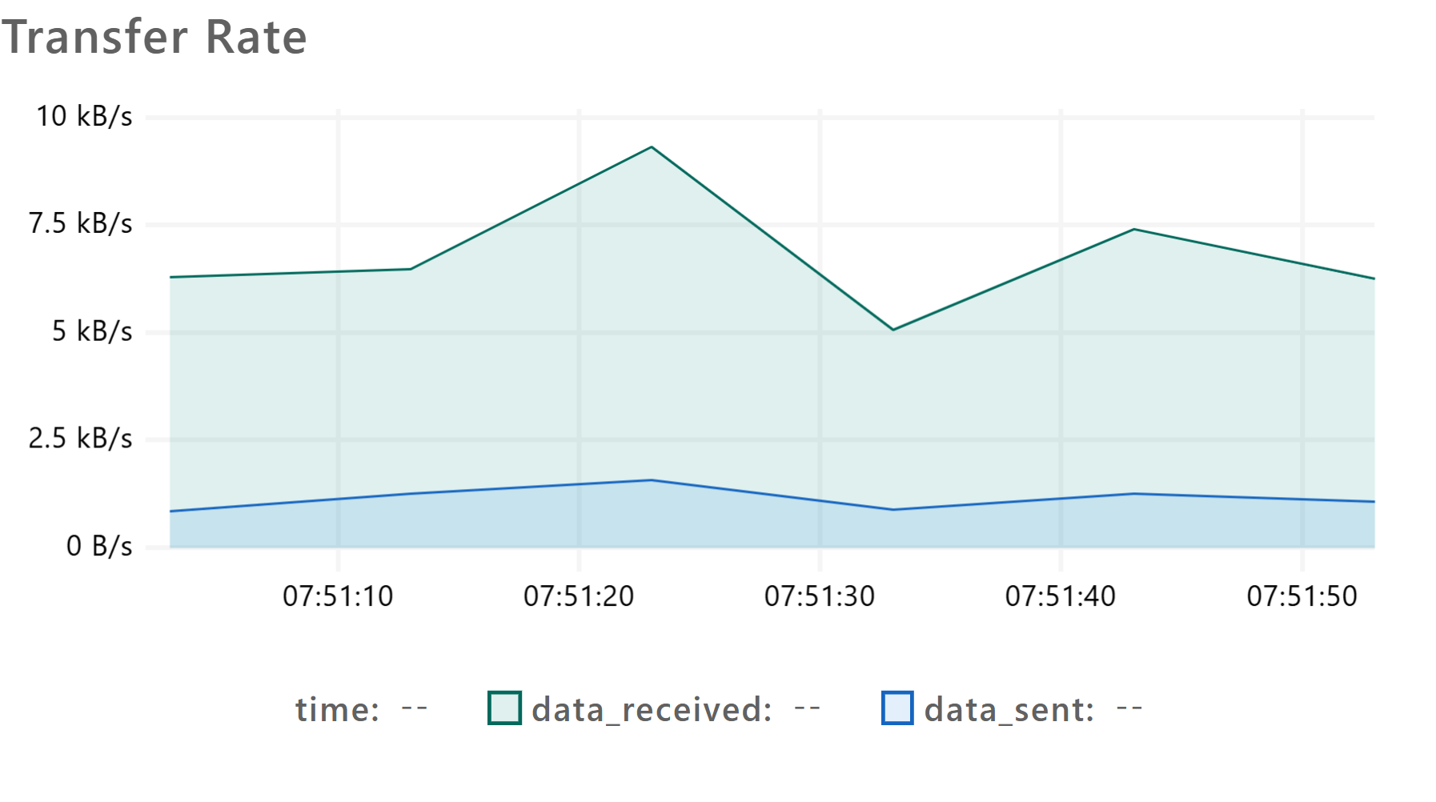
Figure 61. Transfer Rate: data received and sent per second (50 guests).
What it shows: how much data k6 received from the API (data_received, green) and how much it sent (data_sent, blue), in kilobytes per second.
Interpretation: data received goes from 5 to 9.3 kB/s, with a peak at 07:51:23; data sent stays between 1 and 1.5 kB/s. These are small figures because portal responses are light (room types and a single guest’s bookings). In total, 483 kB were received and 83 kB sent: the network is not the limit, the slowness comes from the API processing one request at a time.

7.5 Test conclusions
- Up to 5 simultaneous guests the portal meets every goal (p95 of 480 ms).
- Correct and stable: across all runs there was not a single failed request or 500 error, and simultaneous bookings for the same room were resolved with 409, with no double bookings.
- Secure under load: 401 without a session and 429 when the login limit is exceeded, always in the API’s JSON format.
- From 10 guests it slows down on the laptop because of PHP’s development server, which handles one request at a time (ceiling of about 4.6 requests per second). The fix is to run the API with several PHP processes in parallel and code caching (OPcache) on the final server, and repeat these same tests there, with more guests, once the server is defined.

8. Android and iOS app design
LeGrandHotel will have a phone app that uses the same API and the same roles as the web, without duplicating any business rule. It covers what is convenient to do from a phone: guests book and review their reservations, the front desk handles arrivals and departures from the lobby, and the storeroom records movements in the warehouse.
Role | What they will do in the app
Guest | Sign in with Google, complete DNI and phone, book by room type, view and cancel their reservations, get a reminder one day before arrival
Receptionist | “Today” screen with arrivals and departures, check-in and check-out, reservations, room status and parking
Storekeeper | See the inventory with supplies below the minimum and record stock in and out
Administrator | The summarized dashboard (occupancy, income and alerts); full management stays on the web

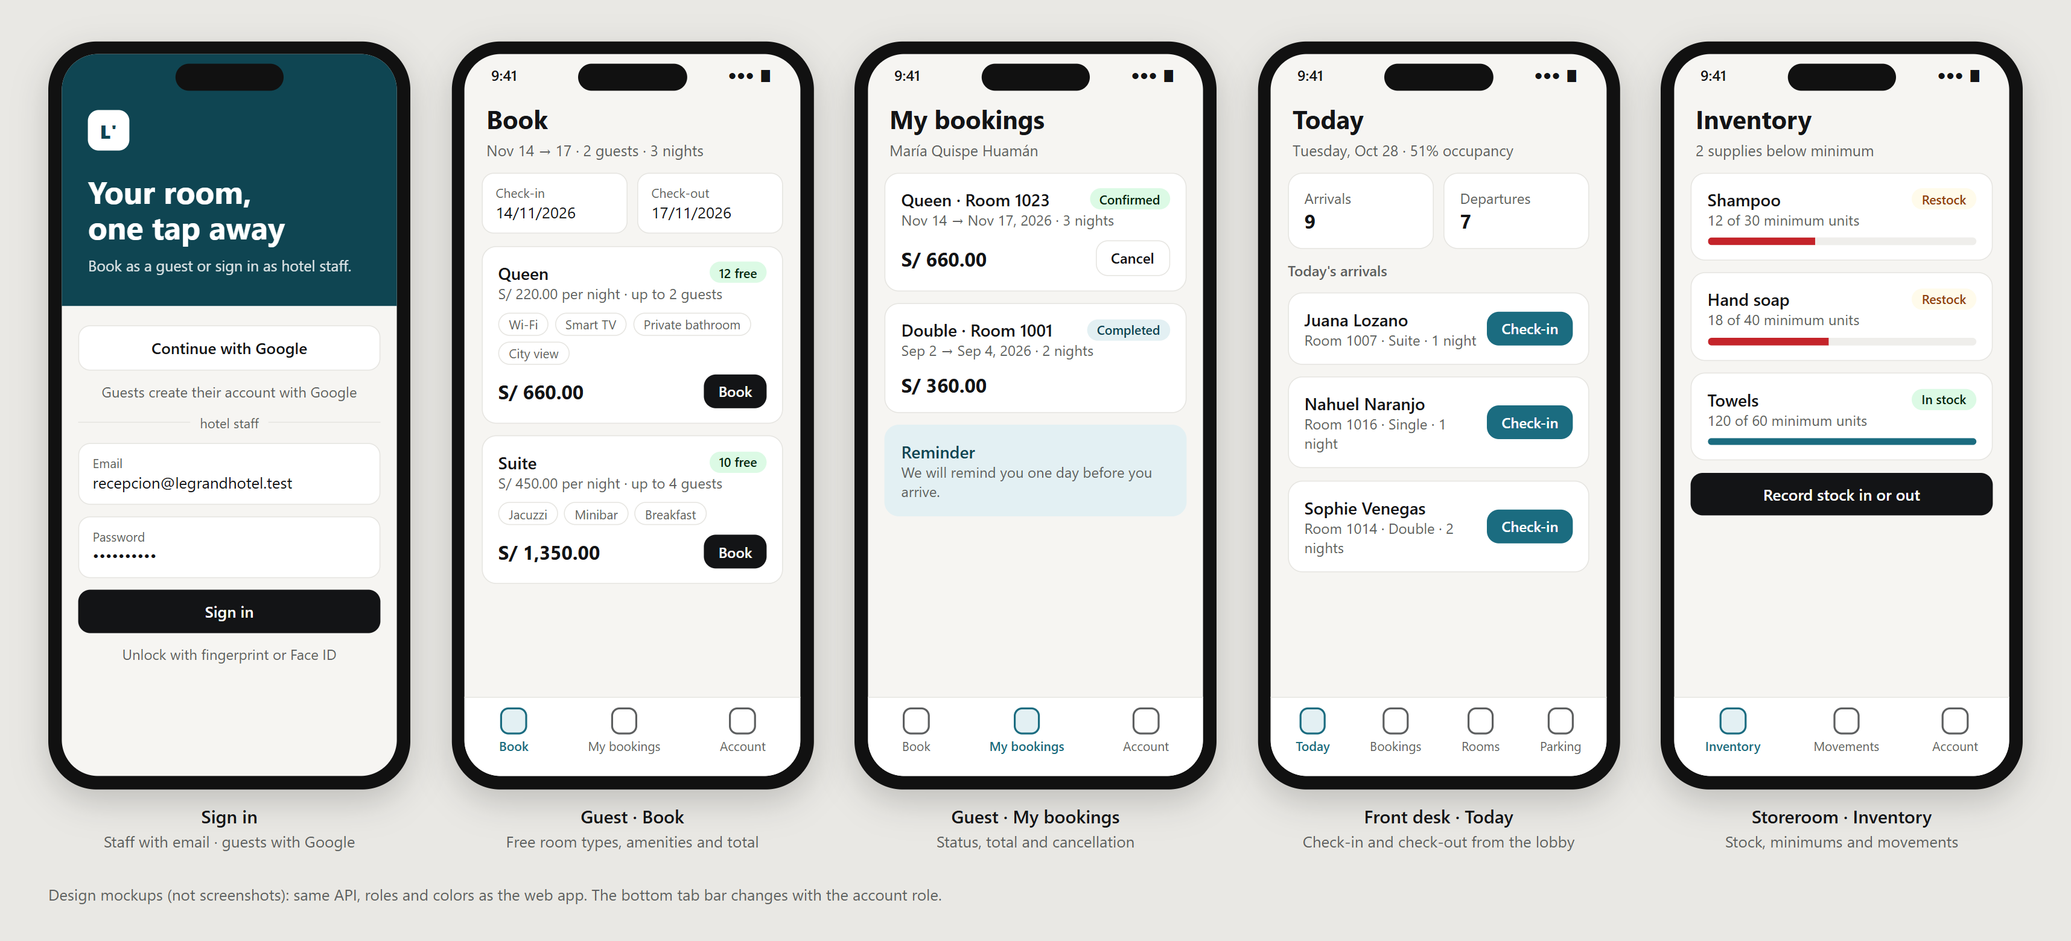
Figure 62. App mockups: sign in, the guest’s Book and My bookings, the front desk’s “Today” and the storeroom’s Inventory.

8.1 Technology
React Native with Expo and TypeScript. A single codebase produces both apps and reuses what the team already uses on the web: React, TypeScript, TanStack Query, Axios and the same data types.
Need | In the app | Web equivalent
Navigation | Expo Router, with a tab bar based on the role | React Router
API calls | TanStack Query and Axios with the same 401/403/429/5xx handling | Same
Session storage | expo-secure-store: Keychain (iOS) and Keystore (Android) | sessionStorage
Google sign-in | expo-auth-session with the link legrandhotel://auth/callback | Socialite with redirect
Notifications | expo-notifications (arrival reminder, room ready, low stock) | —
Unlock | Fingerprint or Face ID (expo-local-authentication) | —
Tests | Jest and Testing Library; Maestro for end-to-end flows | Vitest and Playwright

Option evaluated | Pros | Cons | Decision
React Native + Expo | One codebase for Android and iOS; same language as the web; builds iOS without a Mac (EAS Build) | Very specific native features need custom modules | Chosen
Flutter | Good performance and consistent design | Another language (Dart): nothing from the web is reused | Discarded
Native (Kotlin + Swift) | Full access to the system | Two different apps: twice the work | Discarded

8.2 Security and API changes
- The token is stored in the phone’s secure storage, never in plain text, and is renewed with the same POST /auth/refresh as the web.
- The app contains no secrets: the Google and database credentials stay only in the API.
- The API barely changes: login already accepts a device name (device_name) so each phone gets its own token. Still pending: registering each phone’s notification token (POST /devices) and letting Google sign-in return to the app.

8.3 Build plan
Stage | What is built
1 | Expo project, staff and guest login, secure session and a tab bar per role
2 | Guest: complete registration, book and my bookings
3 | Front desk: “Today” with check-in and check-out, reservations and rooms; Storeroom: inventory and movements
4 | Notifications, fingerprint unlock, tests and a test build for Android and iOS

9. Conclusions
1. The system covers the hotel’s full operation. With 77 REST endpoints and a single response format, LeGrandHotel handles reservations, stays, rooms, guests, parking, inventory, staff, reports and audit, plus online booking for guests.
2. Access is separated and protected. Staff sign in with email and password and are registered by the Administrator or the Developer; guests sign in only with Google. Each role sees only its menu, the API answers 403 even if someone types the address by hand, and there is a single Developer.
3. The server enforces the business rules. The API prevents double booking, two guests in the same room, negative stock and an occupied parking spot (409), calculates the totals and records every change in the audit log.
4. Failures are logged and fixed with evidence. The incident log and the incident code the user sees made it possible to find the cause of each failure in the API log and fix it the same day, with a new automated test when appropriate.
5. The API is stable under load and the next step is clear. In the k6 tests with portal guests there was not a single error with up to 50 simultaneous guests, and with 5 every goal is met; speed on the laptop is limited by the development server and will be measured again once the server is defined. The Android and iOS app will reuse this same API.

