HOW TO CREATE A LEDGER
Ledgers are accounts use to transact business. Example cash account, bank account, customer account, supplier account, expense account, revenue account, etc.
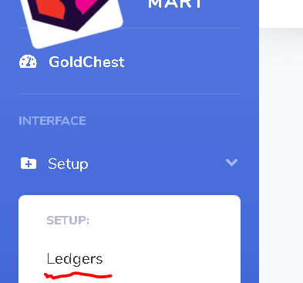
- Click on the Setup Menu
- Click on Ledgers
- Click on New Ledger
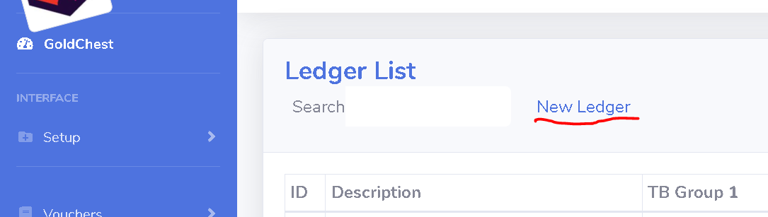

- Type the appropriate of the Ledger in the Description
- Select Active for the Status

HOW TO CREATE CUSTOMER LEDGER (DEBTOR)
6. TB Group 1: Select BALANCE SHEET
7. TB Group 2: Select ASSETS
8. TB Group 3: Select CURRENT ASSETS
9. TB Group 4: Select ACCOUNT RECEIVABLES
10. TB Group 5: Select TRADE DEBTORS
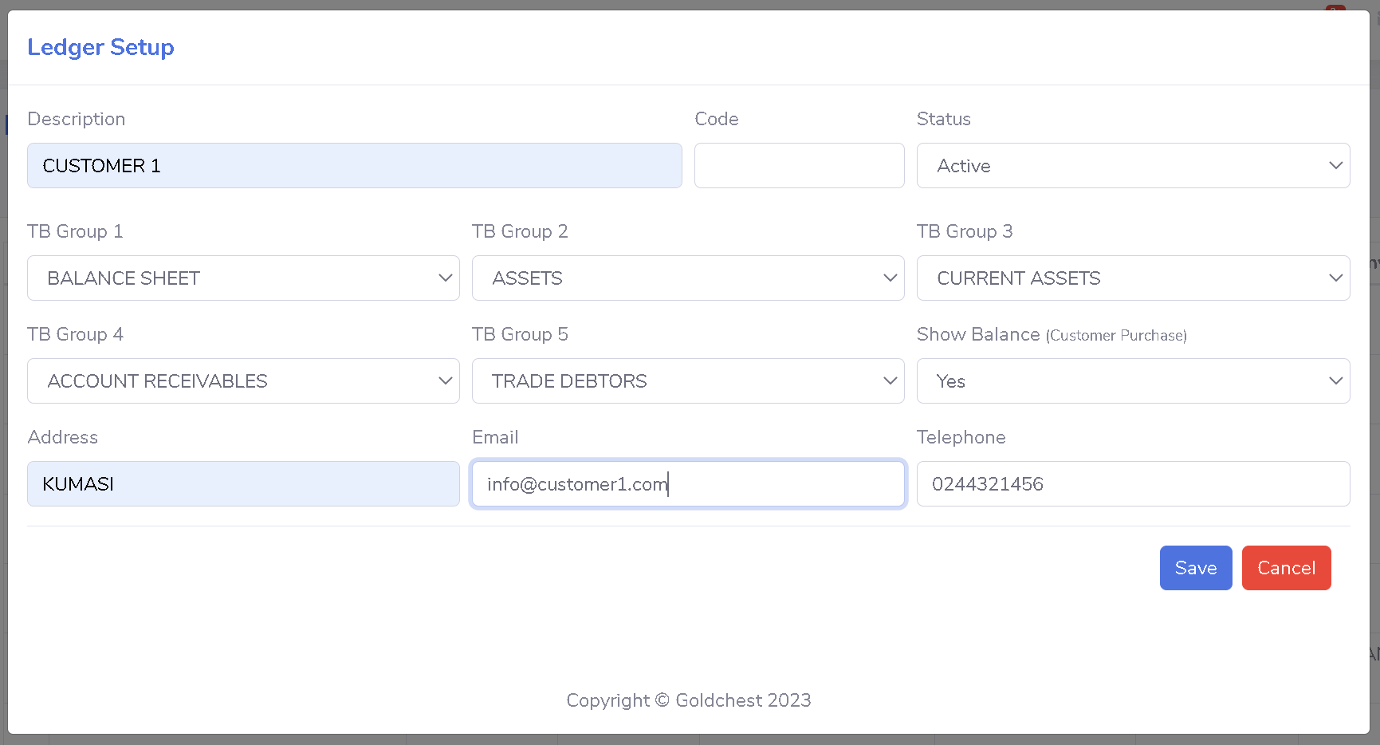

HOW TO CREATE SUPPLIER LEDGER (CREDITOR)
6. TB Group 1: Select BALANCE SHEET
7. TB Group 2: Select LIABILITIES
8. TB Group 3: Select CURRENT LIABILITIES
9. TB Group 4: Select ACCOUNT PAYABLES
10. TB Group 5: Select TRADE CREDITORS
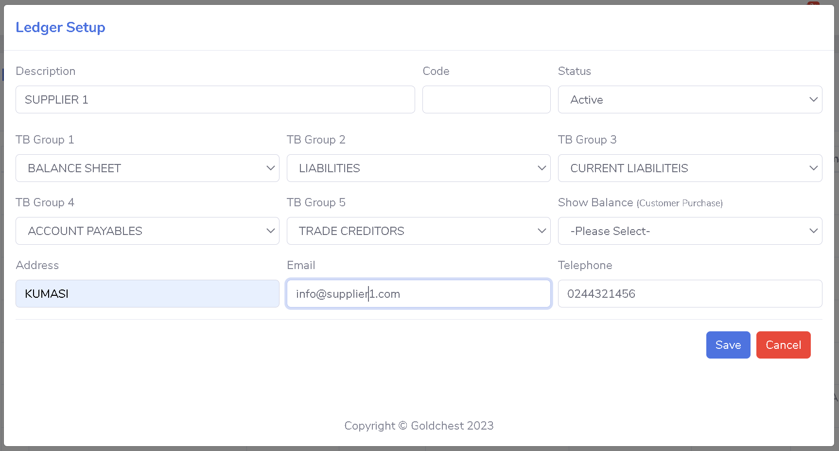

HOW TO CREATE A BANK ACCOUNT
6. TB Group 1: Select BALANCE SHEET
7. TB Group 2: Select ASSETS
8. TB Group 3: Select CURRENT ASSETS
9. TB Group 4: Select CASH AND BANK
10. TB Group 5: Select BANK
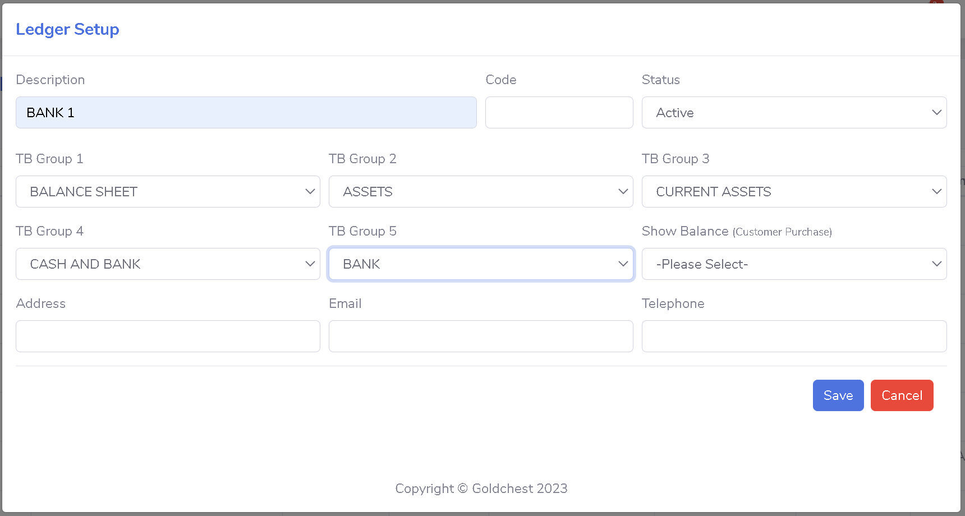

HOW TO CREATE CASH ACCOUNT
6. TB Group 1: Select BALANCE SHEET
7. TB Group 2: Select ASSETS
8. TB Group 3: Select CURRENT ASSETS
9. TB Group 4: Select CASH AND BANK
10. TB Group 5: Select CASH
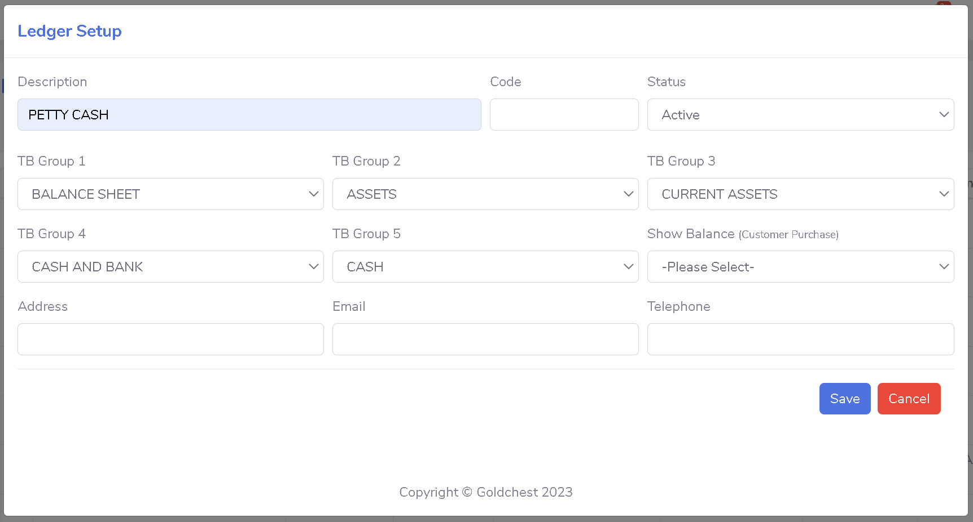

HOW TO CREATE EXPENSE LEDGER
6. TB Group 1: Select PROFIT AND LOSS
7. TB Group 2: Select EXPENDITURE
8. TB Group 3: Select OPERATIONAL EXPENSES
9. TB Group 4: Please Select
10. TB Group 5: Please Select
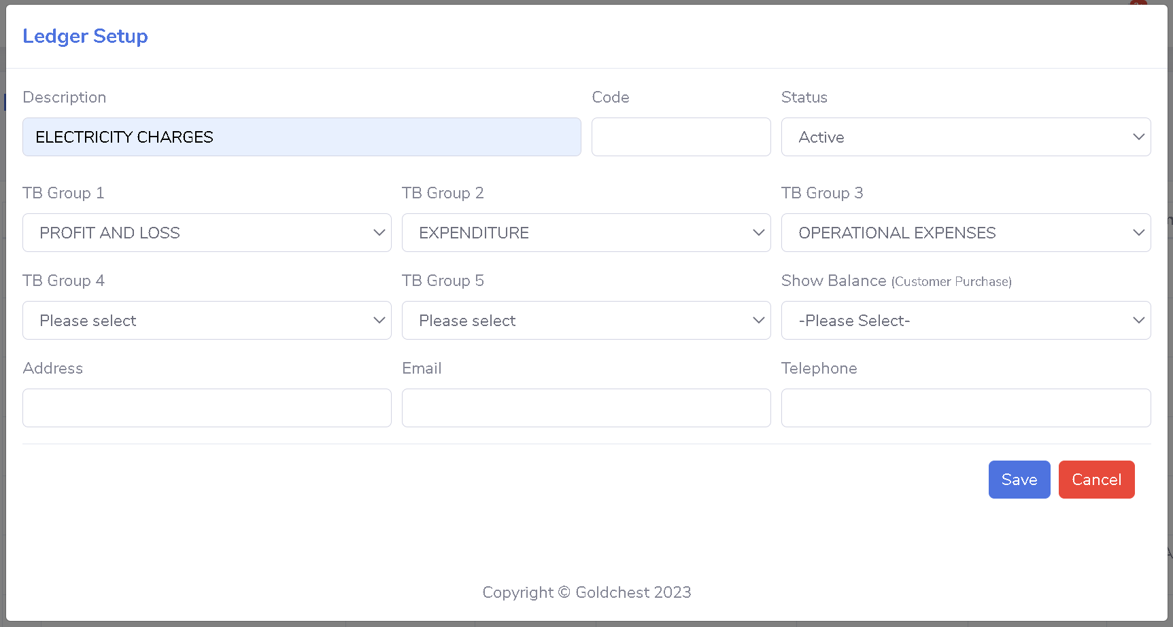

HOW TO CREATE REVENUE LEDGER
6. TB Group 1: Select PROFIT AND LOSS
7. TB Group 2: Select REVENUE
8. TB Group 3: Select OPERATIONAL REVENUE
9. TB Group 4: Please Select
10. TB Group 5: Please Select
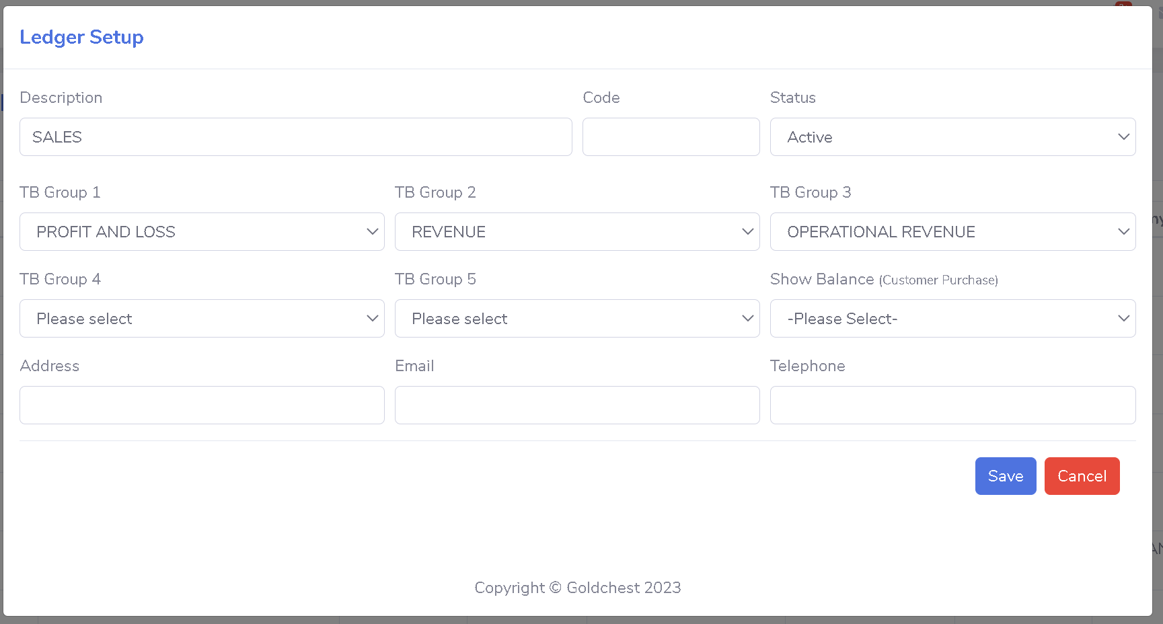

HOW TO CREATE FIXED ASSET LEDGER
6. TB Group 1: Select BALANCE SHEET
7. TB Group 2: Select ASSETS
8. TB Group 3: Select FIXED ASSETS
9. TB Group 4: Select TANGIBLE
10. TB Group 5: Please Select
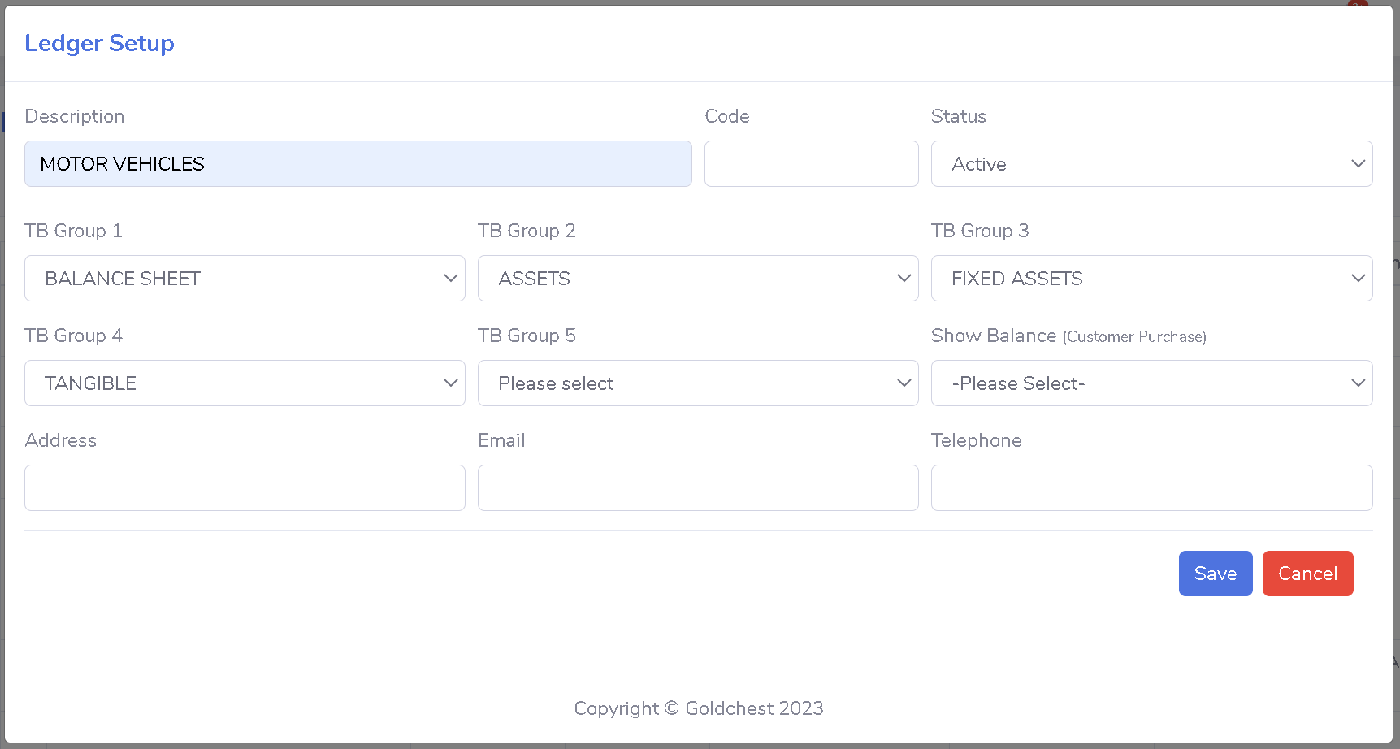

11. Click on Save

