Livedyne Mission Statement

Livedyne is a breakthrough Poly(ATP)-ribose compound synthesised by our proprietary photonreactor. It’s unique because it’s 100% bioavailable to any living cell.

Stem cells have a special relationship to the bodies’ energy & signalling molecule ATP : it’s the difference between viable cell production and problematic growth. Livedyne has confirmed results in stem cells from cartillage to neurons pointing to its absolute centrality in a variety of therapeutics from immuno-imbalance to the root causes of neural dysfunction, biofabrication , organ transplants & wound healing, liver & kidney regeneration, and more such as retinal tissue and vessicles, tympanic membranes, and bone – from popular indications to orphan diseases.

We expect Livedyne to be used to preserve, transfer and assure viability for organs. The Livedyne substance can preserve the organ as well as lengthen its life.

We expect Livedyne to be used in various IA therapies for example to treat osteo-artheritis. Targetted Livedyne delivery is easy to do and is expected to have complete regenerative effects.

We have confirmed results in cartillage cell growth , outclassing existing protocols by a factor of 4. We expect Livedyne to be used in various biofabrication applications from its addition to scaffolds to its role to optimise growth rates.

We expect to confirm our hypothesis in neuron cells : that energy pathways (eg Fragile X syndrome) in cells and mitochondria can be restored to behave as in controls.

The Story So Far

Notable scientists as well as the largest pharmaceuticals have expressed their explicit interest in pursuing a variety of avenues with Livedyne. So many people have offered us their support to develop various verticals in different fields of medicine from research to production environments.

Research scientists have been surprised how easy it is to work with , being able to run short and fundamental confirmatory studies, and the ease of integrating it with cutting edge scaffolding and microbead techiques. Large allograph producers and organ storage centres have been impressed with auditable results in terms of what this can do for them. Folks have been begging us to open a clinic for year-long therapies and cures. We’re currently going with an industrial organ biofabrication and (human?) meat production route via the ARMI consortium.

Motivation for Birthing a New Asset Class

All highly industrialised , highly regulated value chains such as biofabrication and therapy production environments sometimes operate from fossil fuels or with other subsidized pollutants. In fact, crypto uses huge amounts of subsidized and polluting electricity in many countries from the United States to Nigeria. This will eventually lead to inflationary trends in central bank currencies concurrent with climate-change-induced disruptions and strife. Yet, access to products that use Livedyne will remain highly prized. We want to assure that anyone can purchase organs, treatments and care regardless of the inevitable disruptions wrought by climate change compounded by overeliance on obsolete energy and monetary policy.

Definitions

* LIFECells are atributed verticals of the Livedyne Company Network.
* STEM Stations are machine deployments that host trading and services to the network such as charge of airdrops and buybacks..
* BASE Stations are machine deployments that host transactions and mining+staking.
* station weights are calculated based on up time and capacity and bandwidth continuously
* Transaction Efficiency (TxE) and Energy Efficiency (EE) are important performance metrics that guide the optimization of LIFECell networks.

LIFECell Network

LIFECell is a Pareto front efficient cryptocurrency network. This system’s purpose is to provide an unalienable way for lifescience investors to buy LifeCell tokens for use in the Livedyne Ecosystem. This will be done through the regular deployment of LIFECell STEM Stations and BASE Stations within LIFECells.

Once LIFECells are established Their core STEM and BASE Stations will be established within those verticals to assure circulating supply. STEMStations and BASEStations exploitation rights are also for sale for nominal fees of 10000000 and 1000000 LIFECell Coins. These nodes are expected to process more of the network transactions and be driven by experienced informatitians.

BASEStations must report their true location and IP addresses for the STEMStations to attribute correct energy efficiecy metrics on a rolling basis based on public traded market information. The consumer price is not taken into account, only the electricity production price is used.

Transaction Efficiency (TxE) and Energy Efficiency (EE) are important performance metrics that guide the optimization of LIFECell networks. Under typical operating conditions, however, they are conflicting objective functions: There exists no single solution that simultaneously optimizes each of them. There exist, on the other hand, several optimal solutions for which none of the two objective functions can be improved without degrading the other objective.

Multiobjective optimization problems such as programmatic prioritisation , the frontier between private and public investments , and patient scheduling, may have Pareto-optimal fronts ,

The TxE-EE pairs that fulfill the latter optimality condition are referred to as Pareto-optimal solutions, and the corresponding TxE-EE curve is known as the Pareto front. All Pareto-optimal solutions are equally good without any subjective preference information. Therefore the Pareto front contains the best transaction (Tx) combinations for subsequent (subjective) transactions.

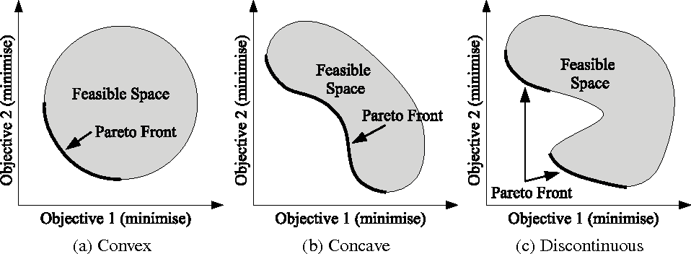

To calculate the Pareto front, LIFECell weighs transaction vectors [ a , 1 – a ] for a from 0 through 1. Then solves the goal attainment problem, by setting the weights to the various values according to updated station weights. After proof-of-work validated computation, the tradeoff between the two objective functions determines the path of the transaction.

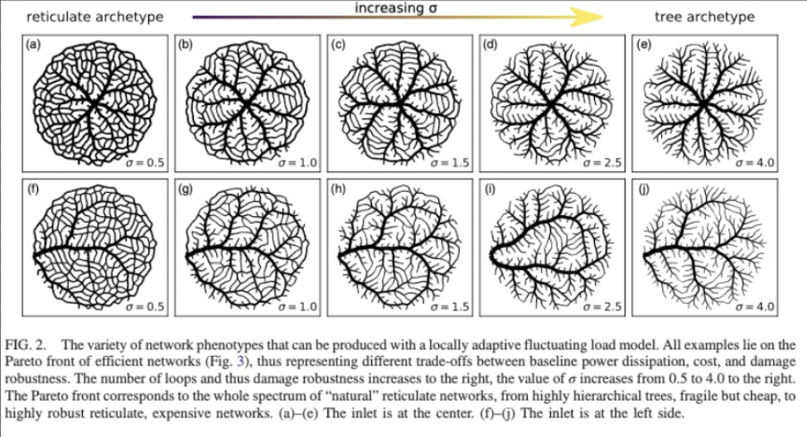

* Coin is issued to miners doing distributed computing.
* Protocol revenue is distributed to Coin holders[1].
* Coin is exchanged through nodes that are in charge of airdrops and buybacks.
* Investors will be able to distribute tokens according to their investment time horizon.
* Coin is traded on DEX by coin holders that can use their existing wallets.

Tokenomics

### Tokenomics

### 15.000 % Team

### 44.000 % DEX

### 12.000 % Liquidity

### 24.000 % Ecosystem

### 5.000 % Reserve

Total token supply : 8,000,000,000

Reserve : 400M (5%)

Supply on DEX : 3,520,000,000

market cap on DEX : $80,000,000

Dex Liquidity: $21,818,181

Token Distribution

|  |  |  |  |  |  |  |
| --- | --- | --- | --- | --- | --- | --- |
|  | Allocation% | Price$ | Token # | Cap, $ | Lockup (Cliff) | Vesting |
| Private Sale | % | 0.01 |  |  |  | 10 |
|  | % | 0.015 |  |  |  | 6 |
| Public Sale | 44% | 0.02 | 3,520,000,000 | $80,000,000 | 0 | 4 |
| Liquidity | 12% | 0.03 | 960,000,000 | $21,818,182 | 0 | 0 |
| Team | 15% | 0.03 | 1,200,000,000 | $27,272,727 | 12 | 12 |
| Advisory | 8% | 0.03 | 640,000,000 | $14,545,455 | 3 | 9 |
| Partners | 15% | 0.03 | 1,200,000,000 | $27,272,727 | 5 | 12 |
| Community + marketting | 9% | 0.03 | 720,000,000 | $16,363,636 | 3 | 12 |
| Incentive Program | % | 0.03 |  |  |  |  |
|  | 100% |  |  | $181,818,182 |  |  |

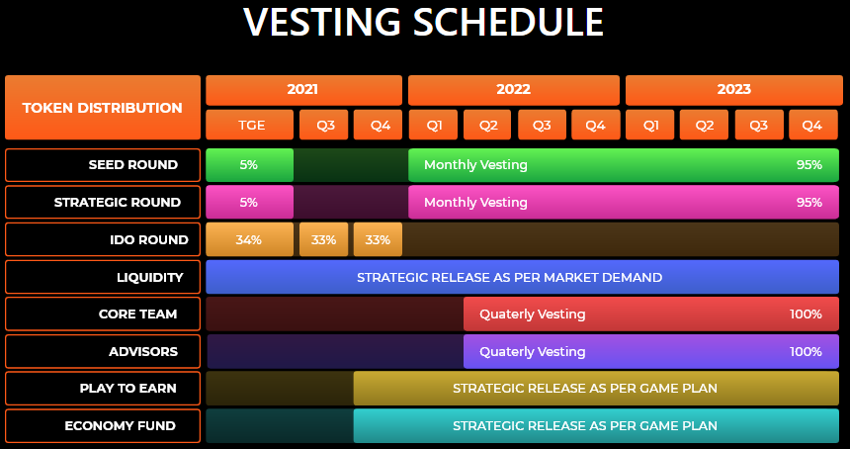

Milestones

|  |  |  |  |  |  |
| --- | --- | --- | --- | --- | --- |
| Q22022 | Q32022 | Q42022 | Q12023 | Q22023 | Q32023 |
| * First NFT + Token issuance * LIFECell IDO & mobile app * incorporation & establishment of the Neuro LIFECell | * Voting on the next LIFECell * First open STEM Stations and BASE Stations | * Establishment of either Cartilage production cell or Osteoartheritis Cell * Seconding NFT + Token Issuance | * Voting on the next LIFECell * Open Air Drops | * Voting on the next LIFECell * Open Air Drops | * Voting on the next LIFECell * Open Air Drops |

Token functions

* Deflationary Tokenomics - Each transaction on the social network charges a commission from the user. Part of the commission is directed to the burning of coins. Since coins are issued only once, there is no inflation model, the number of coins will constantly decrease.
* Governance - All stakeholders can vote for programmatic prioritisation , (their own) patient scheduling & vote for new Cells that will be added to the eco-system to make LIFECell more attractive to new users.
* Staking – Stakeholders receive LIFECell coins according to their investment time horizon
* Trading – LIFECell coins can buy priviledged access to care, therapy and organ growth

Potential LIFECells 2022 – 2024

* clinic
* injectable treatment
* (human?) meat production
* biofabrication – cartilage
* liver and kidney regeneration
* autism , fragile x, huntingtons , parkinsons
* auto-immune diseases
* retinal regeneration
* auditory conduit regeneration
* bone manufacturing
* heart biofabrication

1. so our Coin has a clear use case from day 1