MindeRX

Team Members:

Joshua Jones, Michael Hodnett,

Ke Zhao, and Joseph Sessions

Team Name:

“Team Who Must Not Be Named”

Table of Contents

Introduction 3

Motivation 3

Scope 3

Goal 3

Key definitions 3

Project Description 3

Requirements 4

Functional Requirement 4

Non-functional Requirement 4

Change History 5

UML Diagrams 6

Class Diagram 6

Activity Diagrams 7

Login 7

Update Patient Record 8

Graph Patient Info 10

Manage Patients 11

High-level Class Diagram 13

# Introduction

## Motivation

* Currently the problem is that Nurses/Doctors have to go to a centralized place on a hospital floor to find out information about a patient from a computer and/or potentially dig through   paperwork to find out information about the patient.

## Scope

* This application should be used in medical area. All features are supposed to make medical activities more efficient.

## Goal

* This application is supposed to reduce the time to find out this information about the patient and reduce the redundancy in gathering patient information to make medical decisions.

## Key definitions

* **Nurse:** the person who take care of several patients in one floor
* **Floor nurse:** the person who is in charge of all nurses in one floor and be able to assign patients to nurse.
* **Doctor:** the person who treat some patients. These patients are not necessary in one floor.
* **Administrator:** the person who is able to add patients to hospital database.

## Project Description

* **Record patient vital signs:** Medical staff should be record patient vital signs and put the date/time stamp for when it was recorded
* **Graph patient vital signs based on history:** Medical staff should be able to view wanted patient info on a graph
* **Manage patient to nursing staff:**Floor nurse and administration should be able to assign or unassign a patient to a nurse

# Requirements

## Functional Requirement

* Users should be able to get a list of patients
* Users should be able to view and update patients’ records.
* Floor nurse and administrator should be able to manage patients to nurse.

## Non-functional Requirement

* System requires Android 4.3 or higher
* Mobile device must have a touch screen
* Have an existing database to work with
* Must have a wireless connection

# Change History

|  |  |  |
| --- | --- | --- |
| Version | Summary | Name |
| 0.1 | Initial write up, introduction section and layout | Ke Zhao |
| 0.2 | Format and correct grammar | Joshua Jones |
| 0.3 | Added project descriptions | Joshua Jones |
| 0.4 | Added High-Level Class Diagram and Description | Joseph Sessions, Ke Zhao |
| 0.5 | Added Activity Diagram: Login | Michael Hodnett |
| 0.6 | Added Activity Diagram: Manage Patient Info | Joshua Jones , Joseph Sessions |
| 0.7 | Added Activity Diagram: Graph Patient Info | Joshua Jones, Joseph Sessions |
| 0.8 | Added Activity Diagram: Update Patient Info | Joseph Sessions |
| 0.9 | Reviewed and refactored: Update Patient Info Activity Diagram | Michael Hodnett |
| 1.0 | Added Table of Contents | Joshua Jones |

# UML Diagrams

Class Diagram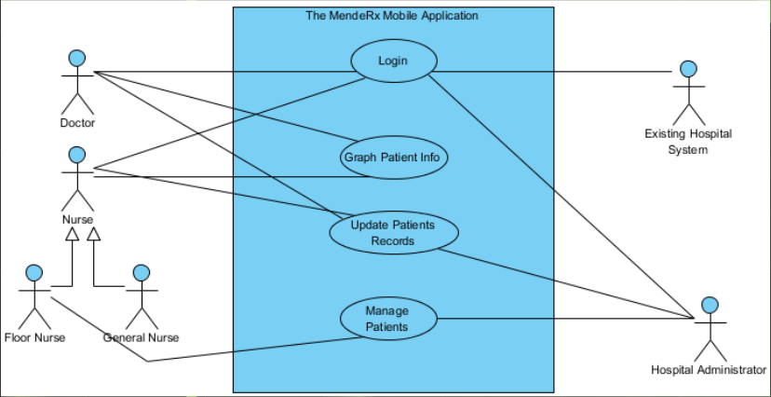

## Activity Diagrams

### Login

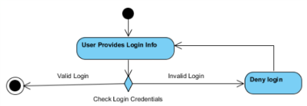

|  |
| --- |
| Use Case: [ Login ] |
| **Context:** The MindeRX Mobile Application provides login screen for accessing hospital system. |
| **Actors:** Nurses, Doctors, Hospital System, Hospital Administrator |
| **Main Success Scenario:**   * **1.0** During hospital operations, the user will provide his or her login credentials and submit it to the system for authorization. |
| **Extensions:**   * **1.A.0** If the Hospital System fails to authorize a user, then the user requesting authorization will be returned back to the login screen. |

### Update Patient Record

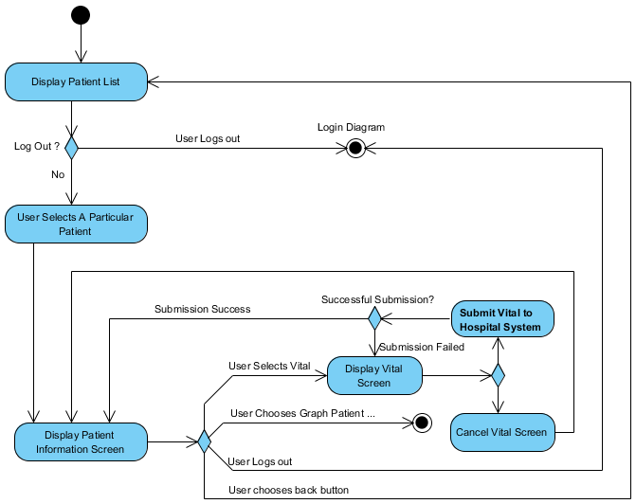

|  |
| --- |
| Use Case: [ Update Patient Record ] |
| **Context:** The MindeRX Mobile Application offers medical staff the ability to record measured vitals for record keeping.. |
| **Actors:** Nurses, Doctors, Hospital System, Hospital Administrator |
| **Main Success Scenario:**   * **1.0** The user selects a patient from the on-screen list and indicates patient management by clicking the “Manage Patients” button. * Patient information screen is displayed to the user. * **2.0** The user selects a vital from the “Patient Information” Screen and is taken directly to the screen associated with that particular vital. * **3.0** The user updates and submits a particular vital. * 3.0.1 MindeRx sends Patient’s vital data to the Hospital System and receives confirmation of Hospital System update. * 3.0.2 A message is displayed to the user confirming the update is complete. * 3.0.3 The user is returned to the “Patient Information” screen. * 3.0.4 Continue at Use Case 2.0 |
| **Extensions:**   * **1.A.0** The user specifies the logout operation.   + **1.A.1** The application suspends the current operation and logs out system user. * **1.A.3** Display the Login screen. * **1.A.2** End this Use Case * **2.A.1** The user chooses “Graph Patient Info” button to access the graphical charts based on the patient’s vitals. * End this Use Case * **2.A.2**  The user chooses the back button to return to the Patient List screen. * Continue at Use Case Scenario 1.0 * **2.A.3** The user chooses the logout button * Continue at Use Case Scenario 1.A.1. * **3.0.A** The user cancels the current vital and is taken back to the “Patient information screen”. * Continue at Use Case Scenario 2.0 * 3.0.1.A Confirmation was not received that the particular vital was updated in the Hospital System * Display “Vital Not Submitted” Error to the user. * Continue at Use Case 3.0 |

### Graph Patient Info

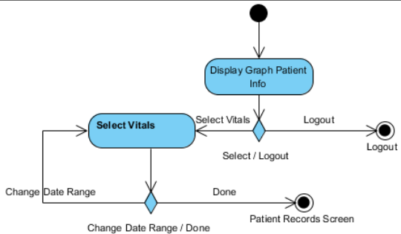

|  |
| --- |
| **Context:** The MindeRX Mobile Application offers medical staff the ability to record measured vitals for record keeping.. |
| **Actors:** Nurses, Doctors, Hospital System, Hospital Administrator |
| **Main Success Scenario:**   * **1.0** The user selects a patient from the on-screen list. * **2.0** The user selects a vital from the list of patient information. * **3.0** The user inputs data to record for the patient’s selected vital at the current time and submits it.   + **3.1** The user inputs a reading into the on-screen text field for recording.   + **3.2** The user presses the “Submit” button. |
| **Extensions:**   * **1.A.0** If the user specifies the logout operation, the application should suspend the current operation  and log the user out, returning them to the login screen. * End this Use Case * **2.A.0** If the user selects the heart rate vital, transition to the blood pressure screen.   **2.A.1** If the user selects the blood pressure vital, transition to the blood pressure screen.  **2.A.2** If the user selects the allergies vital, transition to the allergies screen.  **2.A.3** If the user selects the temperature vital, transition to the temperature screen.  **2.A.4** If the user selects the Sa Level vital, transition to the Sa Level screen. |

## 

## Manage Patients

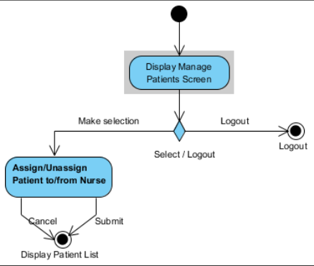

|  |
| --- |
| Use Case: [ Manage Patients ] |
| **Context:** The MindeRX Mobile Application provides the ability to manage patients to nurses for the hospital system. |
| **Actors:** Floor Nurses and Hospital Administrator |
| **Main Success Scenario:**   * **1.0** User assigns a patient to a nurse or unassigns a patient from a nurse and submits.   + **1.1** User selects a patient from a list of the patients they are responsible for.   + **1.2** User selects “Assign” or “Unassign.”   + **1.3** User selects a nurse from the list of nurses they are responsible for.   + **1.4** User selects submit, confirming the transaction. |
| **Extensions:**   * **1.A.0** If the floor nurse or administration does not select one item per field, then the submit button remains greyed. * **2.A.0** If the user specifies the logout operation, the application should suspend the current operation  and log the user out, returning them to the login screen. |

## High-level Class Diagram

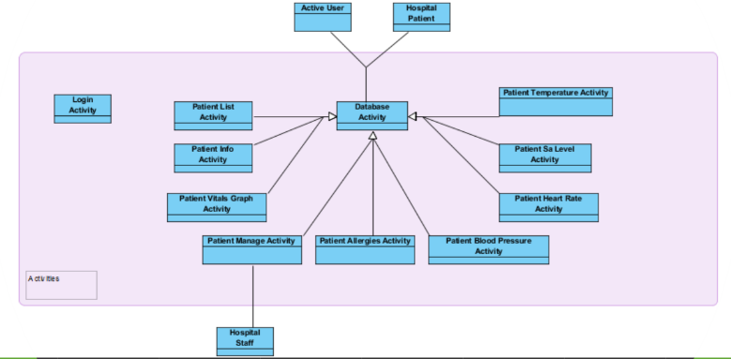

|  |
| --- |
| High-Level Class Diagram |
| **Description:** MindeRx’s class hierarchy is built around Android’s activity framework. This diagram depicts the base classes that we anticipate will be required. |
| MindeRx’s activities primarily subclass an abstract class called “Database Activity”, which allows the system to specify common database acquire/drop operations to minimize claimed resources during operation. Additionally, basic data classes for patients, staff, and the current user are maintained for future extensibility and data encapsulation. |