# CS 340 README Template

Joseph Collett

CS-340

February 5, 2023

## About the Project/Project Title

# Python CRUD

Python CRUD is a module that connects a mongo DB to your python frontend. It performs the basic create and read functionality to date.

## Motivation

This project exists to quickly implement CRUD functionality to your application. One only needs to manipulate the create and read functions to their specific application situation.

## Getting Started

To get started with Python CRUD, simply import the file into the main .py file that runs your app. Then, instantiate the class and implement its functions.

## Installation

To run Python CRUD, you need to install python3 and pip. Then, you need to import crud into the main .py file.

## Usage

*Use this space to show useful examples of how your project works and how it can be used. Be sure to include examples of your code, tests, and screenshots.*

### Code Example

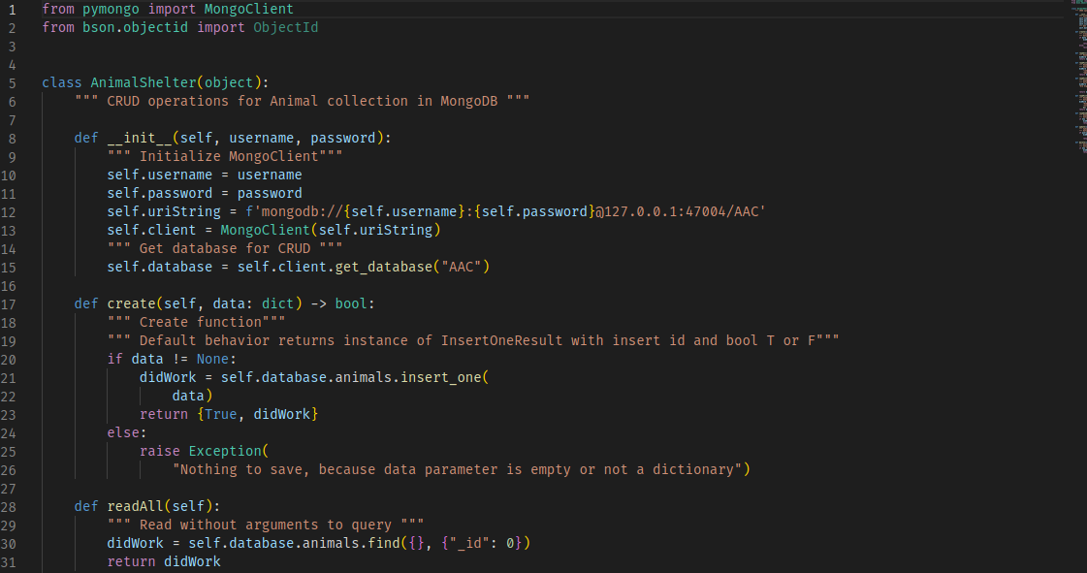

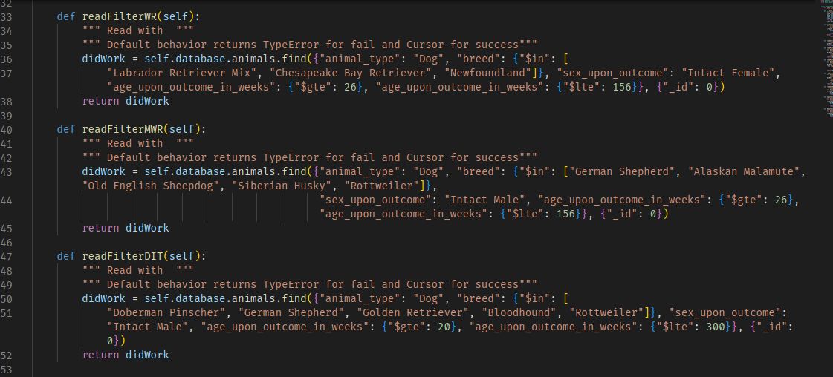

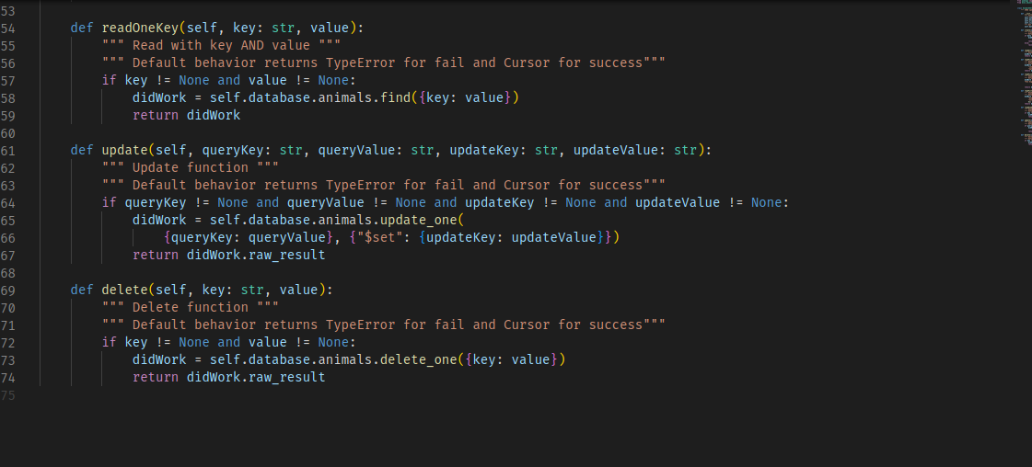

### Tests

First, download and install mongodb with pymongo. Create user authentication into the database. Import the Austin Animal Shelter data into a database "AAC" and into the collection "animals." There are screenshot examples below.



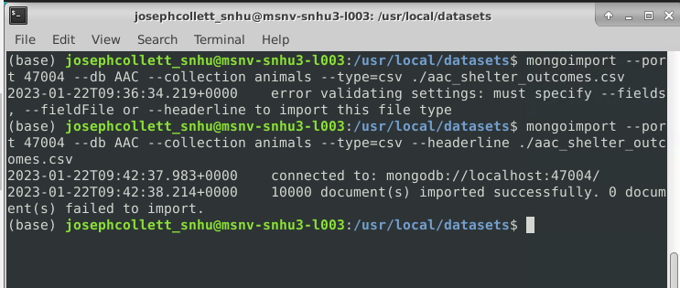

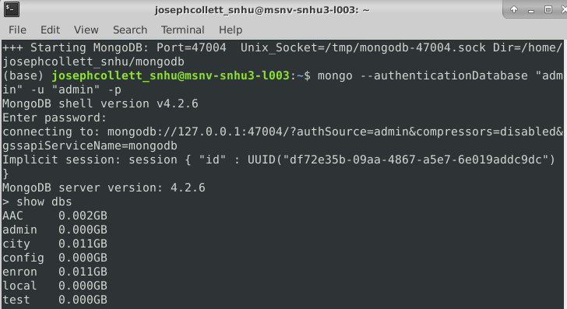

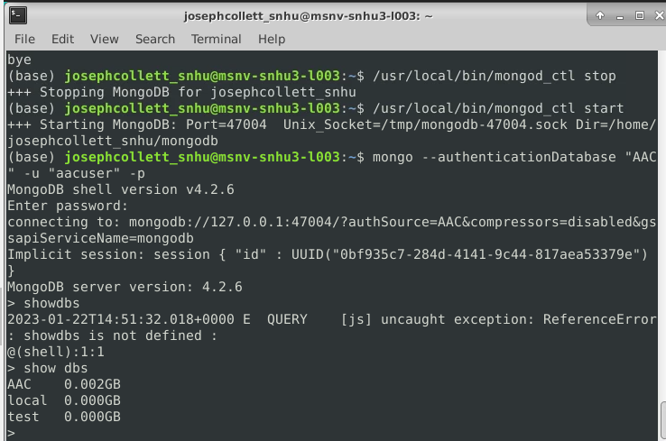

To test Python CRUD, use Jupyter notebooks. Import the file, instantiate the AnimalShelter class and save it to a variable, then execute the create and read functions inherent to the AnimalShelter class instance.

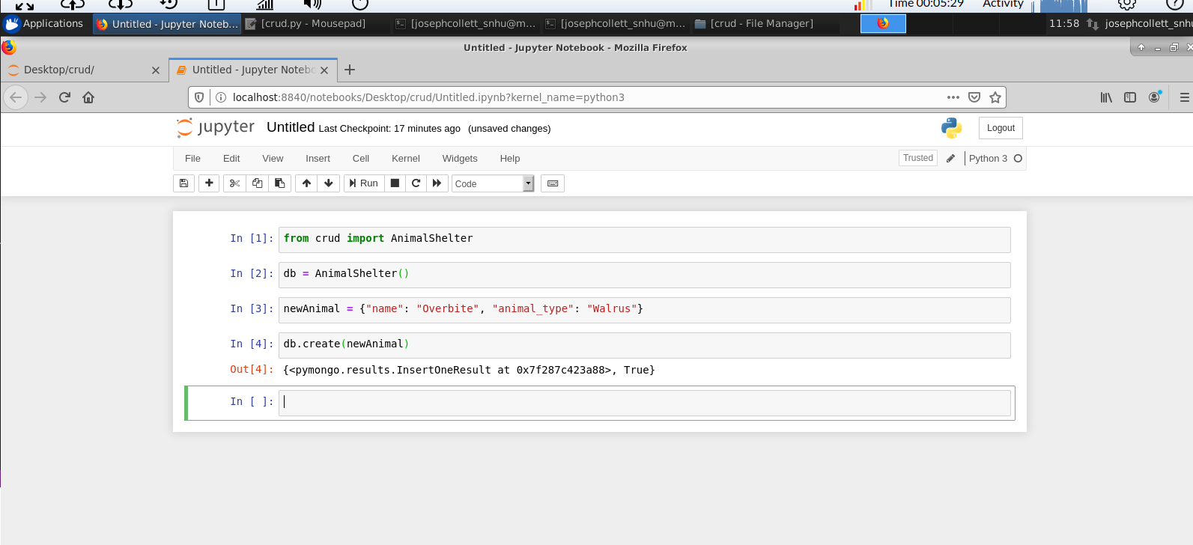

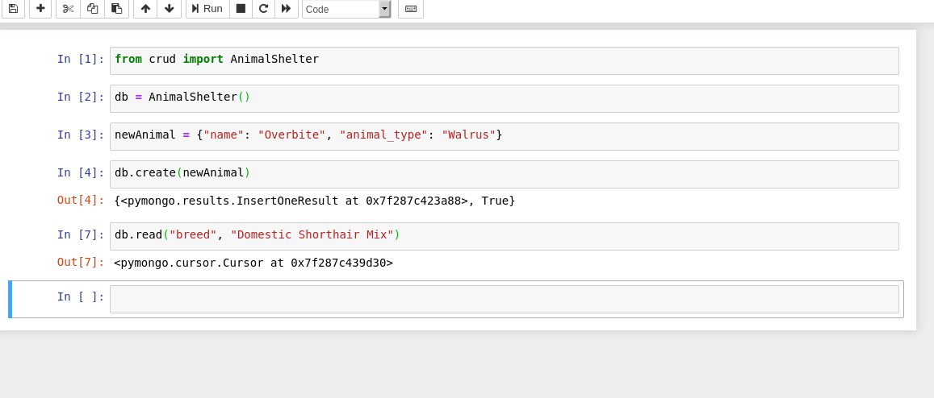

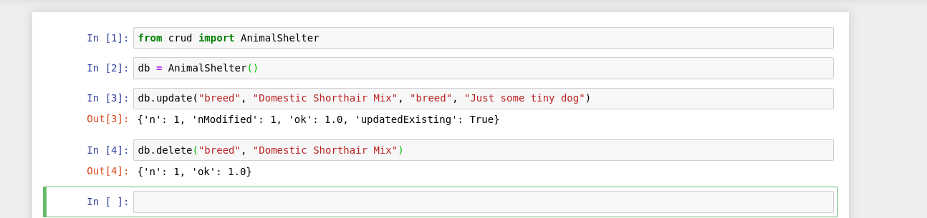

To further test the functionality of crud.py, you can use it as the controller module for a front-end Python Dash client. The Python Dash library is an easy to use front-end client that enables live injection of dynamic data retrieved from a database with API calls. The database used is the horizontally scalable document-based Mongo client with the PyMongo driver to use a Python syntax to access data. Consider the following screenshots to set up your Dash front-end interface.

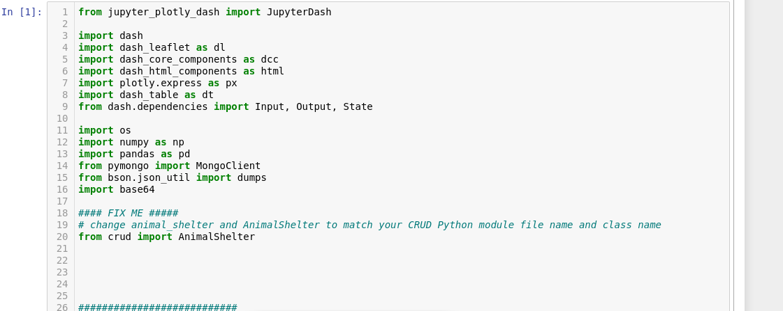

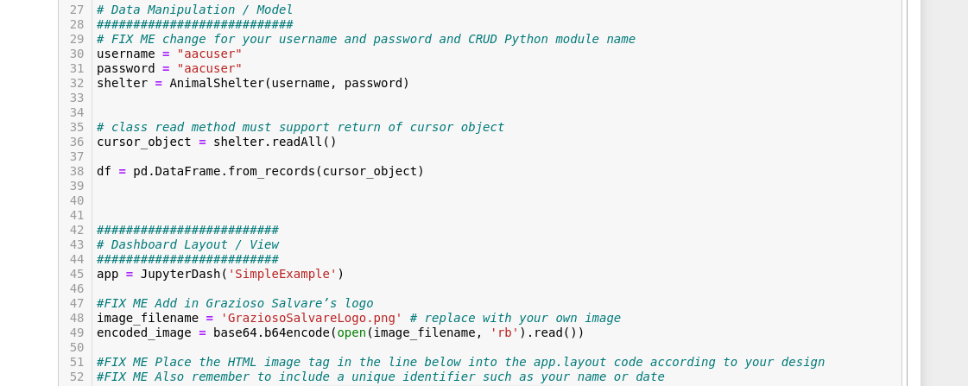

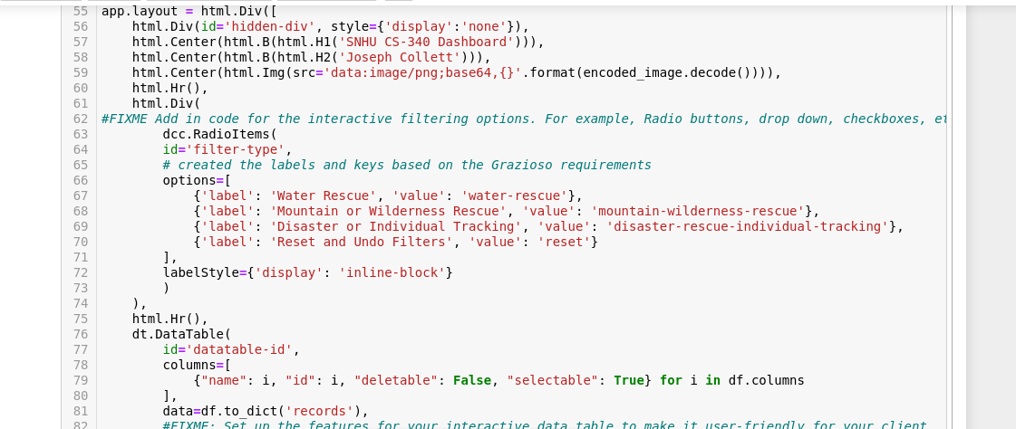

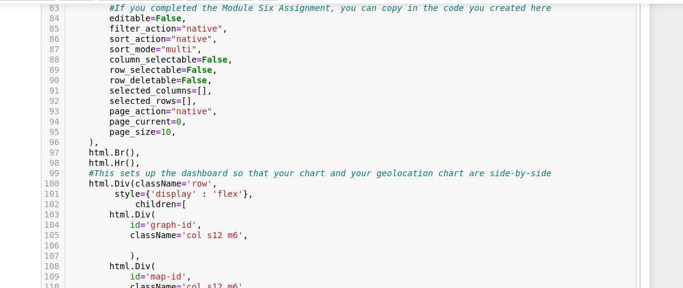

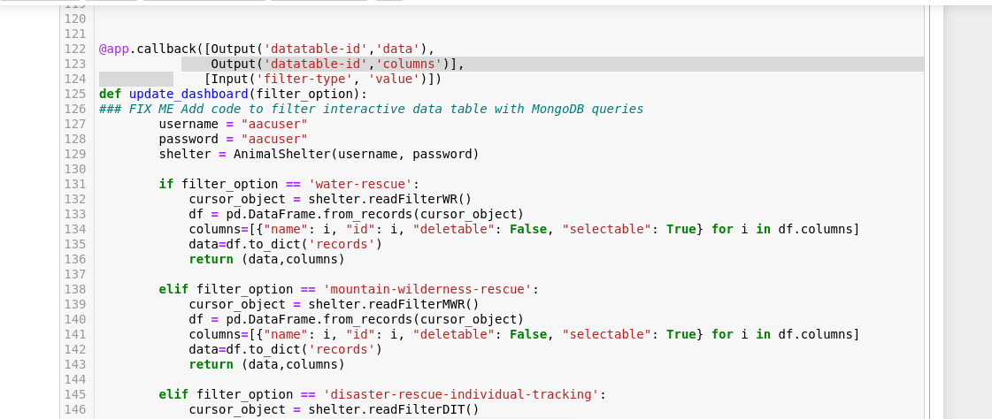

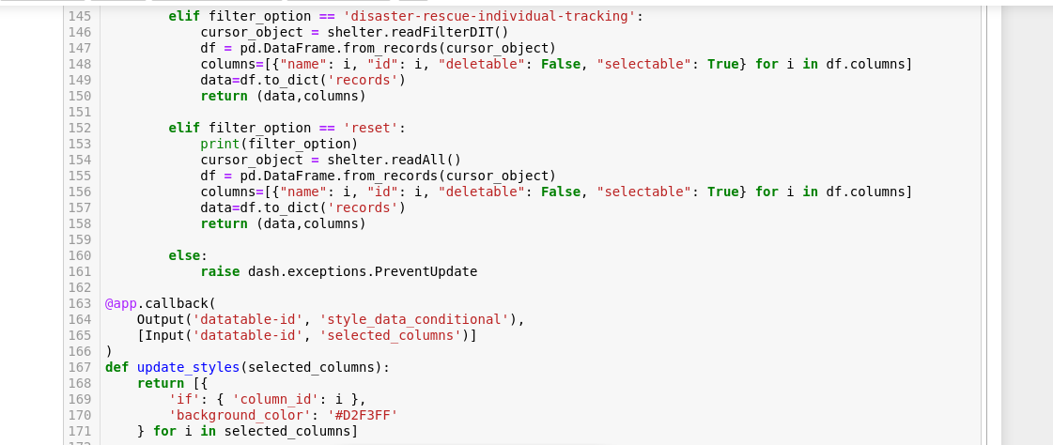

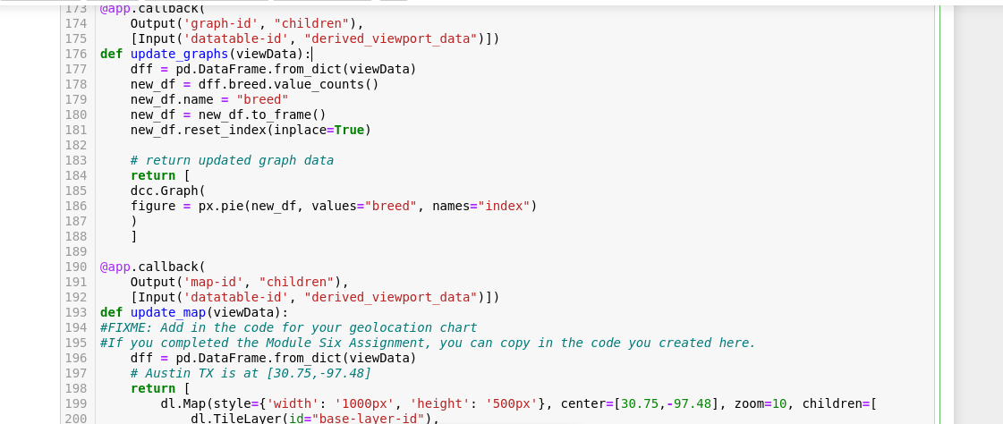

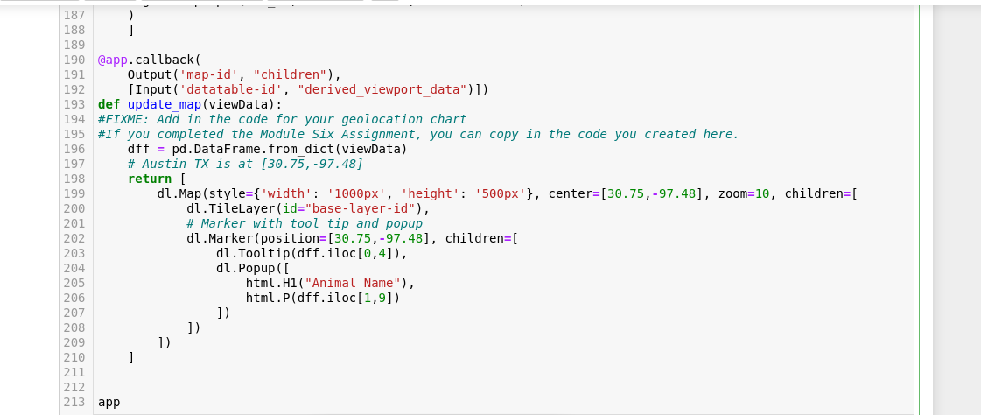

## Roadmap/Features (Optional)

To date, Python CRUD only offers create, read, update, and delete functionality.

## Contact

Joseph Collett