Jenkins

[Exercise files | LinkedIn Learning](https://www.linkedin.com/learning/learning-jenkins-14423877/exercise-files?autoSkip=true&resume=false&u=91931370)

[LinkedInLearning/learning-jenkins-3003221: Learning Jenkins (github.com)](https://github.com/LinkedInLearning/learning-jenkins-3003221)

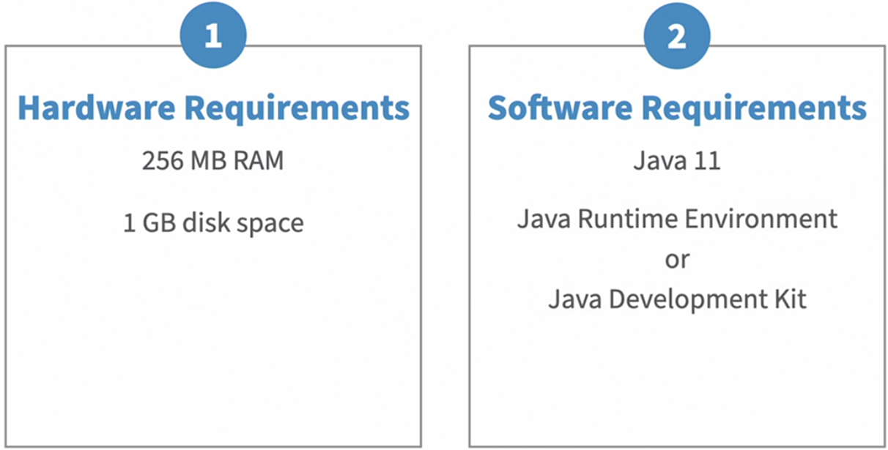

If running Jenkins as a container, the requirements are:

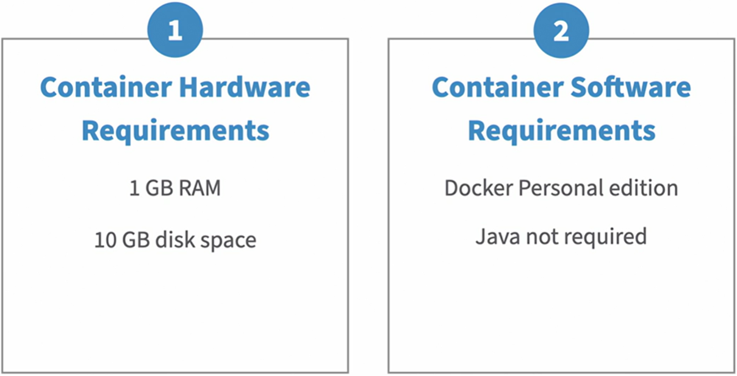

Download and Java JDK [Download the Microsoft Build of OpenJDK | Microsoft Learn](https://learn.microsoft.com/en-us/java/openjdk/download)

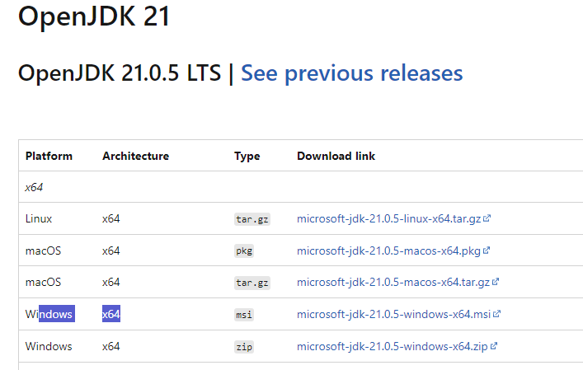

Download and install Jenkins [Download and deploy](https://www.jenkins.io/download/)

