**Blinkit Sales Dashboard Documentation**

**Project Title:** Blinkit – India’s Last Minute App

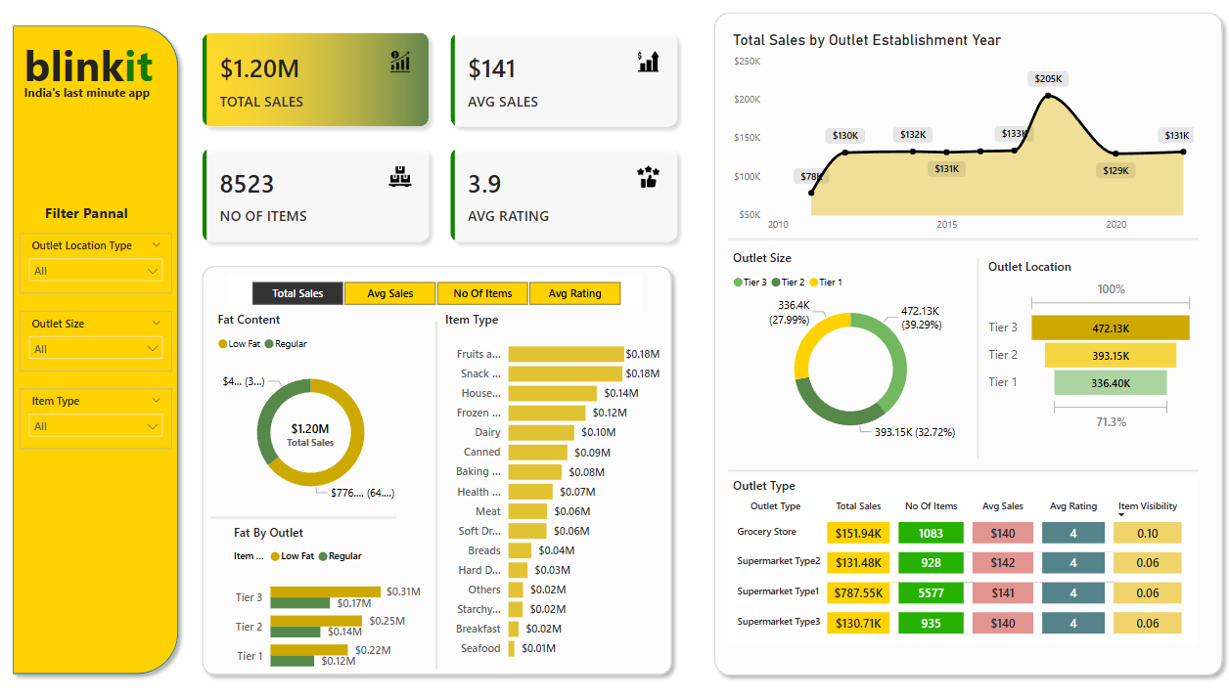

**Tool Used**: Microsoft Power BI  
**Objective**: To visualize and analyze sales performance, item distribution, outlet types, and customer ratings across different outlet categories and locations.

**Overview**

This Power BI dashboard offers a comprehensive summary of Blinkit's business performance using key metrics like total sales, average sales, number of items, and average customer ratings. Filters are provided for deeper insight into outlet type, outlet size, and item categories.

**Key Performance Indicators (KPIs)**

* **Total Sales**: $1.20M
* **Average Sales**: $141
* **Number of Items**: 8523
* **Average Rating**: 3.9

These KPIs give a quick snapshot of the company’s sales and customer satisfaction.

**Filters (Slicers)**

* **Outlet Location Type**
* **Outlet Size**
* **Item Type**

Users can apply filters to interactively explore sales and performance metrics based on different combinations.

**Visual Components**

A. Sales Overview by Fat Content

* Shows distribution between **Low Fat** and **Regular** items.
* Includes a donut chart representing total sales ($1.20M) by fat content.

B. Sales by Item Type

* Highlights top-selling categories like Fruits, Snacks, and Household items.
* Horizontal bars show sales figures for each item type.

C. Total Sales by Outlet Establishment Year

* A line chart showing sales trends from 2010 to 2022.
* Peak observed in 2018 with sales around $205K.

D. Outlet Size Distribution

* Donut chart representing distribution among Tier 1, Tier 2, and Tier 3 outlets.
  + **Tier 3**: 472.13K (39.29%)
  + **Tier 2**: 393.15K (32.72%)
  + **Tier 1**: 336.4K (27.99%)

E. Outlet Type Performance Table

Shows key metrics for each outlet type:

* **Grocery Store**
* **Supermarket Type1, Type2, Type3**

Metrics include:

* Total Sales
* Number of Items
* Average Sales
* Average Rating
* Item Visibility

**Insights**

* **Grocery Stores** have the highest total sales ($151.94K) and ratings.
* **Tier 3 outlets** contribute the largest portion of total sales.
* **Fruits and Snacks** are top-selling categories.
* Item visibility is low overall but consistent across outlet types.

**Purpose and Use**

* Business analysts and managers to track sales performance.
* Marketing teams to identify top products and customer trends.
* Operations for outlet performance comparison and resource allocation.