**Thursday, November 16th, 2023**

**VOCABULARY FOR FURTHER USE**

|  |
| --- |
|  |

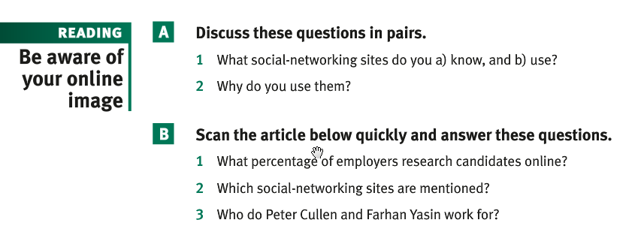

**ANSWERS FOR A**

Top Social working networks: Instagram, Facebook, Twitter, Tik-tok, Snapchat, Pinterest LinkedIn, etc.

1. Top Social working networks: Instagram , Facebook, Twitter, Tik-tok, Snapchat, Pinterest LinkedIn, etc.

Social networking sites can be regarded (considered) as a double-edged knife

What are the negative sides of social-networking sites?

* Risks of addiction / Of being addicted
* Immersion in private life
* influence on studies, behavior , beliefs, concentration

1. I use facebook because it enables (permits, allows) me :

* to find a job
* to be informed about current news
* to share information with other people who even might be in faraway countries
* to buy or sell online
* to enjoy myself (music, films, cartoons, etc.)
* to advertise products
* to chat
* to post a research work, text,
* to be in touch with friends, family, teachers, school or classmates, childhood friends, so forth
* to date (dating sites)
* make videos

To catch someone red-handed = To be caught red-handed

**ANSWERS FOR B**

1. 70%
2. Facebook & Twitter
3. Peter for Microsoft and Farhan for Careerbuilder

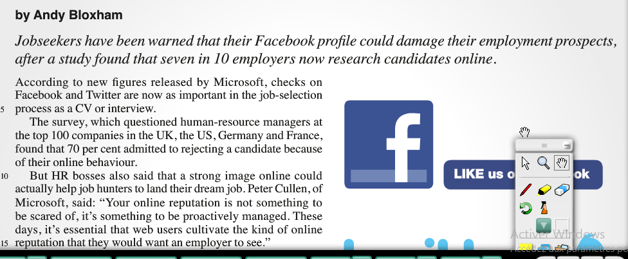

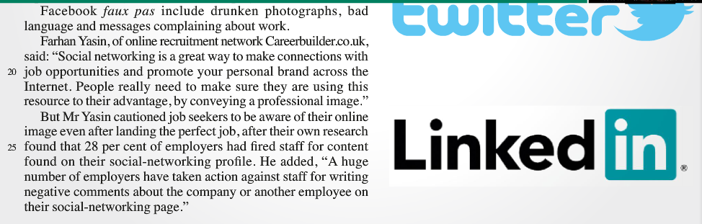

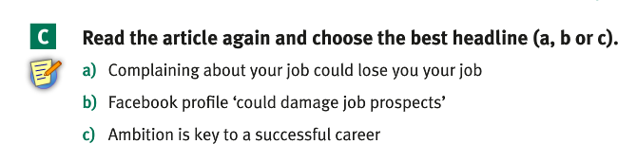

**Answer**

**b) Facebook profile “could damage job prospects”**

To damage = to destroy = to ruin

Social networking sites can damage job prospects in many ways. For example your research history says a lot about your personality. It can be discovered that you regularly visit bad sites promoting violence, immoral practices like pornography, and so forth

Visiting bad sites can:

* damage or cast a slur on a person’s reputation
* Compromise your future
* Get you into troubles

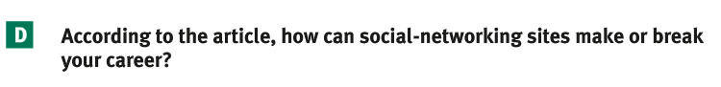

**Answer**

One can be denied a job or a position because of:

1. a bad online behavior;
2. a drunken photograph ( that can present you as a drunkard)
3. Bad language
4. Complaints about work
5. Bad attitude towards staff
6. Negative comment on the company

All the things noted above can reduce your chance for recruitment.

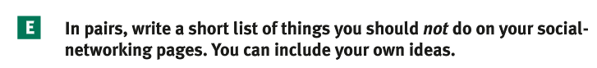

**Answer**

**Here are things one should avoid doing in networking sites:**

1. Identity theft or fraud (a thief, a fraudster ) ;
2. Joining vulgar groups;
3. Scamming, ripping off, hustling
4. Dating strangers
5. Sharing private life
6. Being so naïve to believe everything that is said or proposed is true
7. Posting nude or naked
8. Political, religious topics
9. Publishing confidential information/fake news
10. Using vulgar language
11. Exposing oneself too much
12. Spending /Devoting too much time to them



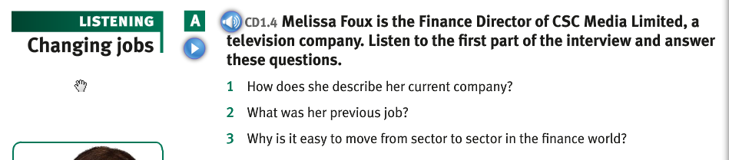

Answer key

1. As the largest independent television business in the world
2. Finance Director of a chocolate pudding business
3. Because the basic skills you need are the same in each case.

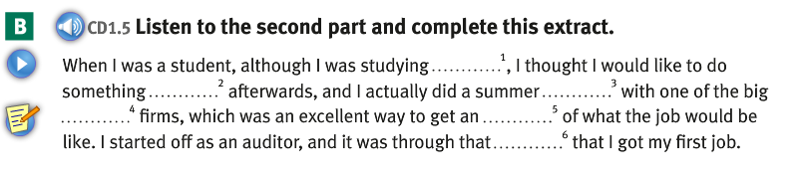

Answer key

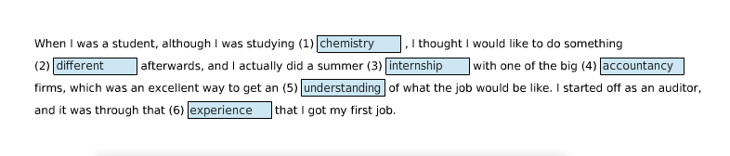

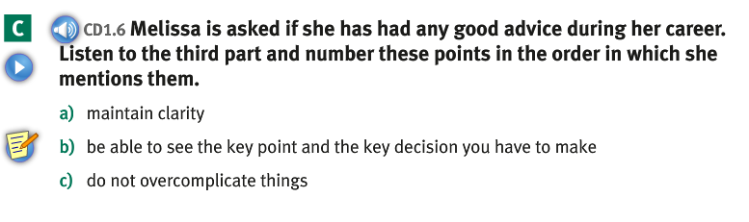

Answer Key

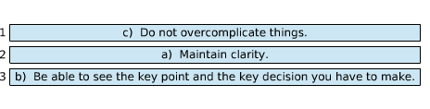

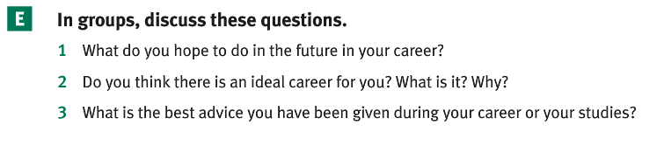

Prompts

1. My neighbor hopes

* to get involved in politics in the future ;
* to become one of the greatest statisticians in Africa

1. My neighbor thinks that the ideal for him/her is that one which allows him/her to apply the theories s/he has learned at college
2. The best advice my neighbor has been given during his/her career is to remain humble and resilient