**FOOD INSECURITY IN AFRICA**

**By: Joseph Ologunja**

**Hamoye ID: 14766f54c8c1f000**

The world population is at an all-time high and Africa’s population is expected to double in the next 20 years. Agriculture is the most significant economic activity for more than half of Africa’s population. The agricultural sector in Africa employs about 75 million people and constitutes 45% of the Gross Domestic Product (GDP). It also employs more than 60% of Africa ‘s rural population.

Africa produced about 40% of its food with less than 2% of its landmass. This makes conventional agriculture a crucial means of increasing food production and strengthening food security in Africa. The land available for producing food has diminished because of extensive conversion to urban areas, mining, and other extractive industries; deterioration of soil fertility through overuse; and degradation due to shifting cultivation (or slash-and-burn).

Approximately, 1.22 billion people in Africa currently suffer from chronic hunger, and the United Nations predicts that number to rise as food production decreases. Political instability, religious strife and lack of infrastructure and development in Africa also make it difficult to establish long-term solutions to these problems.

Studying data on Africa’s population, production of various food items and quantity of food available in every country can highlight inherent problems and insights which can help to proffer possible solutions to the growing food insecurity.

From 2004 to 2013, the mean annual population in Africa is 20019.4 thousand persons. The mean annual food production is 327.8 kilotons and the mean annual food supply is 2467.8 kilotons. The rate of change in Africa’s population remained the same over the years studied, however food production had marked fluctuations with a major reduction in 2007, and food supply as well had a steady decline from 2011. Cumulatively, Africa’s population size increased by 22.5% between 2004 and 2013, food production also increased by 28.5% but food supply increased by only 5.6%.

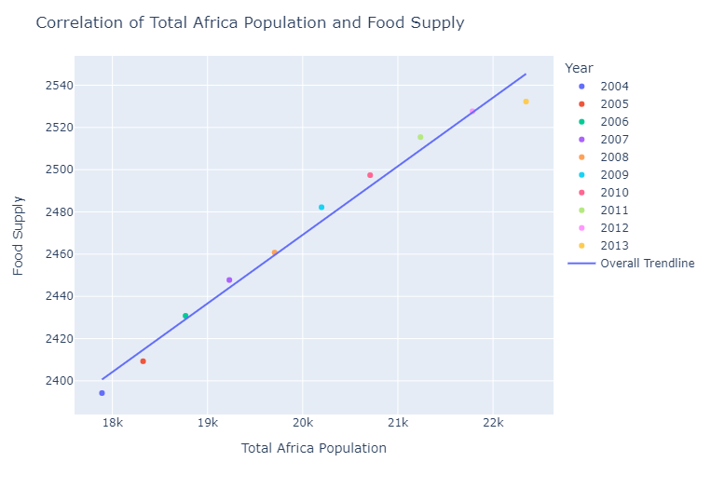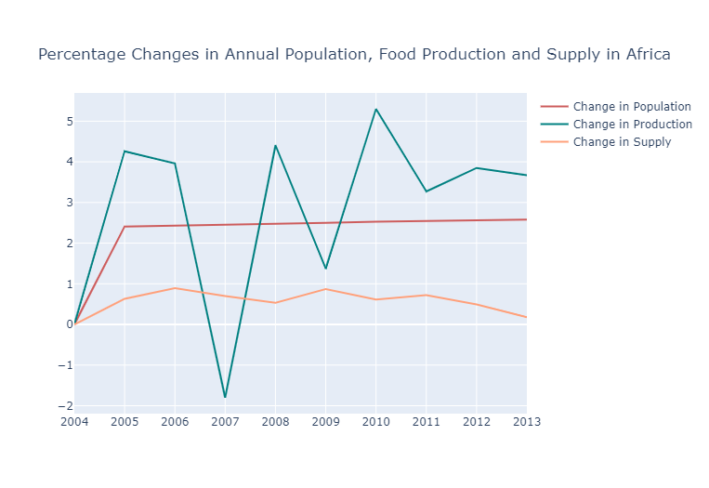 As the population size increased, so did the food supply. However, there was greater change in population than changes in supply.

Furthermore, in most African countries, food production and supply increased between 2004 to 2013, however, some had a decline in food production, supply or both. Central African Republic, Congo, Lesotho, Namibia, Sao Tome and Principe, Swaziland, and Uganda had a marked decline in food supply from 2004 to 2013. Mauritius, Uganda and Zimbabwe also had a marked decline in food production over the years studied.

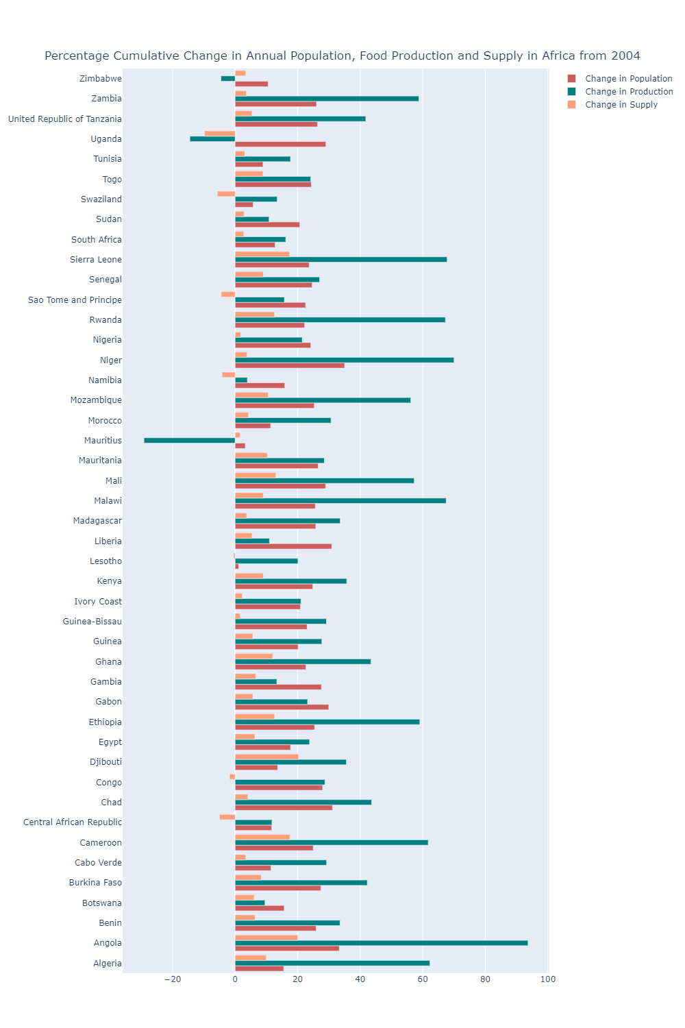

Over the years, of the 45 African countries studied, South Africa, Egypt, Nigeria, the food production capacity out scaled other countries. Also, the food supply in Egypt was particularly higher than other countries.

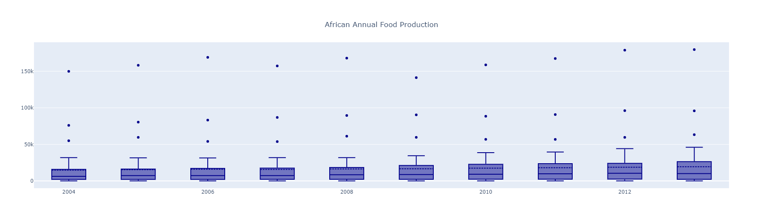

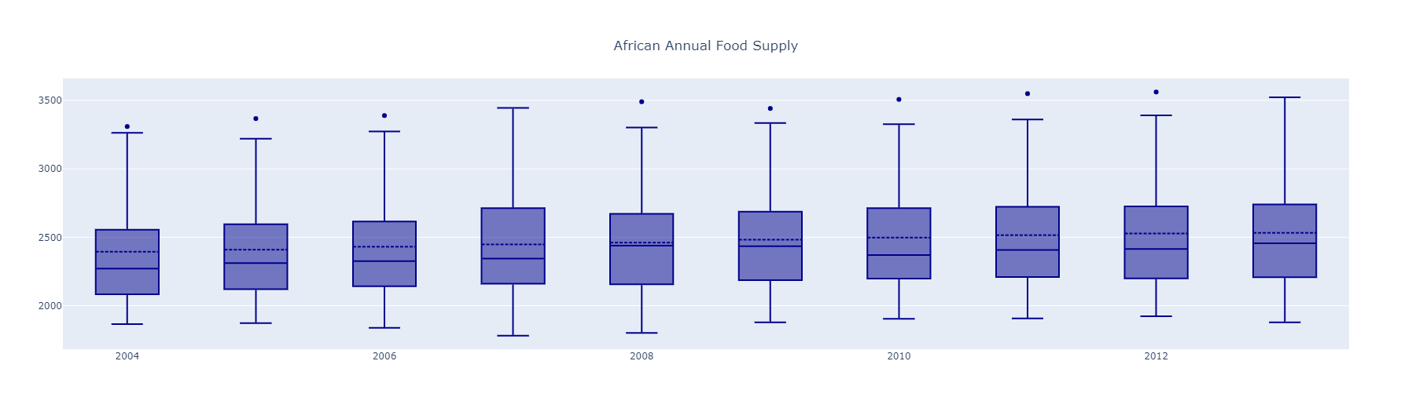

Africa produces about 94 food items, with Cassava and products, Sugar cane, Maize and products, Yams and Vegetables being the top producer in Africa.

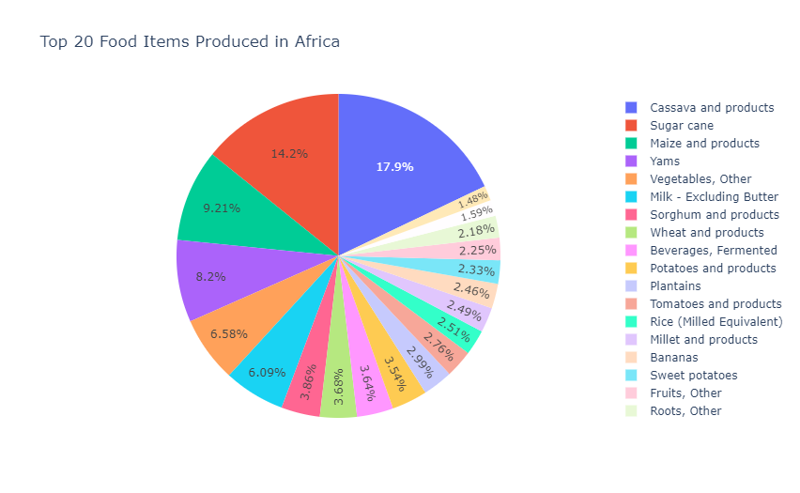

Among the food produce Plantains, Sorghum and products, Beverages-Fermented, Wheat and products, Milk - Excluding Butter, Vegetables-Other, Yams, Maize and products, Sugar cane, Cassava and product, Potatoes and products, Millet and products, Tomatoes and products, Rice (Milled Equivalent), Sweet potatoes, Bananas, were the main focus of food production in many countries.

From the results, there is a major focus on food production than food supply. The change in food production matches similarly to the growth in population size, though food supply increases correlate with population size increase, the change is not significant enough to accommodate the rate of change in population size. There is also a major gap between what is being produced and what is available. This can be a result of poor distribution systems, and poor food storage techniques.

Increasing the supply available by instituting standard food storage techniques and implementing efficient systems to distribute food will improve food insecurity. However, improving agricultural policies and incentives can improve the food production and supply in countries with poor food production and food supply.