JOSHUA FARR
JOSFAR6040
01/30/2026
Week 1 Performance Assessment: WHERE and ORDER BY Clauses
The following questions come from the “Check your understanding” examples of each section of Chapter 2 in your textbook.
After you are finished, please submit the Microsoft Word file that contains screenshots of the SQL statements and output. Be sure to include a comment line with your name at the start of each SQL statement. Your document should be named W1_PA_WhereOrderByStatements_Lastname.docx.

(2-12) Question 1:
List the first name, last name, and department code of the employees in the L_EMPLOYEES table that have department codes SAL, SHP, and ACT. Do this using an in condition.
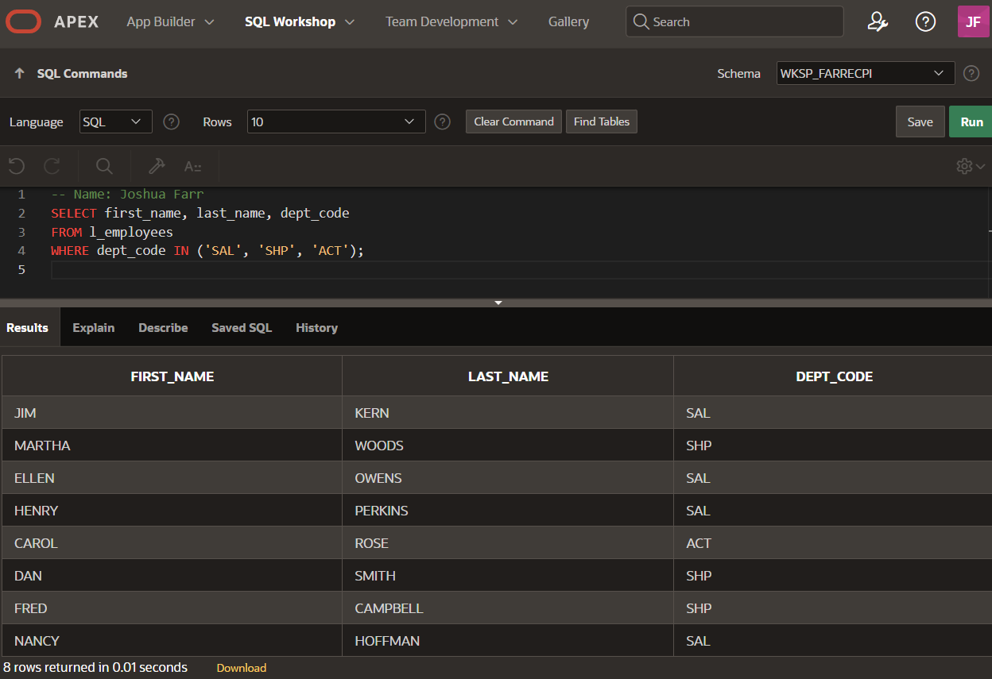
(2-13) Question 2:
List the employee ID, first name, and last name of the employees in the L_EMPLOYEES table that have an employee ID between 201 and 205.
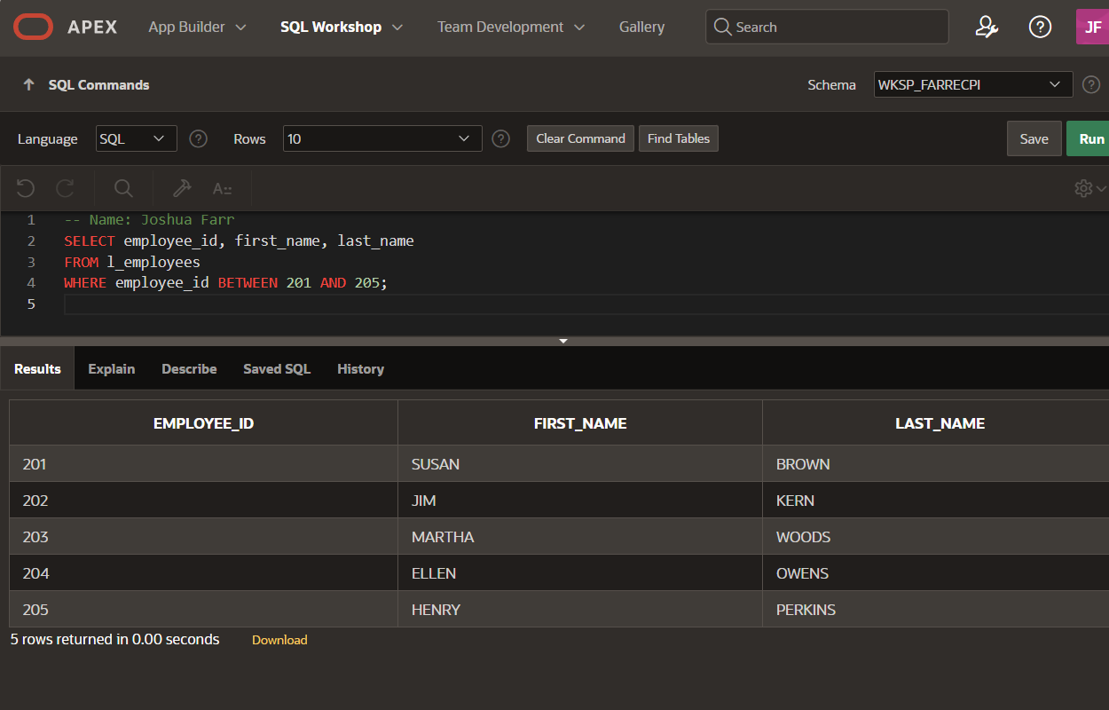
(2-14) Question 3:
List the employee ID, first name, and last name of the employees in the L_EMPLOYEES table that have an employee ID that contains a number 1.
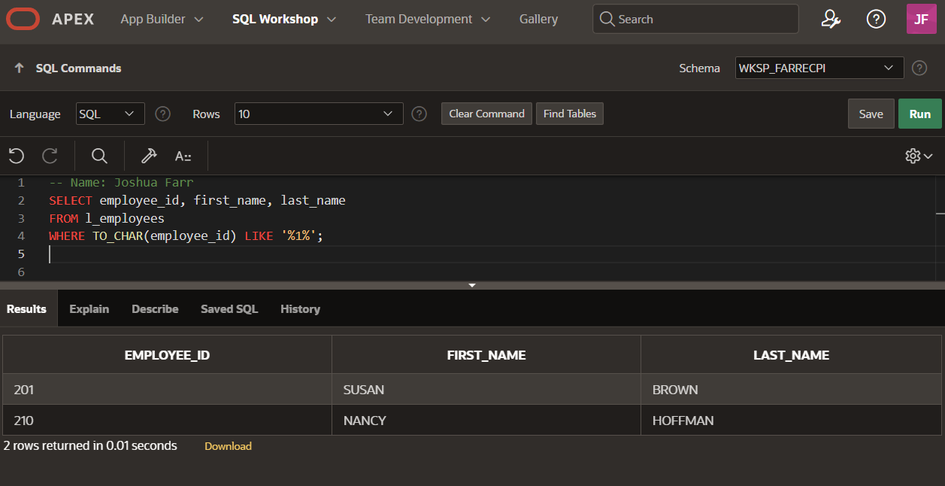
(2-15) Question 4:
List all the columns of the L_EMPLOYEES table for rows that contain a null in the manager_ID column.
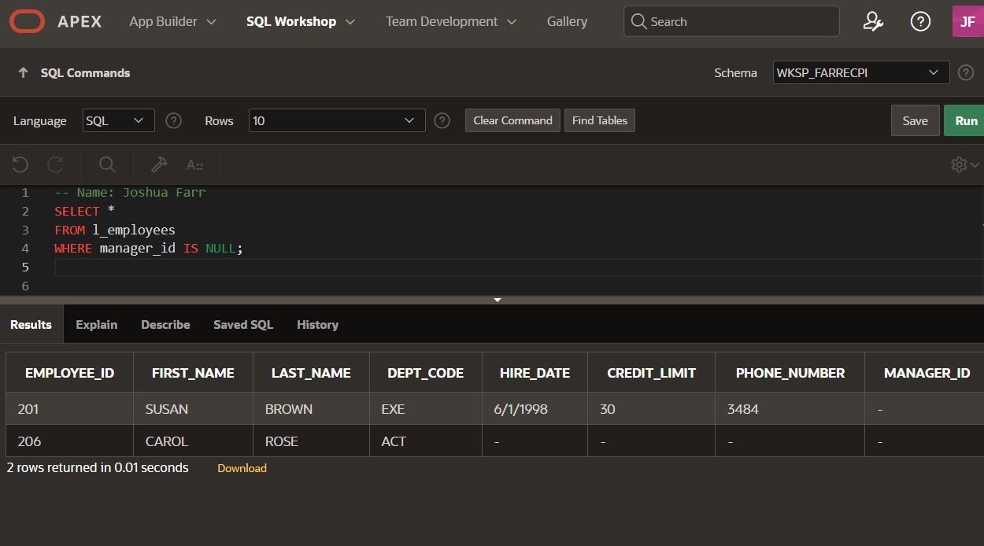
(2-17) Question 5:
List the department_name column from the L_DEPARTMENTS table. Give this column a new name of dept. Put the rows in ascending order. Write this SQL in two different ways.
