Multiple Representations in Human Categorization: Coherence, Similarity, and Idealization

When Exemplar Models Fail: Coherence and Competition in Human Categorization

Beyond Exemplar Similarity: Evidence for Coherence-Based Category Representation

Abstract
Exemplar theory has long dominated explanations of human categorization behavior, but a growing body of evidence reveals systematic failures within artificial classification learning—the very domain where exemplar models should be most successful. The current study investigates an alternative framework based on learned regularities and feature correlations rather than similarity to stored exemplars. This coherence-based approach is embodied by the DIVergent Autoencoder (DIVA) model, which learns to reconstruct category members' features and thereby extracts within-category correlational structure. Experiment 1 directly contrasted DIVA against the Generalized Context Model (GCM) using category structures where the models make opposite predictions. Computational simulations confirmed divergent predictions, and behavioral results favored DIVA: subjects generalized novel items based on learned feature correlations rather than exemplar similarity. Quantitative model fitting showed superior performance for DIVA (MSE = 0.006) compared to GCM (MSE = 0.0075). Experiment 2 examined how the categorization problem influences representational strategy by assessing learning of a highly structured category versus an unstructured category. In this case, most subjects relied on similarity-based generalization that worked across both categories, suggesting strategic adaptation to domain-wide utility. Additionally, in conditions where subjects were told to expect to learn additional categories after the initial two-way training, learners were even less likely to use structure-based strategies–indicating sophisticated reasoning about representational effectiveness. Experiment 3 tested whether correlation strength causally influences coherence-based learning but revealed no graded relationship. Instead, robust category idealization emerged across conditions, with subjects systematically reclassifying training items and rating extreme-valued novel items as more typical than familiar exemplars. This suggests multiple competing representational processes rather than a single dominant mechanism. Together, the three experiments demonstrate that human categorization involves flexible deployment of different representational strategies depending on category structure and task demands. Categories can be organized around stored exemplars, extracted correlational regularities, or contrast-based ideals–with different processes competing or cooperating based on contextual factors. These findings challenge single-mechanism theories and point toward more adaptive accounts of human concept formation and generalization.

Introduction
Exemplar theory has been positioned as the preeminent account of human categorization by numerous empirical demonstrations of its explanatory power: good quantitative fits to classic benchmarks (Kruschke, 1992, 1993; Nosofsky, Gluck, Palmeri, McKinley, & Glauthier, 1994), accurate predictions in the 5-4 category structure (Medin & Schaffer, 1978), accounts of shift learning difficulty (Kruschke, 1996), the inverse base-rate effect (Kruschke, 2001; 2003), and typicality effects (Nosofsky, 1988), among others.

However, a growing body of evidence reveals systematic failures of exemplar theory within the very domain where it should be most successful: artificial classification learning with simple perceptual stimuli. These failures suggest that human categorization involves more than similarity to stored exemplars, pointing instead toward representations organized around learned regularities and structural coherence.

The clearest evidence comes from studies of feature correlation learning. Conaway (2016) found that categories with strong within-category feature correlations are learned more easily than matched controls with between-category and within-category similarity equated but no global statistical structure. The key insight is that similarity structure was held constant while correlation structure varied, and subjects were clearly sensitive to the latter in their learning ability. This suggests that learners extract and utilize regularities in how features co-occur within categories—information that exemplar models do not explicitly represent.

The importance of such regularities becomes even clearer in generalization behavior. Conaway & Kurtz (2017) presented subjects with novel items that maintained learned feature correlations but were not necessarily similar to training exemplars. Subjects systematically classified these items based on whether they conformed to the extracted correlations rather than their similarity to stored instances. This directly contradicts the core assumption of exemplar theory that generalization reflects similarity to remembered cases.

Even within the canonical domain of the Shepard, Hovland, & Jenkins (1961) category structures—long considered a showcase for exemplar models—problems have emerged. Kurtz et al. (2012) demonstrated that the classic Type II advantage depends critically on instructional context. When rule-based language is removed from instructions, the advantage disappears. Crucially, ALCOVE cannot account for both the original and revised orderings: modifications that improve fit to the revised ordering worsen fit to the original data.

These failures are not isolated phenomena. Other challenging findings include contrast-based ideals where extreme-valued items are judged more typical than familiar category members (Levering & Kurtz, 2006; Silliman, 2021) and alternating category structures that subjects can learn and generalize despite violating similarity-based predictions (Kurtz & Wetzel, 2021). While these phenomena may involve different mechanisms, they collectively point to a fundamental limitation in how exemplar models conceive of category representation—as collections of stored instances rather than organized knowledge structures based on extracted regularities.

The DIVergent Autoencoder (DIVA; Kurtz, 2007; 2015) provides an account based on learned coherence that succeeds where exemplar models fail, particularly for phenomena involving feature correlations and structural regularities. DIVA is a modified autoencoder with separate reconstruction channels for each category. During training, the model learns to reconstruct category members' features from a shared hidden representation. This architecture forces DIVA to discover within-category feature regularities—categories with strong feature correlations produce more accurate reconstructions and are easier to learn.

At test, items are classified based on which category channel produces the best reconstruction. Classification depends on whether an item's feature pattern matches the learned regularities of a category, not similarity to stored exemplars. This allows DIVA to generalize based on feature correlations and structural coherence, naturally accounting for the correlation-based learning and generalization effects that challenge exemplar models.

The present experiments systematically test when and how coherence-based representations (as implemented in DIVA) outperform similarity-based accounts (as exemplified by the GCM). We focus on category structures with strong feature correlations where these approaches make clearly divergent predictions, allowing direct empirical tests of their relative explanatory power. Experiment 1 provides a direct computational and behavioral test where DIVA and GCM make opposite predictions about generalization to novel items. Experiment 2 examines how domain structure influences the adoption of coherence-based versus similarity-based strategies. Experiment 3 investigates the relationship between feature correlation strength and coherence-based generalization, while also examining how idealization processes interact with coherence-based learning.

Experiment 1

Methods

Participants
30 undergraduate students from Binghamton University participated for partial fulfillment of a course requirement.

Design
The experiment consisted of a two-way classification task with a supervised training phase followed by a test phase (no feedback) including generalization items. The categories were constructed so that both exhibited the underlying regularity of a strong positive feature correlation: two parallel diagonal lines in 2D space, one for each category (Alpha versus Beta). This category structure is notable for its likeness to Information-Integration (Ashby & Maddox, 1990) and Condensation categories (Gottwald & Garner, 1972; Kruschke, 1993). Figure 1 shows Alpha training stimuli, Beta training stimuli, and test stimuli plotted in feature space. Note that there are two distinct sets of test stimuli: one set of test items (denoted by the letter Y) that falls on the Beta category correlation line, and the other set of test items (denoted by the letter X) that falls on the Alpha category correlation line. It is also critical to note that both groups of test items are equidistant to either of the contrasting sets of training items (see Figure 1). Therefore, under the assumptions of the GCM, either category should be equally likely to be generalized to any test item in either group. However, under the coherence framework offered by the DIVA model, subjects would be expected to incorporate the way features cohere within a category in their knowledge representations, leading to the leveraging of within-category feature regularities upon generalization, i.e., seeing X items as Alpha members and Y items as Beta members. Such clearly divergent predictions from the models of interest make this structure particularly well suited for both computational and behavioral experiments. Predictions for both models were confirmed by running simulations with a thorough sampling of parameter space.

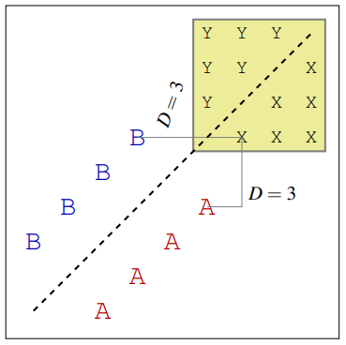
Figure 1

Materials
Stimuli were squares varying in shading and size. The separability of these features justifies using a city-block metric (Garner, 1974) for the determination of psychological distance. Additionally, an independent scaling study verified that the dimensions are nearly equal in perceptual salience. Exemplars were automatically generated at 9 positions on each dimension (9 shading * 9 size = 81 examples).

Procedure
Participants completed 96 training trials (12 blocks consisting of random-order presentation of the 8 training examples). On each trial, a stimulus was presented on a computer screen and learners were prompted to make a classification decision by clicking one of two buttons (labeled ‘Alpha’ and ‘Beta’). After selecting a class label, learners were given feedback on their response. Following the training phase, participants completed 81 generalization trials consisting of items sampled at 9 positions on each dimension. All of the training examples were included (intermixed). Feedback was not provided during the generalization phase. Participants were informed that there would be test trials prior to beginning the experiment.

Results

A Priori Simulation Results
Prior to collecting behavioral data, a computational experiment was run to ensure that the present category structure was indeed a useful probe into the question of whether subjects represent category knowledge based solely on proximity to familiar exemplars (such as the GCM describes) or based on richer knowledge about what makes a category coherent (such as is suggested by the DIVA model). Both DIVA and GCM were trained and tested on the present category structure. Model parameters were varied thoroughly to ensure that the model’s full behavioral repertoire was captured in the simulations.

The training items exhibit a perfect within category feature correlation and can be viewed as being separated by a diagonal boundary that runs through the midpoint of the two lines of correlation on which the two categories lie (see Figure 1). DIVA simulations revealed that the model typically extends this diagonal boundary to the test items: exemplars on the Alpha category side of the extended boundary are more likely to be classified as members of the Alpha category than exemplars on the other side, and vice-versa (i.e., A → X, B → Y). As shown in Figure 2, DIVA can predict anywhere from a slight to strong global coherence basis for categorizing the critical generalization items (depending on parameterization). DIVA’s performance follows directly from its design principles: because DIVA is trained on feature prediction (rather than class prediction), the model learns that the features can be used to predict one another. After training, DIVA reconstructs novel items following its knowledge of each category’s feature correlations, affording an extension of the diagonal boundary.

In simulations with the exemplar model, we found that the GCM could not make the same predictive pattern shown by DIVA. Instead of extending the diagonal boundary, the GCM classifies each critical generalization item with equal probability (see Figure 2). The GCM must behave this way because each of the critical items is equally distant (under a city-block metric) to known members of both categories. While a Euclidean metric would enable the GCM to extend each category to its critical items, the use of a city-block metric reflects the separable stimulus dimensions used in the behavioral experiment reported below (see Garner, 1974). Cityblock distance was also supported by the results of an independent scaling study with our materials: critical items in groups X and Y are not viewed as more similar to items on their own side of the diagonal boundary. Thus, with evenly distributed selective attention, the GCM classifies each item with a probability of 0.5. Unequal allocation of the attention results in uniform changes to the classification gradient – for example, greater allocation to the vertical (Y-axis) dimension results in increased Category B probability for the entire collection of items in the critical area. These a priori results provide a compelling framework to evaluate the behavioral results: the GCM predicts X and Y items to be undifferentiated relative to the learned categories while DIVA predicts a clear alignment of X to Alpha and Y to Beta.

Importantly, other types of reference points (i.e., prototypes, clusters) also lead to the same performance: the critical items are also equally close to the category prototypes of Alpha and Beta, as well as a variety of potential cluster configurations. The GCM’s results therefore characterize a set of predictions made by ‘similarity to stored reference points’ accounts more generally.
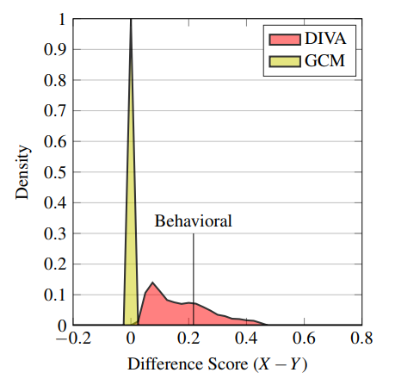
Figure 2: A priori simulations with DIVA and the GCM. Densities in this plot reflect predictions about the classification of critical items, across many different parameter settings. Positive scores indicate that each category was generalized to the items on its side of the diagonal boundary that lies between the two sets of training items, A → X, B → Y.

Behavioral Results
By the end of the training phase, most participants had successfully mastered the categories. On average, participants were 89.2% (SE = 2.5) accurate during the last training block. Only two of 30 participants failed to reach greater than 6/8 correct during the final training block. Aggregate training data is depicted in the left panel of Figure 3. As a test of whether learners extended the diagonal boundary, we compared the average number of Alpha classification responses made to critical items in groups X and Y (Figure 3, right panel). Learners systematically generalized each category – participants were more likely to produce an Alpha response to X than to Y, t(29) = 5.02, p < 0.001, d = 0.56. We then compared the difference score we obtained behaviorally (X −Y) to our a priori results with DIVA and the GCM: as shown in Figure 2, the difference score we observed cannot be explained by the GCM, but falls quite centrally in the range of predictions made by the DIVA model. Aggregate generalization data is depicted in Figure 4.
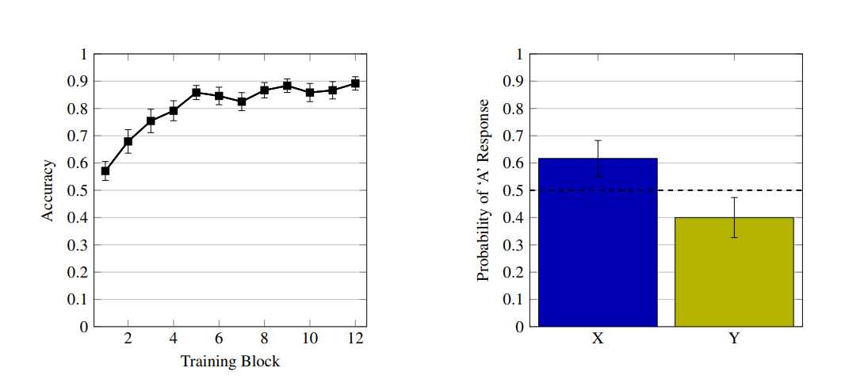
Figure 3

Post-hoc Simulation Results
The overall goal of the following simulations is to formally evaluate the performance of DIVA and the GCM in terms of quantitative fit to the observed generalization behavior. Before proceeding, it is worth noting that DIVA and the GCM are not fully comparable: unlike the GCM, DIVA’s category representations are constrained via back-propagation learning (Rumelhart et al., 1986), and its performance is stochastic. However, model performance on generalization testing can still be compared to assess whether the present results can be explained under a reference point approach.

We used parameter optimization techniques to find each model’s best fit to the observed generalization data using a mean-squared error (MSE) metric. We used a hill climbing procedure to fit the GCM over four parameters: exemplar specificity (c), response mapping (γ), and attention strengths for features 1 and 2 (W1 and W2). DIVA’s behavior is stochastic, which precludes the use of hill-climbing. Consequently, we searched for DIVA’s best fit using a ‘grid-search’ technique to generate predictions along a range of settings for its four parameters: number of hidden units, learning rate, initial weight range, and a focusing parameter, β (Kurtz, 2015). At each point, DIVA was initialized 2000 times with random small-valued weights and a random presentation sequence. The model used logistic hidden units and linear outputs. Attention weighting was allowed to vary freely in both models even though both dimensions are equally relevant toward solving the classification.

Overall, DIVA was able to provide a stronger fit to the full behavioral gradient than the GCM. DIVA’s best fit (MSE = 0.006) was achieved with 3 hidden units, learning rate = 0.55, weight range ±0.5, and β = 3. The GCM’s best fit (MSE = 0.0075) was achieved with c = 5.304, γ = 1.055, W1 = 0.507, W2 = 0.493. Model performance further differentiated the responses to the critical items (rather than the entire gradient): DIVA achieved MSE = 0.0037, and the GCM achieved MSE = 0.02. This wider gap reflects both models providing a good overall fit, but GCM failing in the critical generalization region. Beyond quantitative fitting, it is important to note that DIVA’s predictions match the qualitative patterns of observed performance – the model extends each category to novel items along the diagonal boundary. Conversely, the GCM’s generalization is completely neutral for these items. Each model’s best performance is depicted in Figure 4.

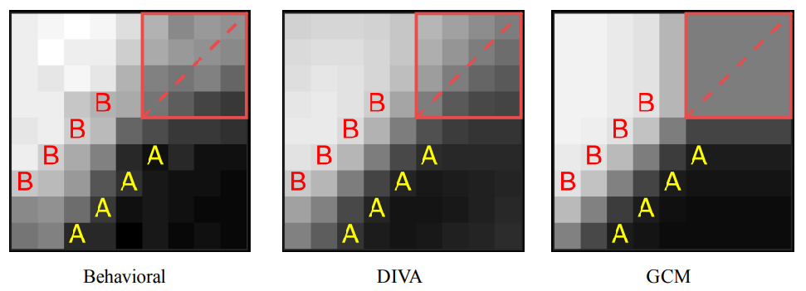
Figure 4

Discussion
Experiment 1 provides strong evidence that human category learning can be based on extracted feature regularities rather than similarity to stored exemplars. When presented with novel items equidistant from both categories' training examples, subjects systematically generalized based on learned feature correlations. Items that fell along a category's correlation line were classified as belonging to that category, despite being no more similar to its exemplars than to the contrast category's exemplars.

This pattern is precisely what DIVA predicts based on its architecture for learning within-category feature relationships, but it cannot be explained by the GCM regardless of parameter settings. The computational simulations confirmed that exemplar-based models predict chance-level responding to these critical items, while DIVA predicts the extension of correlation-based boundaries as observed behaviorally.

This compelling effect suggests that coherence-based representations can dominate similarity-based processing when category structure supports it. Both categories in this experiment exhibited perfect feature correlations, making correlation-based representation viable for the entire domain.

This finding demonstrates that when categories possess clear internal structure, human learners extract and utilize this structure for generalization in ways that go beyond exemplar similarity. The next experiments examine how this process is influenced by domain characteristics and the strength of correlational structure.

Experiment 2

Methods

Participants
Ninety-six undergraduate students participated to receive partial fulfillment of a course requirement.

Design
This experiment tested whether coherence-based representations emerge when only one category in a domain has strong internal structure. The Alpha category exhibited perfect positive feature correlation while the Beta category had weak, inconsistent structure (see Figure 5). Critical test items (T3, T4) lay along the Alpha correlation line but were more similar to Beta exemplars; therebycreating a direct conflict between coherence-based and similarity-based generalization.
We also manipulated learning mode to test whether task demands influence representational strategy. The generative condition informed subjects they would later learn additional categories (Figure 6), potentially encouraging richer within-category knowledge. The discriminative condition used standard two-way classification.

If subjects extract correlational structure whenever available, T3 and T4 should be classified as Alphas despite their proximity to Beta items. If learners rely primarily on exemplar similarity, these items should be classified as Betas.
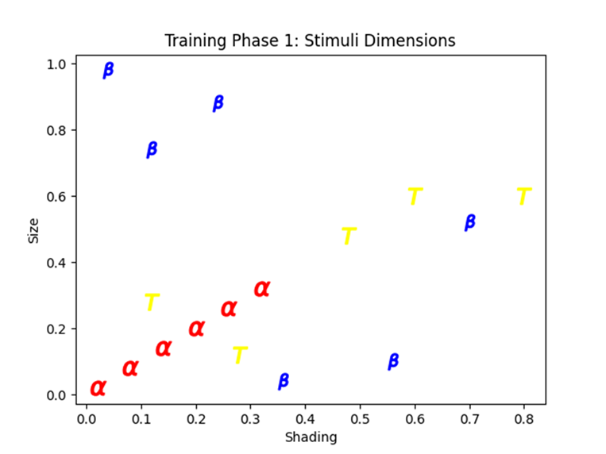Figure 5: Illustration of category structure used during training phase 1 and test phase. Blue Betas represent training items for the Beta category. Red Alphas represent training items for the Alpha category. Yellow T’s represent novel items introduced during the test phase. All stimuli were monochromatic squares that varied along two dimensions:size and shading.
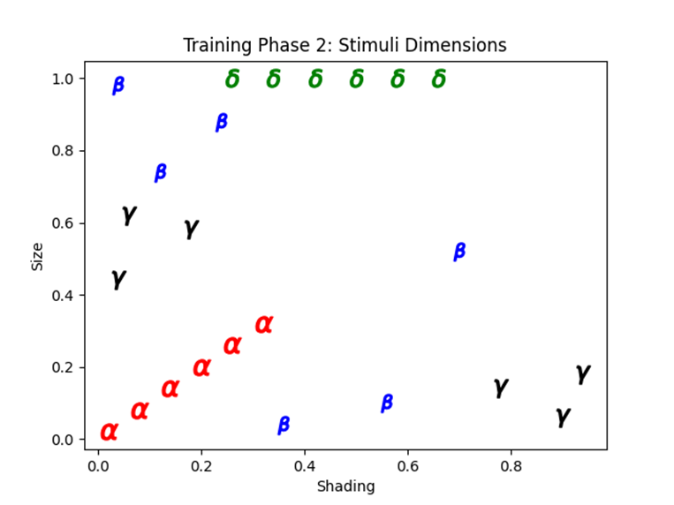Figure 6: Illustration of the category structure used during training phase 2. Blue Betas represent training items for the Beta category. Red Alphas represent training items for the Alpha category. Black Gammas represent training items for the Gamma Category. Green Deltas represent training items for the Delta Category. All stimuli were monochromatic squares that varied along two dimensions: size and shading.

Materials
Stimuli consisted of monochromatic squares that varied along two dimensions: size and gray-scale shading. Figures 5 and 6 show the stimuli plotted with size on the y-axis and shading on the x-axis. A shading value of 0.0 translates to a completely black square, while a shading value of 1.0 translates to a completely white square.

Procedure
Subjects in the Generative condition were told that they would be tasked with learning four categories of geometric shapes (Alphas, Betas, Gammas, and Deltas), but that they would first focus on learning about Alphas and Betas and that Gammas and Deltas would come later. During each training trial, a stimulus appeared at the center of the screen along with text asking which category the stimulus belongs to. At the bottom of the screen there was a row of four buttons with labels corresponding to each of the four categories; however, the Gamma and Delta buttons were gray-ed out and nonfunctional. After submitting a response via mouse-click, subjects received corrective feedback. Training was split into blocks in which each of the 12 training stimuli (6 per category) would appear once in random order. If a subject completed a block with an accuracy of 11 out of 12 correct responses, they were allowed to move on to the next phase of the experiment;subjects were allowed a maximum of 8 blocks to reach this criterion.
The next phase of the experiment was the test phase which was delivered in the same way as the training phase except that no feedback was given and novel test items were included. Each of the previously learned items along with five novel test items were presented once in random order (i.e., the test phase consisted of 17 trials with order randomized).
The final phase of the experiment was the second training phase in which Gamma and Delta items were included among the original Alpha and Beta training items (none of the previously novel items from the test phase were included in the second training phase). The second training phase consisted of two blocks in which each item was presented once in random order.
The procedure for the Discriminative condition was identical to that of the Generative condition except that Discriminative condition subjects were not made aware of the Alpha and Gamma categories (neither via instructions nor presence of response buttons) until the second training phase.

Model Simulations

Results

Training Phase 1 Performance
Twenty-seven subjects failed to meet the predetermined learning criterion (11 out of 12 correct responses within a block) and were excluded from analysis. The remaining subjects (Discriminative: n = 35, Generative: n = 34) showed nearly identical learning curves across conditions, with most reaching criterion well before the maximum of 8 blocks (Figure 7). When constructing learning curves in these cases, it was assumed (as has been assumed by others; see Nosofsky et al., 1994) that performance would be maintained at criterion if the subject remained sufficiently engaged; therefore when subjects were missing block scores due to reaching criterion early, criterion accuracy was used to fill in the missing data (Figure 4).
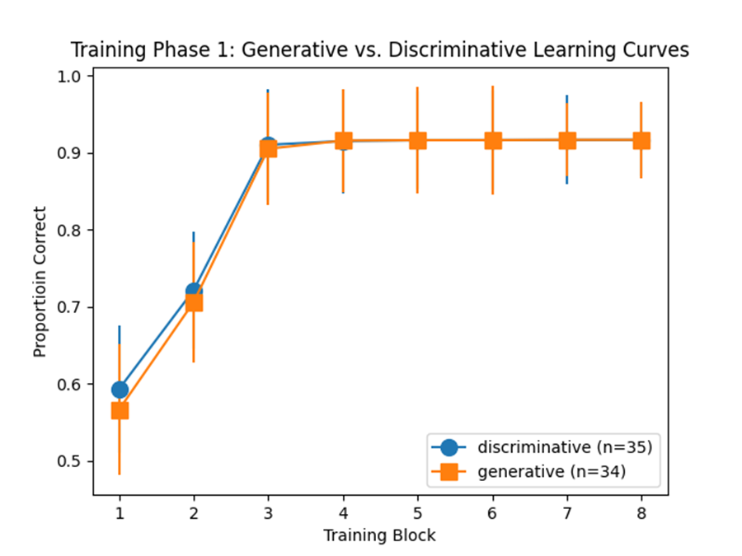Figure 7: Learning curves for Generative and Discriminative conditions in Experiment 2

Test Phase Performance
We examined generalization to critical test items T3 and T4, which lie along the Alpha category's correlation line but are more similar to Beta exemplars. If subjects developed coherence-based representations of the Alpha category, these items should be classified as Alphas despite their proximity to Beta training items.

The aggregate results showed that both critical items were predominantly classified as Betas across both conditions (Figure 8), consistent with similarity-based rather than coherence-based generalization. However, individual differences analysis revealed that subsets of subjects did show coherence-consistent patterns. Nine subjects (26%) in the Discriminative condition classified T3 and/or T4 as Alphas. Six subjects (18%) in the Generative condition showed similar patterns.

Notably, the Generative condition showed a lower proportion of coherence-based generalization than the Discriminative condition, consistent with a domain-general strategy interpretation (see Discussion).
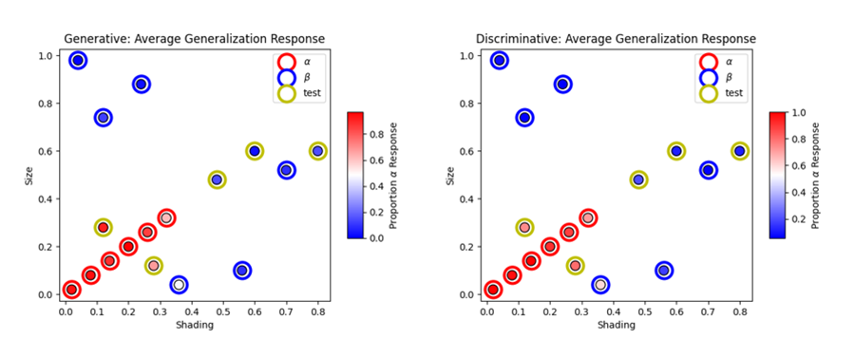Figure 8: Average generalization profiles for Generative and Discriminative conditions. Stimuli are plotted as points in feature space. Outer circles indicate the experimenter defined identities of the stimuli, while inner circles represent average subject response. The inner circles vary along a blue-red color gradient: the blue and red end of the gradients represent high proportions of Beta and Alpha responding respectively.
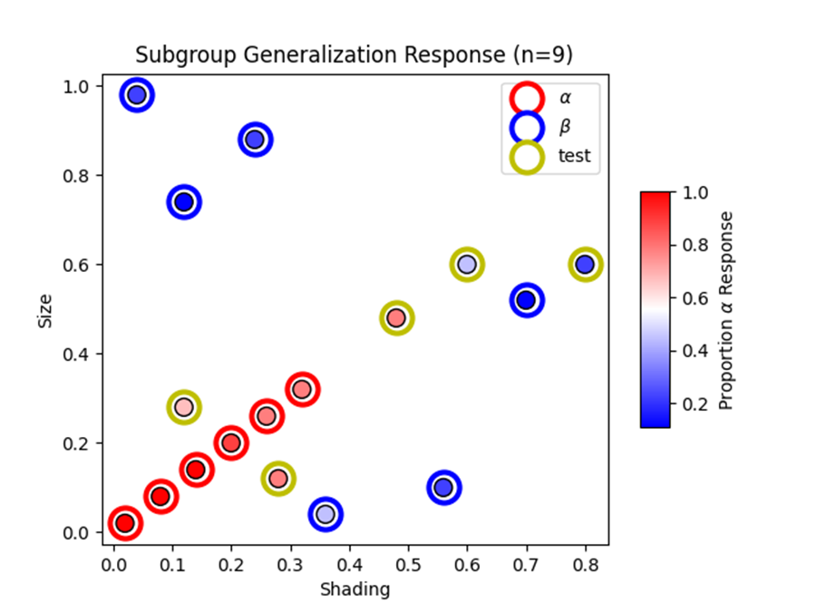Figure 9: Average generalization response from 9 Discriminative condition subjects who classified T3 and/or T4 as Alpha(s).

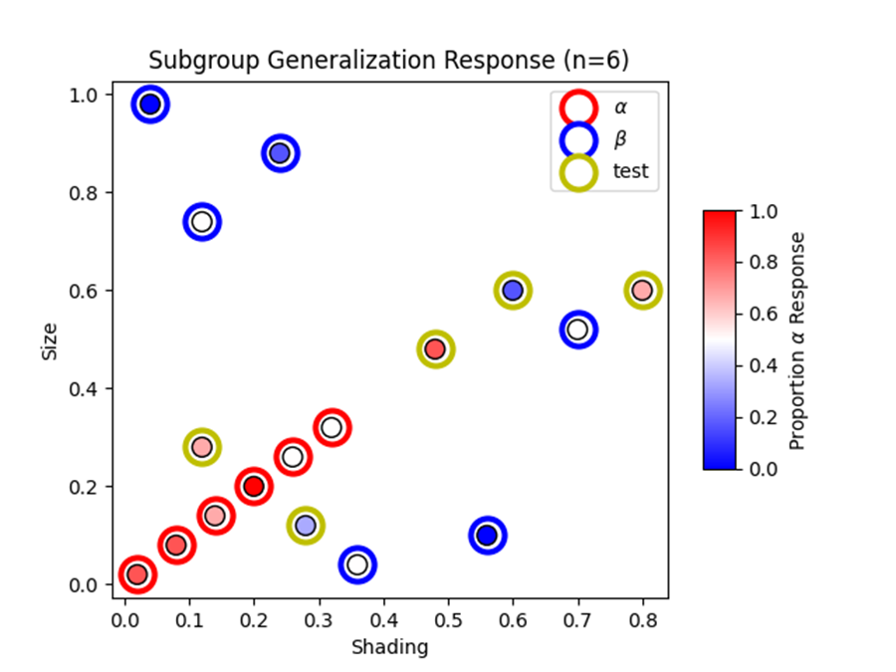Figure 10: Average generalization response from 6 Generative condition subjects who classified T3 and/or T4 as Alpha(s).

Training Phase 2 Performance
Introduction of Gamma and Delta categories in the second training phase showed equivalent performance across conditions (both ~50% accuracy, above chance for 4-category classification; Figure 11).
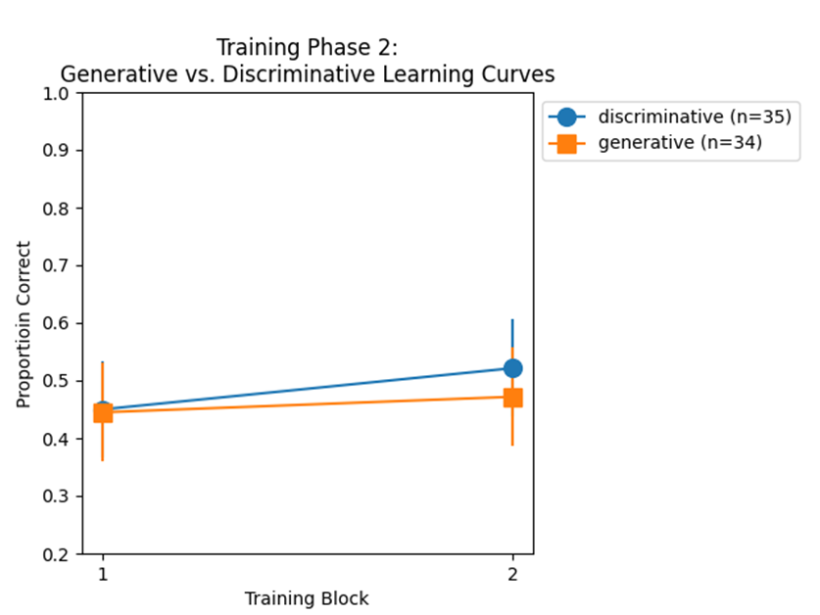Figure 11: Training Phase 2 learning curves for both Generative and Discriminative conditions.

Discussion
Experiment 2 yielded mixed evidence for coherence-based representation. The majority of subjects classified critical items based on exemplar similarity rather than correlational structure, with only subsets (9/35 discriminative, 6/34 generative) showing coherence-consistent patterns. This contrasts sharply with Experiment 1 where coherence-based generalization was the dominant pattern.

The key difference appears to be domain structure. Experiment 1 used two categories that both exhibited perfect correlations, making correlation-based representation viable domain-wide. Experiment 2 included one structured and one unstructured category; when coherence-based strategies work for some categories but not others, subjects may default to an exemplar similarity approach. It could also be that a constraint on the learning of featural regularities is the need to pertain to both categories. This result does nothing to undermine the important phenomenon captured in Experiment 1, but it suggests that, just as there are limits on what reference point similarity can account for, there are also limits on the ability to learn by inducing a statistical model of featural regularities. A potential interpretation is that the property of global coherence needs to hold at the domain level (all categories contributing to the coherence) in order for it to guide category formation and generalization. That said, it is still notable that a non-trivial subset of learners showed a tendency toward extending the diagonal of the coherent category.

The learning mode manipulation failed to increase coherence-based learning in the generative condition. There are several possible explanations. First, the novel approach to inviting a generative approach might have failed. Secondly, it could be the case that encouraging a generative approach is not a valid way to promote coherence-based concept acquisition. Third, it could be a matter of strategic adaptation to domain demands: subjects in the generative condition were explicitly told they would later need to learn additional categories within the same domain, and this could have motivated them to adopt representational strategies likely to prove broadly useful across multiple categories rather than strategies optimized for individual categories.

In the current domain, similarity-based representation works for both the structured Alpha category and the unstructured Beta category, making it the superior domain-general strategy. Coherence-based representation, while potentially useful for Alpha items, offers no advantage for Beta items and would require subjects to maintain multiple representational systems. Generative learners, anticipating the need to handle diverse category types, may therefore be more likely to converge on the similarity-based approach that will serve them well throughout the domain.

The mixed results in this experiment and the outcome of the generative learning mode suggest that the adoption of coherence-based versus similarity-based strategies is not simply a matter of detecting correlational structure, but involves sensitivity to the task context including the set of categories being learned together.. Discriminative learners, focused only on distinguishing the current two categories, may be more willing to exploit category-specific regularities even if they won't generalize broadly. Generative learners, planning for future categories, may prioritize representational consistency over local optimization.

Experiment 3

Methods

Participants

Design

Materials
Stimuli were of the same type as that used in experiment one and two (i.e., squares that varied along the dimensions of size and shading).

Procedure

Model Simulations

Results

Training Phase Performance

Test Phase Performance

Discussion

General Discussion

REFS

