Homework#1
- Functional Block Diagram
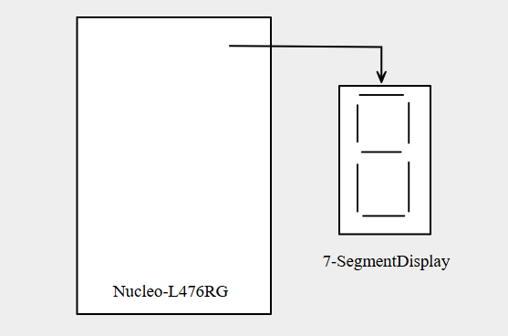
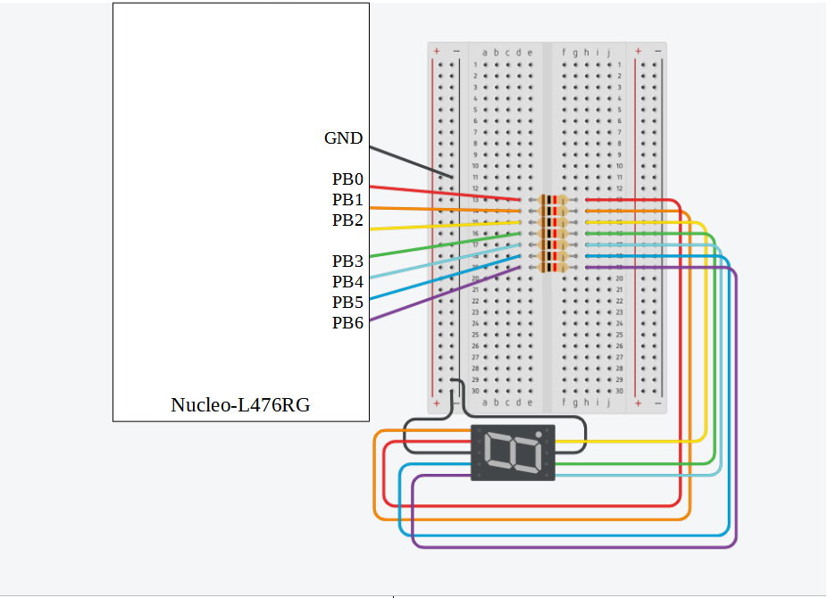
- Breadboard in Tinkercad

- Real Breadboard
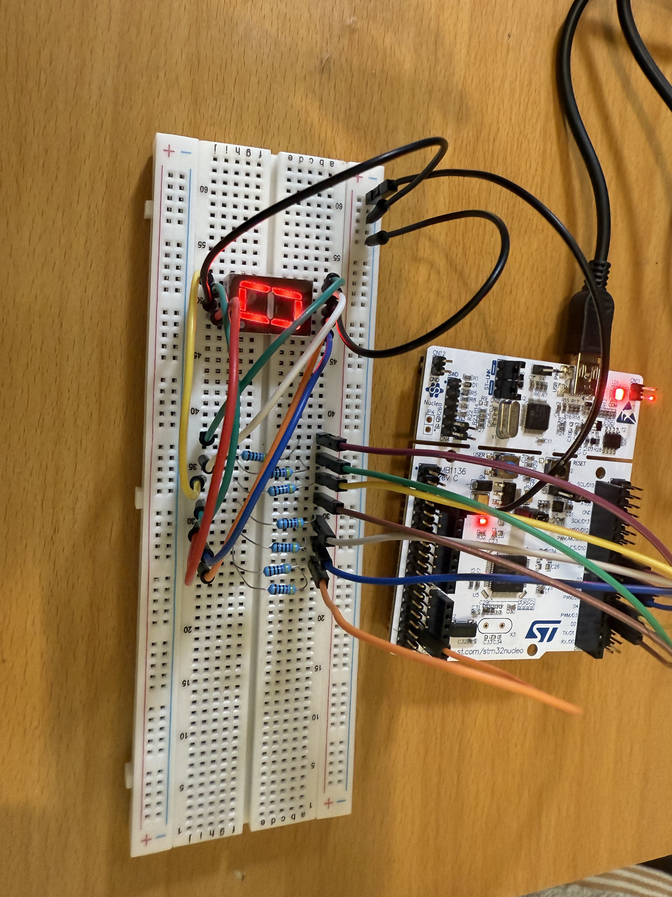
- Code and Result (the total project source code and the video are outside the file)
      - Project Goal :
Implementing a 7-segment display hexadecimal counter which counts from 0-F continuously with one second delay between each other.
      - The Main Code
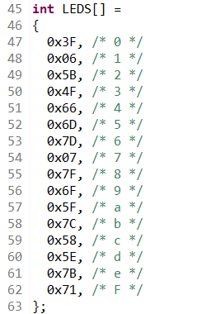
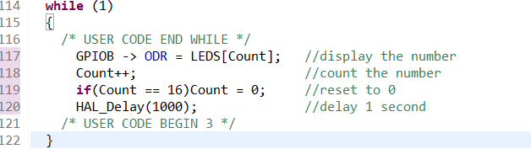
      - Process
        - In order to implementing 7-segment display, we need to declare an array LEDS to display 0-15 in hexadecimal(0~F).
        - First, we use ODR to save the output and then display the number.
        - Next, we need to calculate the number to 16 and then reset the number to 0.
        - Finally, we delay the number with 1 second(1000 milliseconds).

