Homework #2
1. Block Diagram
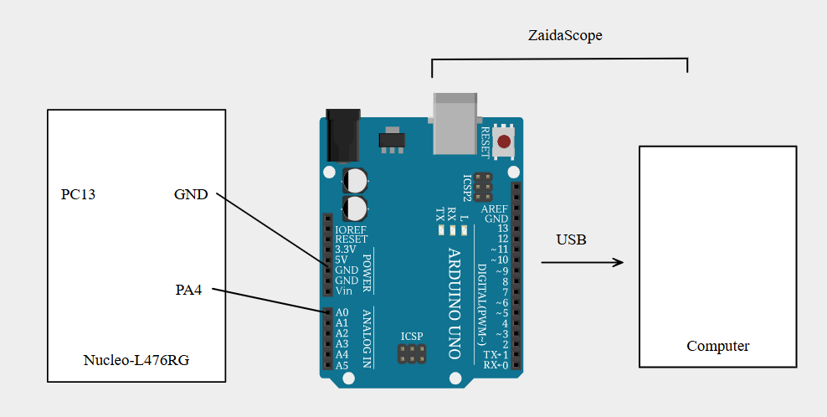

2. On-board Button
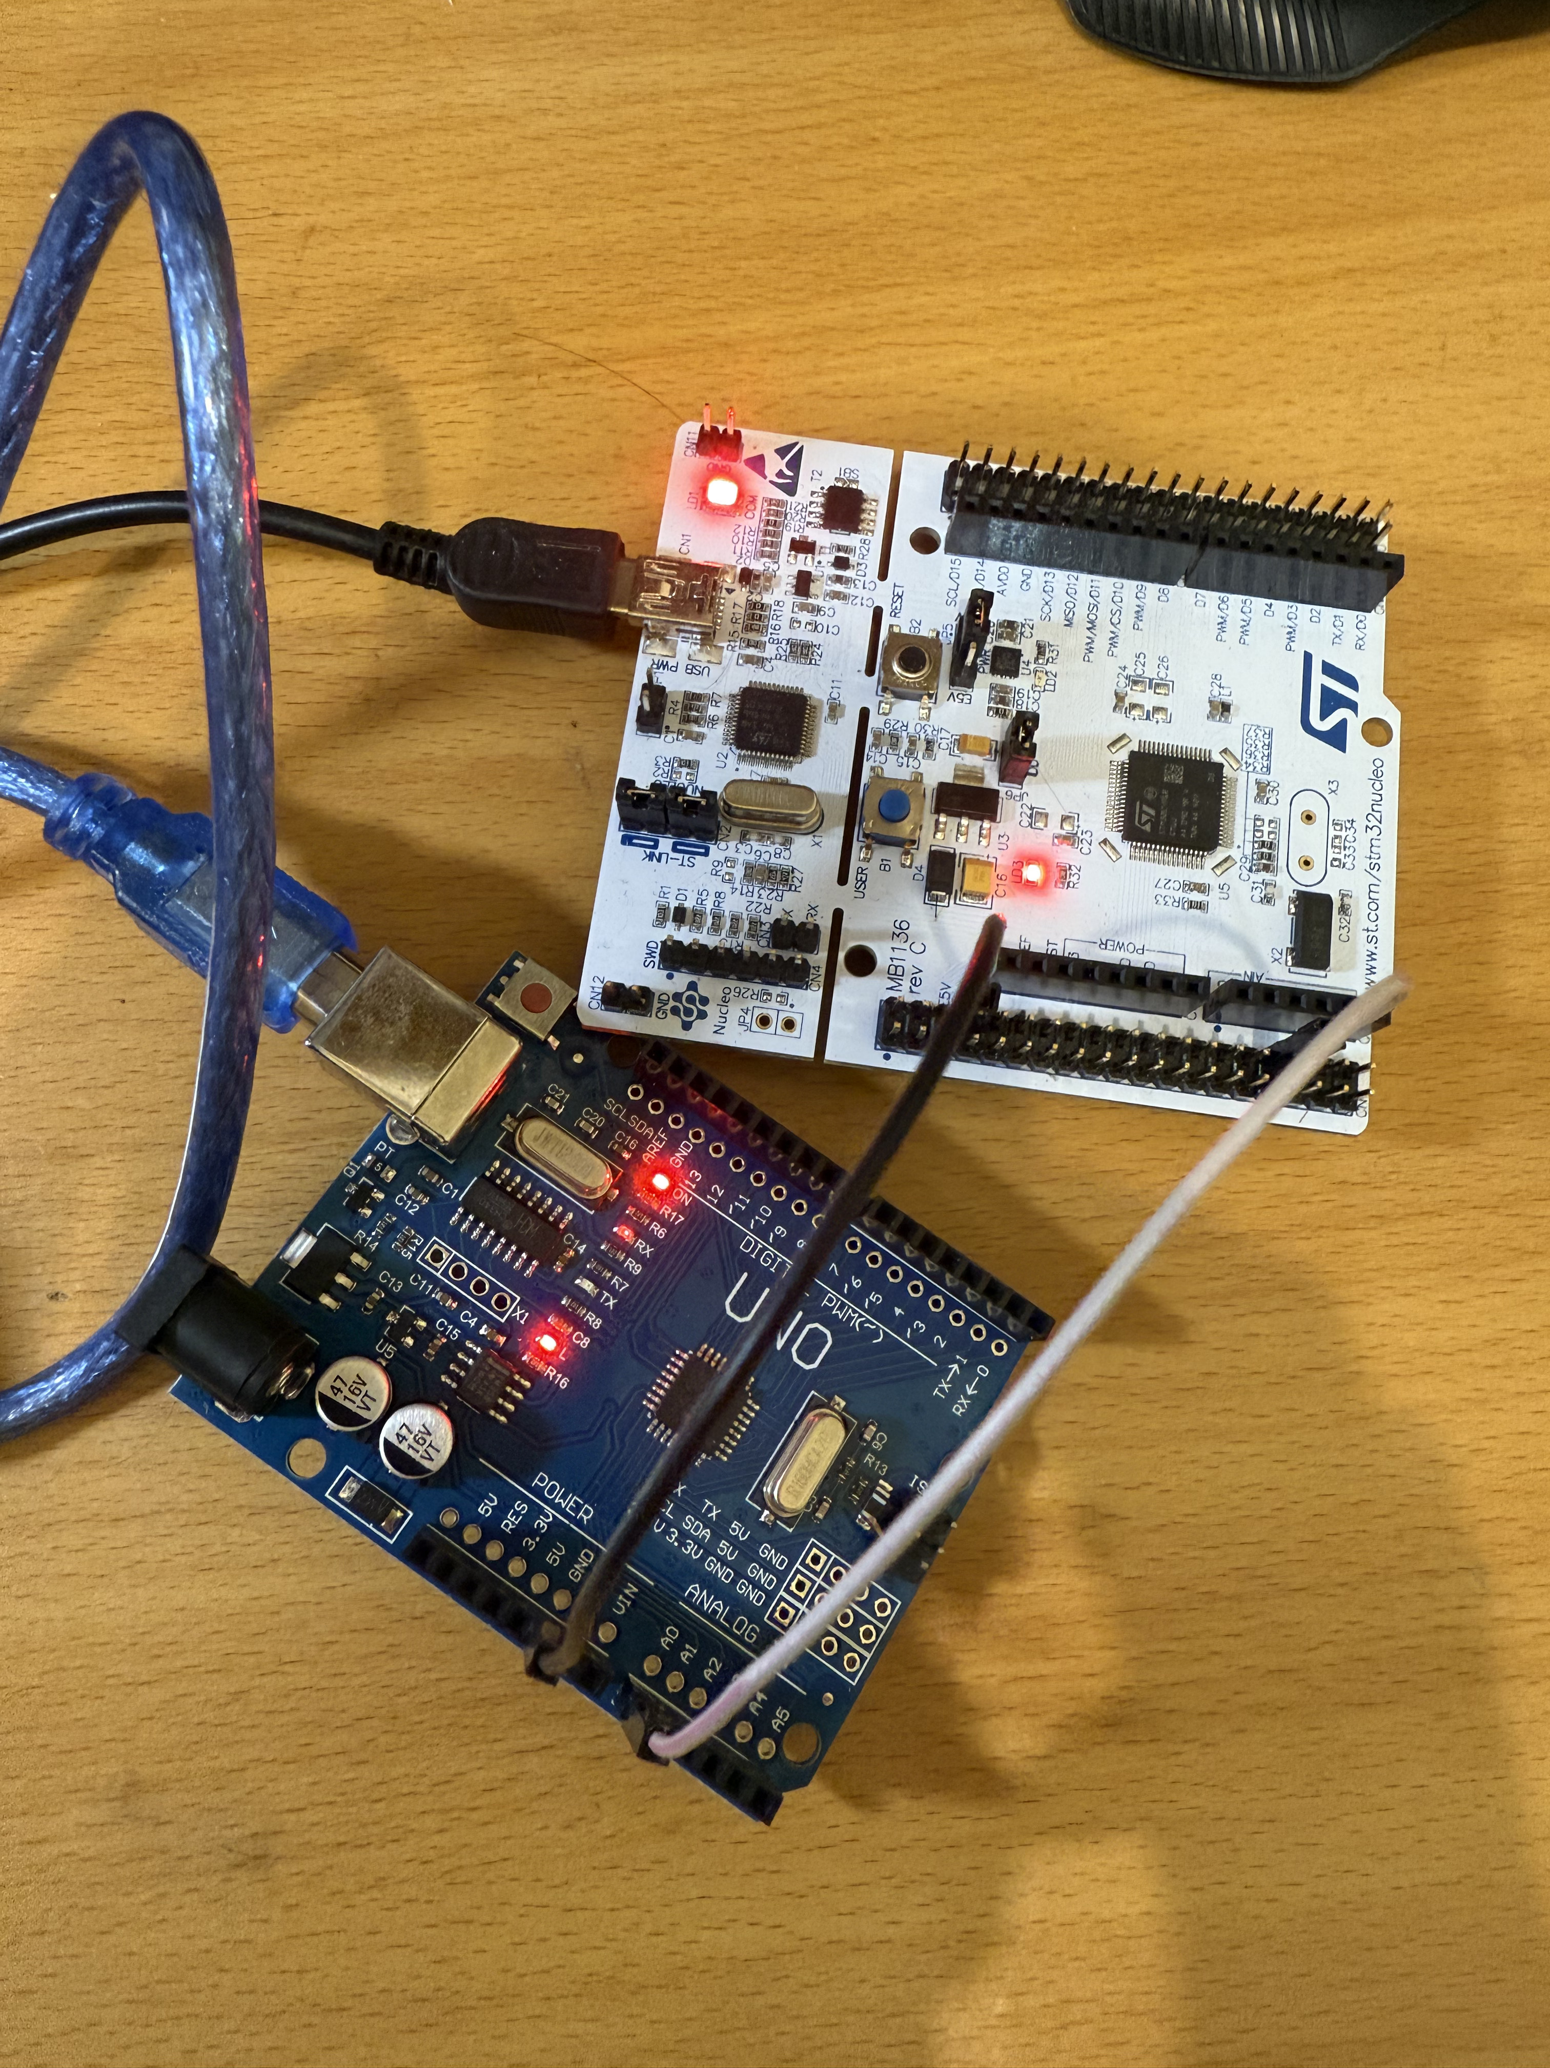

3. Flow Chart
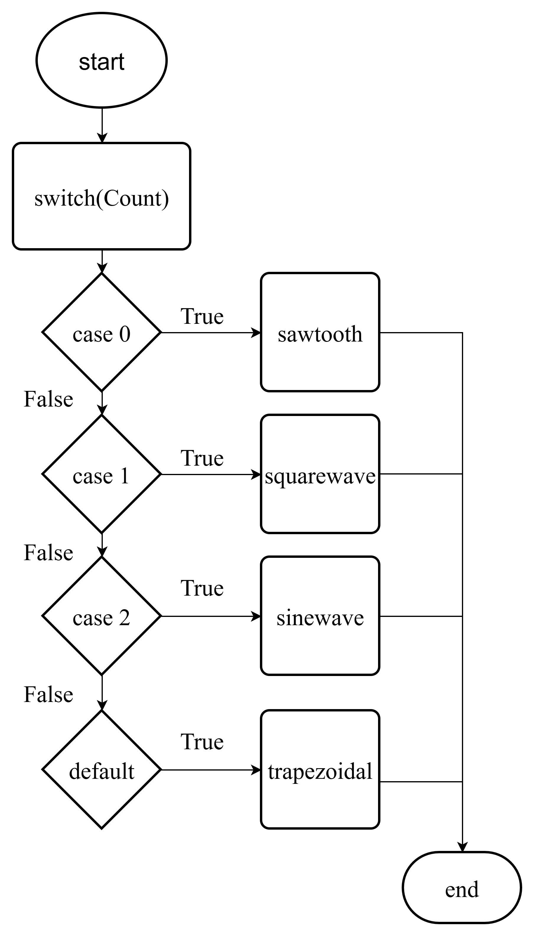

4. Main Code

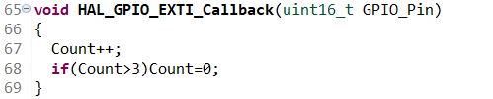

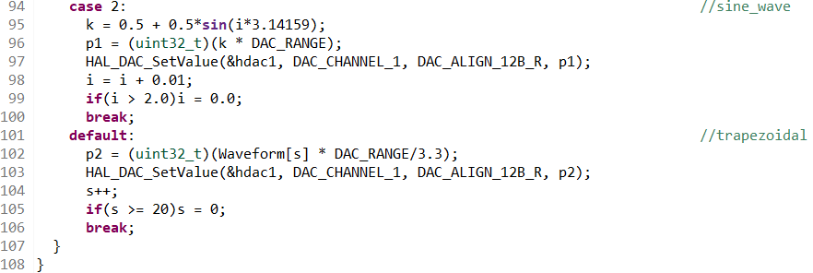
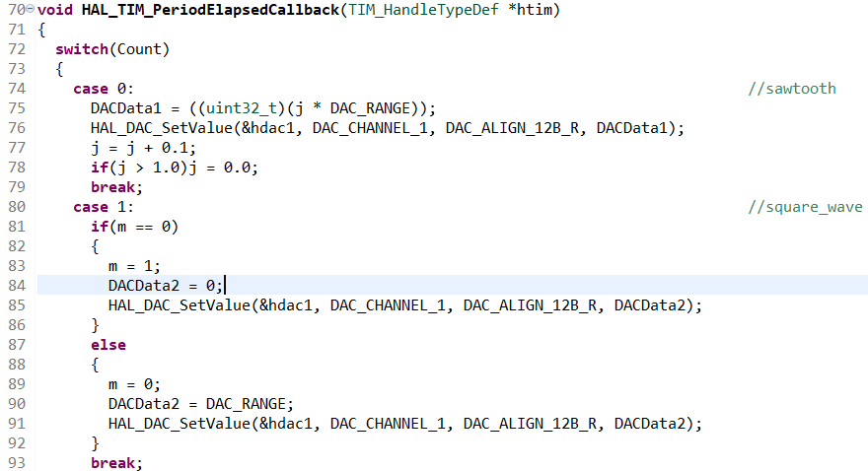

5. Process

- We use HAL_GPIO_EXTI_Callback function to count the number which can switch the wave types.(PC13)
- We use HAL_TIM_PeriodElapsedCallback function to generate different waves, include Sawtooth, Sqaure_wave, sine_wave and trapezoidal.

