## Linux_yum安装MySQL

转载至博客：https://www.cnblogs.com/bigbrotherer/p/7241845.html

在CentOS中默认安装有MariaDB，这个是MySQL的分支，但为了需要，还是要在系统中安装MySQL，而且安装完成之后可以直接覆盖掉MariaDB。

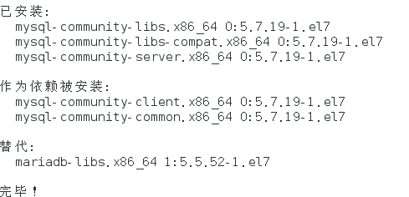

### 1 下载并安装MySQL官方的 Yum Repository

[root@localhost ~]# wget -i -c http://dev.mysql.com/get/mysql57-community-release-el7-10.noarch.rpm

  使用上面的命令就直接下载了安装用的Yum Repository，大概25KB的样子，然后就可以直接yum安装了。

[root@localhost ~]# yum -y install mysql57-community-release-el7-10.noarch.rpm

  之后就开始安装MySQL服务器。

[root@localhost ~]# yum -y install mysql-community-server

**首先启动MySQL**

[root@localhost ~]# systemctl start mysqld.service

 查看MySQL运行状态[root@localhost ~]# systemctl status mysqld.service

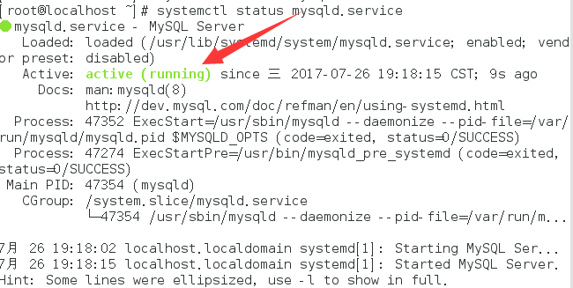

此时MySQL已经开始正常运行，不过要想进入MySQL还得先找出此时root用户的密码，通过如下命令可以在日志文件中找出密码：[root@localhost ~]# grep "password" /var/log/mysqld.log



 如下命令进入数据库：

[root@localhost ~]# mysql -uroot -p

输入初始密码，此时不能做任何事情，因为MySQL默认必须修改密码之后才能操作数据库：

mysql> ALTER USER 'root'@'localhost' IDENTIFIED BY 'new password';

这里有个问题，新密码设置的时候如果设置的过于简单会报错：



首先，修改validate_password_policy参数的值

mysql> set global validate_password_policy=**0**;

Query OK, **0** rows affected (**0.00** sec)

mysql> set global validate_password_length=1;

Query OK, 0 rows affected (0.00 sec)

假设密码修改为xh2018

mysql> set password=password("xh2018");



**设置远程登录权限**

mysql>grant all privileges on *.* to 'root'@'%' identified by 'xh2018';



立即生效:

mysql> flush privileges;



退出quit 或者 exit;

mysql> quit;



**至此，mysql安装流程已结束。**

## 开机服务启动设置：

把mysql.server 拷贝为/etc/init.d/mysqld：(注意自己的实际文件夹)

cp -a /usr/lib/systemd/system/mysqld.service /etc/rc.d/init.d/mysqld



查看是否拷贝成功

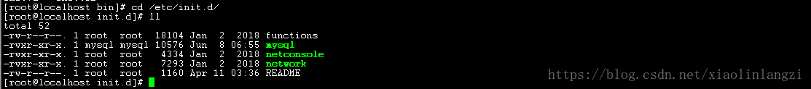

查看mysql服务是否在服务配置中

chkconfig --list mysqld

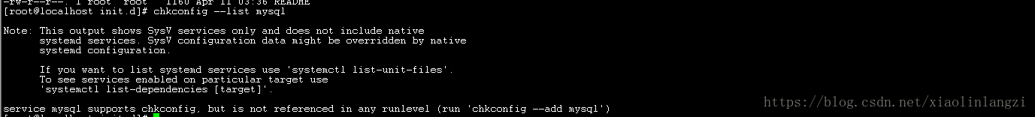

若没有，则把mysqld注册为开机启动的服务，然后在进行查看

chkconfig --add mysqld

可能在执行 chkconfig --add mysql 时报错

 service mysqld does not support chkconfig

修改 /etc/rc.d/init.d/mysqld，在脚本开头的#里加上一句话，# chkconfig: 2345 10 90

再执行chkconfig --add mysqld 就可以了，

最后执行 chkconfig --level 3 mysqld on

chkconfig --list mysqld

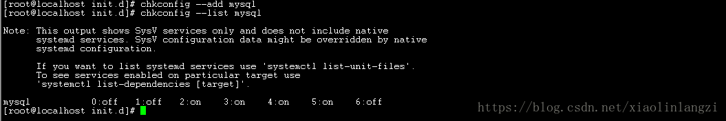

启动

[root@localhost ~]# systemctl start mysqld.service



停止

[root@localhost ~]# systemctl stop mysqld.service

重启

[root@localhost ~]# systemctl restart mysqld.service

其他命令参考systemctl -help

## 开放3306端口

1、开启防火墙端口   
没有防火墙安装防火墙

sudo yum install firewalld #安装防火墙

systemctl start firewalld #启动防火墙

添加3306端口

firewall-cmd --zone=public --add-port=3306/tcp --permanent

重启

systemctl restart firewalld

查看防火墙是否已启动，端口是否开放

systemctl status firewalld #下面就是启动了

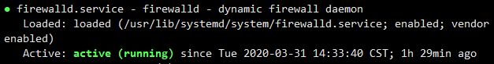  
查看端口是否开放

firewall-cmd --query-port=3306/tcp

在这里插入图片描述  
查看总共开放的端口，这个可忽略

firewall-cmd --permanent --list-ports

在这里插入图片描述

防火墙端口开放也完成

## 更改默认数据存储目录

root@cwzzdb etc]# vi /etc/my.cnf

1 # For advice on how to change settings please see

2 # http://dev.mysql.com/doc/refman/5.7/en/server-configuration-defaults.html

3

4 [mysqld]

5 #

6 # Remove leading # and set to the amount of RAM for the most important data

7 # cache in MySQL. Start at 70% of total RAM for dedicated server, else 10%.

8 # innodb_buffer_pool_size = 128M

9 #

10 # Remove leading # to turn on a very important data integrity option: logging

11 # changes to the binary log between backups.

12 # log_bin

13 #

14 # Remove leading # to set options mainly useful for reporting servers.

15 # The server defaults are faster for transactions and fast SELECTs.

16 # Adjust sizes as needed, experiment to find the optimal values.

17 # join_buffer_size = 128M

18 # sort_buffer_size = 2M

19 # read_rnd_buffer_size = 2M

20 #datadir=/var/lib/mysql

21 datadir=/mysql/data

22 innodb_data_home_dir=/mysql/data

23 socket=/var/lib/mysql/mysql.sock

24 explicit_defaults_for_timestamp=true

25 innodb_buffer_pool_size = 128M

26

27 # Disabling symbolic-links is recommended to prevent assorted security risks

28 symbolic-links=0

29

30 log-error=/var/log/mysqld.log

31 pid-file=/var/run/mysqld/mysqld.pid