Login

Different from the for Deakin login, being blue with a little extra visual behind. Not to be distracting, but also not too plain. So to give a fresh feel something blue I thought was good.

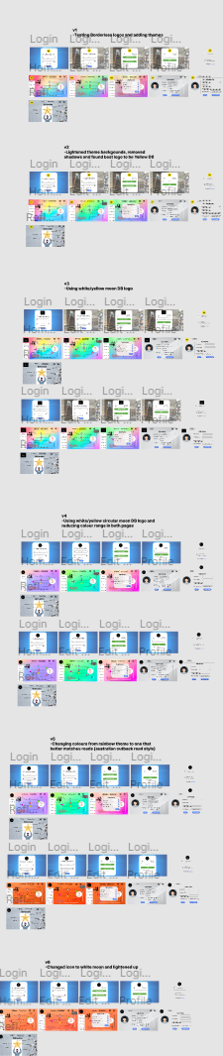

Home

This should not be too distracting for roadmap, but still be colorful enough to match in with the design. I went with colours that are considered relaxing such as pink, green, and blue. I went for a lighter theme as to better accentuate the graphics displayed on top of it whereas a darker theme would have just made it harder for readers. I went with blue as it is usually associated as a calm color.

Edit profile

Just a plain grey with a little extra something. When editing important details, it’s not a good idea for a distracting background. Which is why I assume most sites have a plain background too. The image can be seen above with all the variants of colors used in the prototype.