**Q1. What is cherry-pick? Explain the use case of it also write steps to do it.**

**Answer** :

**Chery-pick :** When we want to bring one or multiple commit from a feature branch to master branch instead of entire branch we use cherry pick

**How to use cherry pick :**

Syntax : git cherry-pick commit_id

**Steps to do cherrypick :**

1. git checkout <name of branch you’d like to grab commit from>

2. git log

3. git checkout <name of branch you would like to add commit to>

4. git cherry-pick [-x] <commit hash>



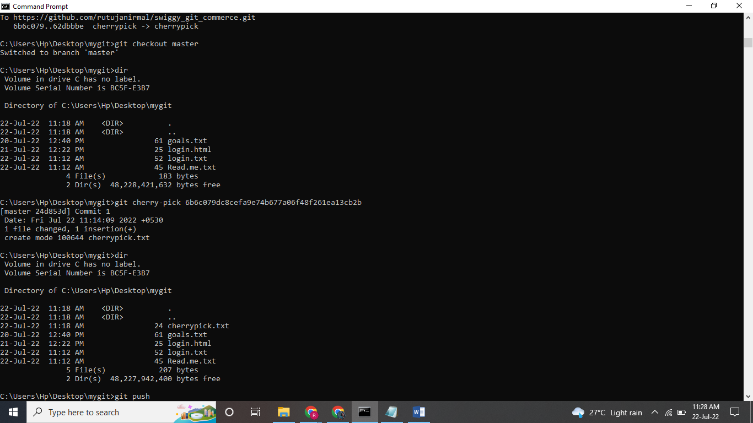

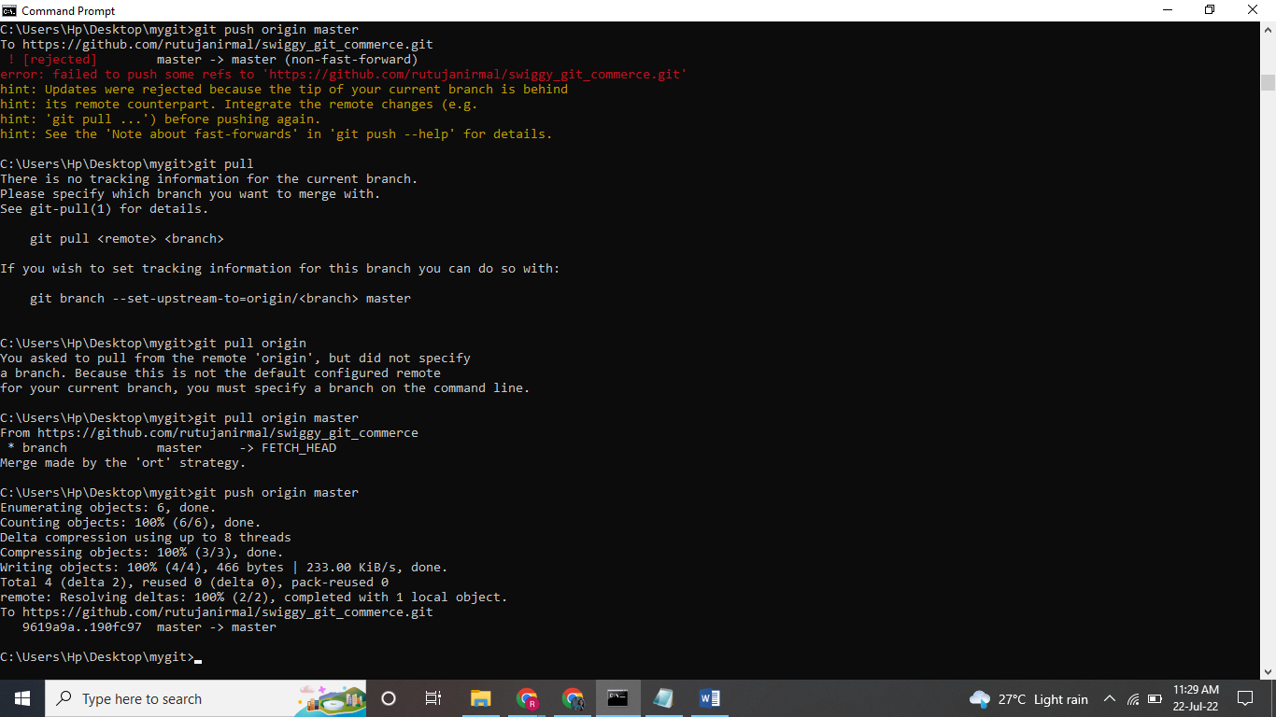

**Commits from only one commit copied in master branch**



