5.2 User-Evaluation Data Collected
This project does not rely solely on a one-time comparison of the new and old Dashboard versions; instead, it continuously evaluates the system through three rounds of iterative user testing. This approach allows for observation of version changes, recording how user feedback translates into development tasks, and verifying the effects of modifications in the next round, thereby more clearly illustrating the process of problem identification—feature improvements—user re-testing—and final validation. The testing is evaluated across seven dimensions: the overall interface, Task–Stage workflow, data import, system feedback, visualisation, analytical efficiency, and future usability intent.
5.2.1 Evaluation Procedure and Participants
This project conducted three rounds of user assessments, corresponding to V1 – Initial Dashboard, V2 – Improved Dashboard, and V3 – Final Validation Dashboard. The formal assessments were carried out via remote screen recording, primarily targeting users with backgrounds in hydrology, ecological management, watershed management, or environmental management, and providing supplementary feedback to participants with backgrounds in environmental science, development experience, or prior experience using the old Dashboard. The feedback from developers and internal participants was retained solely as supplementary technical feedback. Testing utilised Task-based Testing, Think-Aloud, a Custom 1–5 Usability Questionnaire, as well as Post-test Discussions and Interviews.
This combined approach not only records whether users complete tasks but also observes how users understand workflow, system status, and analysis results during operation, and further translates this feedback into the development requirements for the next version.
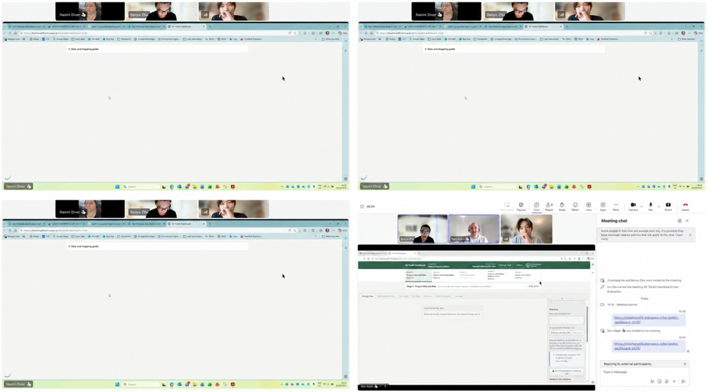
The above image shows the remote Think-Aloud evaluation process used in this project. Participants shared their screens when starting the Dashboard task, enabling them to observe and record their actions, comments, and areas of confusion in real time.
Round 1 – V1 Initial Dashboard
The core purpose of the first round of testing is not to verify whether the Dashboard has met the final requirements, but to establish the initial usability baseline for V1 and observe how users complete the core workflow in the version that has not yet undergone subsequent optimisation.
The test primarily covers Flow processing, Sample Selection, HEV, WQ/RHS, and Stage 4/5 modelling, and records users' understanding, pauses, and the positions requiring additional explanation during the operation process through Task-based Testing and Think-Aloud. The test results indicate that the main issues with V1 are concentrated on the functional division of System Feedback, Flow workflow, Sample Selection, and Stage 4/5: some states and WQ feedback are overly technical, the relationship between Donor Mapping and Flow Site ID is not sufficiently intuitive, samples still require Exclude/Restore for each item, and the functional boundaries and modelling process between Stage 4 and Stage 5 are also not clear enough. The questionnaire results also support this observation, with System Feedback (Q4) scoring only 3.0/5, the lowest score in the first round.
Item | R1 / V1
Version and Date | V1 – Initial Dashboard, 5–6 August 2026
Questionnaire Responses | 6 questionnaire responses
Purpose | Identify baseline usability and workflow issues
Coverage | Flow processing, Sample Selection, HEV, WQ/RHS, Stage 4/5

These issues were subsequently converted into specific modification requirements for V2, including reorganising the operation paths for Flow processing and Donor Mapping, simplifying system state prompts, adding Sample Table/Select All, and further distinguishing the data check function for Stage 4 from the modelling function for Stage 5.

Round 2 – V2 Improved Dashboard
The second round of testing was primarily used to verify the effectiveness of the modified V1 issues and to further check any workflow and UI issues that remained unresolved. Compared to the first round, the Flow workflow, Sample Selection, Stage 4/5 layout, and download functions have been improved, resulting in a clearer overall operation path. At the same time, the testing still found that the position of the Additional Donor Flow is not intuitive, indicating that the Flow workflow still requires further adjustment.
Furthermore, this round also identified a new Flow Heat Map refresh issue, namely that after the Additional Donor Flow update, the charts do not always reflect the latest Flow dataset. Based on these results, the focus of V3's modifications has further concentrated on Flow data updates, Heat Map automatic refresh, and the remaining display and operation issues for Stage 4/5.
Item | R2 / V2
Version and Date | V2 – Improved Dashboard, 12–13 August 2026
Questionnaire Responses | 6 questionnaire responses
Purpose | Verify the improvements in V1 and identify any remaining or new issues
Coverage | Donor Flow, HEV, Sample Selection, Stage 4/5, Heat Map

Round 3 – V3 Final Validation Dashboard
The third round of testing serves as the final validation for the V3 – Final Validation Dashboard, focusing on testing the core functionalities of the Dashboard and whether the Stage 1–5 workflow can support the primary user tasks and core analysis processes following the two iterations of the preceding round. The testing covers multiple stages, including Local File Import, Flow processing, HEV, Sample Selection, Stage 4/5, modelling, and result output, and re-validates any Flow data refresh and interface display issues that still persist from the previous round.
The test results indicate that the core Flow processing can complete normally, the Flow Heat Map can reflect the latest data, and Sample multi-selection and Task–Stage workflow are also clearer and more stable than the previous two rounds. Stage 4 did not detect any obvious core process issues this round, and Stage 5 modelling and diagnostics can also generate the corresponding results normally. Overall, V3 has largely achieved the main functionalities and analysis workflows expected by the project.
The remaining questions are mainly focused on Local File data transfer, WQ Merge and some Stage 4/5 UI display, which are retained as part of the subsequent optimisation content.
Item | R3 / V3
Version and Date | V3 – Final Validation Dashboard, 28 August 2026
Testing Scale | 1 joint session / 2 participants / 2 questionnaire responses
Purpose | Final validation of the revised core workflow
Coverage | Local File, Flow processing, HEV, Stage 4/5, modelling outputs

The three-round testing ultimately formed continuous assessment evidence: R1 identified problems, R2 verified modifications and identified remaining problems, and R3 completed the final validation. Each round of testing was combined with screen recording observation, Think-Aloud, questionnaires and subsequent feedback; detailed questionnaire results and version problem correction records are found in Appendix.

5.2.2 Evaluation Results and Analysis
The results of the three rounds of questionnaires show that the overall score of the Dashboard increased from V1's 3.5/5 to V2's 4.3/5, and reached 4.6/5 in V3. Among them, Workflow (Q2) increased from 3.5 to 4.5, System Feedback (Q4) increased from 3.0 to 4.0, and Visualisation (Q5) increased from 3.8 to 5.0, which is consistent with the continuous improvement directions carried out in the three rounds of testing for workflow, feedback and visualisation. These results are used to describe changes in the Dashboard during the iterative process, not as evidence of statistical significance or causality, because the composition of participants in the three rounds and the testing conditions are not entirely consistent.
- R1/V1: The main issues are concentrated on System Feedback, Flow workflow, Sample Selection and the function division of Stage 4/5.
- R2/V2: Improvements have been made in these areas, but the position of the Additional Donor Flow remains not intuitive, and new Heat Map refresh issues have been identified.
- R3/V3: Flow processing, Heat Map refresh, Sample Selection and Task–Stage workflow have been further validated and improved, and the core functions and analysis workflow have been able to complete normally.
Round | Version | Overall Score | Main Evaluation Result
R1 | V1 – Initial Dashboard | 3.5/5 | Major workflow and usability issues identified
R2 | V2 – Improved Dashboard | 4.3/5 | Most areas improved; remaining and new issues identified
R3 | V3 – Final Validation Dashboard | 4.6/5 | Core workflow largely validated; mainly UI/data-transfer issues remained

The three-round results indicate that user evaluation not only measures the usability of the final version but also directly participates in the iterative development process of the Dashboard. From problem identification in V1 to modification verification in V2 and final confirmation in V3, the main workflow issues are gradually resolved, while the remaining issues are further concentrated on a small number of data transmission and UI display aspects.

5.3 Work Still Needed
Currently, the core functionalities and main workflow of the Dashboard are largely complete. The focus of future work will shift from functional modifications to more extensive practical user validation. In the future, it should be invited to invite more independent end-users from the Environment Agency or relevant environmental management departments to participate in testing, to cover a range of work experience, professional backgrounds, and actual usage scenarios, thereby further validating the usability, workflow clarity, and practical applicability of the Dashboard.
At the same time, more real datasets can be used for long-term testing under more consistent test conditions to confirm the system's performance under different data scales and analytical tasks. This can provide more comprehensive user evidence for applications in Dashboard's subsequent deployment and actual environment management work.

