Copyright (C) 2014 Josh1, All right reserved.

This software ABCD.r is provided 'as-is', without any express or implied warranty.

In no event will the author be held liable for any damages arising from the use of this software.

Permission is granted to anyone to use this software for any purpose, including commercial applications, and to redistribute it freely, subject to the following restrictions:

1. The origin of this software must not be misrepresented; you must not claim that you wrote the original software.

2. This notice may not be removed or altered from any distribution.

Updated on 14th January, 2020

Another Bhavcopy Downloader (ABCD) is an open source End of Day Data Downloader written in Rebol 2.7.8.

Another Bhavcopy Downloader CURL (ABCDCurl) – ABCD was re-written and renamed as ABCDCurl when NSE changed its URL from HTTP to HTTPS.

Copy all files extracted from ABCDCurl.zip into ABCD folder into root of any drive. e.g. - c:\ABCD or d:\ABCD or e:\ABCD

Requirements- ABCDCurl depends on curl.exe (32 bit) for downloading files from NSE and BSE server.

Windows 10 – ships with curl.exe in system32 folder
Windows 8 and before – User will have to copy curl.exe into \windows\system32 folder.
Curl.exe is available from here - https://curl.haxx.se/windows/

Copy GetBhavCopy.format file into ‘your\Amibroker\formats’ folder if you do not have it there.

Copy ABCDCurl shortcut onto your desktop

You can also manually start ABCDCurl from the ABCD folder.
Start cmd (windows terminal) – cd \ABCD – rebol.exe ABCDCurl.r

Supported Exchanges - It downloads daily EOD (End Of Day) data that is Bhavcopy as well as historical data (past EOD data) for –
NSE EQ, BE and DR series
NSE indices.
NSE Futures and Options
NSE Currency
BSE Equity
BSE Currency
BSE Futures

Bhavcopy is downloaded directly from the NSE/BSE servers. Thereafter it is processed and new text file having exchange name data type and date is created with formatted data. For example, 2016-01-01NSE-EQ. This file can be directly imported into AmiBroker, MetaStock as ASCII format using MetaStock downloader. It can be imported in AmiBroker with the same format file as Getbhavcopy.format.

Note:- BSE futures EOD data is in xls format. I do not want to process it. Rest all are processed for easy import into Amibroker.

Operations –
Following source files will be created in installation folder. Do not modify any of them unless you know what you are doing.
- rebol.exe, form-date.r, ABCD.r, unzip.exe, README-ABCD.txt, Indices.txt, Futures.txt, GetBhavCopy.format

Following folders will be created automatically on first download.
NSE, NSECUR, NSEFO, BSE, BSECUR, BSEFO,

The data files are created in these folders below the program directory/installation folder.

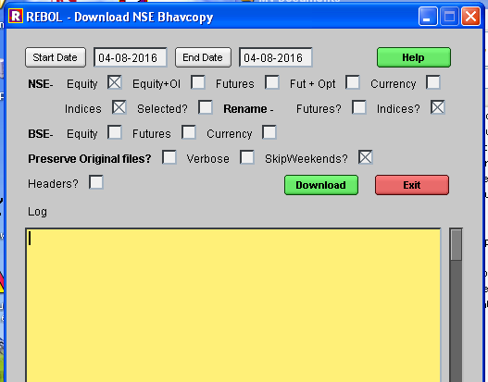

Click on Help to display this file.

Give Start Date and End Date to indicate period for which you want to download Bhavcopy.

Put Check mark against whichever Bhavcopy you want to download and click on Download to get it in respective folder.
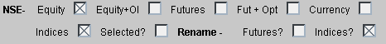

As shown in picture above, NSE Equity, NSE Indices will be downloaded.
NSE Equity and indices are both downloaded in the folder \NSE.

In case of NSE Equity, EQ, BE and DR series are kept. Rest are deleted while processing.

Check Equity+OI if you want to download data of Deliverable along with NSE Equities.

Check Futures if you want to download NSE Futures Bhavcopy.
Check Fut+Opt if you want to NSE Futures Bhavcopy and also options.

Check Currency if you want to download NSE Currency Bhavcopy.

Check Indices if you want to download NSE Indices Bhavcopy.

Check selected if you want only selected indices.
Names of selected indices should be in NSEINDICES.txt file.
Otherwise all indices will be deleted.

Check Rename Indices if you want different name for indices.

In both cases, you will have to maintain Selected indices and their names in NSEINDICES.txt file. Note the format below-

Original Name,Alternate Name

Nifty 50,NSENifty
Nifty Next 50
Nifty 100,NSE100
Nifty 200,NSE200
Nifty 500,NSE500
Nifty Midcap 50,NSEMidcap
Nifty Auto,NSEAuto
Nifty Bank
Nifty Energy
Nifty FMCG

Do not give space after comma or after name. Original Name should be exactly as in Original file from Exchange.
If you do not want to rename, do not give Alternate name.
In above case, ‘Nifty 50’ will be renamed as ‘NSENifty’ but ‘Nifty Next 50’ will remain as is since alternate name is not given.

Check Rename Futures? if you want to rename Futures as -I -II -III or -F1 -F2 -F3 etc. See Futures.txt file to know how to rename.

Note :-Date should match exactly as given by NSE. See format below\

28-Jan-2016,-I
25-Feb-2016,-II
31-Mar-2016,-III

On 28th Jan- 2016, -I contract will end and 28-Apr-2016 contracts will open.
Open the file Futures.txt manually on that date before downloading and change it manually.
It should look like this. Change every month like this.

25-Feb-2016,-I
31-Mar-2016,-II
28-Apr-2016,-III

Check Preserve Original files if you want to keep original zip files from exchange. This will leave original file in respective folder.

Check Verbose to get extra messages while ABCD is processing files. These are used for debugging if there is any error.

Check Headers if you want Column Headings in data files.
"SYMBOL,DATE,OPEN,HIGH,LOW,CLOSE,VOLUME,OI

If you check Headers, you will have to make ‘skiplines 1’ in Getbhavcopy.format file.

Errors- If there were any errors in downloading and some files were not downloaded, see log.txt file in installation folder.
You will know which files were not downloaded. Download them again.

Known issues:
There is a bug in the Date Selector calender. If you select any previous month for start date, it shows the same month name when invoked again but the date is of current month. So select month again.

