LitPath AI User Manual
Document Version: 1.0
Date: August 05, 2026

Table of Contents
- Document Control & Overview
- Getting Started
- Navigation & Interface Layout
- Core Features & Step-by-Step Workflows
- Common Administrative Tasks
- Troubleshooting & FAQs
- Support & Escalation
- Appendices

1. Document Control & Overview

Title & Version
Software Name: LitPath AI
Version: 1.0
Document Date: August 05, 2026

Purpose
LitPath AI is an intelligent academic thesis retrieval system designed to solve limitations in traditional keyword search by providing semantic understanding, cross-disciplinary connections, and structured metadata extraction. It enables university faculty, researchers, and librarians to efficiently discover and analyze academic papers with AI-powered summaries and citation support.

Target Audience
- Students/Researchers: Regular users who search and access academic materials
- Librarians: Staff with extended permissions to manage content and view analytics
- Administrators: IT personnel with full system oversight and configuration rights

Revision History
v1.0 (August 2026): Initial release covering all core modules and user roles

2. Getting Started

System Requirements
- Modern web browser (Chrome 90+, Firefox 88+, Safari 14+, Edge 90+)
- Stable internet connection
- Screen resolution minimum 1024x768 for optimal experience
- JavaScript enabled
- Cookies enabled for session management

Access & Login
- Navigate to the application URL (typically http://localhost:5174/ in development)
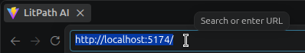

- Click "Login" button
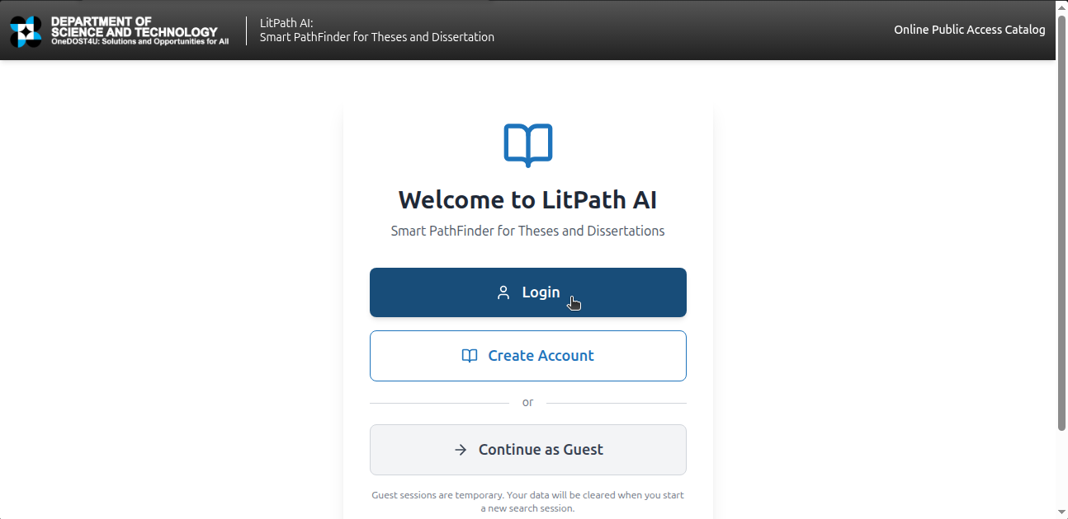

- Enter your credentials:
- - Student/Researcher: Use assigned account credentials
- - Librarian: Email: librarian@dost.gov.ph, Password: librarian123
- - Admin: Email: admin@litpath.com, Password: admin123456
- Click "Login" button
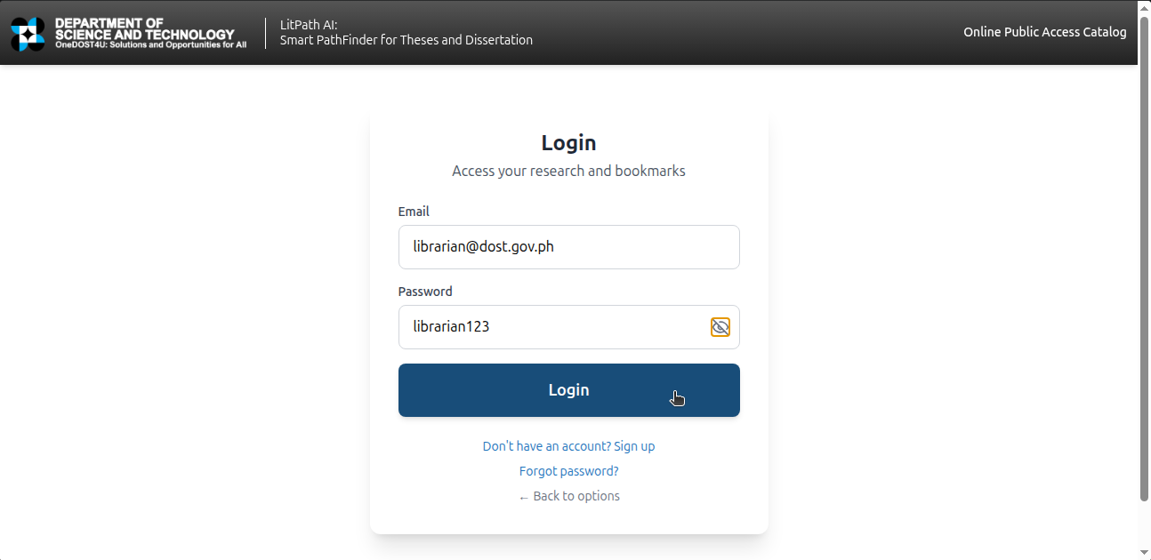

- Accept terms and conditions if prompted

Role & Permissions Overview
- Student/Researcher: Can search, view, bookmark, rate, and provide feedback on materials
- Librarian: All student features plus dashboard analytics, content management, and basic reporting
- Admin: Full system access including user management, advanced analytics, and system configuration

3. Navigation & Interface Layout

Dashboard Overview
Upon successful login, users see:
- Header Navigation: Search bar, notifications, user profile menu

- Main Content Area: Search results, materials, or dashboard depending on role

- Sidebar Menu: Access to different modules based on permissions

- Footer: Support links and version information

Key Controls & Icons
- 🔍 Search: Initiate material search
- 📚 Bookmarks: View saved materials
- ⭐ Rate: Provide material ratings
- 📤 Export: Download citations or reports
- 📊 Analytics: Access dashboard (for authorized roles)
- ⚙️ Settings: Access preferences and account settings
- ❓ Help: Access help documentation

4. Core Features & Step-by-Step Workflows

Module 1: Search & Discovery

For Students/Researchers

Task: Perform Semantic Search
Prerequisites: User must be logged in

Steps:
- Locate the search bar at the top of the page
- Type your research query (e.g., "machine learning applications in agriculture")
- Press Enter or click the search icon
- Wait for results to load (typically 2-5 seconds)
- Review the ranked results with AI-generated summaries
- Click on a material title to view full details

Expected Results:
Relevant academic papers displayed with AI-generated summaries and metadata

Task: Filter Search Results
Prerequisites: Search results must be displayed

Steps:
- Look for filter options below the search bar
- Click on "Filter" button
- Select desired filters (year range, institution, subject areas)
- Click "Apply Filters"

Expected Results:
Results list updated to show only filtered materials

For Librarians

Task: Monitor Search Activity
Prerequisites: User must have librarian role

Steps:
- Navigate to the "Analytics" section from the sidebar
- Click on "Search Trends" tab
- Select date range for analysis
- Review charts showing popular queries and search patterns

Expected Results:
Visual representation of search activity and trends

Module 2: Material Management

For Students/Researchers

Task: Bookmark a Material
Prerequisites: User must be viewing a material detail page

Steps:
- Locate the "Bookmark" button near the material title
- Click the bookmark icon
- Confirm bookmark if prompted

Expected Results:
Material appears in your bookmarked list

Task: Rate a Material
Prerequisites: User must be viewing a material detail page

Steps:
- Locate the star rating system
- Click the desired number of stars (1-5)
- Optionally add a comment

Expected Results:
Rating recorded and reflected in material score

For Librarians

Task: Review Material Metadata
Prerequisites: User must have librarian role

Steps:
- Navigate to "Materials" section in dashboard
- Browse the list of available materials
- Click on any material to view/edit its metadata
- Verify accuracy of extracted information

Expected Results:
Detailed metadata view with edit capabilities

Module 3: Feedback & Reporting

For Students/Researchers

Task: Submit Feedback on Search Results
Prerequisites: User must have interacted with search results

Steps:
- Navigate to "Feedback" section
- Select feedback category (Positive, Issue, For Improvement)
- Provide detailed comment about your experience
- Submit feedback

Expected Results:
Feedback submitted and visible in your feedback history

Task: Export Citations
Prerequisites: User must have selected one or more materials

Steps:
- Select materials by clicking checkboxes
- Click "Export Citations" button
- Choose citation format (APA, MLA)
- Download the generated citation file

Expected Results:
Downloadable citation file in chosen format

For Librarians

Task: Review User Feedback
Prerequisites: User must have librarian role

Steps:
- Navigate to "Feedback Management" in dashboard
- View pending feedback submissions
- Review feedback details and categorize appropriately
- Mark as resolved when addressed

Expected Results:
Feedback queue managed with appropriate status updates

Module 4: Analytics & Reporting

For Librarians

Task: Generate Usage Reports
Prerequisites: User must have librarian role

Steps:
- Go to "Analytics" section
- Select "Usage Reports" tab
- Choose date range and report type
- Click "Generate Report"
- Download or view the report

Expected Results:
Comprehensive report showing system usage statistics

Task: Monitor Material Performance
Prerequisites: User must have librarian role

Steps:
- Navigate to "Material Analytics"
- Review metrics such as views, ratings, and engagement
- Identify popular and underperforming materials

Expected Results:
Insights into material performance and user engagement

For Administrators

Task: Manage User Accounts
Prerequisites: User must have admin role

Steps:
- Go to "User Management" section
- View list of all registered users
- Add new users by clicking "Create User"
- Assign appropriate roles and permissions
- Deactivate accounts as needed

Expected Results:
Updated user list reflecting changes made

Task: Configure System Settings
Prerequisites: User must have admin role

Steps:
- Navigate to "System Configuration"
- Adjust settings for AI models, search parameters, or security policies
- Save changes
- Restart services if required

Expected Results:
System operating with updated configuration

5. Common Administrative Tasks

For Librarians

Task: Bulk Import Materials
- Prepare materials in supported format (PDF with metadata)
- Navigate to "Bulk Operations" section
- Upload materials file
- Review import preview
- Confirm import
- Monitor import progress

Task: Generate Monthly Activity Summary
- Access "Reports" section
- Select "Monthly Summary"
- Choose the month to summarize
- Click "Generate"
- Download or email the report

For Administrators

Task: System Health Monitoring
- Access "System Status" dashboard
- Review server health indicators
- Check database connectivity
- Monitor API usage
- Review error logs

Task: Security Audit Trail Review
- Navigate to "Security" section
- Access audit logs
- Filter by date range and event type
- Review suspicious activities
- Take appropriate actions

6. Troubleshooting & FAQs

Error Messages

"Invalid email or password"
Cause: Incorrect login credentials
Solution: Double-check email and password. Reset password if needed.

"Connection timeout"
Cause: Network connectivity issues or server overload
Solution: Refresh the page or try again later. Check internet connection.

"Search failed"
Cause: Temporary system issue or invalid search query
Solution: Try a different search term or wait a few moments before retrying.

Frequently Asked Questions

Q: How do I recover my password?
A: Use the "Forgot Password" link on the login page and follow the instructions sent to your email.

Q: Why are some search results not relevant?
A: Our AI continuously learns from user interactions. Rate results to improve future searches.

Q: How can I request specific materials to be added?
A: Contact your librarian or submit a request through the feedback system.

Q: Are my searches tracked?
A: Yes, for improving the system and providing personalized recommendations. All data is anonymized per privacy policy.

7. Support & Escalation

Contact Information
- Technical Support: admin@litpath.com
- System Administrator: admin@litpath.com
- Documentation: Available in the Help section of the application

Support Hours
Standard Support: Monday-Friday, 9 AM - 6 PM (Philippine Time)
Emergency Support: Available for system outages affecting all users

Bug Reporting
When reporting issues, please include:
- Steps to reproduce the problem
- Expected vs. actual behavior
- Screenshot of the error (if applicable)
- Browser and operating system information
- Time and date of occurrence
To submit a bug report:
- Navigate to Help → Report Issue
- Fill out the bug report form
- Attach relevant screenshots
- Submit for review by the technical team

Appendix: Role-Based Feature Matrix
Feature | Student/Researcher | Librarian | Admin
Basic Search | ✓ | ✓ | ✓
Advanced Search Filters | ✓ | ✓ | ✓
Bookmark Materials | ✓ | ✓ | ✓
Rate Materials | ✓ | ✓ | ✓
Export Citations | ✓ | ✓ | ✓
Submit Feedback | ✓ | ✓ | ✓
View Analytics Dashboard |  | ✓ | ✓
Manage Materials |  | ✓ | ✓
User Management |  |  | ✓
System Configuration |  |  | ✓
Security Audit |  | ✓ | ✓

This user manual provides comprehensive guidance for all user roles within the LitPath AI system, enabling efficient use of the platform for academic research and library management purposes.

