Josh Beers and Ibrahim Omotosho

[Email address]

At&T Database

Milestone

Contents

Executive Summary and ERD Design 2

Objective 2

Goals 2

Benefit to Users 2

Project Outline 2

Schema design 2

ERD Diagram 3

DDL: Schema Implementation 4

DML: Table Implementation 4

Queries 4

# Executive Summary and ERD Design

## Objective

This database is designed to assist **Star Communications** to keep track and organize their customer’s information.

## Goals

Our goal is to make the company’s life and customer’s lives much more simple with storing, organizing and retrieving all the data we have. We also plan on creating queries and reports that will provide relevant information about the customers and the products they purchase so we can make their experience with Star Comms a lot better.

## Benefit to Users

This database would prove valuable for getting information in a fast and reliable way. It would help make the operations more efficient and help identify customers.

## Project Outline

This project will contain the following:

* Schema Design
* E/R relationship diagram
* Table Implementation
* Queries
* Reports

## Schema design

**Store(**idStore, city, zip)

**Employee(**idEmployee, firstName, lastName, startDate, position, idStore)

FK idStore -> STORE

**Customer(**idCustomer, firstName, lastName, idEmployee)

FK idEmployee -> Employee

**Plan_to_Customer(**idCustomer, idPlan)

FK idCustomer -> Customer

FK idPlan -> Plan

**Plan (**idPlan, type, name, description)

**Product_to_Plan(**idPlan, idProduct)

FK idProduct -> Product

FK idPlan -> Plan

**Product (**idProduct, type, name, description)

## ERD Diagram

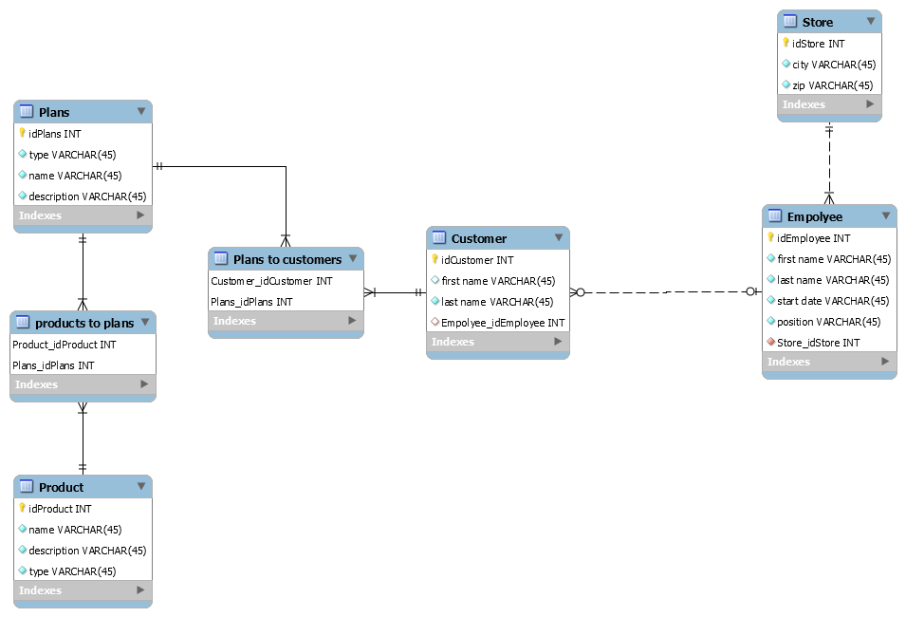

# DDL: Schema Implementation

## Implementation Code

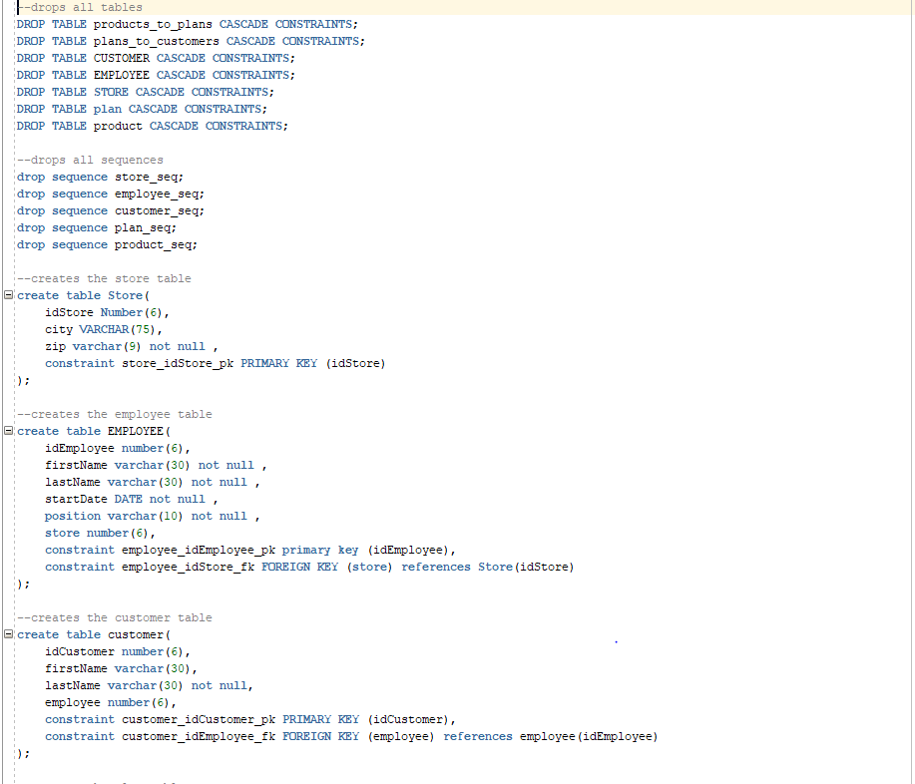

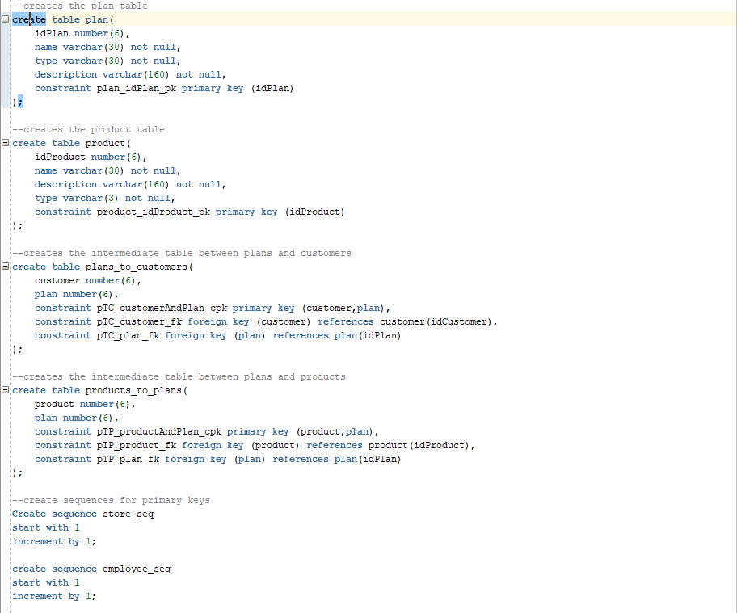

## Proof of run



# DML: Table Implementation

## Table Insertion Code

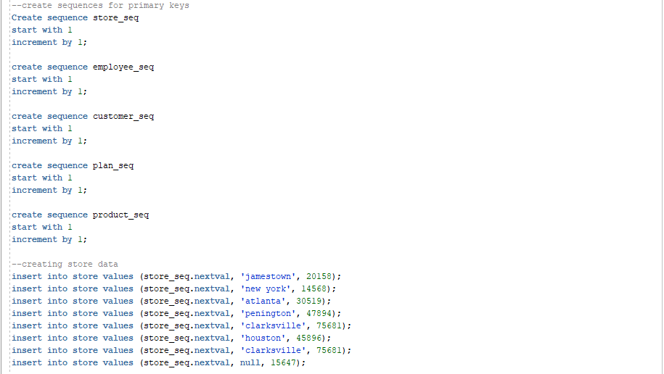

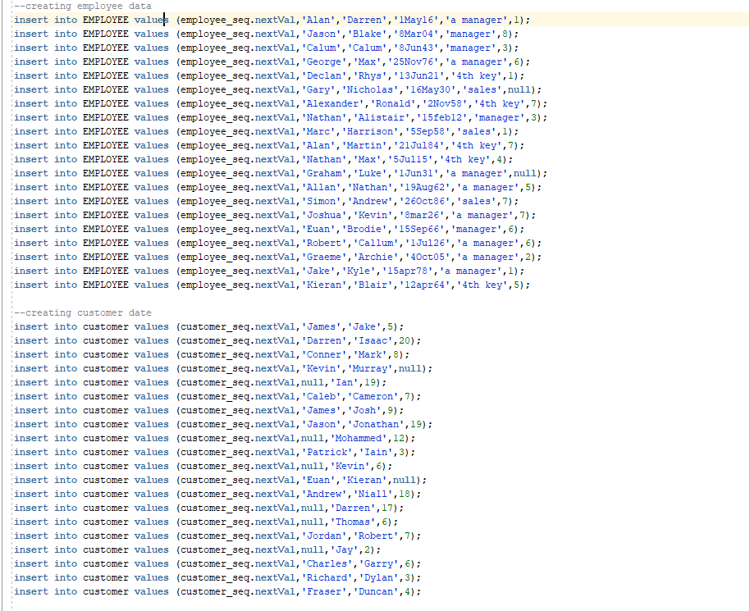

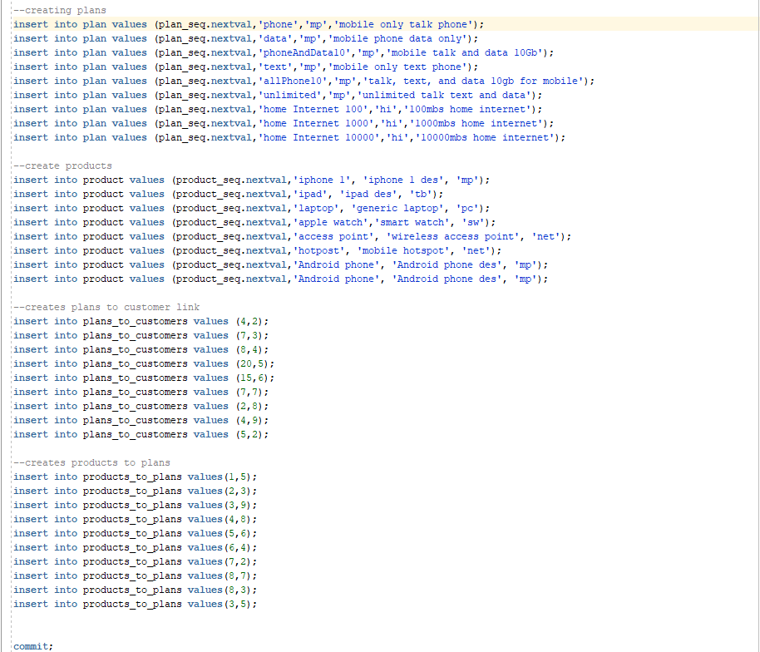

## Tables

### Store

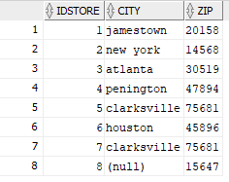

### Plan

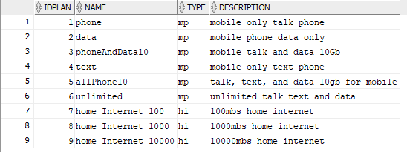

### Employee

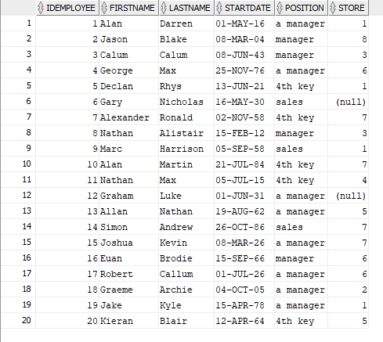

### Customer

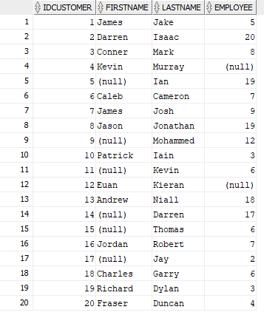

### Product

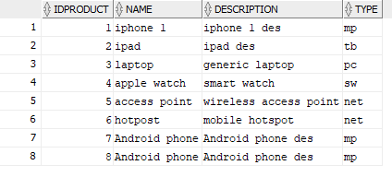

### Plans_to_Customers

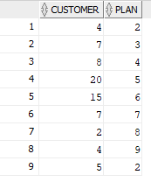

### Products_to_Plans

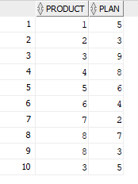

## Proof of run



# Queries

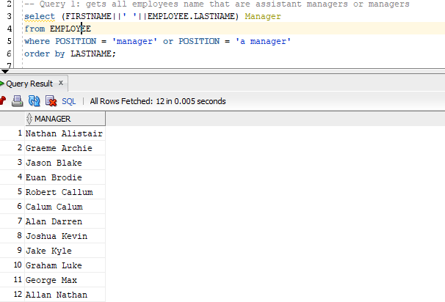

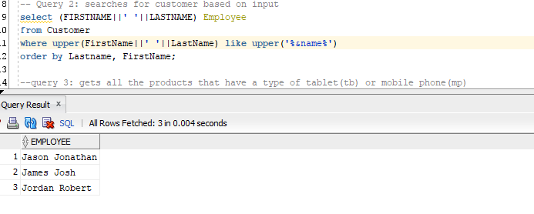

Substitution: ‘jo’

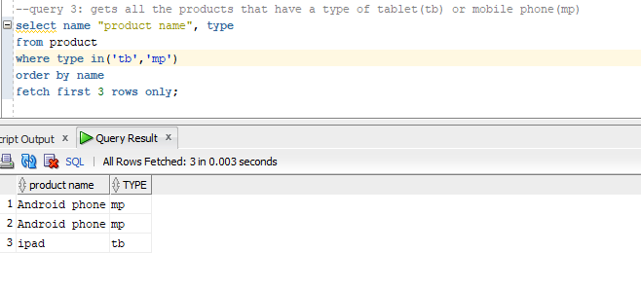

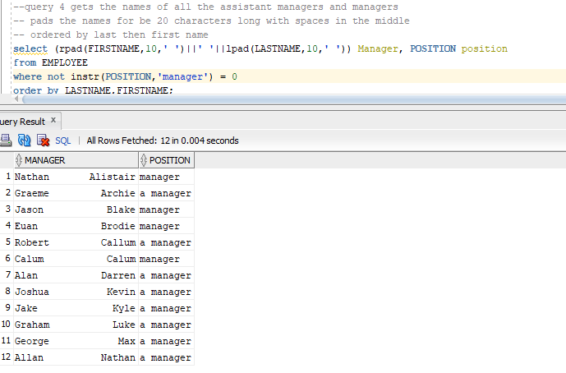

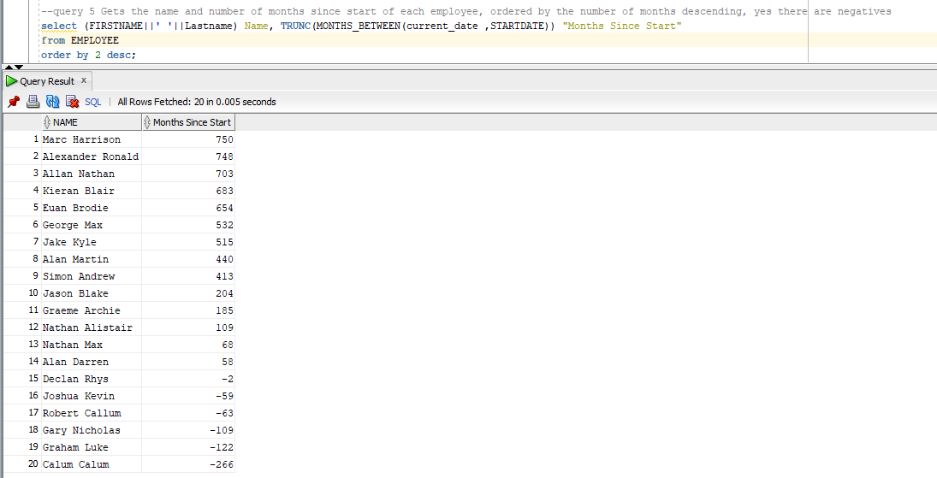

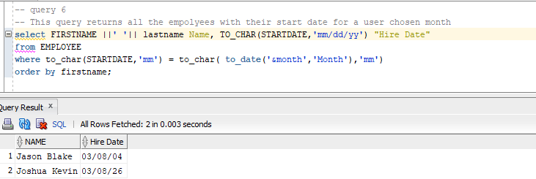

With “March” input for the substitution variable

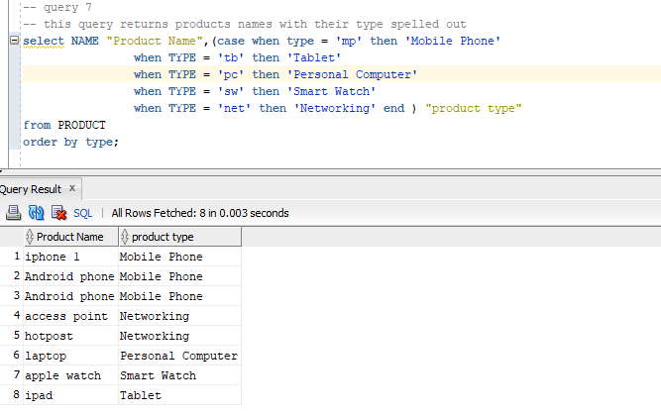

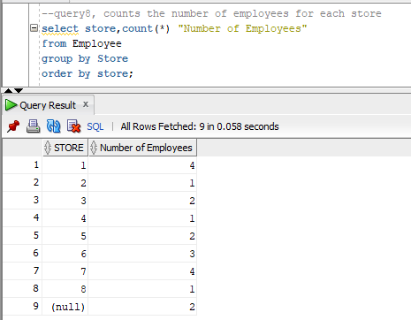

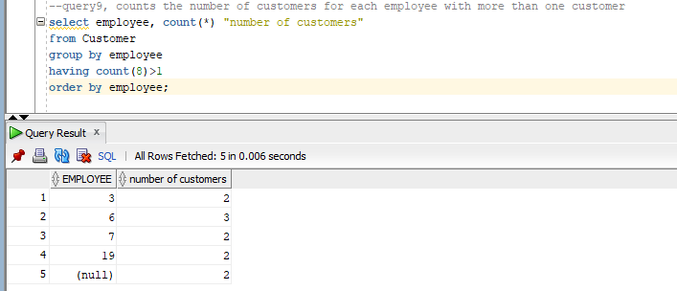

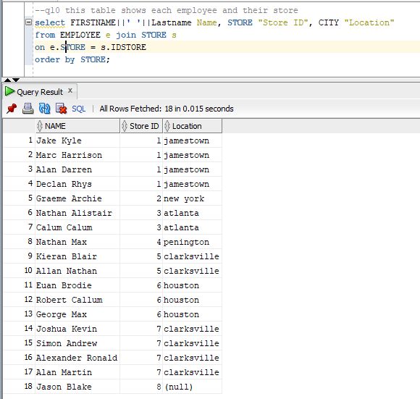

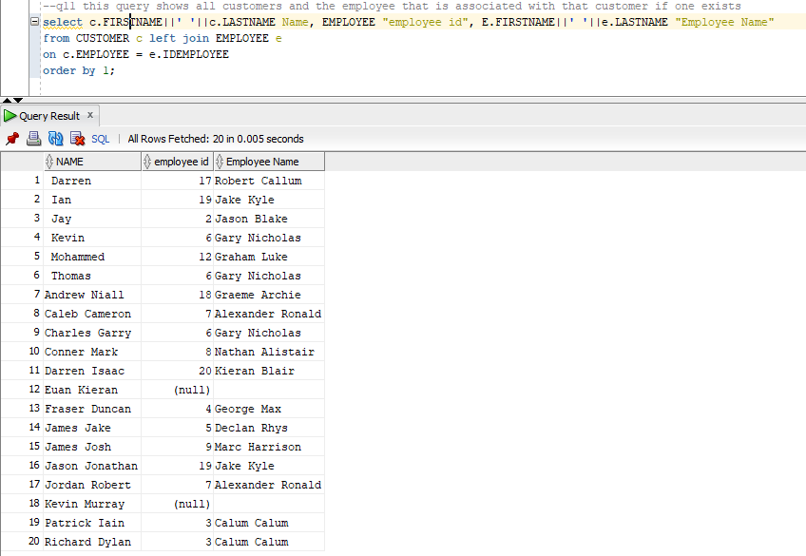

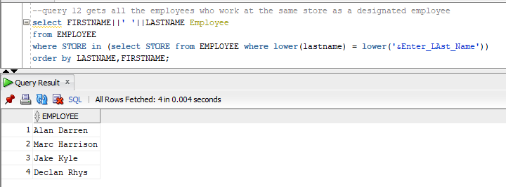

Input: Darren

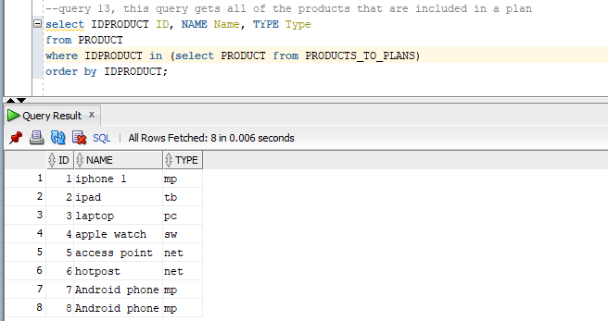

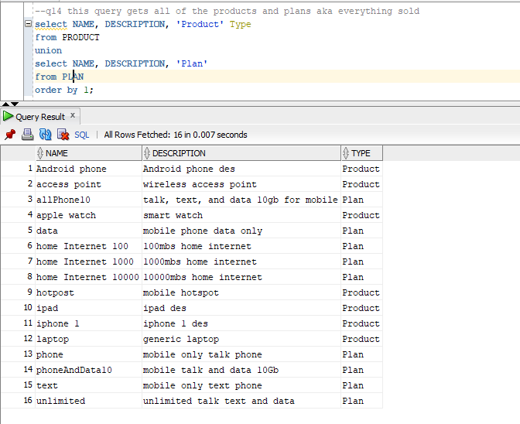

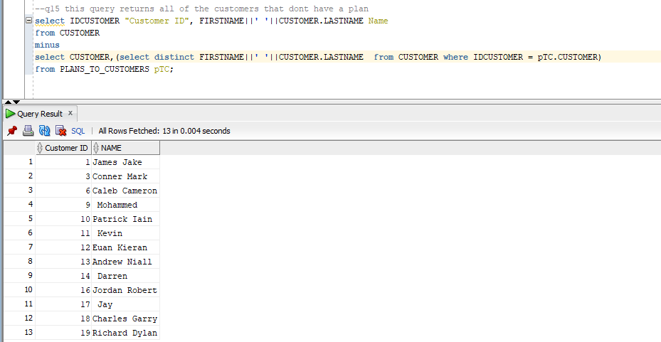

# Schema Objects

## Views

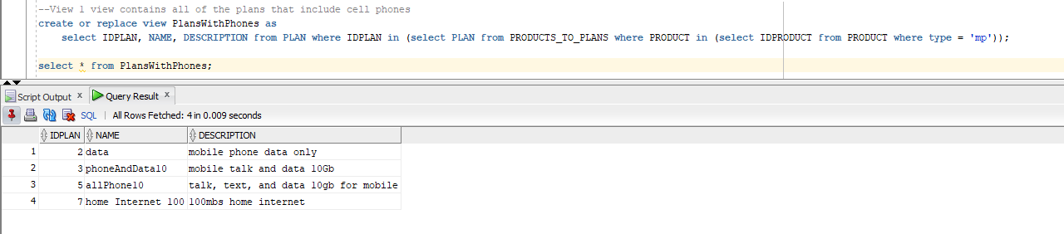

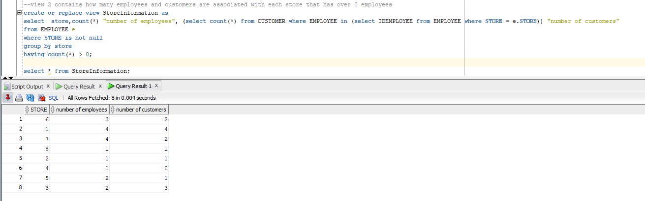

## Indexes

