User Manual: sO2 and Hematocrit Calculator

# Introduction

The sO2 and Hct calculator is developed by Josh Bradshaw, using Sharon Portnoy’s body of work. It is based on *Relaxation Properties of Human Umbilical Cord Blood at 1.5 Tesla* - Magnetic Resonance in Medicine 00:00–00 (2016), and a more recent manuscript which has not yet been published. The motivation for this tool is to provide clinical researchers with a user-friendly and robust means of doing these calculations.

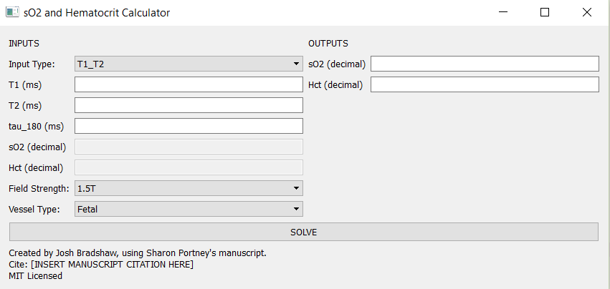

**Figure 1: sO2 and Hematocrit calculator version 1.0.**

# Setting up the calculator

The calculator supports three primary modes of operation:

1. Given T1, and T2, calculate sO2 and Hct
2. Given T1 and sO2, calculate Hct
3. Given T2 and Hct, calculate sO2

These modes can be selected by setting the input type selector to the appropriate input type:

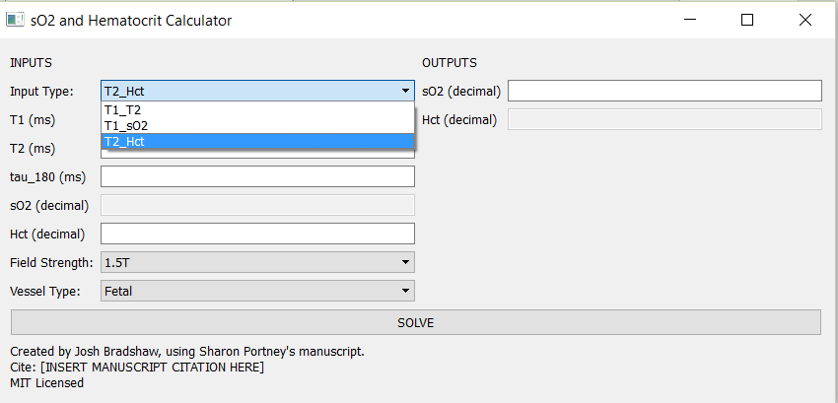

**Figure 2: Selecting the mode of operation**

After selecting the correct mode of operation, the field strength and vessel type fields must be set correctly. The three field strength options are:

1. 1.5T
2. 3T
3. 1.5T variable tau_180

The 1.5T variable tau_180 option isn’t a true field strength option per say. It’s just a little bodge to support the old pulse sequence that we previously used on 1.5T that had variable intervals between refocusing pulses, and thus requires a different analysis.

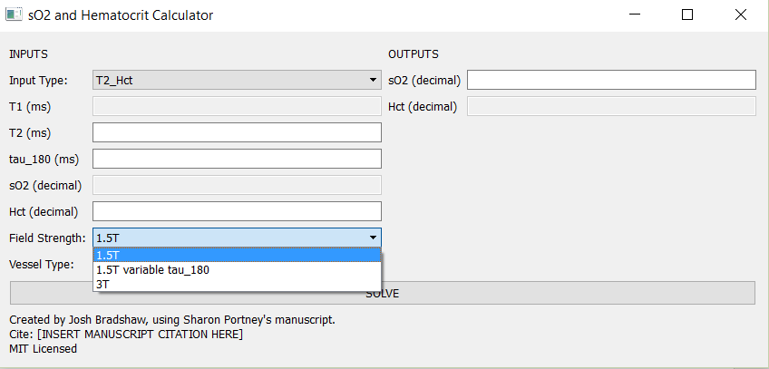

**Figure 3: Selecting the field strength**

At time of writing, all of the combinations work except for 3T. The 3T parameters will be retroactively added by Sharon Portnoy after she finishes calculating them.

# Performing the calculation

Once the input type, field strength and vessel type parameters are set correctly, performing the calculation is a simple matter. A few sample calculations are provided below:

## Example calculation with T1, T2 and Tau_180 as input

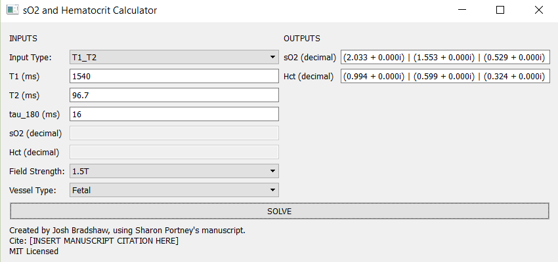

**Figure 5: Sample Calculation with T1 and T2 input.**

The calculator solves a cubic system of equations so it will typically output three pairs of numbers, which are the roots of the cubic equation. The Hct solutions are vertically aligned with their corresponding sO2 solutions. The solutions are provided in the standard complex number notation c = a + bi. According to Sharon Portnoy’s manuscript, the physical possible range for sO2 with measurement error is {-0.1 < sO2 < 1.1} and the physical range for hematocrit with measurement error is {0.05 < Hct < 1.05}.

In this case there is one real solution in the physical range of interest so we take the solution sO2 = 0.529 and Hct = 0.324 as our solution. We can be confident in this solution, because neither of the other two solutions pairs are in the range of physical possibility, and because physically possible solution is real (has an imaginary part of zero).

Some possible ambiguous cases include:

1. The only physically possible solution has in imaginary part. For example:  
     
   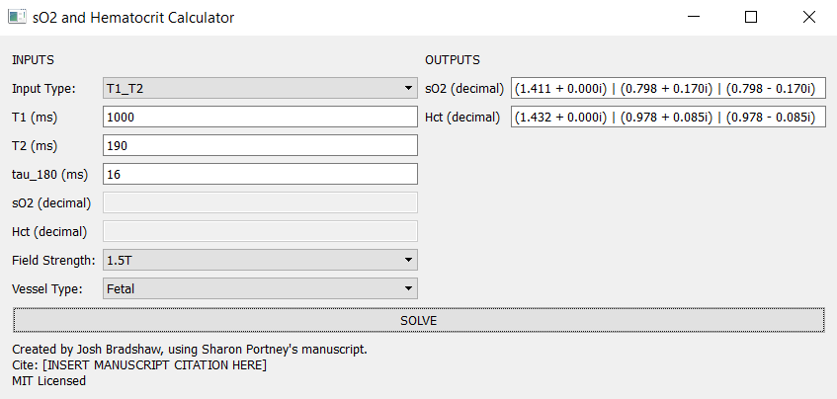  
     
   In this case the only physically possible solution is sO2 = 0.798 and Hct = 0.978, but this is a complex pair of roots, as opposed to a single real root. In this case both physically possible roots have the same real part, so we simply take the real values to get: sO2 = 0.798 and Hct = 0.978.
2. Another possible ambiguous case is one in which there are two distinct roots within the range of physical possibility. This case can occur when T1 is long. If this case arises, send as much information about the problem to Sharon so that she can investigate.

## Example calculation using T1 and sO2 as input

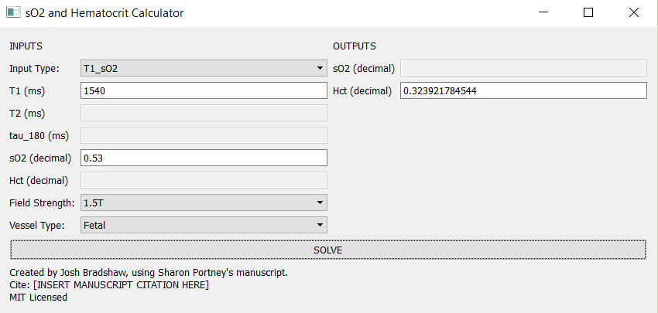

**Figure 6: Sample calculation with T1 and sO2 input**

## Example calculation using T2 and Hct as Input

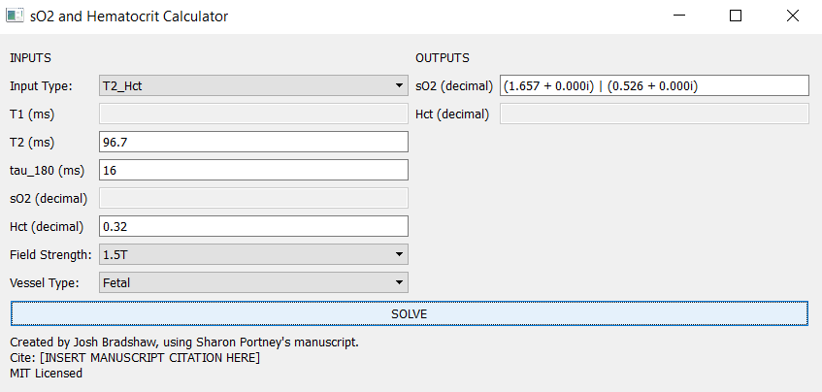

**Figure 7: Sample Calculation with T2 and Hct output.**

Similarly, to the calculation using T1 and T2 as input, the underlying model for this calculation involves solving a quadratic equation, so it will generally yield two solutions. The same rules for interpretation as in the T1 and T2 case apply.

# Testing the Calculator

A simple way to learn how to use the calculator and test that it returns the right answers is to use the numbers from this table:

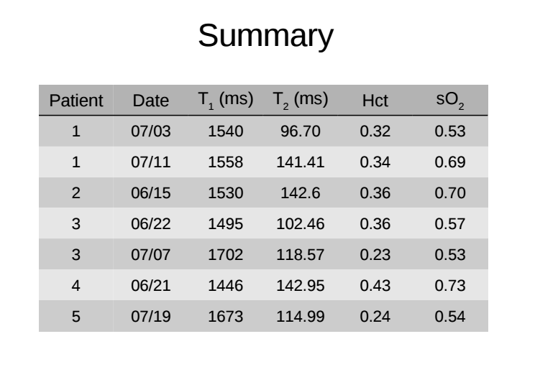

**Figure 8: Test data. Fetal 1.5T tau_180=16ms**