Task 3 Findings

Title
Predictable Session Token Generated with java.util.Random

Short Introduction
The provided APK is a local Android login demo that stores credentials and session state on-device. Because the original source code is not provided, decompilation is necessary to recover the manifest, activities, and security-relevant application logic for analysis. The core Task 3 finding is that the app generates its session token with java.util.Random, which is unsuitable for a security-sensitive secret.

System and Threat Model

Main Components
- MainActivity: collects user credentials and stores them locally.
- Login: validates credentials and creates session state after successful login.
- Profile: represents the logged-in screen and removes session state on logout.

Protected Asset
- SessionPrefs/sessionToken: the app’s explicit session artifact after successful login.

Attacker Model
- Local reverse engineer operating in a controlled assessment environment.
- Realistic environments include an emulator, rooted device, or instrumented test setup.

Attacker Capabilities
- Decompile the APK and recover the token-generation logic.
- Observe or trigger a successful login event.
- Inspect app-private storage and recover SessionPrefs/sessionToken.
- Replay or analyze the locally stored session token.

Scope Boundary
- No visible backend or remote session-validation path exists in the first-party code.
- The most realistic attacker for this APK is therefore local rather than remote.

Vulnerability Discovery and Evidence
Static analysis of the decompiled APK shows that a successful login leads directly to session creation and then transition to the profile screen. In Login.java, the login handler checks credentials, calls createSession(), and then starts the Profile activity. The createSession() method stores a generated value into SessionPrefs under the key sessionToken.
The core vulnerability appears in generateSessionToken(), which constructs the session token using java.util.Random and repeated calls to nextInt(62) over an alphanumeric character set. This is the strongest in-scope issue because it is the only first-party randomness path that directly creates a security-relevant value. Although the output looks random, java.util.Random is a deterministic non-cryptographic pseudo-random number generator and is not designed for secrets such as authentication or session tokens. A session token should be unpredictable to an attacker who knows the algorithm and can observe token-creation conditions.
Dynamic validation on the emulator further supports this conclusion. After a successful login, SessionPrefs.xml contains a sessionToken value, demonstrating that the app stores the generated token as live session state. On logout, the app removes the same key, confirming that this value is lifecycle-managed as the app’s session artifact rather than a cosmetic or UI-only identifier. The app’s first-party manifest also shows no visible backend or INTERNET permission, so the session design and impact boundary are local to the device.

Attack Scenario and Impact

Step-by-Step Scenario
- Decompile the APK and confirm that successful login calls createSession(), which stores a token in SessionPrefs/sessionToken.
- Confirm that generateSessionToken() uses java.util.Random, nextInt(62), and a fixed alphanumeric alphabet.
- Observe or trigger a successful login in a controlled emulator or rooted-device environment.
- Inspect app-private storage and recover the token value written to SessionPrefs.xml.
- Replay or analyze that token as a valid-looking local session artifact, since it is the app’s explicit session state.

Impact
- Strongest evidence-backed claim: local session-token replay or analysis in a privileged assessment environment.
- The token is unsuitable as a secure session secret because it is generated by a deterministic non-cryptographic PRNG.

Important Boundary
- This report does not claim proven remote account takeover.
- No backend or server-side session-validation path is visible in the first-party APK.
- The impact should therefore be described as a local session-token weakness rather than a demonstrated remote compromise.

Fix and Mitigation
The correct mitigation is to replace java.util.Random with java.security.SecureRandom when generating session tokens. SecureRandom is designed for generating unpredictable values for security-sensitive uses such as session identifiers. The root cause is predictability, not merely token length, so the key improvement is the stronger randomness source. Increasing token length can add margin, but it does not solve the fundamental problem if the generator remains non-cryptographic.

Figures
Figure 1. Successful login followed by the profile screen in the emulator.
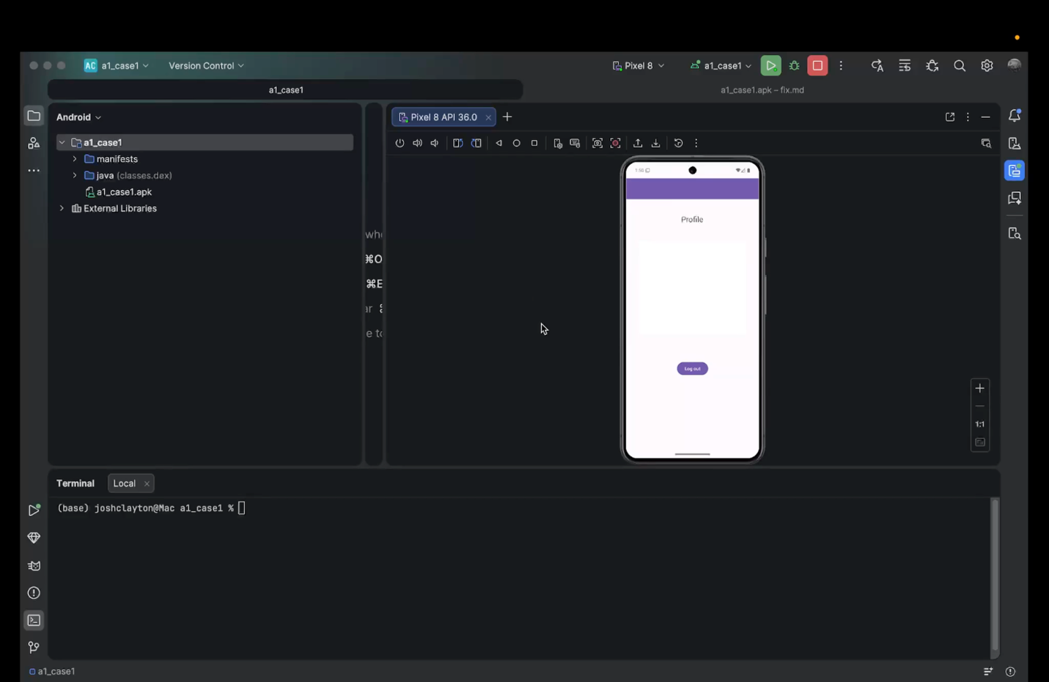

Figure 2. SessionPrefs.xml showing <string name="sessionToken">...</string> after login.
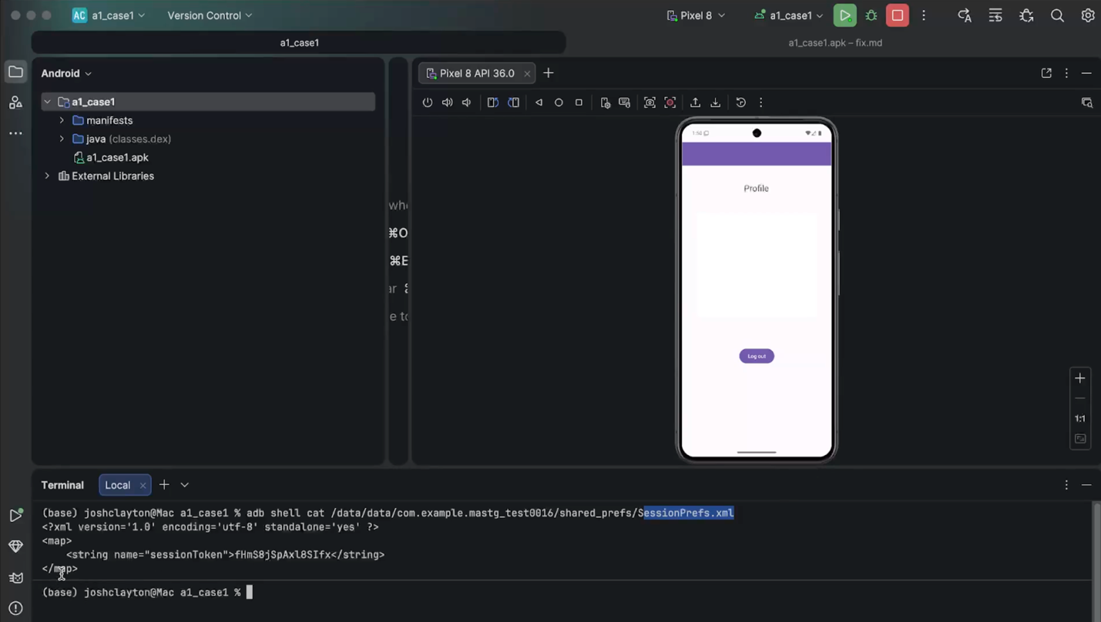
Figure 3. Login.java showing the login handler calling createSession(), the createSession() method storing sessionToken, and generateSessionToken() using java.util.Random.
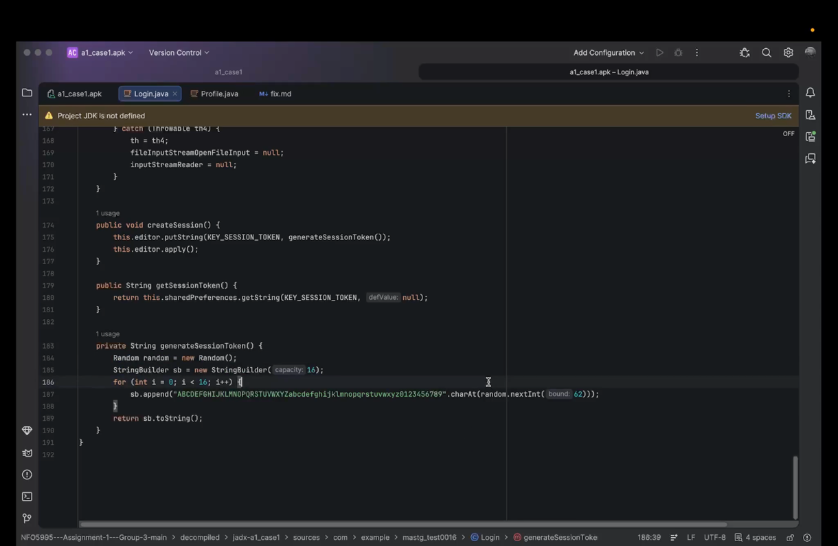

Figure 4. Profile.java showing remove(KEY_SESSION_TOKEN) during logout.
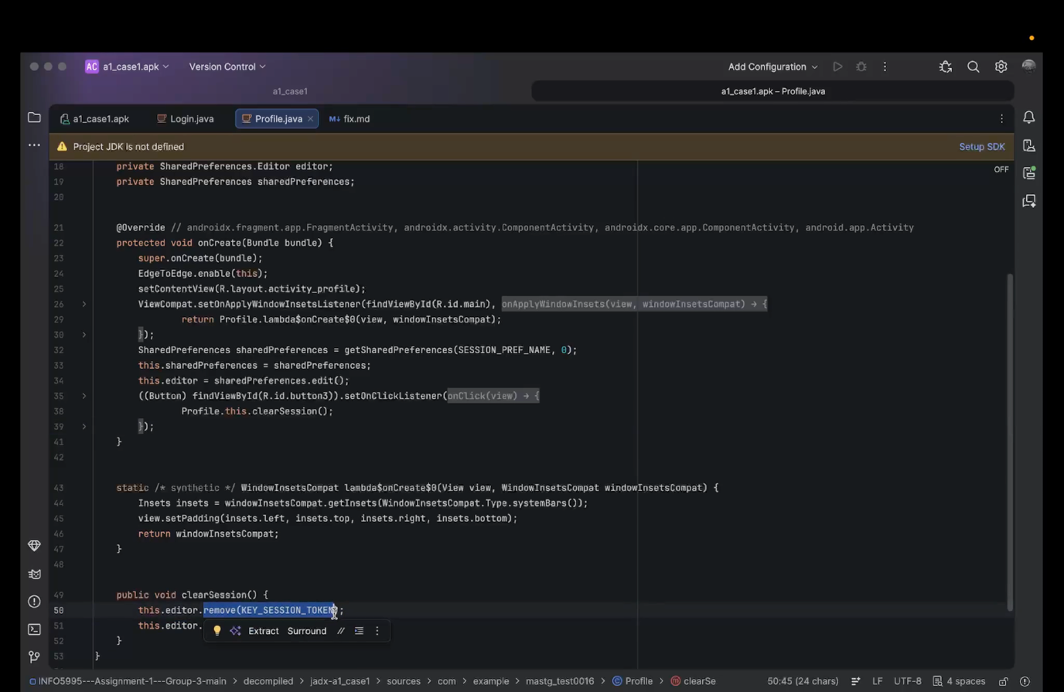
Figure 5. Fix snippet replacing java.util.Random with SecureRandom.
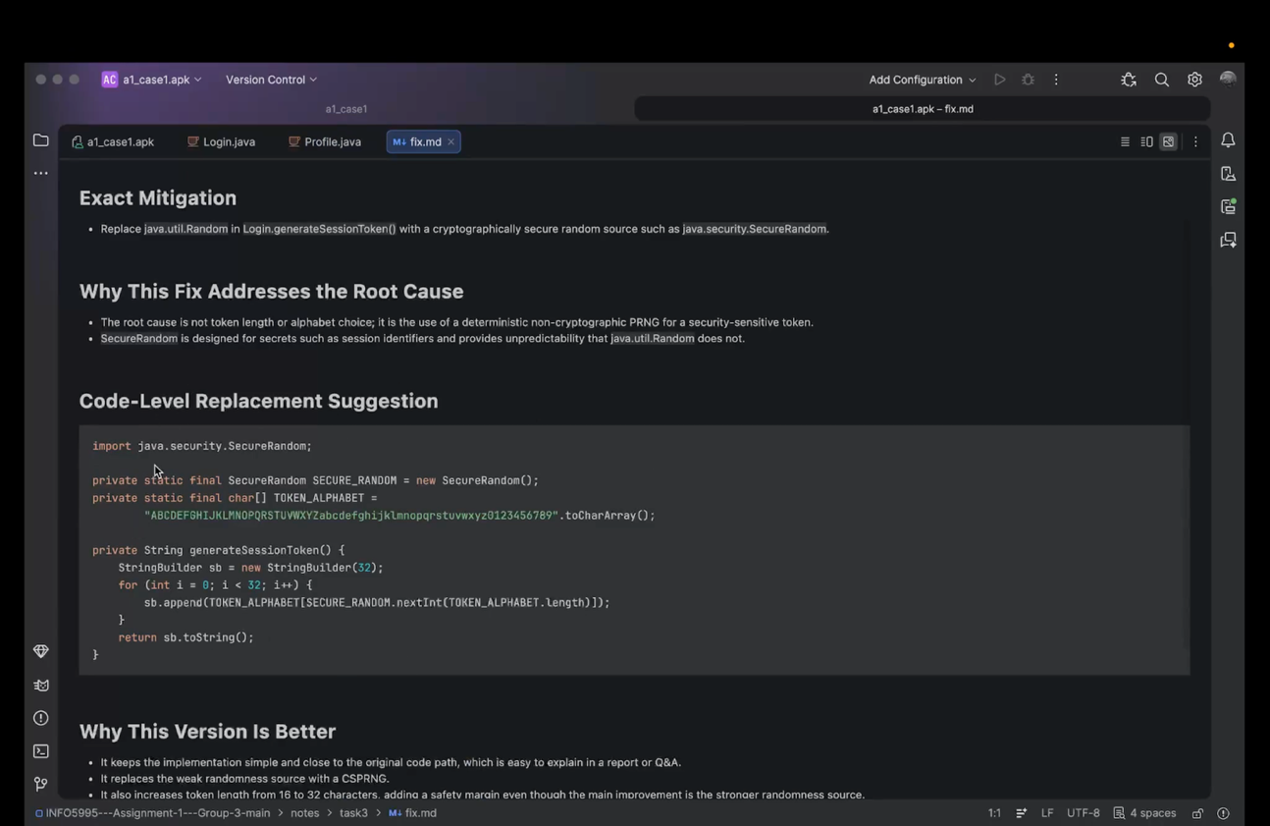

Conclusion
The Task 3 finding is that the APK generates its only explicit session token with java.util.Random and stores it in SessionPrefs/sessionToken after successful login. Static analysis, emulator validation, and logout behavior all support the conclusion that this value is intended to represent session state. Because java.util.Random is a deterministic non-cryptographic PRNG, the token is unsuitable as a secure session secret. The strongest evidence-backed impact for this APK is local session-token replay or analysis in a privileged assessment environment, and the correct mitigation is to replace java.util.Random with SecureRandom.

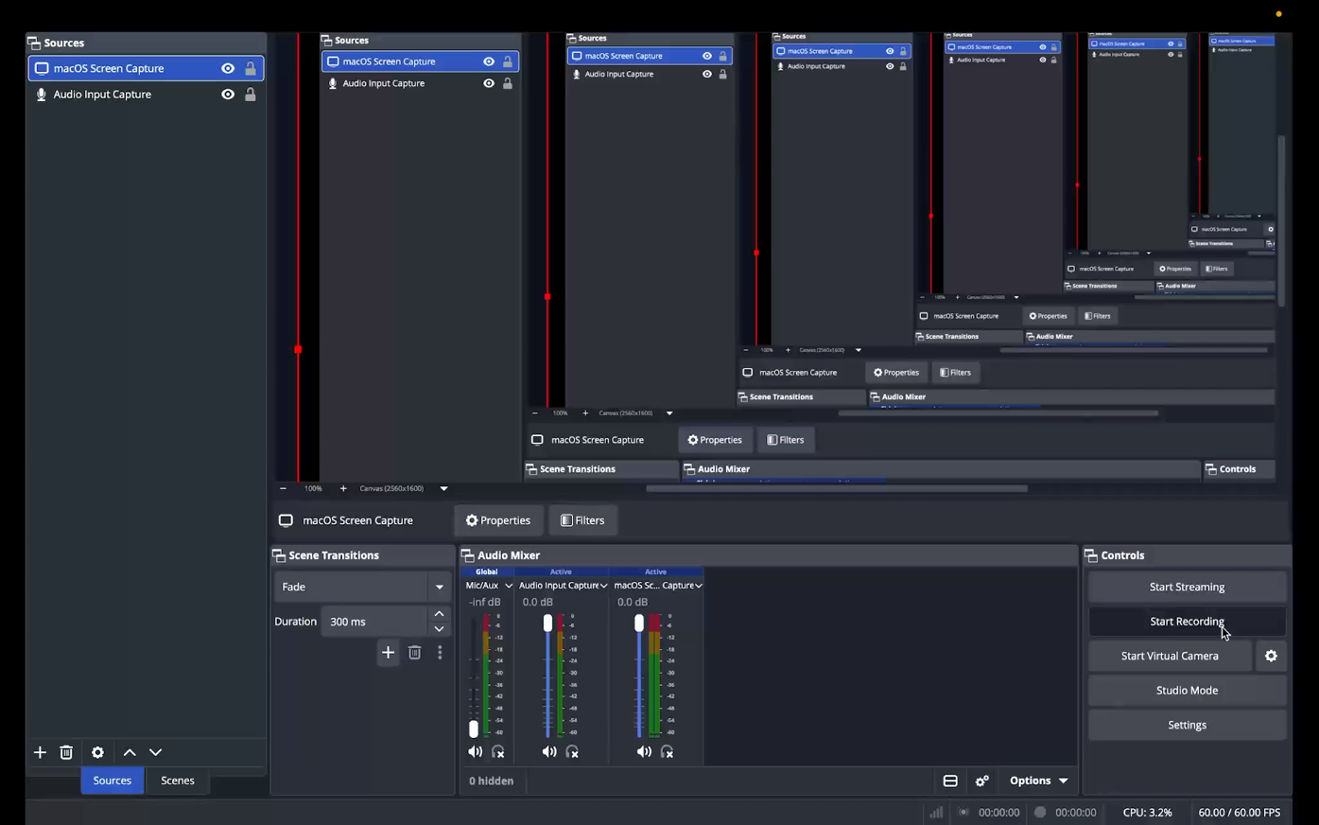
POCS

